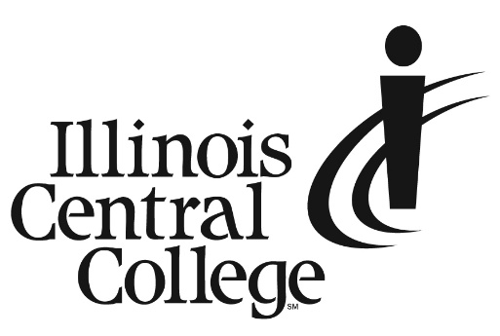 PRESS RELEASE

*MEDIA CONTACT:*   
 Jennifer O’Neil  
Lead Coordinator,

Communications and Media Relations  
Office: (309) 694-5527  
 Email: [PR@icc.edu](mailto:PR@icc.edu)

FOR IMMEDIATE RELEASE

**Illinois Central College to Host Summer Campus Visit Days**

On June 28 and 29, 2023, Illinois Central College is once again inviting the public to Campus Visit Days. These free events are designed to give prospective students an inside look at the College and its innumerable amenities. Learn about scholarships and financial aid, steps to enroll, and much more.

On June 28, explore the Culinary Arts programs and tour the Culinary Arts Institute at the Peoria Campus.

June 29 is a day to learn all about the more than 150 areas of study ICC has to offer and gives attendees the opportunity to tour the East Peoria campus.

Attendees will also have the opportunity to talk in person with staff, faculty, and students to find out why ICC is the smart choice.

**Culinary Arts Visit Day**

**Date/Time:**

**Wednesday, June 28**

**4:00 PM**

**Location:**

**Peoria Campus**

**5407 N University Street**

**Peoria, IL 61635**

**Summer Visit Day**

**Date/Time:**

**Thursday, June 29**

**4:00 PM**

**Location:**

**East Peoria Campus**

**1 College Drive**

**East Peoria, IL 61635**

Register for a Campus Visit Day at icc.edu/visit.

###

Illinois Central College is a two-year community college with campuses in East Peoria, Peoria, and Pekin, Illinois providing a high-quality, affordable education to prepare individuals for success in the workforce or at a four-year college or university. For more information on ICC, visit icc.edu.