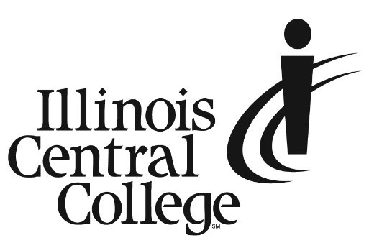

PRESS RELEASE
MEDIA CONTACT:
Jennifer O’Neil
Lead Coordinator,
Communications & Media Relations
Office: (309) 694-5527
Cell: (309) 218-2305
Email: PR@icc.edu

FOR IMMEDIATE RELEASE

Illinois Central College Names Dr. Jon C. Neidy as Vice President of Student Success

Illinois Central College proudly welcomes Dr. Jon C. Neidy (NY-dee) of Peoria, IL, as Vice President of Student Success. He will oversee student services, student development, student success, enrollment services, and athletics. Dr. Neidy has served in this role in an interim capacity since October 2022, and has already made great strides in student engagement and support. Dr. Neidy holds a Ph.D. from Illinois State University in Higher Education Administration.

ICC President Dr. Sheila Quirk-Bailey said, “From his 25+ years of supporting students, to his commitment to our community, Dr. Neidy brings with him the perfect mix of experience to make a positive impact as the Vice President of Student Success at ICC. Jon's focus on student outcomes, addressing the mental health needs of today's students, and his passion for first-generation students are all ideal attributes for his position. He has been and will continue to be a strong advocate for the students at ICC and our community.”

After a 24-year tenure in a wide variety of roles at Bradley University, Dr. Neidy comes to ICC with a wealth of knowledge in higher education and student success practices. Before Bradley, Dr. Neidy was the Director for the MacMurray College Programs for the Gifted where he had the opportunity to support gifted students through the creation of diverse and challenging curriculum.

Dr. Neidy “is looking forward to making a positive impact on the Illinois Central College student community and their post-credential outcomes while collaborating with deeply committed ICC staff, faculty, and administrators.” He adds, “In the short time I have been at ICC, I have found the work both personally and professionally fulfilling. I am grateful for the opportunity to help our local community learn in new and impactful ways and I look forward to facilitating change in the student experience.”

###
Illinois Central College is a two-year community college with campuses in East Peoria, Peoria, and Pekin, Illinois providing a high-quality, affordable education to prepare students to enter the workforce or to transfer to a four-year college or university. For more information on ICC, visit icc.edu.

