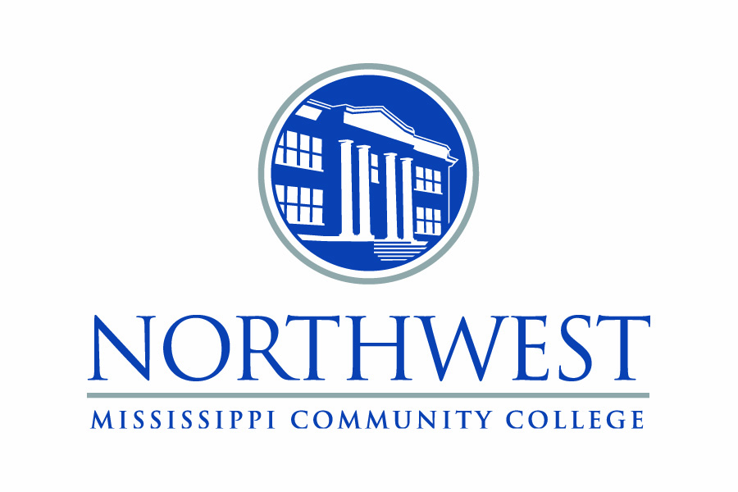

New endowments recognized at ceremonies

FOR IMMEDIATE RELEASE

11/14/22

SUGGESTED CUTLINE…Northwest Mississippi Community College President, Dr. Michael Heindl (far right) congratulates family members receiving plaques honoring new Foundation Scholarship endowments at the college during the Scholarship Recognition Ceremony Nov. 8 at the Haraway Center. Foundation board member Debbie Perkins and board President Sterling Withers (left) were also on hand to honor (center, l to r) W. Jean Moore, the Clen D. and W. Jean Moore Endowed Scholarship; Mary Murphy and Deloris Fields, the Bishop Elvage M. Fondren, Sr. Endowed Scholarship; and Stacy Honeycutt, the Richard Honeycutt Memorial Art Endowed Scholarship. Photo by Julie Bauer

SUGGESTED CUTLINE…Northwest Mississippi Community College celebrated new Foundation Scholarship endowments during the Scholarship Recognition Ceremony Nov. 9 at the Haraway Center. On hand to receive plaques were (front row, l to r) Foundation board members Pat Dhority, Dr. Patsy Sledge and Perrin Caldwell, Jr.; Leeann Elrod, Institutional Advancement specialist representing the Loretta Hentz Hanks Memorial Endowed Scholarship; Tim Hale, Cindy Hale, Buster Hale, Steve Hale representing the Emmette and Evelyn Hale Memorial Endowed Scholarship; Richard Darby representing the Richard Howard Darby Endowed Scholarship; Foundation board member Dennis Paulk; Patti Gordon, executive director of Institutional Advancement representing the Goodwin Family Endowed Scholarship; Foundation board member Debbie Perkins; Leigh Ellen Doddridge, Dr. Edith Robinson, Ellen Haraway, Lundy Robinson and Dr. David Haraway, representing the Bill and Marthola Smith Allen Endowed Scholarship. Photo by Julie Bauer