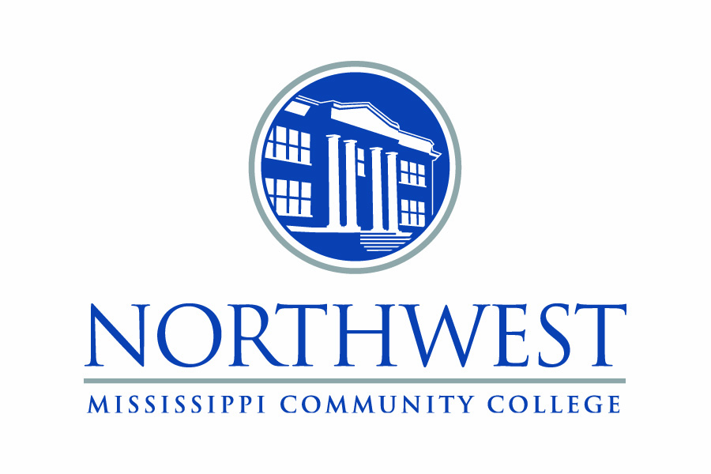

Endowment established for Barry Lee Meier through estate gift

FOR IMMEDIATE RELEASE

11/14/22

By LaJuan Tallo

The Barry Lee Meier Endowed Scholarship was established at Northwest Mississippi Community College with an estate gift left by Meier upon his death in June 2021.

Meier was born in North Carolina on March 9, 1961. After living in North Carolina for most of his life, Meier relocated to Memphis and finally settled in the Greenleaf Community in Tate County. Meier was employed as a car salesman for 12 years at All-Star Chevrolet in Olive Branch.

Those who knew Meier described him as a simple man who liked to fish and hunt and who loved NASCAR. He established many friendships, especially in the Greenleaf Community.

Drew DePriest, owner of All-Star Chevrolet described Meier as a great car salesman and someone people were naturally drawn to. “Barry was a model individual who exemplified taking care of his customers, who became his friends and felt like family to him,” DePriest said.

Meier is survived by his father, Kenneth Meier of Kentucky, his son Adam, sisters Lisa Butler and Nata Lescalleet and brothers Nick and Kenneth, all of North Carolina.

The scholarship is awarded to students in Career-Technical Education. Students must maintain a 2.0 GPA.

—30—

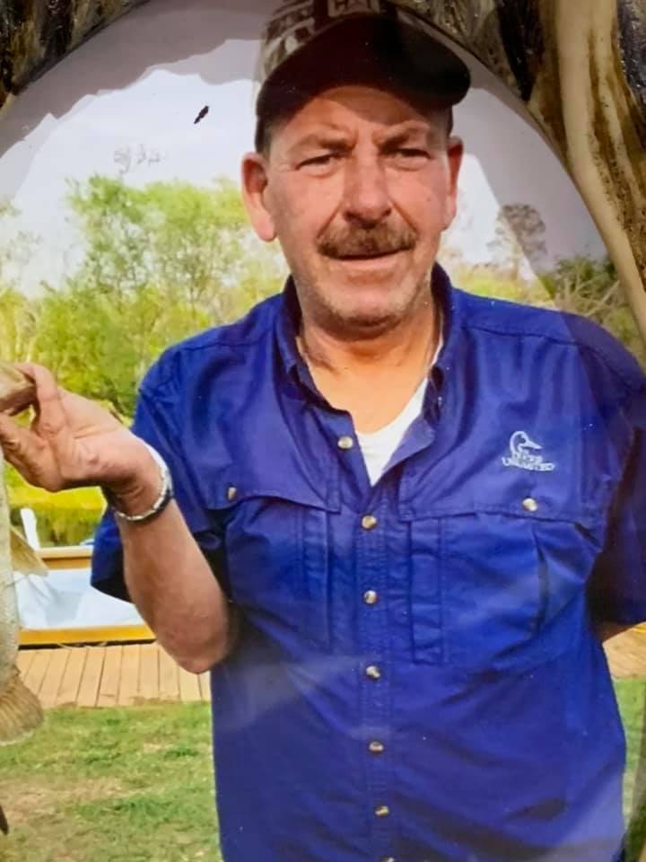

Barry Lee Meier