DMP’s published list of applications for mining licenses:
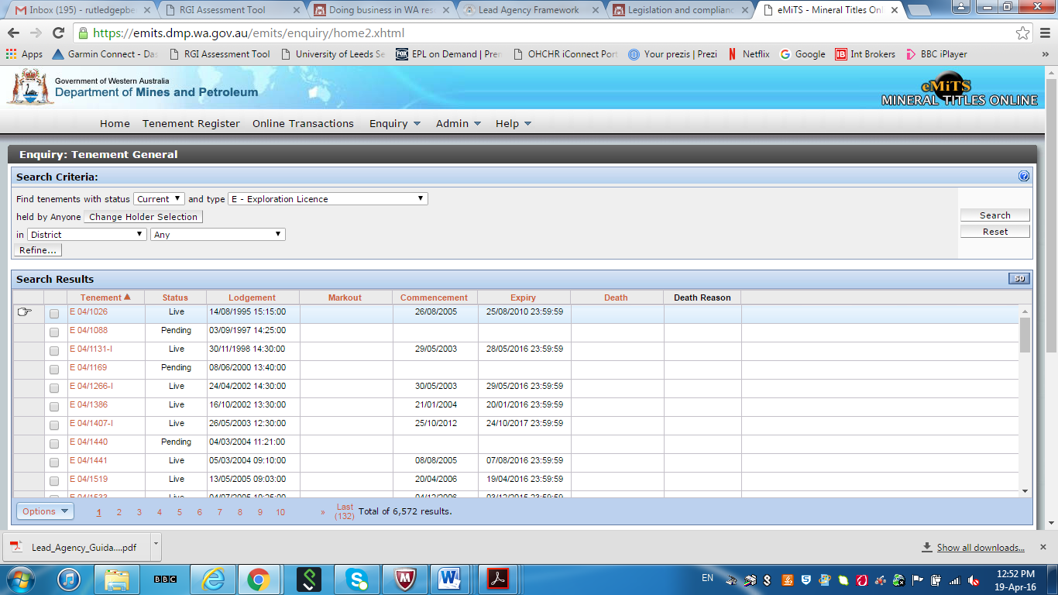

Examples of information provided by DMP on individual live and pending applications:
