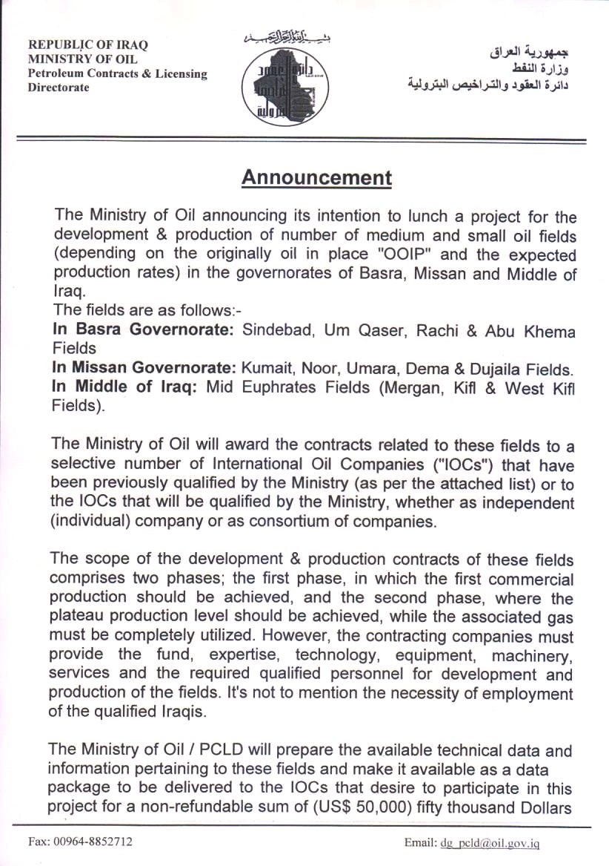
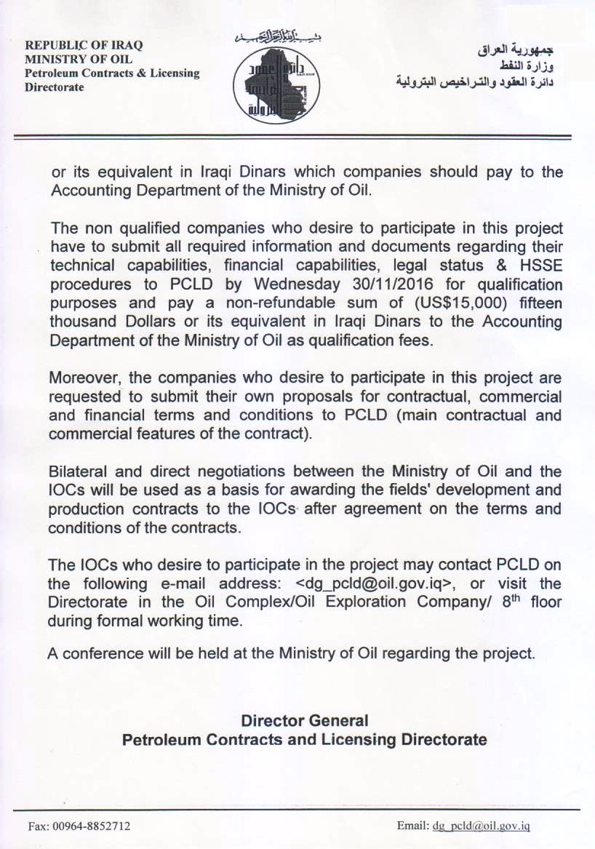
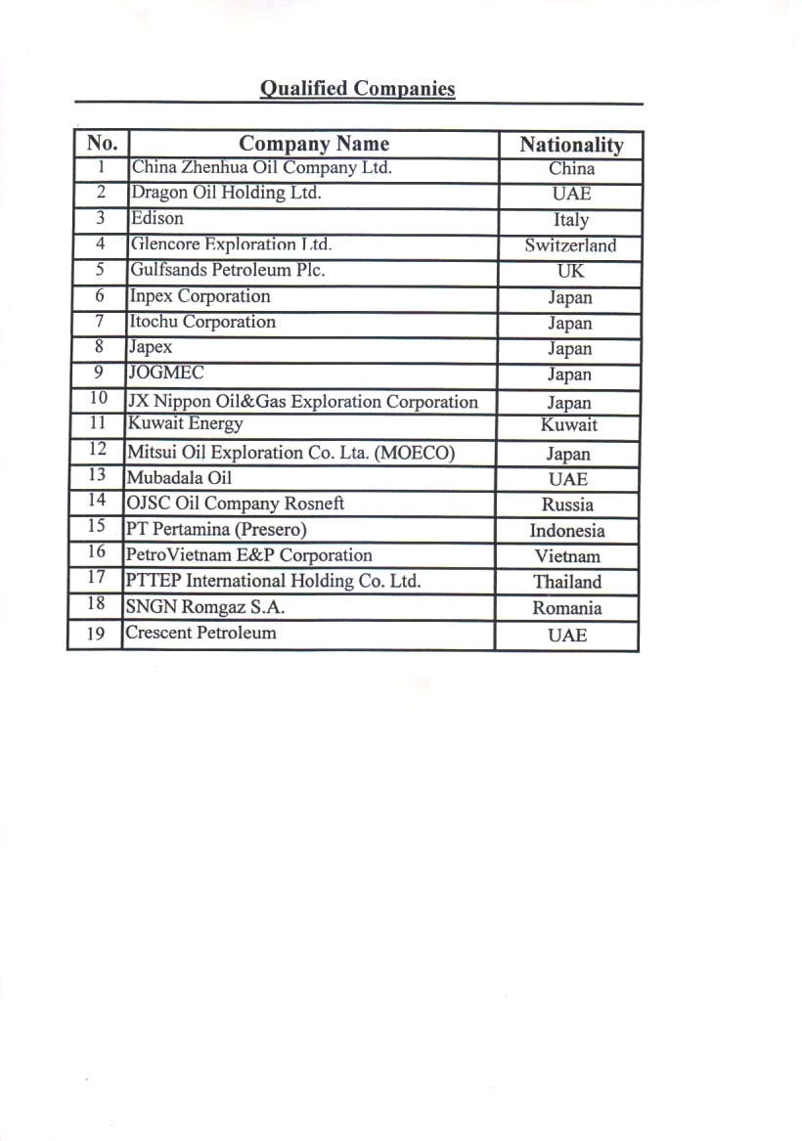
Send by: Site Manager | Date: 23-10-2016 | Time: 01:41:38 pm | Read : 281 |

Topics associated with this article

2016-10-31 - Tender for Sulphur Export from Midland oil Company and North Gas company

2016-09-26 - The Ministry of Oil Announce for the Investment Refineries.

2016-01-04 - the Iraqi Oil Tankers Company Announces for the Provision of the Shipment of Fuel Oil for February/ 2016.

2015-11-24 - the Iraqi Oil Tankers Company Announces for the Provision of the Shipment of Fuel Oil for January/ 2016.

2015-11-11 - The Article of the Society of Petroleum Engineers in the Conference and Exhibition for drilling technology

2015-09-22 - the Iraqi Oil Tankers Company Announces for the Provision of the Shipment of Fuel Oil for November 2015.

2015-09-15 - the Iraqi Oil Tankers Company Announces for the Provision of the Shipment of Fuel Oil for October 2015.

2015-09-13 - Health, Safety and Environment (HSE) Policy.

2014-07-24 - Extension of Closing Date of the Ministry of Oil Guest Palace Project.

2013-07-29 - Attention:

2016-11-23 - The Minister of Oil Meets with the Head of PetroChina Company.

2016-11-22 - The Minister of Oil Declares the Extinguishing of the Well No. 72 in Qayara Oil Field.

2016-11-20 - The Minister of Oil Declares the Extinguishing of the Well No. 38 in Qayara Oil Field.

2016-11-20 - The Senior Deputy Minister: the Oil Ministry is Keen to Elevate the Reserves & Invest Gas.

2016-11-15 - Iraq & Jordan Discuss About the Oil & Gas Pipeline and the Renewable Energy.

2016-11-13 - The Minister of Oil: the Initiation of Rehabilitating the Oil Facilities in Qayara.

2016-11-13 - The Ministry of Oil: the Extinguishing of the Well No. 46 in Qayara Oil Field.

2016-11-13 - The Minister of Oil Meets with the CEO of Gazprom Russian Company.

2016-11-10 - Announcement

2016-11-09 - The Ministry of Oil: Kuwait Supply Iraq with the Oil Well Firefighting Equipment.

