Press Conference of H E the Minister of Mines and Petroleum
Publish Date: May 25, 2015 Category: General
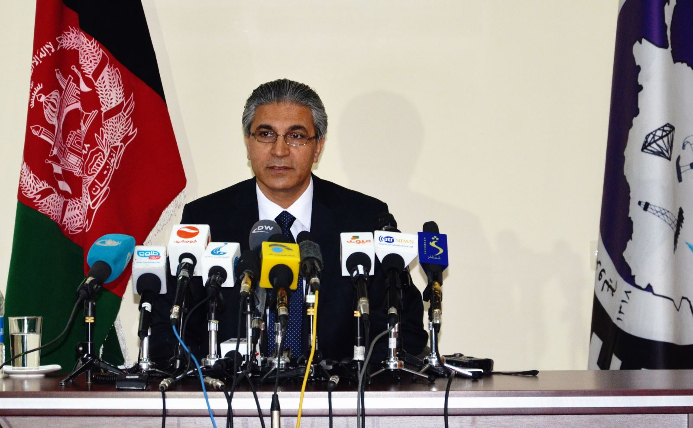
The Minister of Mines and Petroleum of the Islamic Republic of Afghanistan, His Excellency Dr. Daud Shah Saba in a press conference --which was attended by Deputy Minister of Mining Management Eng. Abdul Quddos Hamidi, senior advisor to the Minister Eng. Mohammad Akram Ghayasi, and a number of directors and staff members of the ministry and journalists from the media-- highlighted the various issues to the people of Afghanistan on May 25, 2015.
At the beginning, Dr. Saba rejected the rumors related to the unilateral termination of the Hajigak Iron Ore Contract by Indian consortium, and said: “Recently, many rumors over the termination of the Hajigak Iron Ore Contract issued by the media, that was just a rumor. In fact, there is no contract with Indian Consortium regards to the Hajigak Iron Ore, only an Indian consortium consisting of two Indian companies and one Canadian company, announced as the winner of the tender process for four blocks of the Hajigak iron ore deposit, and three blocks awarded to Indian companies and one to the Canadian. Principally, negotiation with the winning company of the tender continued”
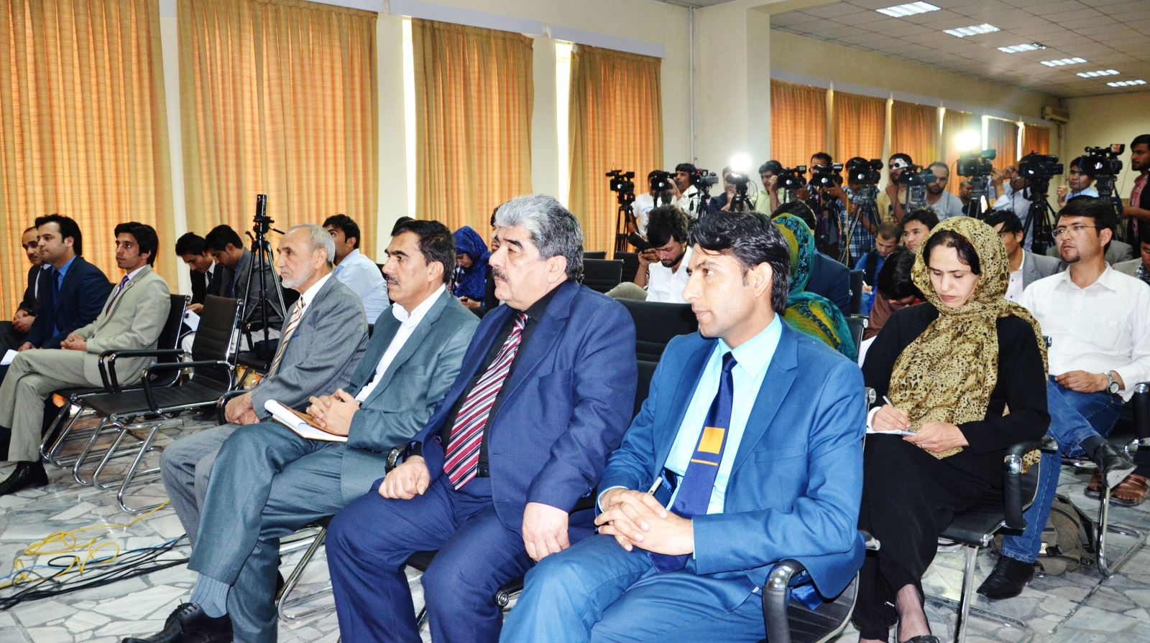
Dr. Daud Shah Saba on behalf of the Indian ambassador to Afghanistan --who had a meeting with the Minister of Mines and Petroleum-- denied the news, and said that the government of India has annual meeting regarding this issue, and this year at the meeting the participants presented various ideas, possibly the publishing of the news related to the termination of the Hajigak contract may originated of that idea.
Then Dr. Saba talked on the Aynak Copper, and considered the contract with the MCC Chinese company as the biggest contract in the mining sector of Afghanistan. He informed the audience of the publication of this major national contract on the website of the MoMP.
Dr. Saba promised that none of the issues relating to the mining contracts will be hidden from the media and the people of Afghanistan, and in order to enforce the transparency and improvement in mining contracts all the legal frameworks has determined, and details of all mining contracts will be made available to the public.
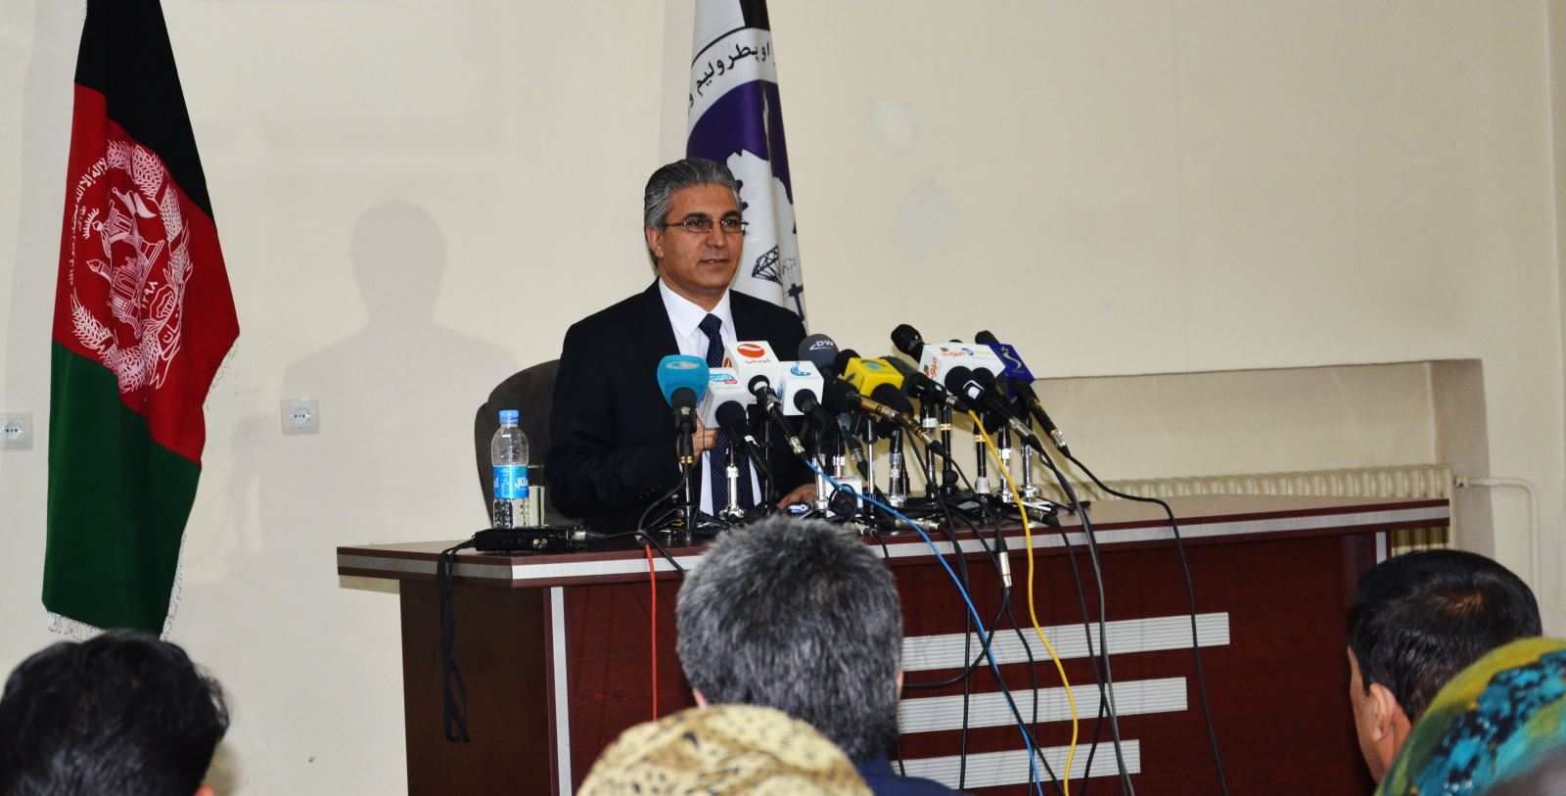
At the final stage, in order to improve the media related affairs and for quickly responding to the media, the Minister of Mines and Petroleum introduced Muhayoddin Noori as new Spokesperson to MoMP, and appreciated the work of former spokesperson.
The press conference concluded with answers by Dr. Saba to the questions of journalists.

