Subsidy reforms to spur development in UAE
Haseeb Haider/Abu Dhabi
Filed on July 23, 2015
- SHARE
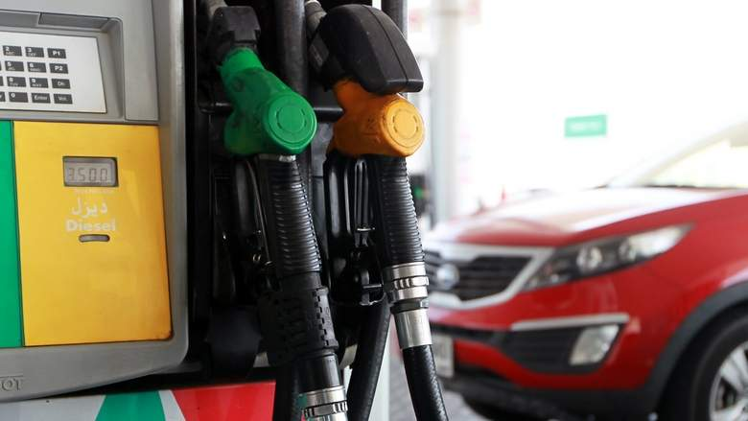
An Enoc petrol station on Al Khail Road, Dubai.
(Rahul Gajjar)

Government can channelise funds into infrastructure, education and healthcare, say economists.
Top economists have welcomed the deregulation of petroleum prices, saying it would allow the government to channel funds away from wasteful inefficient subsidies into productive investments, infrastructure spending, education and healthcare. Such spending would boost economic growth, improve the UAE's global competitiveness and bring in foreign direct investment, they said.
Carla Slim, an economist at Standard Chartered Bank in Dubai, said subsidies reforms will allow the government to allocate more funds for capital expenditure and to keep supporting the economy.
Subsidy reforms are being considered across the GCC and policy shifts are under way, she said.
Dr Monica Malik, chief economist at Abu Dhabi Commercial Bank (ADCB), welcomed the deregulation of petroleum prices in the UAE, calling it a "positive" move.
"The move to reduce subsidies is very positive for strengthening fiscal sustainability, especially given the sharp fall in the oil price," she said.
From a consumer's perspective, it is better to implement reforms when prices of oil are low, she said.
However, Dr Malik said: "We don't expect to see total liberalisation of oil prices or total removal of subsidies in one move, which could have a substantial impact on inflation."
The Ministry of Energy has not released too many details as yet. Dr Malik said: "Not all international prices are deregulated, while others are substantially higher, given taxes."
Mathias Angonin, an analyst with Moody's in Dubai, said the UAE authorities announced a review of the petrol subsidy policy after the Federal National Council asked the government on why retail fuel prices had not dropped in line with market prices.
The UAE has maintained fixed fuel prices throughout past oil price cycles, he said.
There are three constraints that would need to be overcome: first, cheap energy is part of the social contract in the Gulf region, and raising fuel prices would be widely unpopular.
Second, higher fuel prices would hinder the competitiveness of some of the country's non-oil sectors. Third, the increase in fuel prices would have to be coordinated with other GCC countries to avoid arbitrage across countries, Angonin said.
"Subsidies benefit larger, wealthier consumers rather than the less-endowed UAE population. A reduction in subsidies would free up resources that could be directed at social spending," he said.
Moody's Angonin said fuel subsidies create uncertainty in the trajectory of government finances, as they often transfer the cost of fluctuations in oil prices from consumers to the public sector. The fuel subsidy reform would reduce that uncertainty, he said.
"However, as the UAE's federal and emirate budgets do not include fuel subsidies, the move will not impact the UAE's consolidated government deficit, which we forecast at one per cent of gross domestic product (GDP) this year. Nevertheless, the Abu Dhabi National Oil Company (Adnoc) will collect higher revenue from its sales and could use this to finance the government deficit and buttress the UAE's public reserves," the Moody's analyst said.
Alp Eke, a senior economist at National Bank of Abu Dhabi (NBAD), said government revenues had started declining with the drop in oil prices.
The government has to find other options to reduce expenditure. The first such expenditure is subsidies. "The UAE and GCC nations have the lowest prices of gasoline in the world. Subsidies have to be gradually removed. We have already started to see reduction in subsidies in the GCC."
In the first week of March, after serious warnings by the International Monetary Fund, the president of the Oman Central Bank announced that "Oman will cut/reduce natural gas subsidies later this year." Kuwait and Abu Dhabi also reduced subsidies on diesel, natural gas and utilities.
"The UAE, which charges 47 cents for a litre of gasoline, is the highest in the GCC but if we compare to the world, gasoline prices at the pump in the UAE is one of the lowest," Eke said.
GCC nations are estimated to currently have about $3 trillion in net foreign assets. In the past couple of years, due to high oil prices, these countries recorded substantial asset accumulation.
However, "if we assume the oil price were to remain at say $65 for the rest of the year, and no change in planned government spending, GCC nations could experience over $200 billion of depletion in the collective net foreign assets in 2015 alone," Eke said.
Removal of subsidies would not remove budget deficit but would help reduce it, he said.
"UAE government officials are discussing methods to increase revenue (taxation) and methods to reduce spending. All these efforts combined would improve our fiscal position and reduce asset depletion," the economist said.
M.R. Raghu, head of research at Kuwait-based investment bank Kuwait Financial Centre or Markaz, said that the Supreme Council of Energy has indicated that fuel subsidies exceed Dh13 billion or $3.5 billion.
He said the direct impact on the economy would be people having to spend more on essential items such as fuel, leaving a lower disposable income to spend on other items.
- haseeb@khaleejtimes.com

