

SONARA ranked first company in Cameroon
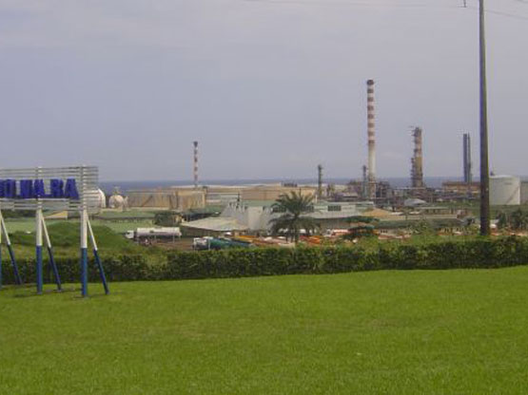
- Saturday, 02 March 2013 04:29
JeuneAfriquemagazine in its latest ranking of the 500 companies in Africa graded the National Refining Company of Cameroon (SONARA) as the first company in Cameroon in terms of turnover.Volume of sales seems to have been the criterion of classification. With nearly 1000 billion francs CFA of turnover reached in 2011, it climbed to the 76th spot in Africa, up from 28 places, ahead of the National Hydrocarbons Corporation (SNH) which is at the 86th position with a jump of three places, Brasseries du Cameroon is 246th, AES African Power Co is 287th, while MTN Cameroon occupies the 308th and Orange Cameroon the 362nd.
Although productive, the former General Manager of SONARA, Charles Metouck was sacked and replaced by Ibrahim TalbaMalla, General Manager of Hydrocarbons Price Stabilization Fund (CSPH), one of the shareholders of SONARA.
SONARA and the other five companies in this classification are among the top 10 companies of Central Africa, in terms of turnover. A total of 39 companies based in Cameroon appear on the list of the best companies in Central Africa.
JV

