Skip to main content
Republic of Ghana

Log in


Search

- Home
- Data
- Agency
- Application
- Developers
- Aid Data Sites
- WW Data Sites
- Contact Us
Get Started
Search Over 124 Datasets In 25 Agencies

Search

Get Involved

Finance

Health

Agriculture

Energy

Education

Environment

Local Government

City Data

Extractive

Statistics
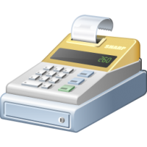
Business

Elections
- About Us
- Open Government
- FAQ
- Aid Data Sites
- Data Policy
- Privacy Policy
- Terms of Use
- Contact Us


The site is designed, hosted and maintained by National Information Technology Agency (NITA) 2012-2016 government of Ghana. All right reserved.


