ABOUT SGRF
State General Reserve Fund (SGRF) was established in 1980 by a Royal Decree 1/80. It endeavors to achieve long term sustainable returns on the revenues generated from the oil and gas, and that are surplus to the state's budgetary requirements
On behalf of the Government of Oman, SGRF manages the reserves placed in its care to achieve best possible long term returns with acceptable risks, through investing in a diversified portfolio of asset classes in more than 25 countries worldwide.
SGRF is regulated and supervised by the Financial Affairs and Energy Resources Council (FAERC).

SGRF VISION

To support the Government's effort in securing funds for the future generations.
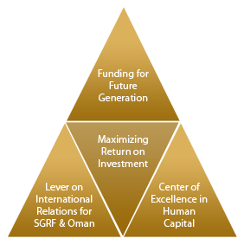

SGRF MISSIONS

To execute on and enhance the followings
Maximize returns while prudently managing its risk profile
Invest strategically with long term time horizon for Oman’s future generations
Leverage global relationships to facilitate investments and build Oman’s Economy
Attract global investments and experiences through global relations net
Develop its current platform into Human Resource Center of Excellence
Communicate and engage with community regarding SGRF's role in the future of Oman
Play a local investment leadership role and facilitate global best practices

BOARD OF DIRECTORS

Name
Designation

H.E. Darwish bin Ismail Al Balushi
Minister Responsible for Financial Affairs Deputy Chairman, Financial Affairs & Energy Resources Council
Chairman
H.E. Dr. Ali bin Mohammed Moosa
Deputy Chairman, Board of Governors, Central Bank of Oman
Director
H.E. Dr. Mohammed bin Hamad Al-Rumhi
Minister of Oil and Gas
Director
H.E. Dr. Ali bin Masoud Al-Sunaidy
Minister of Commerce and Industry
Director
H.E. Nasser bin Khamis Al Jashmi
Undersecretary, Ministry of Finance
Director
H.E. Abdulsalam bin Mohammed Al-Murshidi
SGRF Executive President
Director

HOME I FAQs I LEGAL NOTICES I CAREERS I CONTACT US
Copyright © 2014 State General Reserve Fund. All rights reserved

