- http://www.oilgas.gov.tm/en/m/page/page/25
Home
- Oil&Gas complex

Oil&Gas complex


The Ministry of Oil and Gas of Turkmenistan
The State Agency on Management and Use of Hydrocarbon Resources at the President of Turkmenistan


"Turkmengas" State Concern


"Turkmen Oil" State Concern
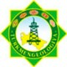
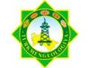
“Turkmengeology” State Corporation


“Turkmennebitgazgurlushyk” State Concern


