GRA exceeds 2015 revenue target
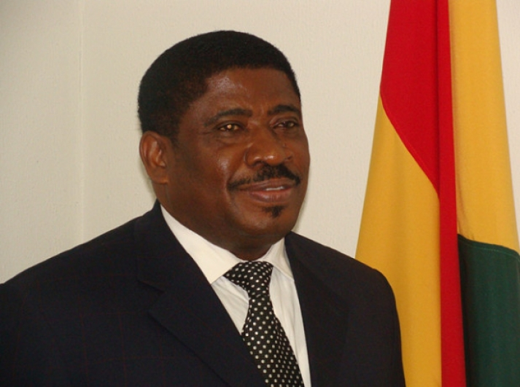Mr George Blankson, Commissioner General of the Ghana Revenue Authority

By: Emelia Ennin Abbey Date : Wednesday, 02 March 2016 13:21
Published in Business News

The Ghana Revenue Authority (GRA) exceeded its 2015 revenue target of GH¢21.57 billion by GH¢620 million, representing an increase of 2.9 per cent.
The 2015 revenue performance shows a revenue growth of GH¢5.014 billion, representing a 29.3 per cent increase over the target of GH¢8.13 billion in 2014.
The Commissioner General of the GRA, Mr George Blankson, who announced this during an interaction with some journalists in Accra, said the authority had been charged to collect GH¢27.59 billion for the national kitty for 2016.
Out of the amount, the Customs Division of the GRA is to collect GH¢10.159 billion, while the rest will come from domestic direct and indirect taxes.
Strategies
Mr Blankson attributed the 2015 achievement to a number of strategies adopted by the management of the authority, the dedication of the staff and support from the media.
The strategies employed included regular external visits and inspection of taxpayers’ businesses to retrieve outstanding taxes, increase in audit and regular engagements with taxpayers through public education.
Additionally, he said, the GRA roped operators in the informal sector into the tax net, while the revenue mobilisation task force of the authority set up in August 2015 also enforced tax payments from recalcitrant taxpayers.
Excise tax
To improve the administration of excise tax, Mr Blankson said the authority would this year begin affixing excise tax stamps on excisable products for both locally manufactured and imported goods.
Some concerns have been raised by some exporters and importers over the excise tax stamp since it was proposed last year.
Mr Blankson explained that the excise tax stamp was not a new tax but rather a new way of administering the excise tax which had been in existence for a long time.
On February 1, 2016, he said, the ECOWAS Common External Tariff (CET) became operational in Ghana with the view to harmonising the taxes imposed on imported products in the country and other ECOWAS countries.
Already, seven countries in the region have implemented the CET.
On other activities expected to be carried out in 2016, Mr Blankson said the authority planned to implement the other phases of the Single Window Concept to enhance and facilitate international trade to boost revenue collection and also serve the public better.
He commended the media for supporting the authority in its public education drive and promoting voluntary tax compliance.

