UK mining firm withdraws permit for jade area in Kachin state
NEWS
Kachinnews
Published: 19 September 2015
Hits: 11217
Share
- Print

- Email
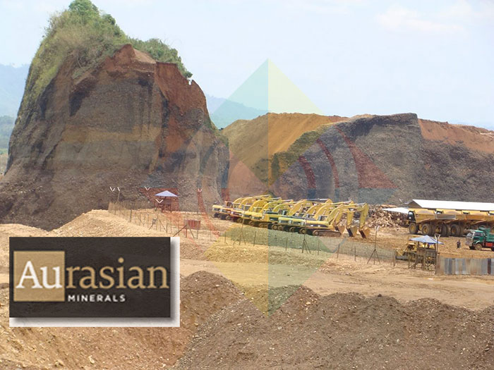
Aurasian Minerals Plc (AuM) a British mining firm that last year had applied for a mineral exploration permit in a jade mining area in Burma announced earlier this month that it had withdrawn the exploration permit citing a delay in a new national mining law. In an article published by the Irrawaddy magazine on Friday September 18th the firm acknowledged that its permit applications were for Kachin state, something previously unacknowledged by the company.
The firm which trades on the AIM, a sub exchange of the London Stock Exchange, had announced in January in an update to shareholders that the previous month it had delivered "three applications for mineral exploration licenses to the Myanmar Mining Authorities." Though the firm did not say where in Burma these applications were made it did reveal that the applications were made in areas that according to the company there exists "jade and gem mining concessions".
The only known commercially viable jade deposits in Burma are located in Kachin state in Hpakant, an area that has seen repeated clashes between the government and the Kachin Independence Organization (KIO) since a 17 year ceasefire collapsed in June 2011. Fighting between the KIO and government forces has continued over the past few months in jade rich Hpakant. Clashes in June forced more than 200 civilians in Hpakant to flee from their homes. Although both sides in the conflict continue to meet regularly for peace talks it remains unclear when the fighting will come to a complete end.
In January's Progress Update Aurasian noted that that its exploration applications for gold, copper and silver were “pending” with Burmese authorities "due to the current security situation in the relevant areas." According to Aurasian "when the areas have been given security clearance the authorities have indicated that they will then process the AuM applications after excising".
Although the firm, which was previously called Triple Plate Junction, did not specify what the "security situation" actually entails this appears to have been a reference to the ongoing conflict between ethnic armed groups and the central government which continues in several parts of the country including in Kachin state. Likewise the firm's statement did not elaborate on what needed to happen in the areas in question before authorities can give "security clearance".
A little less than 20% of Aurasian’s shares are owned by the giant US mining firm Newmont Mining Corporation, the world's second largest gold miner. According to Aurasian, the firm entered into an agreement last year with a subsidiary of Newmont that allows for Aurasian to gain access to "Newmont’s proprietary database covering various exploration activities in Myanmar, Lao PDR, Malaysia, Indonesia and Cambodia".
Newmont was previously involved in Burma in the 1990's before pulling out in 1997 after spending a considerable amount of funds to develop gold deposits in Kyaukpahto in northern Sagaing Division.

