Between 2004 and 2014, researchers with the U.S. Geological Survey worked cooperatively with Afghan colleagues to assess Afghanistan’s natural resources and strengthen its earth science capabilities.

USGS Projects in Afghanistan: A Brief History
For more than 75 years, the U.S. Geological Survey (USGS) has been involved in projects in dozens of countries that focus on helping cooperators develop mineral, water, and energy resources, identify hazards, utilize remote sensing and mapmaking technologies, and access geosciences information. A key component of these projects has been a commitment to institution and capacity building, state-of-the-art training, and hands-on, personal interaction with foreign contributors and scientific colleagues.
USGS participated in collaborative projects in Afghanistan’s natural resource sector from the 1950s through the early 1970s. Beginning in the late 1970s, conflict and instability in the country put an end to USGS involvement for more than a quarter century. During that time, Afghan natural resource agencies and institutions were decimated. Scientists, technicians, and other employees were unable to continue their work or stay current in their research fields. Facilities and laboratories became largely non-functional. Instruments and equipment, as well as vehicles and logistical support, all but disappeared. However, many Afghan scientists were able to preserve decade’s worth of vital and irreplaceable geographic information and other data, in some cases safeguarding it in their own homes.
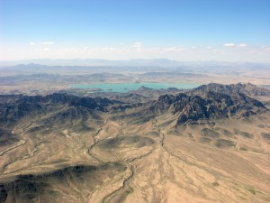
In 2002, many employees of Afghanistan’s ministries and agencies began returning to work. Safeguarded materials—including maps, reports, tables, charts, and notebooks—found their way back into libraries and repositories within these government organizations. Additional historical information about the country’s natural resources was also gathered from sources outside Afghanistan. This body of knowledge, albeit largely outdated, together with returning scientists and technicians formed the starting point for restoring and updating Afghanistan’s natural resources sector.
In 2004, USGS began providing technical assistance to Afghan government ministries and agencies to help assess natural resources and participate in the rebuilding of institutions and infrastructure. A primary focus involved working to restore and revitalize earth science organizations, upgrade facilities, and retrain technical staff. The training effort took a variety of forms, from inviting Afghan scientists and staff to attend special classes at USGS facilities in the United States to holding seminars, workshops, and courses in Afghanistan and neighboring countries taught by USGS instructors, industry specialists, and/or representatives from professional or academic institutions working under the auspices of international organizations or other U.S. government agencies.
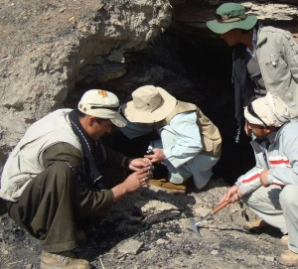
A second focus of USGS activities in Afghanistan was on gathering new natural resource data via wide-spread collaborative fieldwork, drilling and coring, satellite remote sensing, airborne geophysics and seismic surveys, establishment of stream gage networks, and extensive studies in ground and surface water quality and quantity. These more recent data enhanced and broadened Afghanistan’s existing natural resource datasets, and are vital for both short-term and long-range planning regarding management of these resources, as well as for identifying potential new resources that may attract foreign investment and create employment opportunities for Afghans. In addition to gathering data, USGS also worked to develop an integrated Geographic Information System (GIS) data framework for Afghanistan consisting of geologic and topographic map data, satellite imagery and accompanying databases, data documentation, and a system for the efficient archiving, retrieval, and distribution of data to a wide user community. Such a GIS data framework is an essential tool for conducting assessments of coal, oil, natural gas, minerals, and water resources, evaluating earthquakes and other hazards, analyzing ecosystem management strategies, and supporting a wide variety of other activities.
USGS Projects in Afghanistan were coordinated with other U.S. government organizations including the Departments of State, Interior, Treasury, and Defense, the U.S. Embassy in Kabul, the U.S. Agency for International Development (USAID), and the Trade and Development Agency (TDA). Within Afghanistan, USGS collaborated with numerous Afghan ministries—including the Ministry of Mines, Ministry of Energy and Water, Ministry of Agriculture, Irrigation, and Livestock, Ministry of Rural Rehabilitation and Development, Ministry of Transport and Civil Aviation, and Ministry of Communications and InfoTechnology—and worked closely with Kabul University, Afghanistan Information Management Services (AIMS), and several German, French, and Danish government organizations and NGOs.
USGS Projects in Afghanistan concluded in late 2014, having successfully carried out more than a decade of extensive scientific research and having produced many unique and important data products, including the 2007 Preliminary Assessment of Non-Fuel Mineral Resources of Afghanistan, the 2011 Summaries of Important Areas for Mineral Investment and Production Opportunities of Nonfuel Minerals in Afghanistan, and related natural resource studies. Also significant was the progress made in scientific capacity building within the Afghan agencies that collaborated in these diverse projects throughout the ten-year duration of this effort. Arguably, it is on this front where USGS Projects in Afghanistan may have made its most significant impact: contributing to the rebuilding of a sustainable scientific infrastructure in Afghanistan.

