href='http://bnftandbt.com/adserver

Search

‘GNPC takeover with Ghana Gas almost complete’
April 4, 2016
Source: Eugene Davis | B&FT Online | Ghana
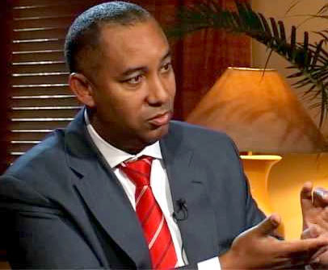

Petroleum Minister, Emmanuel Armah-Kofi Buah has said that the process leading to a takeover of Ghana Gas by the Ghana National Petroleum Corporation (GNPC) is almost complete.
“One of the processes is to make sure that the CEO of GNPC is a board member of Ghana Gas. There are some legal processes that need to be done. They are left with paperwork. Basically the two companies are working together with this in mind: that they are one company,” he told the B&FT.
He also explained that: “GNPC by law is the company that is interfacing in buying all the gas produced offshore. Ghana Gas is the one processing all the gas. Do we want GNPC to negotiate one gas agreement, get Ghana Gas to negotiate another and create some weak link in the process?”
The MP for Ellembelle also added that: “We believe Ghana Gas can benefit with a strong balance sheet of GNPC as we go forward, and I believe it is good for Ghana”.
The GNPC is Ghana’s National Oil Company (NOC), established in 1983 by PNDC Law 64 to support government's objective of providing adequate and reliable supply of petroleum products, and reducing the country's dependence on crude oil imports through developing the country’s own petroleum resources.
Chief Executive Officer of the GNPC Alex Mould earlier said: "The acquisition process is ongoing. The shareholder -- Ghana government -- and GNPC have signed an agreement and agreed the sale. What is left to complete the takeover is more of an administrative registration issue at the Registrar-General's. As soon as government decides to do that, we will consummate the transaction. But in terms of the agreement, we signed it long ago.
"My understanding is that it is a Cabinet decision -- which has been passed, so we are just waiting for it to happen and it could happen any day from now," he said.
The decision to cede management and operations of the gas processing company to the GNPC has been acrimonious, with the Board of Ghana National Gas Company challenging the decision in what many considered as a power-play.
After several boardroom wranglings, government through the Ministry of Energy and Petroleum announced in December last year that it has executed the legal instrument assigning its entire shareholding in GNGC to GNPC, making the GNPC sole shareholder of GNGC with full control.
Mr. Mould however explained that the GNPC is yet to take over Ghana National Gas, contrary to speculations amid criticism that the takeover idea is the result of GNPC's lobbying.
He said the decision to bring Ghana Gas under GNPC, though not a proposition of the corporation, is a prudent one that must be commended.
Please enable JavaScript to view the &lt;a href="https://disqus.com/?ref_noscript" rel="nofollow"&gt;comments powered by Disqus.&lt;/a&gt;

Follow Us

