China's Global 500 companies are bigger than ever—and mostly state-owned
- by

- Scott Cendrowski

- @scendrowski
JULY 22, 2015, 9:01 AM EDT
- E-mail

- Tweet

- Facebook

- Linkedin
Share icons
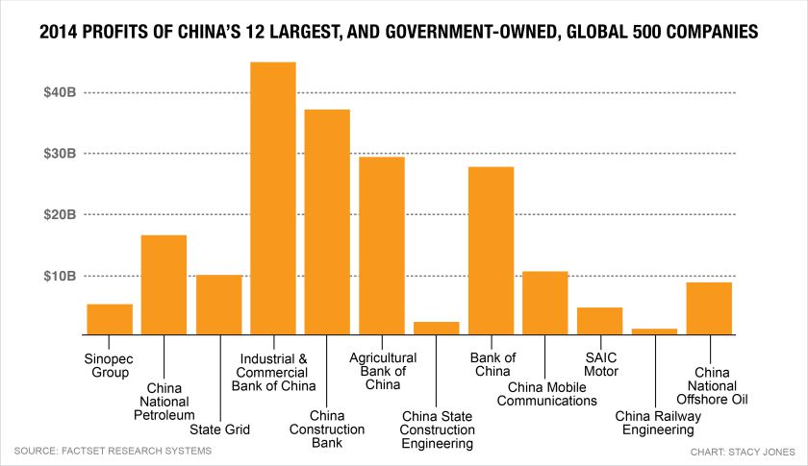

China’s state-owned enterprises enjoy massive government financial support, but many still face tough economic challenges.
Take a look at the number of Chinese companies on this year’s Fortune Global 500 list and it’s hard not to come away impressed—even a bit intimidated. Ninety-eight companies are based in China, including those headquartered in Hong Kong. That puts China second only to the U.S., which has 128 companies on the list. (You can filter the companies of the Global 500 by country using Fortune’s new, searchable and sortable database.) If you compare this year’s figure to recent ones, China’s rise is even more spectacular. China had just 46 companies appearing on the list in 2010, and only 10 in 2000. The U.S. has trended in the other direction: 139 American companies made the list in 2010 and 179 in 2000.
But dig a little deeper, and China’s rise begins to look less imposing. First, the top 12 Chinese companies are all state-owned. They include massive banks and oil companies that the central government controls through the State-Owned Assets Supervision and Administration Commission of the ruling State Council (SASAC), which appoints CEOs and makes decisions on large investments. Of the 98 Chinese companies on the list, only 22 are private.
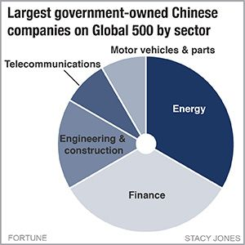
With the government as their largest shareholders, China’s state-owned enterprises (SOE) enjoy massive state support, which fosters growth and insulates them from competition. “What would the chairman of China’s largest bank do if the chairman of PetroChina asked for a loan?” wrote Carl Walter and Fraser Howie in their history of China’s markets, Red Capitalism. “He would say, ‘Thank you very much, how much, and for how long?’” He’d probably do so from one of the extravagantly designed SOE-headquarters, many with foreign architects, that line two major thoroughfares in Beijing.

Second, the Chinese companies are anything but global brands. They enjoy monopolies or oligopolies at home, but often struggle to expand their business outside of the protected borders of their home country. “Chinese companies that wish to go global are hindered because they lack adequate knowledge of consumers in target markets and experience in building leading brands,” Boston Consulting Group partners wrote earlier this year. Size is no substitute for strength in international competition. Today, many of the Chinese brands that are most known around the world—including Alibaba, Tencent, Baidu and Xiaomi, none of which are state-owned—remain too small (in terms of revenue) to make the list.
The number of Chinese companies appearing onFortune‘s list should continue growing in the coming years, because it is a government priority to rise up the rankings. At a SASAC event in 2013, the economist Hu Angang, Director of the Institute for Contemporary China Studies at Tsinghua University and a vocal proponent of the Communist Party and its state-owned companies system, said that by 2020 the number of SOEs on the Fortune Global 500 list would hit 130.
But until Chinese companies grow international brands commensurate with their size back home, they will be like B-movie actors who count 1 million Twitter followers: they will never be as impressive as their revenue numbers suggest.
Some other takeaways from the Chinese companies on this year’s Global 500 list:
-Of the 54 companies with the biggest losses last year, 16 were Chinese, the most of any country. (Japan ranked second with eight companies, while the U.S. had just four.) Chinese coal miners and oil drillers were hit especially hard in 2014 by oversupply and falling prices.
-The state-owned bank ICBC had the highest profits of any company, with $45 billion.
-The number of Chinese megafirms with women CEOs: Zero. Of the 14 women CEOs at the helm of FortuneGlobal 500 companies, 12 are in the U.S., two in India.
-Five of the list’s 10 biggest employers were Chinese. A sixth was Taiwanese: Hon Hai Precision Industry, known as Foxconn. Chinese companies ranked No. 1 in aggregate on the list with 18.7 million total employees vs. 16.2 million for the Global 500 firms in the U.S.
Here are snapshots of China’s 12 biggest companies–all of which rank among the world’s 75 biggest companies by revenue, and all of which are state-owned.
To see the full Fortune Global 500 list, visithttp://fortune.com/global500/.
Chart by Stacy Jones

1. Sinopec Group
- E-mail

- Tweet

- Facebook

- Linkedin
Share icons
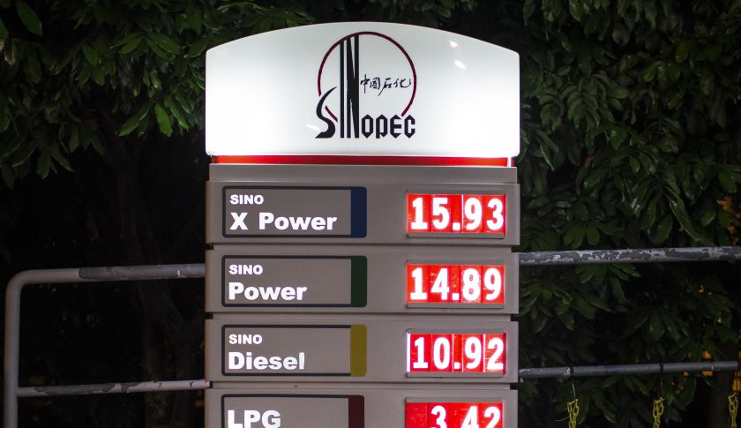
Photograph By Billy H.C. Kwok – Getty Images
Global 500 Rank: 2
2014 Revenue: $446.8 billion
Sinopec remains Asia’s largest oil refiner and a king in China’s state-owned corporate hierarchy. However, following a 30% decline in profits in 2014 amid lower oil prices, failed overseas investments, and a corruption crackdown that has targeted the company’s senior officials, Sinopec SPTJF 10.45% no longer looks invincible. Last year marked Sinopec’s worst year of financial performance since the financial crisis, and executives have remained out of the limelight amid the corruption crackdown, which has diminished the influence of oil companies in the country.

2. China National Petroleum
- E-mail

- Tweet

- Facebook

- Linkedin
Share icons
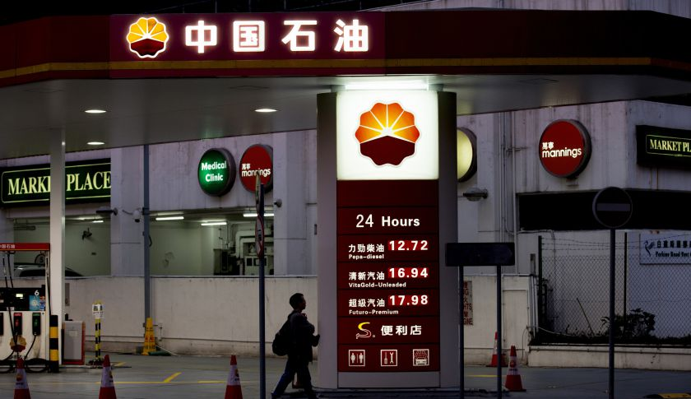
Photograph by Brent Lewin – Getty Images
Global 500 Rank: 4
2014 Revenue: $428.6 billion
Known as the parent company of PetroChina, China’s biggest oil producer was hurt by lower oil prices throughout the year. Profits fell by 17%. Like its state-owned rival Sinopec, CNPC was also the focus of an intense anti-corruption campaign. In fact, CNPC has been one of the campaign's prime targets over the past two years. Zhou Yongkang, former CNPC chairman, was jailed for life this year on graft charges. His case highlighted Beijing's efforts to break the power clique at CNPC. During the year, CNPC’s strong refining and distribution businesses helped mitigate losses from oil price declines.

3. State Grid
- E-mail

- Tweet

- Facebook

- Linkedin
Share icons
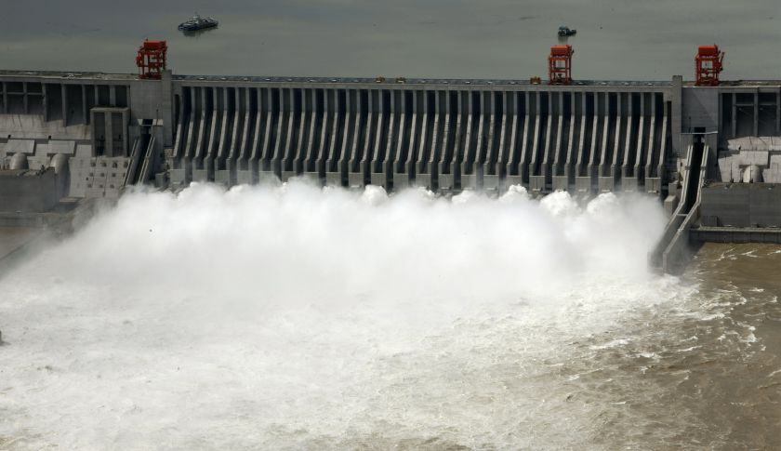
Photograph by Getty Images
Global 500 Rank: 7
2014 Revenue: $339.4 billion
Last year, the world's largest utility announced $65 billion in annual spending for the next five years to upgrade its network to handle China’s massive alternative energy supply. State Grid already operates the world’s largest solar farm, but transporting that supply across the country is its next challenge as it plans to reduce the percentage of coal used to produce electricity. The state-owned enterprise is also building “ultra high voltage” power lines across the country to transport wind and solar-produced energy from the western desert areas to population centers in China's central and eastern provinces.

4. Industrial & Commercial Bank of China
- E-mail

- Tweet

- Facebook

- Linkedin
Share icons
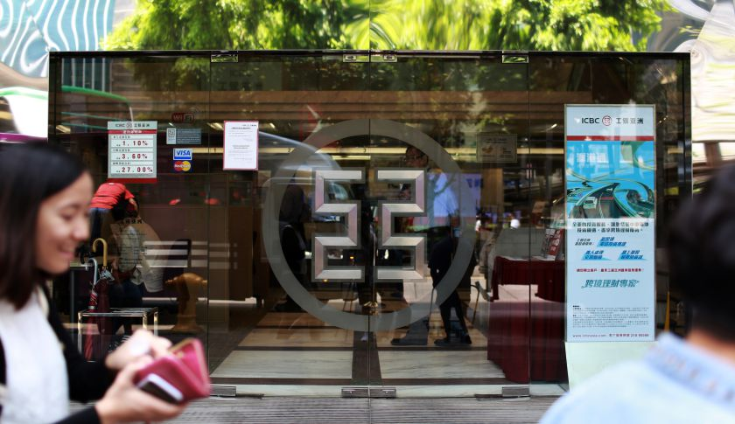
Photograph by Billy H.C. Kwok – Getty Images
Global 500 Rank: 18
2014 Revenue: $163.2 billion
The state-owned firm is the world’s biggest bank, a major force in China’s market, and, according to a ranking by The Banker magazine, the world’s strongest bank based on its amount of capital in 2014. Four big state-owned banks are central to China’s financial system. ICBC is the biggest among them. It has raised money for the Three Gorges Dam project and has been a part of China’s expansion abroad, especially its infrastructure projects in Africa. At the same time, ICBC's international exposure remains low compared to U.S. and European banks. For a sense of its scale, in 2014 ICBC earned almost $60 billion, nearly double the profits of Wells Fargo.

5. China Construction Bank
- E-mail

- Tweet

- Facebook

- Linkedin
Share icons
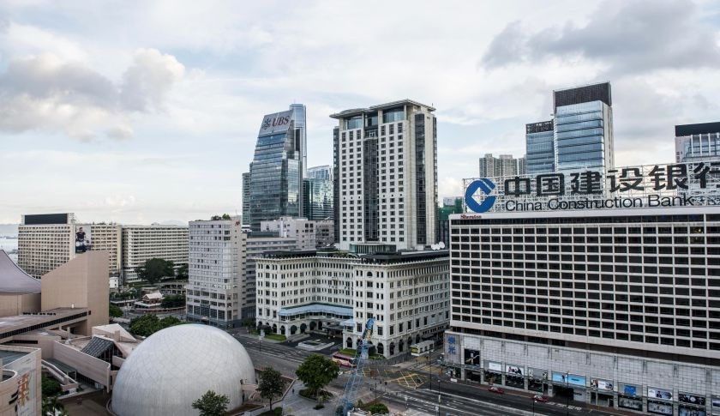
Photograph by Xaume Olleros – Getty Images
Global 500 Rank: 29
2014 Revenue: $139.9 billion
China’s second largest state-owned bank is grappling with a slowing Chinese economy like the rest of the country’s largest lenders. The government’s recent interest rate cuts have hurt margins and the overall economic slowdown is making observers nervous about the potential of China Construction Bank CICHY -0.90% over the next few years. In the fourth quarter it reported its first quarterly profit decline since the financial crisis of 2009. Its fortunes remain tied to China because of its founding as a state-controlled lender, but it is slowly expanding outside the country as China’s government expands its interests abroad.

6. Agricultural Bank of China
- E-mail

- Tweet

- Facebook

- Linkedin
Share icons
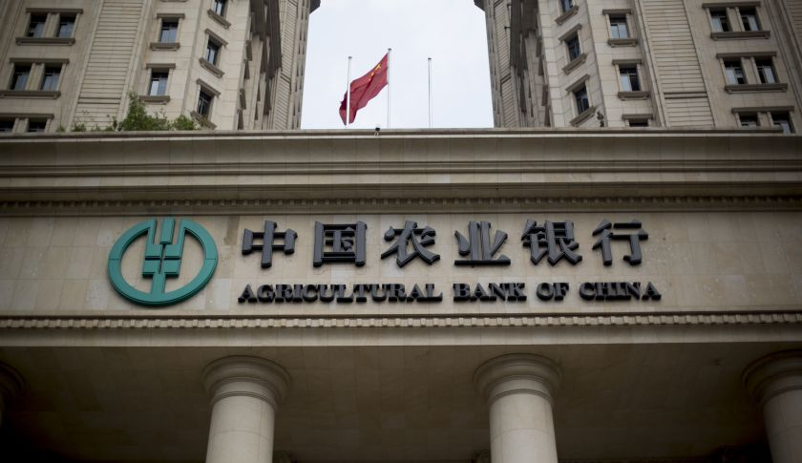
Photograph by Brent Lewin – Getty Images
Global 500 Rank: 36
2014 Revenue: $130 billion
The third biggest (by revenue) of the four state-owned banks that anchor China’s financial system, Agricultural Bank of China ACGBY -0.44% (also known as ABC or AgBank) originally specialized in financing commercial and industrial enterprises in rural China, but more recently it has diversified into consumer and corporate banking, credit cards, and currency trading. The bank’s branch network—the biggest in China, according to research firm Morningstar—has made it the dominant bank in rural areas, and many analysts expect ABC to benefit as more of its rural customers move to urban areas and become more affluent. The bank saw a change of leadership in October 2014, as Liu Shiyu, a former official at the People's Bank of China, became chairman.

7. China State Construction Engineering
- E-mail

- Tweet

- Facebook

- Linkedin
Share icons
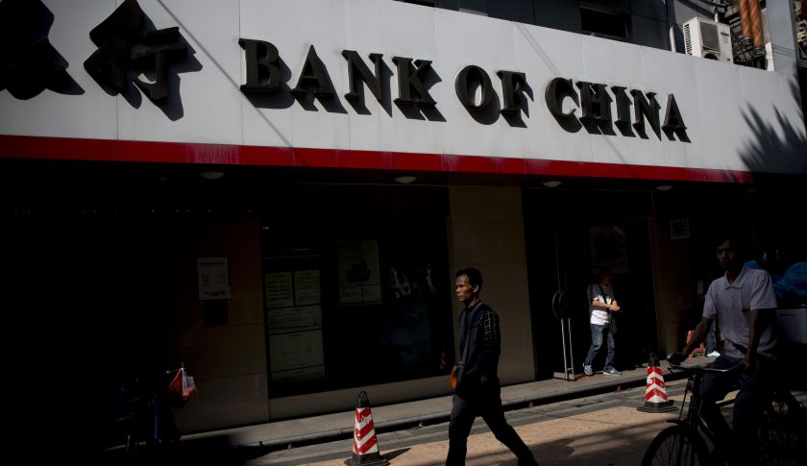
Photograph by Brent Lewin — Getty Images
Global 500 Rank: 37
2014 Revenue: $129.9 billion
CSCEC, a state-owned construction and real estate conglomerate, opened its first foreign office in the 1970s (in Kuwait) and has had a presence in the U.S. since the mid-1980s. It has doubled down on foreign projects in this decade, and its revenue has risen accordingly, growing more than 17% in 2014. The American Enterprise Institute estimates that the company is currently involved in more than 70 overseas construction projects valued at $100 million or more. The company now encompasses multiple construction and investment subsidiaries in fields ranging from public infrastructure to residential real estate: Its high-profile current projects include a major role in the Beijing's push to expand China's affordable housing stock. That project also highlights the company’s greatest uncertainty: Whether a slowing economy in China will hurt the state’s appetite for big public building projects.

8. Bank of China
- E-mail

- Tweet

- Facebook

- Linkedin
Share icons

Photograph by Getty Images
Global 500 Rank: 45
2014 Revenue: $120.9 billion
Bank of China (or BOC) is among China’s Big Four state-owned banks (although it shouldn’t be confused with the People’s Bank of China, China’s central bank). The bank’s history predates Communist rule in China, and it has appeared on the Global 500 more often than any of the other Big Four (21 years). Not coincidentally, BOC BACHF 5.58% has a strong cross-border banking business, and international banking helped sustain its profits in 2014; its year-over-year growth in profits and revenue outpaced its rivals, and it was the only state-owned bank that didn’t see its profits fall in the fourth quarter. China’s softening economy is a concern for all the country’s big banks, but BOC may be well-positioned to weather the slowdown, thanks in part to its diversification: More than a quarter of its loans involve lending outside China, and it derives a lot of income from businesses that are less sensitive to the economy's ups and downs, including investment banking and insurance.

9. China Mobile Communications
- E-mail

- Tweet

- Facebook

- Linkedin
Share icons
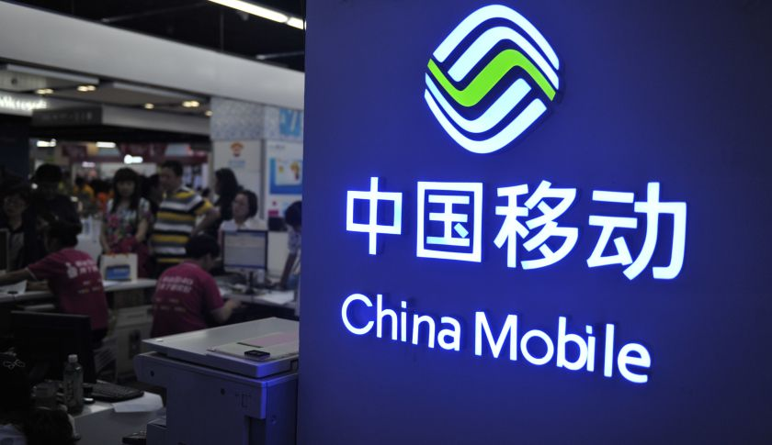
Photograph by AP
Global 500 Rank: 55
2014 Revenue: $107.5 billion
China Mobile is the biggest wireless phone provider in the world, with more than 800 million customers and a 60% share of its home nation’s telecom market. The last two years have been particularly good to China Mobile CHLKF 0.00% , thanks in part to two largely unrelated tech trends: The company’s 4G network, seen as a big improvement over its 3G network, helped it sign up a new wave of customers. And a wider migration from Android devices to the iPhone among Chinese customers also benefited China Mobile, which is Apple’s main service-provider partner in China. The company can’t afford to rest on its laurels, however. China’s cellphone market is maturing as the country nears 100% penetration, and some investors have criticized China Mobile for not doing more to curb operating costs. Government officials have also faulted the country’s cell providers for not offering faster data speeds, and many analysts believe that the state could either break up China Mobile or divert some of its resources to two smaller state-owned telecoms in the name of improving service.

10. SAIC Motor
- E-mail

- Tweet

- Facebook

- Linkedin
Share icons
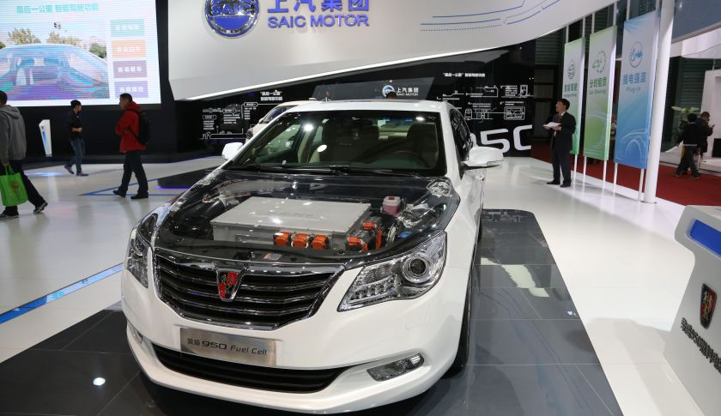
Photograph by AP
Global 500 Rank: 60
2014 Revenue: $102.2 billion
SAIC isn’t a household name to most American consumers, but it is the biggest auto manufacturer in China. The company has partnerships with several Western brands, including General Motors and Volkswagen.

11. China Railway Engineering
- E-mail

- Tweet

- Facebook

- Linkedin
Share icons

Photograph by Getty Images
Global 500 Rank: 71
2014 Revenue: $99.5 billion
China Railway Engineering is the parent company of China Railway Group, which in turn is one of the two state-controlled companies that handle almost all railway infrastructure projects in China. (The other? China Railway Construction. Confused? Don’t worry: There will be no quiz.) Railroads have been a great business to be in over the past decade, as China’s government has invested heavily in a national high-speed rail network; far less certain is how the company will fare once the network is built out. CRG has seen a steep drop-off in new contracts so far in 2015, according to Morningstar, but it’s also had some success in diversifying—about 17% of its revenue now comes from non-railroad projects, including highway construction.

12. China National Offshore Oil (CNOOC)
- E-mail

- Tweet

- Facebook

- Linkedin
Share icons
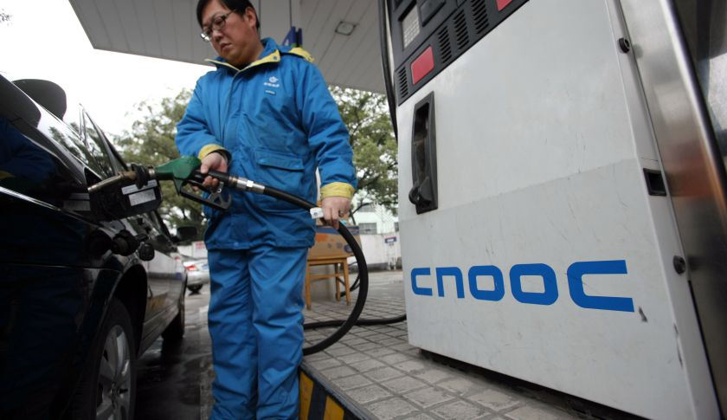
Photograph by Weng lei
Global 500 Rank: 72
2014 Revenue: $99.2 billion
Most energy companies have had a rough ride over the past year or so, as a glut of oil and natural gas on global markets sent commodity prices and shares tumbling. But CNOOC CEOHF -2.61% , the smallest of China’s three state-controlled oil “majors,” has had an easier time than most, managing to increase both profits and revenues in 2014. The company announced earlier this year that it would increase its oil output for the year, even as its fellow majors, Sinopec and PetroChina, are cutting production. CNOOC has two advantages that many other oil giants lack: It doesn’t own refining operations, which often become money-losers when oil prices fall; and its near-monopoly rights over China’s offshore oil resources make its exploration costs extremely low. Energy analysts expect the company to ride a rebound in oil prices to modest growth for 2015.

