CH2M Hill is working on Adnoc Bab sour gas pre-FEED
BP, ExxonMobil, Korean National Oil Company (KNOC), Shell and Total are the happy few pre-qualified international oil companies to submit offer for the $10 billion development of the Bab sour gas project in joint venture with Abu Dhabi National Oil Company (Adnoc) in the United Arab Emirates (UAE).
Postponed since 2007, the selection of Adnoc‘s partner in this project takes a special dimension as it comes a year ahead a much bigger game with the renewal of the actual allocated concessions for theonshore exploration and production of the Abu Dhabi oil and gas fields for the next 30 years.
The offshore concessions will come for renewal in the same way in 2018.
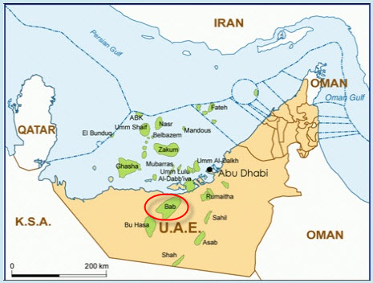Bab is part of these sour gas fields inAbu Dhabi with Shah and Hail tocontain a high percentage of hydrogen sulphide and carbon dioxide (CO2).
To be developed originally together with Shah, the escalation of the project costs and technical challenges convinced Adnoc toproceed step by step.
In 2008, Adnoc awarded the Shahgas development project toConocoPhillips.
But in 2010, ConocoPhillips withdrew from the project and was replaced by Occidental Petroleum (Oxy) in 2011.
Shah gas development was already a challenging project with 27% CO2, but Bab sour gas comes now with 50%, about twice more.
In addition, Bab gas field is given to contain less valuable condensate in quantity and in quality that could help the profitability of the investment.
For this reason, Adnoc is looking for partners such as BP, ExxonMobil, Shell or Total with a proven expertise in handling such a complex project with costs well under control.

After UK and South Korea, France courts Abu Dhabi
The engineering company CH2M Hill is currently working on the pre-front end engineering and design (Pre-FEED).
At this Pre-FEED stage, Adnoc is working on two scenario of development, one based on 500 million cubic feet per day (cf/d), one to reach 1 billion cf/d of sour gas.
From the actual estimation, Bab sour gas project should also require $10 billion capital expenditure.
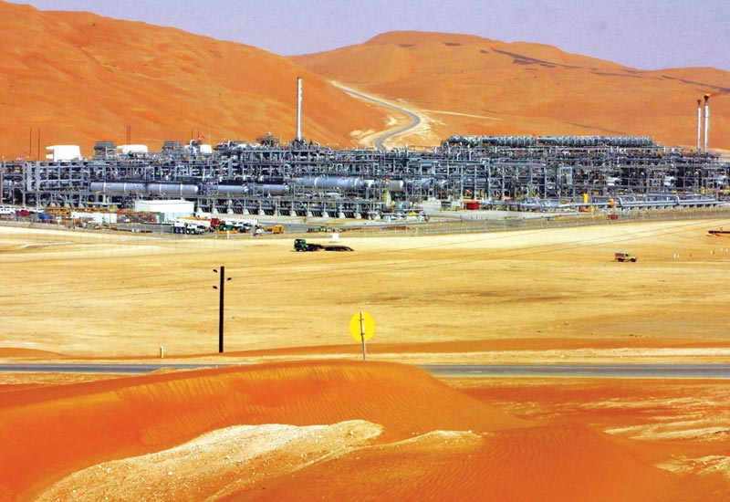The selected company should form a joint venture with Adnoc where the national oil company should hold 60% stakes while leaving 40% to the winning bidder.
Anticipating on the rules to be enforced with the concessions renewals, the nominated Adnoc‘s partner will be the operator of the concession to develop the Bab sour gas project on the next 30 years supported by a production sharing agreement.
With the nearing deadline, the competition between the companies intensifies involving the Governments of the most motivated countries.
On November 5th 2012, UK Prime Minister David Cameron visited Abu Dhabi with several objectifsincluding to add BP on the list of the invited companies to participate to the concessions renewal and of course to be considered carefully for Bab Sour gas in respect with BP experience in challenging fields.
Only two weeks later, on November 21st 2012, a delegation of the South Korean Government paid a visit to Abu Dhabi with the support of the national oil company KNOC to position itself on new fields to be developed and secure minimum crude oil supply.
Following this visit Adnoc announced to re-tender the $4 billion Upper Zakum EPC2 package that might have escaped to South Korean contractors at that time.
In January 15th 2013, French President François Hollande attended the World Future Energy Summit inAbu Dhabi to promote Total as the most reliable partner for the onshore concessions and provider of technology for Bab sour gas.
With 9.5% shares in Abu Dhabi Company for Onshore Operations (Adco) Total benefits from a long standing experience in Abu Dhabi with additional shares in Abu Dhabi Marine Operation Company (Adma-Opco) and Abu Dhabi Gas Industries (Gasco).
So far the development of the gas fields, especially sour gas, in the UAE was not a priority but with the economical growth calling for more gas-fired power plants, gas injection to boost oil production and thedevelopment of the petrochemical sector, gas has become a critical resource in Abu Dhabi giving Gasco aleading role in the UAE.
In this context, the competition between BP, ExxonMobil, KNOC, Shell and Total should intensify on Bab sour gas until Adnoc makes the decision on first half 2013.

