OIL AND GAS EXPLORATION AND PRODUCTION
With a view to increasing oil and gas reserve and discovering new fields to meet domesticdemand and export, Petrovietnam has been carrying out effective exploration and production of oil and gas both at home and abroad through PSC, JOC, JOA, BCC contracts, self-investment and self-management in exploration, making important petroleum discoveries, quickly bringing the discovered fields into production phase with the application of state-of-the-art technologies to increase production as well as oil and gas recovery rate, thus protecting the environment and natural resources.

Domestic exploration and production activities: Petrovietnam has recently signed six new petroleum contracts of blocks 05- 2/10 (with PVEP/Talisman), 148-149 (with PVEP), 135-136/03 (with PVEP/Talisman/Pearl), 45 (with Mitra/PVEP), 102&106/10 (with PVEP) and 13/03 (with Santos/PVEP), increasing the number of effective contracts to 60.

VIET NAM'S PETROLEUM OPERATION MAP

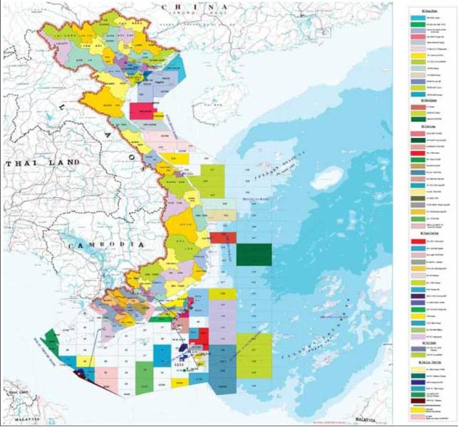

During the last year, Petrovietnam conducted survey and acquisition of over 12,500 km 2D and 5,600 km2 3D seismic in accordance with the signed contracts and general exploration programme for exploration and appraisal of oil and gas potential in structures. Petrovietnam drilled 82wells, among them 11 for exploration, 10 for appraisal, 61 for production and some others for water injection andwell-to-well connection with the total drilling length of 222,000m at the expense of about 1.160 billionUS Dollars. As a results of such exploration – appraisal drilling campaign, several significant oil and gas discoveries were made in wells GT-1X,MT-1X (Block 09-1, Vietsovpetro), CVX-2X (Block 117-119, ExxonMobil) and others, leading to the total recoverable reserve increaseby 35 million t.o.e in2011, thus ensures the reserves increaseby 130 to140 million t.o.e for the period 2011-2015.

Overseas exploration and production activities: Implementing the Decision No. 386/QD-TTg dated 9 ofMarch 2006 by the Prime Minister of Vietnam in regards to the vision and primary targets in-overseas investment strategy, during the last year Petrovietnam engaged in new petroleum contracts, increasing the total number of effective exploration and production projects to 20 in 14 countries, including the Russian Federation, SNG countries,Middle East, Northern and Central Africa, Latin America and ASEAN countries.

Generally, in the period of 2011 – 2015, Petrovietnam will expedite the exploration and production activities both in Vietnam and overseas, targeting on recoverable resource increase by 35-40 million t.o.e and sustainable production of 25-28 million t.o.e a year. To achieve such the goal, the active promotion programme were carried out, the significant investment amounts were attracted for its in-country projects and a number of petroleum contracts were signed, including ones in the deepwater and remote offshore acreages. As for its overseas investment strategy, Petrovietnam have gained positive achievements, thus enables to increase the oil and gas reserves and production, contribute considerably to the national energy security of Vietnam andgraduallyenhance the Group's positionandimagein the regionalandglobal arena.

Oil producing fields | Contract Block | Operator | Year of production
Bach Ho (White Tiger) | 09-1 | VSP | 1986
Rong (Dragon) | 09-1 | VSP | 1994
Dai Hung(Big Bear) | 05-1a | PVEP POC | 1994
Block (overlapping area between Vietnam and Malaysia with 50% interest of Vietnam) | PM3-CAA | PM3 CAATML | 1997
Rang Dong | 15-2 | JVPC | 1998
Ruby | 01&02 | PCVL | 1998
Block | 46-CN | 46 CNTML | 1999
Su Tu Den (Black Lion) | 15-1 | CLJOC | 2003
Cendor | PM-304 (Malaysia) | Petrofac | 2006
Su Tu Vang | 15-1 | CLJOC | 2008
Song Doc | 46/02 | TSJOC | 2008
Ca Ngu Vang | 09-2 | HVJOC | 2008
Phuong Dong | 15-2 | JVPC | 2008
Nam Rong - Doi Moi | 09-3 | VRJ/VSP | 2010
Pearl | 01&02 | PCVL | 2010
Topaz | 01&02 | PCVL | 2010
Su Tu Den Dong Bac | 15-1 | CLJOC | 2010
D30 | SK350 (Malaysia) | PCPP | 2010
North Khoseidaien | Nhenhexky (Russian Federation) | Rusvietpetro | 2010
Dana | SK350 (Malaysia) | PCPP | 2011
Visovoi | Nhenhesky (Russian Federation) | Rusvietpetro | 2011
Te Giac Trang | 16-1 | HLJOC | 2011
Chim Sao | 12W | POVO | 2011
Western Khoseidaien | Nhenhexky (Russian Federation) | Rusvietpetro | 2012
Junin-2 | (Venezuela) | JV “PetroMacareo” | 2012
Su Tu Trang | 15-1 | CLJOC | 2012
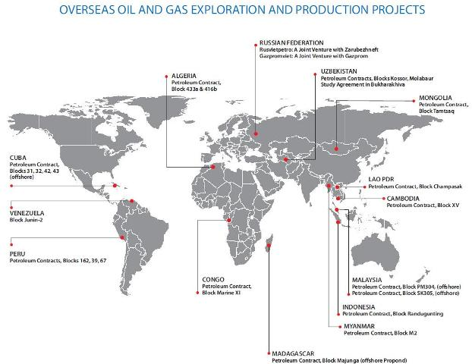

Gas producing fields | Contract Block | Contractor | Year
Tien Hai C (Natural gas) | Song Hong basin | PVEP SH | 1981
Bach Ho & Rong (Associated gas) | 09-1 | VSP | 1995
Rang Dong (Associated gas) | 15-2 | JVPC | 2001
Lan Tay (Natural gas) | 06.1 | TNK Vietnam | 2002
East Bunga Kekwa – Cai Nuoc (Natural and associated gas) | PM3-CAA & 46-CN | TML&TVL | 2003
West Bunga Kekwa (Natural and associated gas) | PM3-CAA | TML | 2003
Bunga Raya | PM3-CAA | TML | 2003
Bunga Seroja (Natural gas) | PM3-CAA | TML | 2003
D14 & Song Tra Ly (Natural gas) | Song Hong basin | PVEP SH | 2004
Rong Doi/West Rong Doi (Natural gas) | 11-2 | KNOC | 2006
Bunga Tulip (Associated gas) | PM3-CAA | TML | 2006
Phuong Dong (Associated gas) | 15-2 | JVPC | 2008
Ca Ngu Vang (Associated gas) | 09-2 | HVJOC | 2008
Bunga Orkid (Natural gas) | PM3-CAA | TML | 2008
Su Tu Den/Su Tu Vang Northeast Su Tu Den (Associated gas) | 15-1 | CLJOC | 2009
D30 (Malaysia) | SK305 | PCPP | 2009
Dana (Malaysia) | SK305 | PCPP | 2010
Te Giac Trang (Associated gas) | 16-1 | HLJOC | 2011
Chim Sao (Associated gas) | 12W | POVO | 2011
Lan Do | 06-1 | TNK Vietnam | 2012

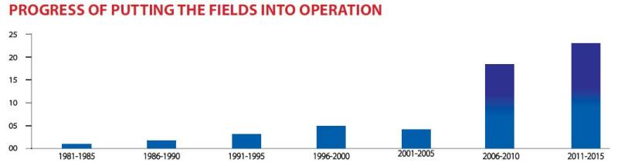
PROJECTS CALLING FOR INVESTMENT

