Archived - Annual Financial Report of the Government of Canada
Fiscal Year 2014–2015
Archived information
Archived information is provided for reference, research or recordkeeping purposes. It is not subject to the Government of Canada Web Standards and has not been altered or updated since it was archived. Please contact us to request a format other than those available.
Note to Readers
The financial results in this report are based on the audited consolidated financial statements of the Government of Canada for the fiscal year ended March 31, 2015, the condensed form of which is included in this report. For the 17th consecutive year, the Government has received an unmodified audit opinion from the Auditor General of Canada on the consolidated financial statements. The complete consolidated financial statements are available from the Public Works and Government Services Canada website.
The Fiscal Reference Tables have been updated to incorporate the results for 2014–15 as well as historical revisions to the National Economic and Financial Accounts published by Statistics Canada.

Report Highlights
- The Government posted a budgetary surplus of $1.9 billion for the fiscal year ended March 31, 2015, compared to a budgetary deficit of $5.2 billion in 2013–14.
- Revenues increased by $10.7 billion, or 3.9 per cent, from 2013–14, reflecting increases across all major revenue streams. Program expenses increased by $5.2 billion, or 2.1 per cent, reflecting increases in major transfers to persons and other levels of government, offset in part by a decrease in direct program expenses. Public debt charges were down $1.6 billion, or 5.8 per cent, due mainly to a lower average effective interest rate on the stock of interest-bearing debt.
- The federal debt (the difference between total liabilities and total assets) stood at $612.3 billion at March 31, 2015. The federal debt-to-GDP (gross domestic product) ratio was 31.0 per cent, down from 32.3 per cent a year earlier.
- As reported by the Organisation for Economic Co-operation and Development (OECD), Canada's total government net debt-to-GDP ratio, which includes the net debt of the federal, provincial/territorial and local governments, as well as the net assets held in the Canada Pension Plan and Québec Pension Plan, stood at 40.4 per cent in 2014. This is the lowest level among Group of Seven (G-7) countries, which the OECD expects will record an average net debt of 86.8 per cent of GDP for the same year.
- For the 17th consecutive year, the Government has received an unmodified audit opinion from the Auditor General of Canada on the consolidated financial statements.
Table 1
Financial Highlights
$ billions
 | 2013–14¹ | 2014–15
Budgetary transactions
Revenues | 271.7 | 282.3
Expenses
Program expenses | 248.6 | 253.8
Public debt charges | 28.2 | 26.6
Total expenses | 276.8 | 280.4
Budgetary balance | -5.2 | 1.9
Non-budgetary transactions | 22.7 | -4.6
Financial source/requirement | 17.5 | -2.7
Net change in financing activities | -13.4 | 6.2
Net change in cash balances | 4.1 | 3.6
Cash balance at end of period | 31.4 | 35.0
Financial position
Total liabilities | 1,001.7 | 1,023.6
Total financial assets | 319.4 | 336.7
Net debt | 682.3 | 687.0
Non-financial assets | 70.4 | 74.6
Federal debt (accumulated deficit) | 611.9 | 612.3
Financial results (% of GDP)
Revenues | 14.3 | 14.3
Program expenses | 13.1 | 12.9
Public debt charges | 1.5 | 1.3
Budgetary balance | -0.3 | 0.1
Federal debt (accumulated deficit) | 32.3 | 31.0
Note: Numbers may not add due to rounding.
¹ Certain comparative figures have been reclassified to conform to the current year’s presentation.

Recent Economic Developments^{[1]}
In 2014 and early 2015 there were two main factors which affected the performance of Canada's economy: persistent weakness in the global economy and the decline in global commodity prices, with the fall in crude oil prices having a significant impact.
Global growth remained subdued in 2014, reflecting relatively weak growth in the euro area and Japan and moderating growth in China. This weak external demand weighed on Canadian exports. Without solid growth in global demand, Canadian businesses were cautious about expanding capacity. As a result, real business investment growth slowed, between mid-2012 and the end of 2014, to an annual rate of about 1 per cent.
The sharp decline in crude oil prices since mid-2014 has further weighed on the Canadian economy, particularly in early 2015. For Canada, as a producer and net exporter of crude oil, lower oil prices have had a net negative impact on Canada's nominal GDP growth—the broadest measure of the tax base. In particular, the value of Canada's crude oil exports in the second quarter of 2014 (before the decline in oil prices) was $100 billion, or 5.1 per cent of nominal GDP. The decline in crude oil export prices reduced the value of exports, and hence nominal GDP, by over $45 billion (2.3 per cent of GDP) by the first quarter of 2015 (export volumes remained broadly unchanged). In addition, lower oil prices led to a significant retrenchment in real business investment in the oil and gas sector in the first quarter of 2015.
Nominal GDP growth in 2014 was higher than anticipated in Budget 2014. However, due to the fall in oil prices, growth fell from an average of 4.9 per cent in the first three quarters of 2014 to 0.4 per cent in the fourth quarter. In the first quarter of 2015, nominal GDP declined by 2.9 per cent.
In response to economic conditions, short- and long-term interest rates have remained at historically low levels over the last two years and in 2014 were below Budget 2014 projections. Interest rates fell in early 2015, and in the first quarter of 2015 were lower than anticipated at the time of Budget 2015.
The unemployment rate declined from 7.1 per cent in 2013 to 6.9 per cent in 2014. Consumer Price Index (CPI) inflation remained below the mid-point of the Bank of Canada's target band in 2013 and 2014. Reflecting excess slack in the economy and lower commodity prices, CPI inflation in 2014 was lower than projected in Budget 2014.
Table 2
Average Private Sector Forecasts
per cent
 | 2013 | 2014 | 2015
Real GDP growth
December 2013 survey/Budget 2014 | 1.7 | 2.3 | 2.5
March 2015 survey/Budget 2015 | 2.0 | 2.5 | 2.0
Actual | 2.0 | 2.4
Nominal GDP growth
December 2013 survey/Budget 2014 | 3.2 | 3.9 | 4.5
March 2015 survey/Budget 2015 | 3.4 | 4.4 | 1.6
Actual | 3.4 | 4.3
3-month treasury bill rate
December 2013 survey/Budget 2014 | 1.0 | 1.0 | 1.5
March 2015 survey/Budget 2015 | 1.0 | 0.9 | 0.6
Actual | 1.0 | 0.9
10-year government bond rate
December 2013 survey/Budget 2014 | 2.3 | 3.0 | 3.5
March 2015 survey/Budget 2015 | 2.3 | 2.2 | 1.7
Actual | 2.3 | 2.2
Unemployment rate
December 2013 survey/Budget 2014 | 7.1 | 6.8 | 6.6
March 2015 survey/Budget 2015 | 7.1 | 6.9 | 6.7
Actual | 7.1 | 6.9
Consumer Price Index inflation
December 2013 survey/Budget 2014 | 1.0 | 1.5 | 1.9
March 2015 survey/Budget 2015 | 1.0 | 1.9 | 0.9
Actual | 1.0 | 1.9
Sources: December 2013 private sector survey for Budget 2014 and March 2015 private sector survey for Budget 2015. Statistics Canada data for actual.

The Budgetary Balance
The Government posted a budgetary surplus of $1.9 billion in 2014–15, compared to the $5.2-billion deficit recorded in 2013–14.
Revenues were up $10.7 billion, or 3.9 per cent, from the prior year, reflecting increases across all major revenue streams.
Expenses were up $3.6 billion, or 1.3 per cent, from the prior year. Program expenses increased by $5.2 billion, reflecting increases in major transfers to persons and other levels of government, offset in part by a decrease in direct program expenses. Public debt charges decreased by $1.6 billion, or 5.8 per cent, from the prior year, due mainly to a lower average effective interest rate on the stock of interest-bearing debt.
To enhance the comparability of financial results over time and across jurisdictions, the budgetary balance and its components are often presented as a percentage of GDP. The following chart shows the budgetary balance as a percentage of GDP since 1986–87. In 2014–15, the budgetary surplus was 0.1 per cent of GDP, compared to a deficit of 0.3 per cent of GDP a year earlier.
Budgetary Balance
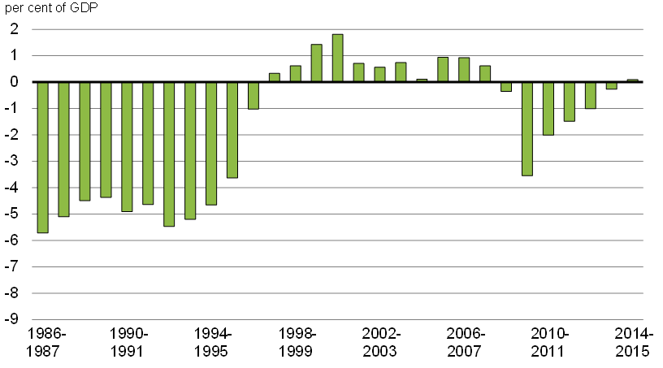Sources: Public Accounts of Canada and Statistics Canada.

Comparison of Actual Budgetary Outcomes to Projected Results
The Government estimated a deficit of $2.0 billion for 2014–15 in the April 2015 budget. The final budgetary outcome for 2014–15 was a surplus of $1.9 billion.
Revenues were $3.0 billion higher than expected, primarily reflecting gains in personal and corporate income tax revenues.
Program expenses were $0.8 billion lower than forecast, largely reflecting lower-than-expected direct program expenses, which are comprised of other transfer payments and other program expenses. This is attributed in part to a higher-than-expected lapse of departmental spending authorities.
Major transfers to persons were $0.8 billion higher than projected. This difference reflects the accrual of retroactive payments for elderly benefits and higher-than-expected Employment Insurance (EI) benefits, reflecting both a higher-than-expected number of beneficiaries and higher-than-expected average benefits.
Public debt charges were $0.1 billion lower than forecast, reflecting a lower-than-expected average interest rate on the stock of interest-bearing debt.
Table 3
Comparison of Actual Outcomes to April 2015 Budget
$ billions
 | Actual | April 2015 Budget¹ | Difference
Revenues
Personal income tax | 135.7 | 134.2 | 1.5
Corporate income tax | 39.4 | 37.9 | 1.5
Non-resident income tax | 6.2 | 6.4 | -0.1
Other taxes and duties | 47.2 | 47.4 | -0.2
Employment Insurance premium revenues | 22.6 | 22.6 | 0.0
Other revenues | 31.2 | 30.9 | 0.3
Total | 282.3 | 279.3 | 3.0
Program expenses
Major transfers to persons
Elderly benefits | 44.1 | 43.7 | 0.4
Employment Insurance benefits | 18.1 | 17.8 | 0.3
Children's benefits | 14.3 | 14.2 | 0.1
Total | 76.5 | 75.7 | 0.8
Major transfers to other levels of government
Support for health and other social programs | 44.7 | 44.7 | 0.0
Fiscal arrangements | 16.3 | 16.3 | 0.0
Gas Tax Fund | 2.0 | 2.0 | 0.0
Other transfers | 0.2 | 0.2 | 0.0
Total | 63.1 | 63.2 | -0.1
Direct program expenses | 114.3 | 115.8 | -1.5
Total program expenses | 253.8 | 254.6 | -0.8
Public debt charges | 26.6 | 26.7 | -0.1
Budgetary outcome/estimate | 1.9 | -2.0 | 3.9
Note: Numbers may not add due to rounding.
¹ Comparative figures from the April 2015 budget have been reclassified to conform to the presentation in the audited consolidated financial statements.

Federal Debt
The federal debt (accumulated deficit) is the difference between the Government's total liabilities and its total assets. At the end of 2014–15, the federal debt stood at $612.3 billion.
Table 4
Federal Debt (Accumulated Deficit)
$ millions
 | 2013–14 | 2014–15 | Net change
Federal debt at beginning of year | 609,391 | 611,881 | 2,490
Annual deficit or surplus (-) | 5,150 | -1,911 | -7,061
Other comprehensive income (-) or loss | -2,660 | 2,360 | 5,020
Federal debt at end of year | 611,881 | 612,330 | 449
The federal debt increased by $0.4 billion in 2014–15, as the 2014–15 budgetary surplus of $1.9 billion was more than offset by a $2.4-billion other comprehensive loss. The $2.4-billion other comprehensive loss largely reflects $0.5 billion in net unrealized losses on available-for-sale financial assets and $1.9 billion in net actuarial losses on pension and other employee future benefits recorded by enterprise Crown corporations and other government business enterprises.
The following chart shows the federal debt as a percentage of GDP since 1990–91. The federal debt stood at 31.0 per cent of GDP in 2014–15, down from 32.3 per cent in 2013–14 and less than half of its post-World War II peak of 67.1 per cent at March 31, 1996.
Federal Debt (Accumulated Deficit)
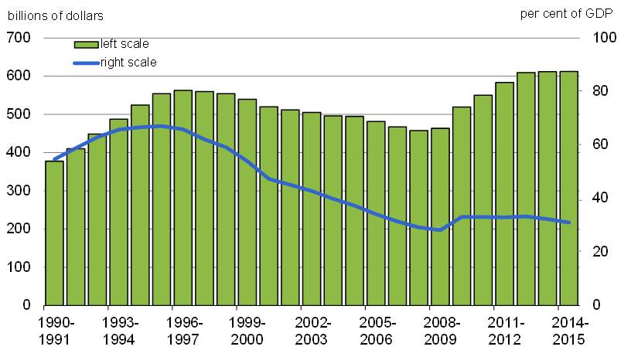Sources: Public Accounts of Canada and Statistics Canada.
Measures of Government Debt
The consolidated financial statements of the Government of Canada are presented on an accrual basis of accounting. On this basis, there are several generally accepted definitions of government debt.
Net debt represents the total liabilities of the Government less its financial assets. Financial assets include cash and cash equivalents, accounts receivable, foreign exchange accounts, loans, investments and advances, and public sector pension assets.
The accumulated deficit is equal to total liabilities less total assets—both financial and non-financial. Non-financial assets include tangible capital assets, such as land and buildings, inventories, and prepaid expenses and other. The annual change in the accumulated deficit is equal to the budgetary balance plus other comprehensive income or loss.
Other comprehensive income or loss represents certain unrealized gains and losses on financial instruments and certain actuarial gains and losses related to pensions and other employee future benefits reported by enterprise Crown corporations and other government business enterprises. In accordance with Canadian public sector accounting standards, other comprehensive income or loss is not included in the Government's annual budgetary balance, but is instead recorded directly to the accumulated deficit.
The federal debt, referred to in the budget documents and the Annual Financial Report of the Government of Canada, is the accumulated deficit. It is the federal government's main measure of debt. The following table shows net debt and the federal debt at March 31, 2015.
Net Debt and the Federal Debt at March 31, 2015
 | ($ billions) | (% of GDP)
Total liabilities | 1,023.6 | 51.8
Less: Financial assets | 336.7 | 17.0
Net debt | 687.0 | 34.8
Less: Non-financial assets | 74.6 | 3.8
Federal debt (accumulated deficit) | 612.3 | 31.0
Note: Numbers may not add due to rounding.

Net Debt
Net debt is the difference between the Government's total liabilities and its financial assets. Under this measure of debt, liabilities are reduced only by financial assets as non-financial assets cannot normally be converted to cash to pay off the debt without disrupting government operations. At the end of 2014–15, the Government's net debt stood at $687.0 billion, up $4.6 billion from 2013–14.
The net debt ratio, net debt expressed as a percentage of GDP, measures debt relative to the ability of the country's taxpayers to finance it. The following chart shows the net debt ratio since 1990–91. The ratio stood at 34.8 per cent in 2014–15, down from 36.0 per cent a year earlier, and down by more than half from its peak of 72.5 per cent in the mid-1990s.
Net Debt Ratio
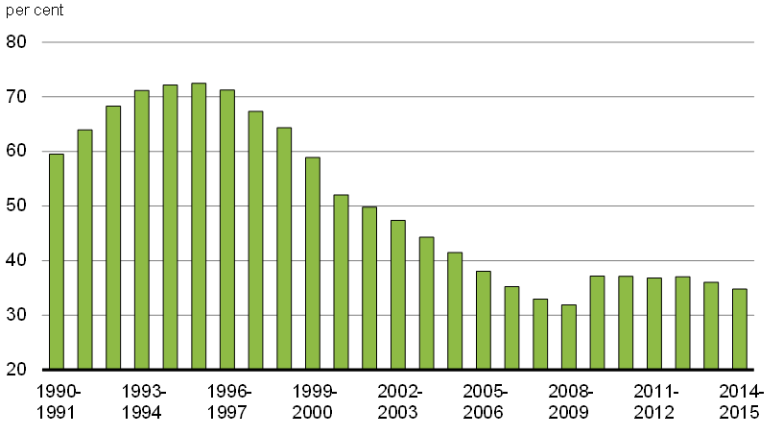Sources: Public Accounts of Canada and Statistics Canada.

International Comparisons of Government Debt
International comparisons of net debt are made on a total government, National Accounts basis, which for Canada includes the net debt of federal, provincial/territorial and local governments, as well as the net assets held in the Canada Pension Plan and Québec Pension Plan. Further details on the calculation of Canada's net debt, along with a reconciliation of federal net debt on a National Accounts basis and a Public Accounts basis, are provided in the annex.
Canada's total government net debt-to-GDP ratio stood at 40.4 per cent in 2014, as shown in the following chart. This is the lowest level among G-7 countries and is less than half of the G-7 average, which the OECD estimates stood at 86.8 per cent of GDP in that same year.

G-7 Total Government Net Debt, 2014
Canada Has the Lowest Total Government Net Debt Burden Among G-7 Countries
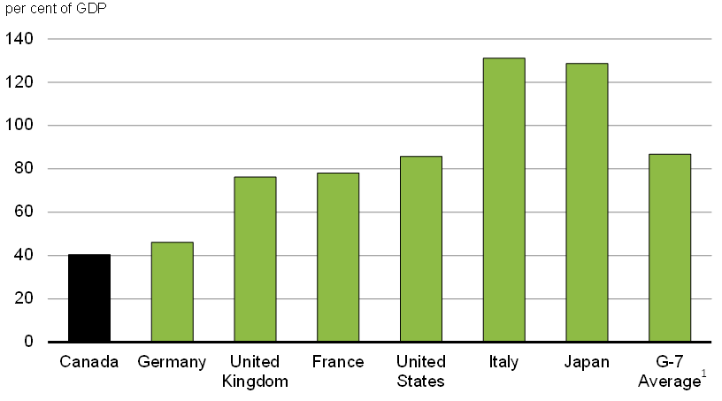¹ Weighted by GDP on a purchasing power parity basis.
Source: OECD Economic Outlook, No. 97 (June 2015).

Financial Source/Requirement
The financial source/requirement measures the difference between cash coming in to the Government and cash going out. It differs from the budgetary balance, which measures revenues and expenses as they are earned or incurred rather than when the associated cash is received or paid.
There was a financial requirement of $2.7 billion in 2014–15, compared to a financial source of $17.5 billion in 2013–14. The year-over-year change in the financial source/requirement largely reflects a decrease in repayments of principal on assets maturing under the Insured Mortgage Purchase Program (IMPP) administered by Canada Mortgage and Housing Corporation (CMHC) in 2014–15. All assets under the IMPP had matured by March 31, 2015.

Revenues
Revenues totalled $282.3 billion in 2014–15, up $10.7 billion, or 3.9 per cent, from 2013–14 (Table 5), reflecting increases across all major revenue streams.
The following chart illustrates the composition of revenues for 2014–15. The largest source of federal revenues is personal income tax revenues, which accounted for 48.1 per cent of total revenues in 2014–15. The second largest source was corporate income tax revenues at 14.0 per cent. Goods and Services Tax (GST) revenues were 11.1 per cent of revenues while other taxes and duties were 5.6 per cent. EI premium revenues contributed 8.0 per cent of revenues and non-resident income tax revenues made up 2.2 per cent. Other revenues, which include net profits from enterprise Crown corporations, revenues of consolidated Crown corporations, revenues from sales of goods and services, returns on investments, net foreign exchange revenues and miscellaneous revenues, contributed 11.0 per cent of revenues in 2014–15.
Composition of Revenues for 2014-15
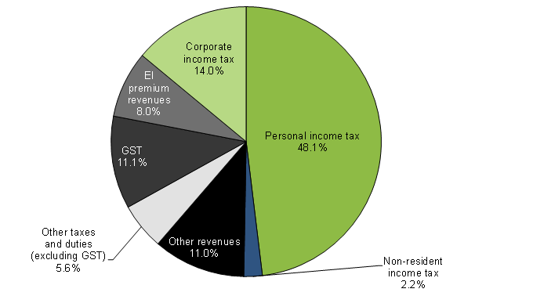Source: Public Accounts of Canada.
Personal income tax revenues increased by $4.9 billion, or 3.8 per cent, reflecting gains in personal income.
Corporate income tax revenues increased by $2.9 billion, or 7.8 per cent, reflecting growth in corporate taxable income which was broadly distributed across industry sectors.
Non-resident income tax revenues decreased by $0.2 billion, or 2.9 per cent. This decrease reflects one-time factors which raised 2013–14 revenues but did not recur this year.
Other taxes and duties increased by $1.0 billion, or 2.3 per cent. GST revenues grew by $0.4 billion in 2014–15, or 1.1 per cent, while energy taxes grew by $42 million, or 0.8 per cent. Customs import duties and other excise taxes and duties each increased by $0.3 billion.
EI premium revenues increased by $0.8 billion, or 3.7 per cent, reflecting growth in insurable earnings.
Other revenues increased by $1.2 billion, or 4.1 per cent, due mainly to an increase in revenues from Crown corporations, offset in part by a decrease in interest and penalties.
The revenue ratio—revenues as a percentage of GDP—compares the total of all federal revenues to the size of the economy. This ratio is influenced by changes in statutory tax rates and by economic developments. The following chart illustrates the revenue ratio since 1990–91. The ratio stood at 14.3 per cent in 2014–15, which was slightly lower than in 2013–14. This relative decrease reflects the fiscal cost of tax relief measures for families announced in the fall of 2014 (notably the Family Tax Cut) as well as the fact that a number of one-time factors temporarily increased revenues and the revenue ratio in 2013–14. Overall, the revenue ratio has declined since 2001–02, due primarily to tax reduction measures.
Net Debt Ratio
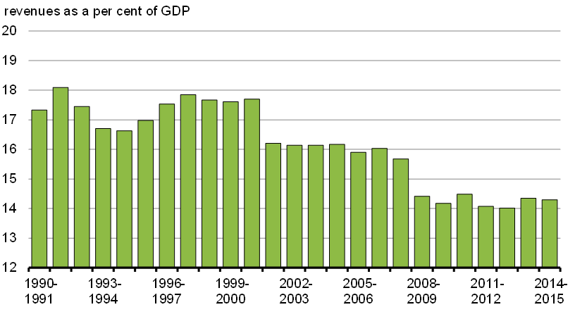Sources: Public Accounts of Canada and Statistics Canada.
Table 5
Revenues
 | 2013–14 | 2014–15 | Net change
 | ($ millions) | ($ millions) | ($ millions) | (%)
Tax revenues
Income tax
Personal | 130,811 | 135,743 | 4,932 | 3.8
Corporate | 36,587 | 39,447 | 2,860 | 7.8
Non-resident | 6,404 | 6,216 | -188 | -2.9
Total | 173,802 | 181,406 | 7,604 | 4.4
Other taxes and duties
Goods and Services Tax | 30,998 | 31,349 | 351 | 1.1
Energy taxes | 5,486 | 5,528 | 42 | 0.8
Customs import duties | 4,239 | 4,581 | 342 | 8.1
Other excise taxes and duties | 5,413 | 5,724 | 311 | 5.7
Total | 46,136 | 47,182 | 1,046 | 2.3
Total tax revenues | 219,938 | 228,588 | 8,650 | 3.9
Employment Insurance premium revenues | 21,766 | 22,564 | 798 | 3.7
Other revenues
Crown corporations | 11,455 | 13,480 | 2,025 | 17.7
Other programs | 16,836 | 16,359 | -477 | -2.8
Net foreign exchange | 1,682 | 1,355 | -327 | -19.4
Total | 29,973 | 31,194 | 1,221 | 4.1
Total revenues | 271,677 | 282,346 | 10,669 | 3.9
Note: Numbers may not add due to rounding

Expenses
Expenses consist of program expenses and public debt charges. In 2014–15, expenses amounted to $280.4 billion, up $3.6 billion, or 1.3 per cent, from 2013–14.
The chart below shows the composition of expenses for 2014–15. Major transfers to persons (elderly, EI and children's benefits) and major transfers to other levels of government (the Canada Health Transfer, the Canada Social Transfer, fiscal arrangements, Gas Tax Fund transfers and other transfers) were the two largest components of expenses in 2014–15, representing 27.3 per cent and 22.5 per cent of expenses, respectively.
The remaining elements of program expenses (other transfer payments, Crown corporation expenses, and operating expenses of departments and agencies) make up the Government's direct program expenses. Operating expenses of government departments and agencies, excluding National Defence, made up 17.1 per cent of total expenses in 2014–15. Operating expenses include items such as salaries and benefits, amortization of facilities and equipment, and supplies. Operating expenses of National Defence accounted for 8.4 per cent of expenses. Other transfer payments, which include transfers to Aboriginal peoples, assistance to farmers, students and businesses, support for research and development, and foreign aid and international assistance, made up 12.5 per cent of total expenses in 2014–15, and Crown corporation expenses accounted for 2.7 per cent of expenses.
Public debt charges amounted to 9.5 per cent of expenses in 2014–15. This is down from a peak of nearly 30 per cent in the mid-1990s, when public debt charges were the largest component of spending.
Composition of Expenses for 2014–15
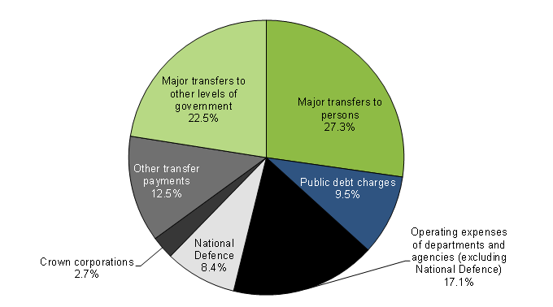Source: Public Accounts of Canada.
Program expenses amounted to $253.8 billion in 2014–15, up $5.2 billion or 2.1 per cent from 2013–14 (Table 6).
Within program expenses, major transfers to persons increased by $4.2 billion, or 5.9 per cent, in 2014–15.
- Elderly benefits consist of Old Age Security and Guaranteed Income Supplement and Allowance payments. Total benefits were up $2.3 billion, or 5.5 per cent, in 2014–15, reflecting growth in the elderly population and changes in consumer prices, to which benefits are fully indexed. The increase in elderly benefits also reflects the accrual of retroactive payments.
- EI benefits consist of regular benefits, special benefits (sickness, maternity, parental, adoption and fishing) and work-sharing agreements. Total benefits increased by $0.8 billion, or 4.3 per cent, in 2014–15, reflecting higher average regular benefits, as well as increased special benefits (e.g. for maternity, parental and sickness purposes).
- Children's benefits, which include the Canada Child Tax Benefit and the Universal Child Care Benefit, increased by $1.2 billion, or 8.9 per cent, due mainly to the accrual of benefits related to the expansion and enhancement of the Universal Child Care Benefit for the January to March 2015 period.
Major transfers to other levels of government include the Canada Health Transfer (CHT), the Canada Social Transfer (CST), fiscal arrangements (Equalization, transfers to the territories, a number of smaller transfer programs and the Quebec Abatement), Gas Tax Fund transfers, and other transfers. These transfers increased by $2.6 billion, or 4.4 per cent, compared to 2013–14.
- The CHT and CST—block-funded transfers—support health care, post-secondary education, social assistance and social services, including early childhood development. These programs provide support in the form of cash and tax transfers to the provinces and territories. Transfers in support of health and other social programs increased by $1.9 billion in 2014–15, reflecting legislated growth.
- Total entitlements under fiscal arrangements increased by $0.7 billion in 2014–15, mainly due to legislated growth in Equalization and Territorial Formula Financing payments.
- Gas Tax Fund transfers decreased by $0.1 billion.
- Other transfers increased by $0.2 billion, reflecting payments made in 2014–15 to provinces and territories for matters relating to the establishment of the Cooperative Capital Markets Regulatory System.
Direct program expenses include transfer payments to individuals and other organizations not included in major transfers to persons and other levels of government, and other direct program expenses, which consist of operating expenses of National Defence, other departments and agencies, and expenses of Crown corporations. Direct program expenses decreased by $1.6 billion, or 1.4 per cent, in 2014–15
- Other transfer payments decreased by $1.6 billion, or 4.3 per cent, largely reflecting the one-time accrual in 2013–14 of a liability for disaster assistance related to the 2013 flood in Alberta as well as decreases in spending across a number of departments in 2014–15. These decreases were offset in part by an increase in Aboriginal claims expenses.
- Other direct program expenses decreased by $0.1 billion, or 0.1 per cent.
  - Crown corporation expenses increased by $0.1 billion, or 1.4 per cent, compared to 2013–14.
  - National Defence expenses increased by $2.2 billion, or 10.0 per cent, largely reflecting the accrual impact of amendments made to veterans future benefit plans in 2014–15.
  - All other departmental and agency expenses decreased by $2.3 billion, or 4.6 per cent, primarily reflecting a decrease in pension and other future benefit costs based on the Government's latest actuarial valuations, offset in part by a number of smaller increases in spending recorded across several departments.
Public debt charges decreased by $1.6 billion, or 5.8 per cent, to $26.6 billion in 2014–15, reflecting a lower average effective interest rate on the stock of interest-bearing debt.
The following chart illustrates the interest ratio (public debt charges as a percentage of revenues) since 1990–91. This ratio has been decreasing in recent years, falling from a peak of 37.6 per cent in 1990–91 to 9.4 per cent in 2014–15. This means that, in 2014–15, the Government spent approximately 9 cents of every revenue dollar on interest on the public debt.
Interest Ratio
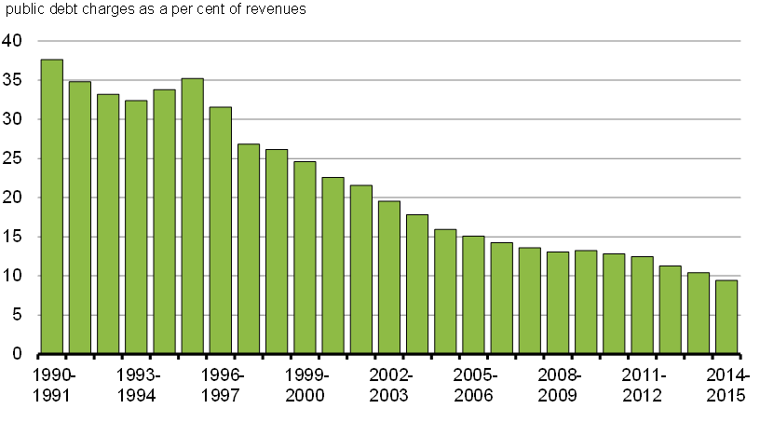Source: Public Accounts of Canada.
Table 6
Expenses
 | 2013–14 | 2014–15 | Net change
 | ($ millions) | ($ millions) | ($ millions) | (%)
Major transfers to persons
Elderly benefits | 41,786 | 44,103 | 2,317 | 5.5
Employment Insurance benefits | 17,300 | 18,052 | 752 | 4.3
Children's benefits | 13,136 | 14,303 | 1,167 | 8.9
Total | 72,222 | 76,458 | 4,236 | 5.9
Major transfers to other levels of government
Support for health and other social programs | 42,758 | 44,696 | 1,938 | 4.5
Fiscal arrangements | 15,610 | 16,271 | 661 | 4.2
Gas Tax Fund | 2,107 | 1,973 | -134 | -6.4
Other transfers | 0 | 169 | 169 | n/a
Total | 60,475 | 63,109 | 2,634 | 4.4
Direct program expenses
Other transfer payments | 36,698 | 35,126 | -1,572 | -4.3
Other direct program expenses
Crown corporations | 7,484 | 7,590 | 106 | 1.4
National Defence | 21,511 | 23,669 | 2,158 | 10.0
All other departments and agencies | 50,217 | 47,889 | -2,328 | -4.6
Total other direct program expenses | 79,212 | 79,148 | -64 | -0.1
Total direct program expenses | 115,910 | 114,274 | -1,636 | -1.4
Total program expenses | 248,607 | 253,841 | 5,234 | 2.1
Public debt charges | 28,220 | 26,594 | -1,626 | -5.8
Total expenses | 276,827 | 280,435 | 3,608 | 1.3
Note: Numbers may not add due to rounding

The Budgetary Balance and Financial Source/Requirement
The budgetary balance is the most comprehensive measure of the federal government's fiscal results. It is presented on an accrual basis of accounting, recording government expenses when they are incurred, regardless of when the cash payment is made, and recording tax revenues when earned, regardless of when the cash is received.
In contrast, the financial source/requirement measures the difference between cash coming in to the Government and cash going out. It differs from the budgetary balance in that it includes cash transactions in loans, investments and advances, public sector pensions, other specified purpose accounts, foreign exchange activities, and changes in other financial assets, liabilities and non-financial assets. These activities are included as part of non-budgetary transactions.
Non-budgetary transactions also include adjustments for the effects of non-cash items included in the budgetary balance and for any accruals of past or future cash receipts or payments. Examples of non-cash items include amortization of tangible capital assets, pension expenses not funded in the period, and the recognition of previously deferred revenue.
Non-budgetary transactions resulted in a net requirement for funds amounting to $4.6 billion in 2014–15, compared to a net source of funds of $22.7 billion in 2013–14. The year-over-year change in the financial/source requirement largely reflects a decrease in repayments of principal on assets maturing under the IMPP.
With a budgetary surplus of $1.9 billion and a net requirement from non-budgetary transactions of $4.6 billion, there was a financial requirement of $2.7 billion in 2014–15, compared to a financial source of $17.5 billion in 2013–14 (Table 7).
The Government financed this financial requirement of $2.7 billion and increased its cash balances by $3.6 billion by increasing unmatured debt by $6.2 billion.
Cash balances at the end of March 2015 stood at $35.0 billion, up $3.6 billion from their level at the end of March 2014. Included in the March 31, 2015 balance of cash and cash equivalents is $20 billion which has been designated as a deposit held with the Bank of Canada with respect to prudential liquidity management. The Government's overall liquidity is maintained at a level sufficient to cover at least one month of net projected cash flows, including coupon payments and debt refinancing needs.
Table 7
Budgetary Balance, Financial Source/Requirement and Net Financing Activities
$ billions
 | 2013–14 | 2014–15
Annual deficit (-) or surplus | -5.2 | 1.9
Non-budgetary transactions
Pensions and other accounts
Public sector pension liabilities | 1.4 | -0.5
Other employee and veteran future benefit liabilities | 4.1 | 4.2
Other liabilities | -0.1 | 0.1
Public sector pension assets |  | -0.3
Total | 5.4 | 3.4
Non-financial assets | -1.5 | -4.2
Loans. investments and advances | 39.9 | 1.6
Other transactions
Accounts payable, receivable, accruals and allowances | -7.7 | 7.3
Foreign exchange activities | -13.5 | -12.8
Total | -21.2 | -5.4
Total non-budgetary transactions | 22.7 | -4.6
Financial source/(requirement) | 17.5 | -2.7
Net change in financing activities
Marketable bonds (Canadian currency) | 4.3 | 14.6
Treasury bills | -27.7 | -17.3
Retail debt | -1.2 | -0.7
Other | 11.1 | 9.6
Total | -13.4 | 6.2
Change in cash balances | 4.1 | 3.6
Cash at end of year | 31.4 | 35.0
Note: Numbers may not add due to rounding.

Federal Debt

Liabilities
The Government's liabilities consist of interest-bearing debt and accounts payable and accrued liabilities. Interest-bearing debt includes unmatured debt, liabilities for pensions and other employee future benefits, and other liabilities. At March 31, 2015, interest-bearing debt amounted to $900.0 billion, up $10.0 billion from a year earlier (Table 8). Within interest-bearing debt, unmatured debt increased by $6.2 billion and liabilities for pensions and other employee future benefits increased by $3.7 billion. Other liabilities, which include deposit and trust accounts and other specified purpose accounts, increased by $0.1 billion. The increase in unmatured debt largely reflects a $4.3-billion increase in the value of cross-currency swaps due to exchange rate movements coupled with a $1.1-billion increase in unamortized discounts and premiums on market debt.
Accounts payable and accrued liabilities amounted to $123.6 billion at March 31, 2015, up $11.9 billion from the close of 2013–14. This increase largely reflects growth in other accounts payable and accrued liabilities, deferred revenue and amounts payable to taxpayers. Other accounts payable and accrued liabilities increased by $2.3 billion in 2014–15. Within this component, accrued salaries and benefits increased by $1.1 billion, largely reflecting the implementation of a payment-in-arrears payroll practice for government employees in 2014–15, while liabilities under provincial, territorial and Aboriginal tax agreements increased by $1.0 billion due to settlements of prior years' tax assessments and timing differences. Deferred revenue increased by $5.2 billion in 2014–15. This increase is due in large part to a combined $4.7 billion in licence fees received in 2014–15 under the 700 megahertz wireless spectrum auction and Advanced Wireless Services auction. Amounts payable to taxpayers increased by $3.6 billion in 2014–15, from $52.6 billion at March 31, 2014 to $56.2 billion at March 31, 2015.

Assets
The Government's assets consist of financial assets (cash and other accounts receivable, taxes receivable, foreign exchange accounts, loans, investments and advances, and public sector pension assets) and non-financial assets (tangible capital assets, inventories, and prepaid expenses and other). Financial assets totalled $336.7 billion at March 31, 2015, up $17.2 billion from March 31, 2014. Cash and other accounts receivable increased by $2.1 billion. Taxes receivable increased by $6.0 billion during 2014–15 to $98.5 billion. Foreign exchange accounts increased by $12.8 billion, due mainly to growth in foreign exchange reserves held in the Exchange Fund Account, reflecting $5.4 billion in foreign exchange gains and $8.4 billion in additional advances to the Account during the year. Under the Government's prudential liquidity plan, liquid foreign exchange reserves will continue to rise sufficiently to maintain their level at or above 3 per cent of GDP.
The Government's investments in enterprise Crown corporations and other government business enterprises increased by $2.5 billion, reflecting $8.4 billion in net profits recorded by these corporations and enterprises during 2014–15, offset in part by $2.4 billion in other comprehensive losses and $3.5 billion in dividends paid to the Government and other equity transactions. Loans and advances to enterprise Crown corporations and other government business enterprises decreased by $7.9 billion in 2014–15, due mainly to a decrease in loans to Crown corporations under the consolidated borrowing framework. This decrease was driven by the repayment of principal on assets maturing under the IMPP administered by CMHC. Other loans, investments and advances increased by $1.5 billion.
Public sector pension assets of consolidated Crown corporations increased by $0.3 billion.
The Government's net debt (total liabilities less financial assets) stood at $687.0 billion at March 31, 2015, up $4.6 billion from March 31, 2014.
Non-financial assets amounted to $74.6 billion at March 31, 2015, up $4.2 billion from March 31, 2014, due mainly to an increase in prepaid expenses and other. Prepaid expenses and other non-financial assets increased by $2.9 billion in 2014–15, largely reflecting an increase in progress payments and advances to Canadian exporters made by the Canadian Commercial Corporation.

Federal Debt (Accumulated Deficit)
With total liabilities of $1.0 trillion, financial assets of $336.7 billion and non-financial assets of $74.6 billion, the federal debt (accumulated deficit) stood at $612.3 billion at March 31, 2015, up $0.4 billion from March 31, 2014. The federal debt stood at 31.0 per cent of GDP at March 31, 2015, down from 32.3 per cent the previous year.
Table 8
Outstanding Debt at Year-End
$ billions
 | 2013–14¹ | 2014–15
Liabilities
Accounts payable and accrued liabilities | 111.7 | 123.6
Interest-bearing debt
Unmatured debt | 659.0 | 665.2
Pensions and other employee future benefits | 225.1 | 228.8
Other liabilities | 5.9 | 6.0
Total interest-bearing debt | 890.0 | 900.0
Total liabilities | 1,001.7 | 1,023.6
Financial assets
Cash and other accounts receivable | 36.1 | 38.2
Taxes receivable | 92.5 | 98.5
Foreign exchange accounts | 72.3 | 85.0
Loans, investments and advances | 117.6 | 113.7
Public sector pension assets | 0.9 | 1.3
Total financial assets | 319.4 | 336.7
Net debt | 682.3 | 687.0
Non-financial assets
Tangible capital assets | 61.9 | 63.3
Inventories | 7.3 | 7.3
Prepaid expenses and other | 1.2 | 4.0
Total non-financial assets | 70.4 | 74.6
Federal debt (accumulated deficit) | 611.9 | 612.3
Note: Numbers may not add due to rounding.
¹ Certain comparative figures have been reclassified to conform to the current year’s presentation.

Annex
OECD Measure of Total Government Net Debt
International comparisons of net debt are made on a total government, National Accounts basis, which for Canada includes the net debt of federal, provincial/territorial and local governments, as well as the net assets held in the Canada Pension Plan (CPP) and Québec Pension Plan (QPP).
The following table provides a breakdown of Canada's net debt for 2013, the most recent complete year for which historical estimates have been published by the OECD.
Table 9
OECD Measure of Total Government Net Debt on a National Accounts Basis, 2013
 | ($ billions) | (% of GDP)
Total federal net debt | 504.6 | 26.6
Add: Net debt of provincial/territorial and local governments | 495.3 | 26.2
Add: Net assets of the CPP/QPP | -248.5 | -13.1
Total government net debt | 751.3 | 39.7
Note: Numbers may not add due to rounding
Source: Statistics Canada
The primary differences between National Accounts federal net debt as published by the OECD and federal net debt on a Public Accounts basis relate to the Government's liabilities for federal public sector pensions and other future benefits and the basis of measurement for total federal net debt. With respect to public sector pensions and other future benefits, these liabilities are excluded from the measurement of Canada's net debt for international comparison purposes as the vast majority of advanced economies do not record such liabilities. With respect to the basis of measurement, National Accounts federal net debt as published by the OECD values assets and liabilities at their current market value, meaning the value of the debt tends to rise when interest rates fall. Federal net debt on a Public Accounts basis is generally measured on the basis of historical cost, in accordance with Canadian public sector accounting standards. The following table presents a reconciliation between the two measures of federal net debt.
Table 10
Reconciliation of Federal Net Debt on a National Accounts and a Public Accounts Basis
 | ($ billions) | (% of GDP)
Net debt (Public Accounts basis) | 682.3 | 36.0
Less: Liability for public sector pensions | 153.2 | 8.1
Liability for other future benefits | 72.0 | 3.8
Add: Conversion to market value of total federal net debt (National Accounts basis) | 41.1 | 2.2
Other¹ | 6.2 | 0.3
Total federal net debt (National Accounts basis) | 504.6 | 26.6
Note: Numbers may not add due to rounding
¹ Other includes timing differences (National Accounts data are as of December 31), differences in the universe covered by each accounting system, and differences in accounting treatments of various transactions such as capital gains.
Sources: Statistics Canada and Public Accounts of Canada.

Independent Auditor's Report
To the Minister of Finance
The accompanying condensed consolidated financial statements, which comprise the condensed consolidated statement of financial position as at 31 March 2015, the condensed consolidated statement of operations and accumulated deficit, condensed consolidated statement of change in net debt and condensed consolidated statement of cash flow for the year then ended, and related notes, are derived from the audited consolidated financial statements of the Government of Canada for the year ended 31 March 2015. I expressed an unmodified audit opinion on those consolidated financial statements in my report dated 3 September 2015.
The condensed consolidated financial statements do not contain all the disclosures required by Canadian public sector accounting standards. Reading the condensed consolidated financial statements, therefore, is not a substitute for reading the audited consolidated financial statements of the Government of Canada.

The Government’s Responsibility for the Condensed Consolidated Financial Statements
The Government is responsible for the preparation of the condensed consolidated financial statements on the basis described in Note 1.

Auditor’s Responsibility
My responsibility is to express an opinion on the condensed consolidated financial statements based on my procedures, which were conducted in accordance with Canadian Auditing Standard (CAS) 810, “Engagements to Report on Summary Financial Statements”.

Opinion
In my opinion, the condensed consolidated financial statements derived from the audited consolidated financial statements of the Government of Canada for the year ended 31 March 2015 are a fair summary of those consolidated financial statements, on the basis described in Note 1.

Michael Ferguson, CPA, CA
FCA (New Brunswick)
Auditor General of Canada
3 September 2015
Ottawa, Canada

Condensed Consolidated Financial Statements of the Government of Canada
The fundamental purpose of these condensed consolidated financial statements is to provide an overview of the financial affairs and resources for which the Government is responsible under authority granted by Parliament. Responsibility for the integrity and objectivity of these statements rests with the Government.
Government of Canada
Condensed Consolidated Statement of Operations and Accumulated Deficit
for the Year Ended March 31, 2015
$ millions
 | 2015  Budget  (Note 4) | 2015  Actual | 2014  Actual
Revenues
Income tax revenues | 180,405 | 181,406 | 173,802
Other taxes and duties | 47,049 | 47,182 | 46,136
Employment insurance premiums | 22,655 | 22,564 | 21,766
Other revenues | 26,229 | 31,194 | 29,973
Total revenues | 276,338 | 282,346 | 271,677
Expenses
Transfer payments
Old age security benefits and related payments | 43,797 | 44,103 | 41,786
Major transfer payments to other levels of government | 62,559 | 63,109 | 60,475
Employment insurance benefits | 17,670 | 18,052 | 17,300
Children's benefits | 13,211 | 14,303 | 13,136
Other transfer payments | 35,812 | 35,126 | 36,698
Total transfer payments | 173,049 | 174,693 | 169,395
Other program expenses | 77,192 | 79,148 | 79,212
Total program expenses | 250,241 | 253,841 | 248,607
Public debt charges | 28,175 | 26,594 | 28,220
Total expenses | 278,416 | 280,435 | 276,827
Annual surplus (-) or deficit | 2,078 | (1,911) | 5,150
Accumulated deficit at beginning of year | 611,881¹ | 611,881 | 609,391
Other comprehensive loss or income (-) |  | 2,360 | (2,660)
Accumulated deficit at end of year | 613,959 | 612,330 | 611,881
The accompanying notes are an integral part of these condensed consolidated financial statements.
¹ Adjusted to the actual closing amount of the previous year.

Government of Canada
Condensed Consolidated Statement of Financial Position
as at March 31, 2015
$ millions
 | 2015 | 2014
Liabilities
Accounts payable and accrued liabilities | 123,631 | 111,730
Interest-bearing debt
Unmatured debt | 665,180 | 658,958
Pensions and other future benefits | 228,804 | 225,121
Other liabilities | 6,002 | 5,914
Total interest-bearing debt | 899,986 | 889,993
Total liabilities | 1,023,617 | 1,001,723
Financial assets
Cash and accounts receivable | 136,696 | 128,574
Foreign exchange accounts | 85,018 | 72,262
Loans, investments and advances | 113,681 | 117,635
Public sector pension assets | 1,263 | 938
Total financial assets | 336,658 | 319,409
Net debt | 686,959 | 682,314
Non-financial assets
Tangible capital assets | 63,347 | 61,942
Other | 11,282 | 8,491
Total non-financial assets | 74,629 | 70,433
Accumulated deficit | 612,330 | 611,881
Contractual obligations and contingent liabilities (Notes 5 and 6)
The accompanying notes are an integral part of these condensed consolidated financial statements.

Government of Canada
Condensed Consolidated Statement of Change in Net Debt
for the Year Ended March 31, 2015
$ millions
 | 2015  Budget  (Note 4) | 2015  Actual | 2014  Actual
Net debt at beginning of year | 682,314¹ | 682,314 | 678,313
Change in net debt during the year
Annual surplus (-) or deficit | 2,078 | (1,911) | 5,150
Acquisition of tangible capital assets | 9,136 | 7,204 | 7,129
Amortization of tangible capital assets | (5,471) | (5,090) | (4,865)
Other | (400) | 2,082 | (753)
Net increase in net debt due to operations | 5,343 | 2,285 | 6,661
Other comprehensive loss or income (-) |  | 2,360 | (2,660)
Net increase in net debt | 5,343 | 4,645 | 4,001
Net debt at end of year | 687,657 | 686,959 | 682,314
The accompanying notes are an integral part of these condensed consolidated financial statements.
¹ Adjusted to the actual closing amount of the previous year.

Government of Canada
Condensed Consolidated Statement of Cash Flow
for the Year Ended March 31, 2015
$ millions
 | 2015 | 2014
Cash used by operating activities
Annual surplus or deficit (-) | 1,911 | (5,150)
Items not affecting cash | (2,014) | (9,370)
 | (103) | (14,520)
Cash used by capital investment activities | (5,850) | (6,254)
Cash provided by investing activities | 9,156 | 43,989
Cash provided or used (-) by financing activities | 367 | (19,127)
Net increase in cash | 3,570 | 4,088
Cash and cash equivalents at beginning of year | 31,429 | 27,341
Cash and cash equivalents at end of year | 34,999 | 31,429
Supplementary information
Cash used for interest | 15,152 | 16,123
The accompanying notes are an integral part of these condensed consolidated financial statements.

Notes to the Condensed Consolidated Financial Statements of the Government of Canada

1. Applied Criteria in the Preparation of the Condensed Consolidated Financial Statements
The criteria applied by the Government in the preparation of these condensed consolidated financial statements are as follows:
- These condensed consolidated financial statements are extracted from the audited consolidated financial statements available from the Public Works and Government Services Canada website.
- The condensed consolidated financial statements are in agreement with the related information in the audited consolidated financial statements and contain the information necessary to avoid distorting or obscuring matters disclosed in the related complete consolidated financial statements, including the notes thereto.
- As these condensed consolidated financial statements are, by their nature, summarized, they do not include all disclosures required by Canadian Public Sector Accounting Standards.
- Readers interested in the disclosure of more detailed data should refer to the audited consolidated financial statements available from the Public Works and Government Services Canada website.

2. Summary of Significant Accounting Policies
The reporting entity of the Government of Canada includes all of the government organizations which comprise the legal entity of the Government as well as other government organizations, including Crown corporations, which are separate legal entities but are controlled by the Government. The financial activities of all of these entities, except for enterprise Crown corporations and other government business enterprises, are consolidated in these financial statements on a line-by-line and uniform basis of accounting after eliminating significant inter-governmental balances and transactions. Enterprise Crown corporations and other government business enterprises, which are not dependent on the Government for financing their activities, are recorded under the modified equity method. The Canada Pension Plan (CPP), which includes the assets of the CPP under the administration of the Canada Pension Plan Investment Board, is excluded from the reporting entity because changes to the CPP require the agreement of two thirds of participating provinces and it is therefore not controlled by the Government.
The Government accounts for transactions on an accrual basis, using the Government's accounting policies that are described in Note 1 to its audited consolidated financial statements, which are based on Canadian Public Sector Accounting Standards. The presentation and results using the stated accounting policies do not result in any significant differences from Canadian Public Sector Accounting Standards.
Financial assets recorded on the Condensed Consolidated Statement of Financial Position can provide resources to discharge liabilities or finance future operations and are recorded at the lower of cost or net realizable value. Non-financial assets cannot normally be converted into cash to finance future operations without disrupting government operations; they are recorded at cost less accumulated amortization. Liabilities are recorded at the estimated amount ultimately payable, adjusted for the passage of time, as required. Obligations for pensions and other future benefits are measured on an actuarial basis. Allowances for valuation are established for loans, investments and advances, as well as for loan guarantees and other obligations.
Effective April 1, 2014, the Government of Canada adopted new Public Sector Accounting Standard PS 3260, Liability for Contaminated Sites. The standard was adopted retroactively and did not affect the recognition or measurement of liabilities for contaminated sites.
Some amounts in these condensed consolidated financial statements are based on estimates and assumptions made by the Government. They are based on facts and circumstances available at the time estimates and assumptions are made, historical experience and general economic conditions and reflect the Government's best estimate of the related amount at the end of the reporting period. Estimates and underlying assumptions are reviewed annually as at the date of the condensed consolidated financial statements. Revisions to accounting estimates are recognized in the period in which estimates are revised if revisions affect only that period or in the period of revision and future periods if revisions affect both current and future periods.
A material measurement uncertainty exists when it is reasonably possible that a material variance could occur in the reported or disclosed amount in the near term. Near term is defined as a period of time not to exceed one year from the date of the condensed consolidated financial statements. The Government has determined that a material measurement uncertainty exists with respect to the reported amounts for public sector pensions and other employee and veteran future benefits; the accrual of tax revenues, the related amounts receivable and payable, and the allowance for doubtful accounts; and environmental liabilities included in accounts payable and accrued liabilities. It is reasonably possible that the Government's reassessments of these estimates and assumptions could require a material change in reported amounts and/or disclosures in the condensed consolidated financial statements.

3. Comparative Information
Certain comparative figures have been reclassified to conform to the current year's presentation. In particular, the Government has changed the presentation of the Condensed Consolidated Statement of Financial Position to segregate a significant class of pensions and other employee future benefits related to consolidated Crown corporations and other entities which were included in other accounts payable and accrued liabilities in previous years. The change in presentation has no financial impact on the Condensed Consolidated Financial Statements of the Government.

4. Source of Budget Amounts
The budget amounts included in the Condensed Consolidated Statement of Operations and Accumulated Deficit and the Condensed Consolidated Statement of Change in Net Debt are derived from the amounts that were budgeted for 2014-15 in the February 2014 Budget Plan (Budget 2014). To enhance comparability with actual 2014-15 results, Budget 2014 amounts have been restated to reflect the change in the Government's accounting policy for bond buy-back operations in 2013-14. This restatement has resulted in an $800 million decrease in budgeted public debt charges and a corresponding decrease in the budgeted 2014-15 annual deficit.
Since actual opening numbers of the accumulated deficit and net debt were not available at the time of preparation of Budget 2014, the corresponding amounts in the budget column have been adjusted to the actual closing numbers of the previous year.

5. Contractual Obligations
The nature of government activities results in large multi-year contracts and agreements, including international treaties, protocols and agreements of various size and importance. Any financial obligations resulting from these contracts and agreements are recorded as a liability when terms for the acquisition of goods and services or the provision of transfer payments are met.
Contractual obligations that will materially affect the level of future expenditures include transfer payment agreements, acquisitions of tangible capital assets, and goods and services, operating leases and funding of international organizations. At March 31, 2015, contractual obligations amount to $103,780 million ($91,263 million in 2014), of which $26,660 million pertains to fiscal year 2016.

6. Contingent Liabilities
Contingent liabilities arise in the normal course of operations and their ultimate disposition is unknown. The Government's contingent liabilities include guarantees provided by the Government, callable share capital in international organizations, claims and pending and threatened litigation, and insurance programs of agent enterprise Crown corporations.
- Guarantees provided by the Government include guarantees on the borrowings of enterprise Crown corporations and other government business enterprises, loan guarantees, insurance programs managed by the Government, and other explicit guarantees. At March 31, 2015, the principal amount outstanding for guarantees provided by the Government amounts to $442,904 million ($407,039 million in 2014) for which an allowance of $317 million ($386 million in 2014) has been recorded. Of the total amount guaranteed, $253,049 million ($245,223 million in 2014) relates to guarantees on the borrowings of agent enterprise Crown corporations for which no allowance (nil in 2014) has been recorded.
- The Government has callable share capital in certain international organizations that could require payments to those agencies. At March 31, 2015, callable share capital amounts to $30,601 million ($28,217 million in 2014).
- There are thousands of claims and pending and threatened litigation cases outstanding against the Government. While the total amount claimed in these actions is significant, their outcomes are not determinable. The Government has recorded an allowance for claims and litigation where it is likely that there will be a future payment and a reasonable estimate of the loss can be made. Claims and litigation for which the outcome is not determinable and for which an amount has not been accrued are estimated at approximately $8,304 million ($7,300 million in 2014). Certain large and significant claims relate to comprehensive land claims, specific claims, and assessed taxes under objection or appeal.
- At March 31, 2015, insurance in force relating to self-sustaining insurance programs operated by four agent enterprise Crown corporations amounts to $1,671,666 million ($1,648,444 million in 2014). The Government expects that all four corporations will cover the cost of both current claims and possible future claims.

7. Subsequent Event
Subsequent to the end of the fiscal year, through an enterprise Crown corporation, the Government sold its remaining 73 million common shares in General Motors Company through an unregistered block trade. The shares were sold on April 6, 2015 for proceeds of $3,254 million, resulting in a realized gain of $2,131 million recorded in other revenues that will be reflected on the Condensed Consolidated Statement of Operations and Accumulated Deficit for fiscal year 2015.

¹ This section incorporates data available up to and including August 10, 2015.
Terms and Conditions | Transparency Date modified: 2015-09-14
- About Us
  - Our Minister
  - Parliamentary Secretary
  - Branches
  - Organizational Structure
  - University Recruitment
- News
  - News Releases
  - Notices to the Media
  - Speeches
- Contact Us
  - Help
  - Site Map
  - Frequently Asked Questions
- Stay Connected
  - Flickr
  - Twitter
  - YouTube
  - LinkedIn
  - RSS Feeds
- HEALTH
healthycanadians.gc.ca
- TRAVEL
travel

