10 CSOs petition Mahama over secret ownerships of mineral concessions
Source: Ghana|myjoyonline.com
Date: 11-05-2016 Time: 06:05:52:pm
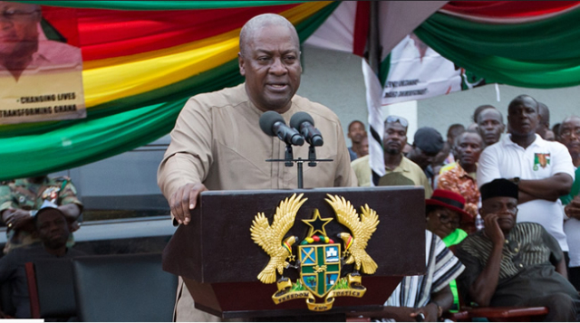
Ten civil society organizations have petitioned President Mahama to cause the disclosure of the identities of persons behind the ownership of oil blocks.
The groups have raised the alarm about the possibility of politicians hiding behind secretive, non-disclosure legislation to award oil blocks to themselves.
This comes 24 hours before President John Mahama delivers an address at the global anti-corruption summit in the United Kingdom.
The civil society groups have written a letter to him demanding immediate action to avoid international sanctions from the Financial Action Task Force.
Executive Director of the Africa Centre for Energy Policy, Dr. Amin Adam, who signed the letter raised suspicion of wrongdoing in the minerals sector on Joy FM’s Top Story Wednesday.
He explained that weak laws on disclosure could provide politicians and power brokers the opportunity to open companies in the name of other persons.
The public officer then goes to cause the award of contracts to the company he owns but has not disclosed.
Read statement below
Civil Society Anti-Corruption Agenda on Extractive Industries
Civil Society Organizations at a Dialogue on Anti-Corruption on Extractive Industries organized by the Africa Centre for Energy Policy (ACEP) on the 9th of May 2015, as prelude to the UK Anti-Corruption Summit, have called on the Government of Ghana to declare its commitment to fight corruption in Ghana and in the extractive industries in particular.
The Dialogue considered the hotspots for corruption in Ghana and recommended specific commitments expected of the President of Ghana to ensure that Ghana takes bold steps at eradicating corruption.
The participants called on the President to commit to a 10-point anti-corruption agenda as follows:
An open and competitive process for awarding oil, gas and mining concessions
A mandatory requirement for the disclosure of oil, gas and mining contracts
A mandatory requirement for the establishment of a public register of beneficial owners in the extractive industries and all their associated interest in Ghana and abroad. This could be done through a number of planned legislations – the Petroleum (Exploration and Production) Bill, the Extractive Industries Transparency Initiative Bill or the Companies Bill.
A requirement for the criminal prosecution of public officials found to have engaged in conflict of interest during oil, gas and mining licensing and in the regulation of operations
The passage of the Right to Information Bill
The passage of the Petroleum (Explorations and Production) Bill
The Subscription to Open Data Standards across Ministries Departments and Agencies
Confirm Appointed Heads of Institutions in time to ensure their independence and security of tenure
Sign on to the Voluntary and Automatic Frameworks for exchange of information to address illicit financial flows
Effectively implement the National Anti-Corruption Action Plan (NACAP) or transform it into an Anti-Corruption Law.
These commitments should also be backed by timelines to enable citizens to hold the President to account. It was agreed that much of the commitment to fight corruption in the past has been mere rhetoric without timelines and clarity on actions to be taken.
It is our belief that our President who will be among world leaders to address the UK anti- corruption summit, will use this great platform to commit the government to an anti- corruption agenda that will lay the foundation for a transformative society in Ghana, in which official impunity, corruption, and mismanagement of public resources will be stopped.
- See more at: http://www.myjoyonline.com/politics/

