BP and Oman Oil signed Khazzan and Makarem tight gas project

BP – OOC start Oman Block-61 development phase-1
BP and the Sultanate of Oman took one year to align on a $16 billion capital expenditure program to develop the first phase of the Khazzan and Makarem tight gas fields of the Block 61 in the center of Oman.
With this investment BP is becoming the largest investor in Oman.
In addition this Block 61 phase-1 tight gas project represents the largest development of unconventional resources in the Middle-East.
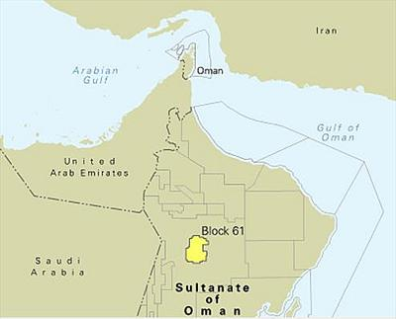Located right in the center of the Sultanate of Oman faces the double challenge of the water supply in one way and the export of gas in another way.
As Oman is running short of gas the location of the site and the water challenges confers BP a unique market leadership.
During this year of discussion, BP and theSultanate of Oman agreed on the gas price and the production sharing agreement (PSA).
As a result, the price gas has not been disclosed, but BP and the national oil company (NOC) Oman Oil Company (OOC) will share the working interests in such a way that:
– BP 60% is the operator
– Oman oil 40%
The new PSA will also extend BP and Oman Oil exploration rights in the block and its operatorship from 25 to 30 years.

WorleyParsons completed BP Khazzan pre-FEED work
According to the pre-front end engineering and design (pre-FEED) work completed by WorleyParsons, BP is planning the development of Khazzan and Makarem project with:
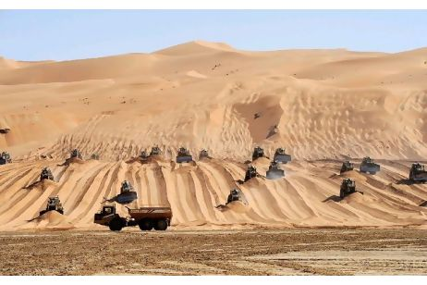 – 400 wells to be deployed in clusters
– Hydro fracturing equipment
– Water treatment and water disposal facilities
– 500 kilometers gathering system of flowlines
– Gas central processing facility (CPF)
– 100 kilometers export pipeline
– Offsite and Utilities
To be located near the existing Saih Rawl gas plant, the BP Khazzan central processing facility should have a capacity of:
– 1 billion cubic feet per day (cf/d) of natural gas
– 25,000 barrels per day (b/d) of condensate
The BP Khazzan and Makarem project will generate its own power, but in the meantime it works and in case of emergency, BP and Oman oil are planning to connect their facility to the existing Petroleum Development of Oman (PDO) Mussallim facilities through a 132kV power line.
Called 132kV Intertie, this package will include the extension of the Mussallin substation with an additional bay on its east side to supply BP Khazzan including all the protection relays and UPS system and batteries.
The contractors to bid on this particular package will have the qualified by the joint venture BP – Oman oil and by PDO.
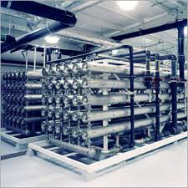WorleyParsons used its Canadian expertise to design the water complex including the water desalination, recycling and treatment of the disposal.
For the BP Khazzan Phase-2, BP and Oman oil are planning to add 1 billion cf/d capacity that should require only $8 billioncapital expenditure as it should benefit from phase-1infrastructure.
For the Khazzan and Makarem phase-1 development within theBlock 61, BP and Oman oil qualified eight engineering companies to bid on the different packages to be awarded in 2014in expecting the first production to start in 2017.

