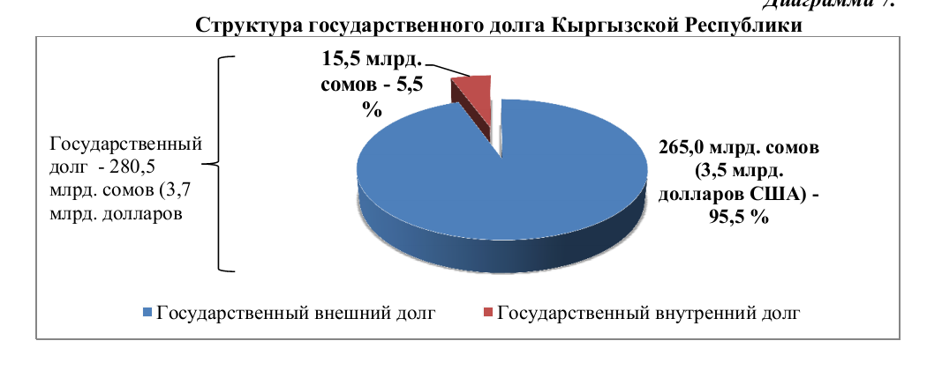
Рисунок 1The structure of government debt of KR. External debt – by blue color, internal debt – by red color

