The mines of the rugged northeastern province of Badakhshan are one of the richest assets of the Afghan people, an extraordinary national treasure that should be a powerful resource for development.
Instead, as a two-year investigation reveals, they are a major source of conflict and grievance, supply millions of dollars of funding to armed groups, insurgents, and strongmen, and provide a tiny fraction of the benefit they should to the Afghan people. Without a coherent response, these mines – and others like them across Afghanistan – represent not just a lost opportunity, but a threat to the whole country.
The direct rivals in the violent competition for Badakhshan’s ancient lapis lazuli mines are two local strongmen. Both have exploited the mines, both have links to national politics, and both allegedly have had back-door ties to the Taliban. According to rough but plausible estimates, the revenue going to these strongmen and the Taliban from just one small area of Badakhshan rivals the government’s declared income from the entire Afghan natural resources sector. For now, the lapis which supplies much of the world market is, by any reasonable definition, a conflict mineral.
For now, the lapis which supplies much of the world market is, by any reasonable definition, a conflict mineral.
This struggle is one of resources, not ideology: a “business war.” But it has nonetheless created the conditions in which the Taliban – who have a close relationship with the local affiliate of the Islamic State – threaten to take the mines, and already control the much of their revenue. And it is a major reason why a province which resisted the Taliban at the height of their power is now one of their strongholds. Amid the conflict and lawlessness around the mines, it is the insurgency that has benefitted above all.
Badakhshan illustrates wider dangers around Afghanistan’s natural resources. Mining is implicated in violence from Balkh to Helmand. Nationally, it is thought to be the Taliban’s second largest source of revenue, while contributing less than 1% of state income in 2013. Afghanistan’s estimated $1trn of mineral reserves could in theory generate $2bn revenue a year: hopes for the country’s economic growth, and by extension its independence from foreign aid, rely on their development. But they threaten to do the opposite – to be a chronic source of conflict and corruption, while generating little revenue. Improving the governance of the whole sector is not just a matter of legality or of morality: it is of fundamental importance to the future of the country.
According to estimates, the revenue going to the Taliban from just one small area of Badakhshan rivals the government’s declared income from the entire Afghan natural resources sector.
That urgency has not so far been adequately reflected in the policy of either the Afghan government or its partners– despite some distinctly encouraging recent announcements. They should make it a first-order priority, first by increasing accountability, transparency, and local engagement around mining (notably in the mining law), and by prioritising security in mining areas. Badakhshan, where both the scale of the threat and the potential reward are disproportionately high, is worth particular attention – but reform is needed for the whole country. With some basic safeguards yet to be implemented, effective action is possible.

Global Witness’ research covered two of the most important minerals in Badakhshan, lapis lazuli and tourmaline –semi-precious decorative stones mainly exported to China.
The report focuses on the lapis mines of Kuran wa Munjan district, but the nearby tourmaline mines at Deodarra raise similar issues.
This mine is itself a general...It will make people fight.
‘Haji Bashir’, an elder from the district of Kuran wa Munjan
The competition for these resources among armed groups and political elites is part of a long-standing pattern. Haji Abdul Malek, a former district police chief and commander with the Jamiat e Islami party, seized control of the lapis mines in January 2014. But the government’s nominal control before this was effectively a façade behind which the mines were exploited by another formerJamiat commander, serving Badakhshan MP Zulmai Mujadidi. Mujadidi is widely thought to effectively control official police and militia troops, including the official Mining Protection Force (MPF), led by his brother Asadullah Mujadidi – the key force in Kuran wa Munjan before 2014. Another local MP, the former lapis trader and current head of Parliament’s natural resource commission, Zekria Sawda, is a smaller but active player. Finally, the Taliban and more recently the Islamic State are a growing presence around the mines.

Abdul Malek (Haji Malek/Commander Malek)
A former commander with the Jamiat e Islami political and military faction, Abdul Malek was part of the National Front which held Badakhshan during the civil war of the 1990's and for much of the preceding period of jihad against the communist government and its Soviet backers. As the military commander for the Kuran wa Munjan district before 2001, Malek had direct control of the lapis mines. After 2001, he retained significant local influence, transitioning to become the Chief of Police of Kuran wa Munjan, a position he held until late 2012. He was transferred elsewhere but returned to lead an armed takeover of the district in January 2014.

Zulmai Mujadidi (Zulmai Khan)
Zulmai Mujadidi was born in 1958 to a prominent local elder in Jurm district of Badakhshan. He reportedly holds a bachelor degree in geology from Kabul University. another former Jamiat e Islami commander who joined the fight against the Soviet-backed government, Mujadidi rose to head the 10th directorate of the National Directorate of Security (NDS), which dealt with protection of high-ranking officials – including, after 2001, the new Afghan president, Hamid Karzai. Mujadidi developed a close relationship with Karzai, shifting his allegiance from his former mentor, theJamiat leader Burhanuddin Rabbani. He became an AMP in the 2005 elections, and was seen as Karzai’s virtual ‘shadow viceroy’ in Badakhshan, supported as a counter-weight to Rabbani and other alternative centres of power.

Asadullah Mujadidi (Asadullah Khan)
Brother to Zulmai Mujadidi, Asadullah was appointed in 2007 as the head of the paramilitary security force for the lapis mines, the Mining Protection Force (MPF), reportedly through the influence of his brother. Officially, the MPF has jurisdiction only over the Kuran wa Munjan district where the lapis mines are found, but Asadullah and his men have also operated in the Deodarra region, where tourmaline is mined.

Muhammad Zekria Sawda
Son of Barat Muhammad Sawda, Muhammad was born in 1971 in Faizabad, the capital of Badakhshan. He was schooled in Pakistan and in Jurm district and obtained a Bachelor’s degree in Law and Political Science at Kabul University. Sawda is an MP and former minerals trader and businessman who was elected to Parliament's lower house in 2010. He is the chair of the Natural Resources and the Environment Commission, which deals with mining – a position that would represent a particular conflict of interest if he were shown to have a stake in mining himself.

- In 2014 the two mining areas of Deodarra and Kuran wa Munjan alone provided around $20m to armed groups, according to rough but conservative estimates – equivalent to the government’s declared revenue from the entire extractive sector in 2013. This includes about $18m to Commander Malek and informal armed groups linked to him, and more than $1m each to the Taliban and to armed groups mainly allegedly associated with Zulmai Mujadidi.
- Armed groups made at least $12m from lapis in 2015, according to rough but credible estimates, with a government ban on the trade in early 2015 countered by massive smuggling through the Panjshir valley. The Taliban increased their share of this as their strength grew, to an estimated $4m. As of mid 2016, payments to the Taliban reportedly amount to at least 50% of the revenue from the mines.
- Natural resources are a key driver of instability. Competition for the mines has directly fuelled a series of violent incidents in Badakhshan, and put an entire district out of government control for more than two years. Abuses around the mines, especially the lack of benefit for local people, created significant backing for Malek’s takeover of Kuran wa Munjan in 2014. As one elder put it, “people were excluded from their rights to the mine (…) the majority of people supported [the coup].”
- Similar grievances have pushed individuals to support the Taliban. People “see the underground resources and public wealth in the hands of the looters,” a miner said: “they choose the Taliban (…) for their revenge.” Revenue from the mines, and their compromising effect on government legitimacy and the integrity of the local administration and security forces, have helped the Taliban infiltrate Badakhshan to a far greater extent than they could at the height of their power in the 1990's. There are also credible indications the mines are a strategic priority for the Islamic State in Badakhshan.
- From the mines of Kuran wa Munjan and Deodarra alone, the Afghan government lost revenues of at least $18.1m in 2014 alone, at least 98% of the potential take, as a result of illegal exploitation, irregular contracts, and artificially low official valuations for lapis. Around $2.4m in revenue appears to have been lost from a single convoy in early 2015. Massive underpayment of taxes appears to be routine, and several sources made allegations of corruption against government officials. The Ministry of Mines itself could not provide full revenue and production data for lapis, a serious concern in itself.
- Multiple sources alleged that Asadullah Mujadidi profited from illegal lapis extraction when he controlled the lapis mines before 2014, and that he and forces under his control used intimidation to capture profits from tourmaline mining in Jurm district.
- Zulmai Mujadidi and Commander Malek have links to higher level political networks. Former Defence Minister Bismillah Mohammadi was alleged to have been in contact with Commander Malek even after his takeover of the mines, and was widely believed to have benefitted from the lapis trade, along with other political figures (although some sources disputed this, and Global Witness was unable to find any independent verification of the claims).
- Highly questionable contracts for lapis and tourmaline illustrate the need for greater transparency. An unpublished ‘contract’ allowing certain individuals in Baharak district to extract a toll from lapis was described as illegal by a senior local official: evidence suggests it benefited members of the Mujadidi family. A tourmaline contract held by the Pamir Badakhshan International Mining company (PBIM) was more formal but produced very little tax revenue, and appears to be controlled by the MP Zekria Sawda.
- Multiple sources also allege that Zulmai Mujadidi had a hidden interest in the Lajwardeen Mining Company (LMC), which holds the only official contract for Badakhshan’s lapis. The Afghan government sanctioned a problematic arrangement in 2014 whereby the transit of lapis continued under LMC’s name despite the takeover of the mines by Commander Malek, though it is not clear that the company profited significantly from its role. The arrangement was ended and the LMC contract suspended by early 2015, but there is likely to be a political struggle over its future.
Zekria Sawda and Asadullah Mujadidi both deny involvement in mining in Badakhshan, or with illicit armed groups. Zulmai Mujadidi also strongly denied the allegations, saying that the “sources of [this] information are not objective, but rather have originated from or influenced by my political opponents and foes; the issues raised are nothing more than propaganda.” He supplied a copy of a summary decision of the Afghan Media Complaints Commission against a media outlet which made similar allegations. General Mohammadi did not comment, while Commander Malek could not be reached to request his views, although in public statements he has denied that the lapis mines profit the Taliban or that extensive illegal mining takes place.
Many of the concerns set out above are relevant across Afghanistan,where there are thousands of illegal mines outside of government control. Direct comparisons can be misleading, but there is a clear risk Afghanistan could see a prolonged, resource-fuelled conflict of the kind that has been so damaging elsewhere. The specific problems around mining are closely linked to deeper challenges of conflict, corruption, and the weakness of Afghan state institutions. But that does not mean action is futile: there are a range of practical policy measures that could reduce the risks associated with extractives, without placing unrealistic demands on government capacity.

There are grounds to hope that the Afghan government will respond to these challenges. President Ashraf Ghani has spoken of the dangers of the resource curse with refreshing clarity, and in May 2016 the government announced new measures, including plans to publish beneficial ownership information.
But while this provides a foundation for reform, for now the government has yet to put in place a number of basic protections – notably to strengthen the Mining Law, publish mining data, reinforce oversight capacity, and support community monitoring of mining. Illegal extraction remains widespread, with little or no accountability for the powerful figures involved, and large-scale smuggling of lapis through the Panjshir valley continues. For their part, donors have spent many millions promoting mining, but with a few honourable exceptions have focused on overcoming obstacles to new contracts more than on the fundamental governance challenges, which at this stage pose a much greater threat.
We are risk of the curse of plenty, [the] curse of resources.
Ashraf Ghani, President of the Islamic Republic of Afghanistan
The government faces great challenges, and cannot realistically regain control of the thousands of illegally exploited mines in Afghanistan overnight. The question is whether the problems around mining are given a level of priority that reflects their importance – and whether the government is doing the things that are relatively easy, like reforming the mining law. If there is the will to act, a sustained reform of the sector could generate millions of dollars in revenue, improve the lives of ordinary Afghans, and help lay the foundations for lasting stability. In the battle for Afghanistan’s future, mining is not a bad place to start.

Badakhshan
- Make Badakhshan the initial focus of a systematic effort to re-establish rule of law, reform mining oversight, create the conditions for legitimate trade, and increase revenues.
- Use all available peaceful means to re-stablish control over Kuran wa Munjan, including enforcing the blockade of the lapis trade through Panjshir province. Avoid any deal with local actors which does not effectively address the current abusive exploitation of the mines.
- Investigate ‘pro government’ armed groups in Badakhshan, and hold them accountable. The Mining Protection Force should be brought under new leadership and reconstituted as a part of a specially trained, independent and accountable force. Disband Afghan Local Police (ALP) groups linked to abuses.
- Transparently and fairly investigate the Baharak, PBIM and LMC contracts, and ensure accountability if significant abuses are confirmed. Avoid scapegoating traders for abuses mainly linked to armed groups.

Transparency and Accountability
- Amend the Afghan Mining Law to require all contracts and ancillary documents to be published as a condition of their becoming valid. Remove licensing and revenue collection from local MoMP offices.
- Create a clear legal requirement for the publication of the beneficial ownership of any company applying for substantial government contracts, including mining concessions.
- Amend the law to require publication of project-level data on payments between companies and the Afghan government, and on minerals production. Require published annual audits of larger extractive companies. Create a single, dedicated, and transparent account for all extractive sector payments.
- Urgently strengthen the oversight and data management capacity of the Ministry of Mines. Require the Ministry to implement basic data standards, and publish full revenue and other data, within six months.

Communities
- Develop a program for community monitoring of mining. Allocate a modest percentage of the legal revenue of a mine directly to communities, to help incentivise legal extraction. Give communities a greater stake and say in mining through stronger dispute resolution, consultation and local employment requirements.

Security
- Make Kuran wa Munjan and other significant mining areas across Afghanistan a key focus for security policy, to ensure appropriate protections against the exploitation of the mines by armed groups. In Kuran wa Munjan, provide vetted ANA reinforcements to ensure security until the MPF can be reformed.

RECOMMENDATIONS FOR AFGHANISTAN'S INTERNATIONAL PARTNERS
Ehsan, a lapis lazuli digger, a semi-precious blue gem, goes down to the near village carrying a rock weighing more than 100 kilos (200 Lbs). It will take him several hours to climb down the steep and slippery sides of the mountain. Credit: Philip Poupin
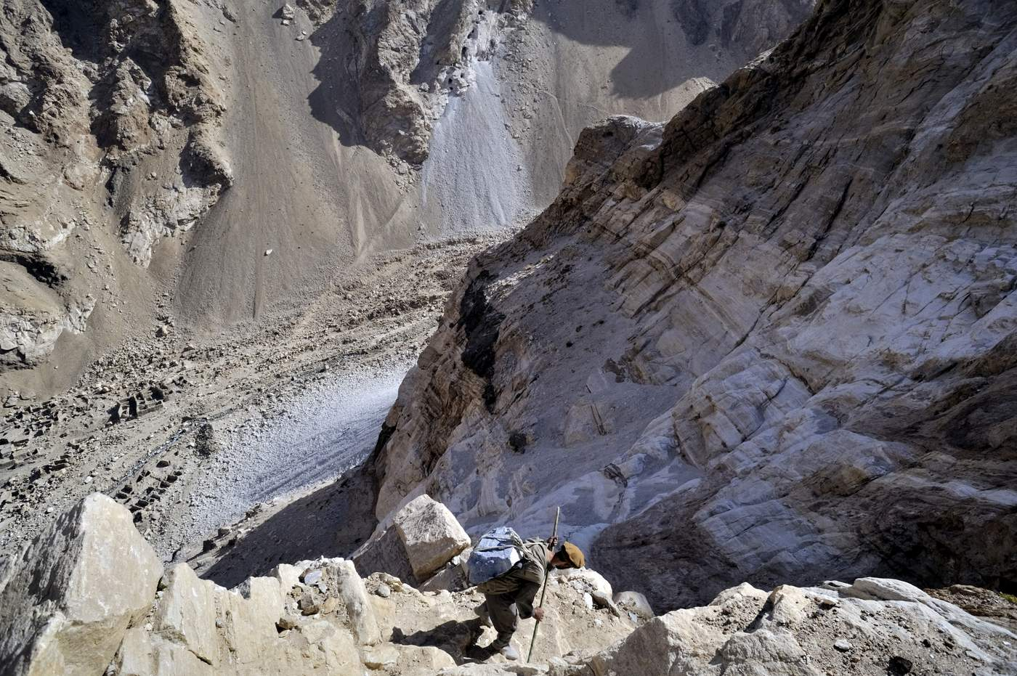
- Make the strengthening of extractive sector governance a key priority for engagement with the Afghan government, and work to integrate robust measures into core benchmarks for mutual accountability. Hold the government to its commitments to reform, but also ensure strong and coordinated support to its efforts.
- Work with the Afghan government to provide technical, financial and other support for stronger extractives governance, with a particular priority given to legal reforms and building oversight capacity.
- Work with the Afghan government to implement supply chain due diligence and prevent trade in minerals which could contribute significantly to conflict and abuses, with an initial focus on lapis lazuli. The UN Sanctions Committee should investigate links between the lapis trade and funding for groups under its remit.
To read a full version of the report including footnotes and references please click here.
All photos by Philip Poupin were taken in August 2008. Global Witness investigators and sources have found conditions to be very much the same in 2015.

