For Immediate Release

June 19, 2023

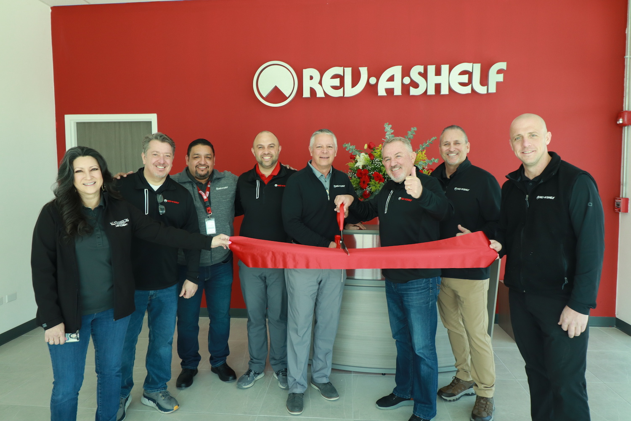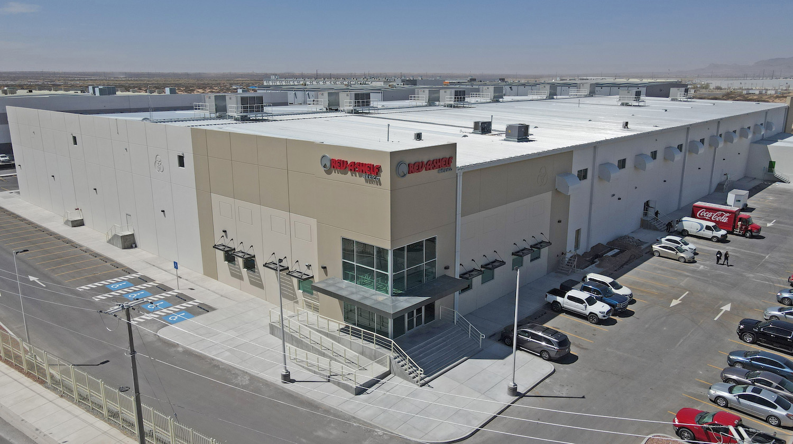

Rev-A-Shelf® Opens New State-Of-Art Facility in Mexico
Louisville, KY – June 19, 2023 – Rev-A-Shelf®, the industry leader in kitchen cabinet storage, organization, and lighting accessories, recently celebrated opening a new state-of-the-art plant in Juarez, Mexico. It is the first site dedicated to producing the highest quality, most affordable wood products made on the North American Continent.
"With this facility, we've diversified our manufacturing capabilities to support our customers and continue our mission of designing and introducing innovative wood products to the market," said David Noe, General Manager for Rev-A-Shelf®.
The Juarez plant currently produces 54 wood products, including drop-in drawer inserts, dovetail pantry drawers and various new and existing wood components. We plan to expand by another 30 SKUs by early 2024. More than 61 employees currently support production at the plant, which boasts a footprint of 125,652 sq. ft., with room for expansion in the future.
"As we continue to accelerate our product offerings, the Juarez facility presents Rev-A-Shelf® with big potential," said Mike Brown, Director of Wood Manufacturing for Rev-A-Shelf®. "The opening of this plant is another example of our commitment to providing cost-effective and quality products, made in North America. This expands capacity and reinforces our investment in the future."
Rev-A-Shelf® continues to expand its organizational solutions consistently. Alongside their quality wood products, Rev-A-Shelf® also produces polymer and wire products for baths, closets, kitchens, laundry rooms, and pantries, and a full line of safety-tested LED products for the residential and commercial markets under the Tresco® Lighting brand.
About Rev-A-Shelf LLC.
Established in 1984 as a division of the family-owned Jones Plastic & Engineering, Rev-A-Shelf’s product line began as metal and polymer Lazy Susan components manufactured for the largest U.S. cabinet manufacturers and have since grown into the market-leading innovator of residential cabinet storage solutions and L.E.D. cabinet lighting.

Rev-A-Shelf, located in Louisville, KY., manufactures thousands of innovative accessories for the kitchen, bath or closet. Under the Tresco Lighting brand, Rev-A-Shelf offers a full line of LED lighting options for residential cabinetry and commercial display fixtures. Rev-A-Shelf’s primary markets include cabinet hardware distributors, large O.E.M. cabinet manufacturers, Lowe’s and Menards home centers, and an array of online web resellers.

