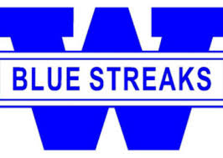

Woodstock Athletes

Help support the Turf Fund Raising Campaign

Davis Speed Center is helping to raise money for the new turf field. Dave Davis is a Woodstock Alumni who runs a speed and agility camp out of the MAC (Formerly Regional Sports Center) off of Ridgefield Rd. He was a member of the 1997 state championship football team. Dave has worked with many of the top athletes in the area for the past 12 years.

In the month of May Davis Speed Center is offering a promo code for use on any speed, strength, or adult fitness program. Use the Promo Code WHSTURF and you will get 10% off any program. In addition Davis Speed Center will donate back 50% of your program fee’s towards the Turf Fund Raising Campaign.

Here is your chance to improve your athletic performance and help raise money for the new field at the same time.

More info on the Davis Speed Center programs can be found online at www.davisspeed.com

How it works:

- go online to www.Davisspeed.com
- Hover of the schedule tab and click the new member registration drop down link.
- choose a program and use the WHSTURF code at checkout.

Dave can be contacted directly at dave@davisspeedcenter.com or (815) 575-9142

It’s an exciting time to be a Blue Streak!

