CRYSTAL LAKE SOUTH
F/S Football Packet 2018

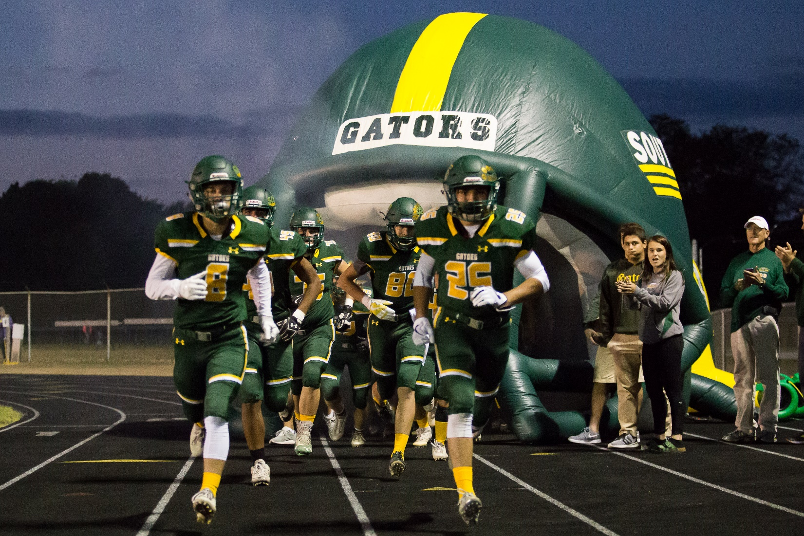
Our top priority in football at
Crystal Lake South is EDUCATION!

You are a STUDENT FIRST and then an Athlete.

We have had many more students get Scholarships for academics than we have had for athletics; work hard in the classroom!

We believe that participation in a sound athletic program contributes to the development of:

- ACCOUNTABILITY
- Health and happiness
- Physical skills
- Teamwork
- Emotional maturity
- Self-confidence
- Leadership skills
- Time management skills
- Responsibility for individual performance
- Social competence
- Sound moral values
- Cooperation
- The will to win

We have 4 levels of competition:
- Varsity
- Junior Varsity
- Frosh
- Frosh B

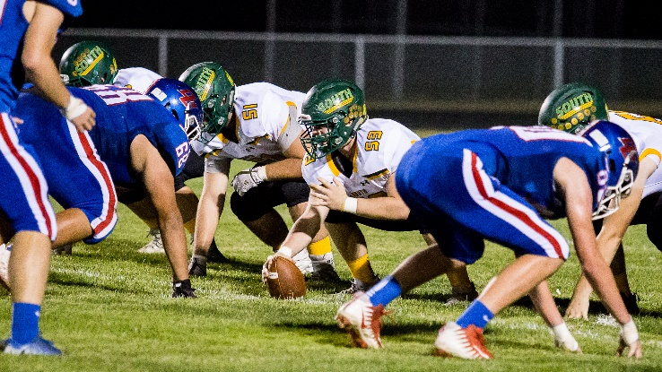
PARENT / PLAYER MEETING
Tuesday May 15th 7:00 PM Aux Gym
Topic: Summer Football Program

The Summer:

- Weight Training Orientation:
June 7th and 8th from 7 am to 8 am
Registration will open March 26th 2018
https://chsd155.revtrak.net/tek9.asp?pg=RW_SSummerCamp
Weight Training: June 4th – July 27th (M, T, Th, F) $100
All Campers will get a Tee Shirt
- F/S will lift from 9 - 10 am
- F/S will do speed/agility/conditioning from 10 - 11 am
- Equipment Handout: July 2nd Subject to change (F/S 11:00 am)
Mini-Camp:
- July 9th - July 13th, July 16th –July 20th, and July 23rd – July 27th
- M, T, Th, F 11:15 am – 1:15 pm Wednesday 8:30 am-11:00 am
- Fundraiser in July (Each guy is responsible to sell 10 or more cards to help the program continue to buy new equipment, uniforms, and software for our athletes to benefit from)
Registration will open by March 26th 2018 https://chsd155.revtrak.net/tek9.asp?pg=RW_SSummerCamp
- Register and Sign up for Email alerts online: https://drive.google.com/file/d/0B2Ck4mYT0Ss2ODA4YkQtQ09mVGM/edit
- First day of practice: August 6th at 7:30 am

Expectations for the Summer:
- Attend weights and conditioning sessions
- Attend Mini-Camp
- Follow training rules
- Communicate to coaches about vacations
- Sell 10 fundraiser books prior to July 27th (incentives for selling is available)
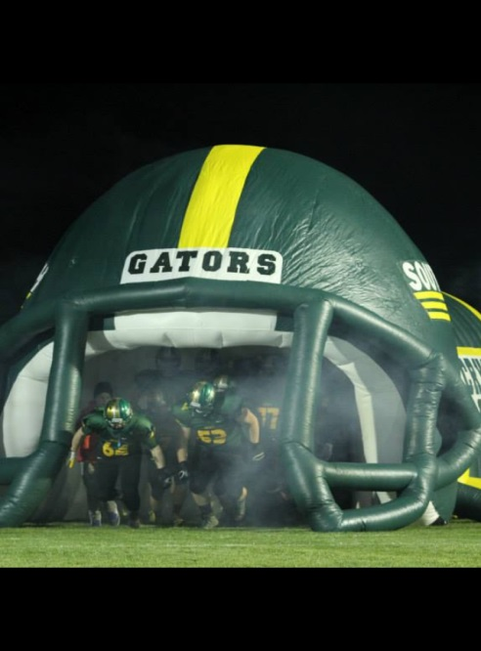
The Season:

- First Practice: August 6th, 7:30 am - 10:30 pm
- First Day of Full Pads: August 11th
- Pictures: August 18th, 7:00 am followed by
practice until 10:30 am
- Meet the team: August 18nd, 11 am in the Theater.
- First Frosh game: @ Cary Grove, August 24th 5:00 pm
- First Varsity game: @ Cary Grove, August 24th 7:00 pm
- First JV game: Home vs. Cary Grove, August 25th 9:00 am
- First Frosh B Game: Home vs. Cary Grove, August 25th 11:00 am

Expectations for the Season:

- All players must be at every practice and game.
- According to IHSA rules, you must have 13 days of practice before you can play!
- If you are going to miss practice, call and leave a message or email your Head Coach
- 2 unexcused absences may result in removal from the team.
- Continue to lift 2 Days a week in PE class (Monday/Wednesday)
- Saturdays are REQUIRED for all levels/players plan accordingly
- WE before ME. Football is a team sport and everyone needs to own that philosophy. Gator Football is all about the TEAM!

Transportation:
- Every player must ride the team bus to and from them.
- If you have a family matter and you must leave with your parents after the game, you must fill out the travel request form and have it signed by an administrator before you can leave. Please plan ahead!
- Travel request form can be found on the school webpage listed at the end of the packet.
Expectations for the Off Season:
- Attend all SALT meetings (Student Athletic Leadership Team)
- Start EARNING your points for next season (Daily points for lifting after school, or get a set # of points based on sport played during the offseason) During the winter season I Highly encourage our guys to join wrestling if they don’t play basketball. In spring go out and compete in Track and Field if you are not playing another CLS Sport.
- Join another sport (If you’re not in a sport we lift M,T,Th,F after school from 3-4:15) All lifting is lead by Davis Speed Center in our facilities at no extra cost to you.
- Focus on your grades and Test Preps
- Attend open gyms and agility work

In the Event of a Injury:
See Ms. O’Brien, our Certified Athletic Trainer from Centegra Sports Care FIRST!

Check List:
Register for Weights/Conditioning & Mini-Camp
- $100.00 for Weights Training Camp (8 weeks long or 45+ hours of coaching)
- $175 for Summer Mini-Camp Due July 4th (3 weeks long, over 30+ hours of coaching and camp Tee shirt and shorts)
- $35 check for Clean Issue (laundry service for the whole season Due Aug. 6th)
- Physical (Due by the first day of practice August 6th or the player cannot practice!)
- Register online and sign up for Email Alerts: http://il.8to18.com/cls

Contact Info:
Rob Fontana, Head Varsity Coach
Email: rfontana@d155.org
Phone: (815)-455-3860 X3374
Twitter: @CLS_Football or @Coach_Fontana

Frequently Asked Question:
When is the best time to take a family vacation? May 25th-June 3rd, 4th of July week and the first week in August. IHSA has a “Dead Period” 7/30-8/5 We are off from 7/28-8/5

