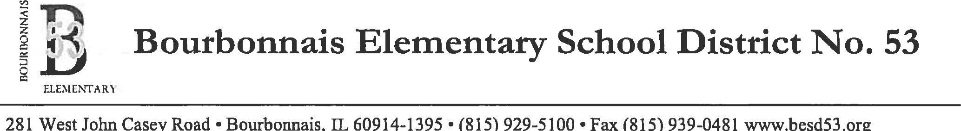
•
•
Dr. Adam Ehrman
Superintendent of Schools

Parental Authorization Form — Return Travel from Extracurricular and Co-Curricular Activities
I, the parent or guardian of ______________________________hereby authorize the persons listed below to transport my son or daughter home after the following extracurricular or co-curricular activity at which my son or daughter has participated on behalf of the Bourbonnais Elementary School District. In granting this authorization to these listed persons, I hereby release the Bourbonnais Elementary School District from, and waive any claim against the School District for, any and all liability or causes of action related to, or arising out of, my son or daughter's transportation from an extracurricular or co-curricular activity with one of the listed persons. I further understand that this list may only be revised upon my written authorization.
Activity (List only one):
The following adults may transport my son or daughter home after the above-listed School District extracurricular or co-curricular activity:
Name: ______________________________________________Relationship: ______________________________
Address and Phone: ____________________________________________________________________________

Name: ______________________________________________ Relationship: ______________________________
Address and Phone: ____________________________________________________________________________

Name: ______________________________________________ Relationship: ______________________________
Address and Phone: ____________________________________________________________________________

Name: ______________________________________________ Relationship: ______________________________
Address and Phone: ____________________________________________________________________________

Name: ______________________________________________ Relationship: ______________________________
Address and Phone: ____________________________________________________________________________

Parent or Guardian Signature Date
Form 7:240-E1
08/24/2004

The mission of Bourbonnais School District #53 is to:
Collaborate with staff, students, families, and community;
Provide a safe learning environment with innovative instructional practices; and
Inspire all students to reach their unique potential as globally conscious learners.

