Plastic hinge length requirements in reinforced concrete couple shear wall buildings for seismic reinforcement detailing
Hossain, Sk Amjad¹, Bagchi, Ashutosh²
¹ Ph.D. Candidate, Building, Civil and Environmental Engineering Department, Concordia University, Montreal, Quebec, Canada and Lecturer, Department of Civil Engineering and Construction Managements, The University of Texas, Tyler (Houston Engineering Center), Houston, TX USA
² Professor and Chair, Department of Building, Civil and Environmental Engineering, Concordia University, Montreal, Quebec, Canada
Email : shossain@uttyler.edu, Ashutosh.Bagchi@concordia.ca

ABSTRACT: Proper reinforcement detailing in plastic hinge regions is one of the important measures that could help damage control of structural walls subjected to any severe earthquake event. Inelastic curvatures are commonly assumed to be uniform over a height called plastic hinge length. Non-linear dynamic analyses are performed on a set of coupled shear wall buildings of simple configurations for different heights. Inelastic curvatures are calculated on numerous heights of all the buildings and plotted along with the height of the buildings. Plastic hinge lengths are estimated with the yield curvatures from analytical results. It becomes a common practice to estimate the plastic hinge length equal to 0.5 to 1.0 times the wall length, which basically were developed from experimental studies on beam and column elements. As per the Canadian standards CSA A23.3-04, the requirements to calculate plastic hinge lengths are identical for both cantilever and coupled shear walls, i.e., 1.5 times the wall length in the direction under consideration. Results from the present study show that inelastic curvatures are not uniform over the plastic hinge length and the Canadian requirement to calculate plastic hinge length is unconservative for couple shear walls and more critical for slender coupled shear walls. A new multiplication factor is proposed for the safe estimation of plastic hinge length for couple shear walls of medium and high rise reinforced concrete buildings. Results indicate that it needs to consider 2.0 times wall length instead of 1.5 times wall length in the direction under consideration for the safe estimation of coupled shear wall plastic hinge length calculations.
KEY WORDS: Reinforced Concrete, Buildings, Couple Shear wall, Non-linear Dynamic analysis, Plastic Hinge, Seismic design, Inelastic Curvatures, Damage control.

introductions
In seismic design of concrete shear wall, the design philosophy is to ensure the flexural displacement capacity is greater than flexural displacement demand. The inelastic portion of the flexural displacement demand developed from the inelastic displacement curvatures in the bottom potion of the wall is considered in single plastic hinge design philosophy. For simplicity, the inelastic curvatures are usually assumed to be uniform over a height and this height is called plastic hinge length of the wall. It has been found by different researcher through experimental and analytical results that at the bottom portion of the walls, the inelastic curvatures are not uniform and vary linearly. And properly damage control of structural walls subjected to any severe earthquake depends on proper detailing of this plastic hinge zone of cantilever and couple shear walls. The coupled shear wall system is one of the effective potential options in comparison with other moment resisting frame (MRF) and shear wall combination system in earthquake resisting building design. Moment resisting frame and shear wall combination systems are governed by both shear and flexural behavior; whereas, the couple shear wall combination systems is usually governed by flexural behavior. And, the behavior of conventional beam in MRF and shear wall combination systems is governed by flexural capacity and the behavior of coupling beams in couple shear wall system is usually controlled by shear capacity. The energy dissipation happens through both inelastic yielding in beams and columns for MRF and shear wall frame combination systems; whereas energy dissipation happens through inelastic yielding in coupling beams and base of the wall in coupled shear wall systems during the earthquake. Hence, the amount of earthquake energy dissipation and ductility obtained from moment resisting frame (MRF) and shear wall frame systems is less than that of coupled shear wall combination systems.
A common practice is to assume that the plastic hinge length of a cantilever shear wall varies from 0.5 to times the larger horizontal dimension of wall length. But this was established basically on beam test results, Paulay, T. (1986) and Wallace et al. (1992).
2. RESEARCH SIGNIFICANT
It becomes a common practice to assume the inelastic curvatures at the base of cantilever wall constant throughout a height. But practically this plastic hinge length is not uniform throughout the height. Analytical studies done on plastic hinge length by different researcher and found that it depends on wall length, height, axial force etc. ACI 318 2005 assume the plastic hinge length is equal to half of the length of the wall to determine the confining requirements at the end of the wall. According to CSA A23.3 2004 standards the requirements for estimating plastic hinge length are identical for Cantilever and Couple shear wall. But the structural behavior should not be same or not even closer for Cantilever and Couple shear wall.
Another important observation that most of the previous worked done on individual wall member, very less amount of work done on the effect of concrete wall systems on plastic hinge length. And, it is still not very clear the parameters that effect mostly for accurate prediction of plastic hinge length calculations in concrete shear wall buildings including couple shear wall buildings.

3 OBJECTIVES
The objectives of this study to investigate parameters that affect the plastic hinge length of couple shear walls, using non-linear dynamic analysis. The analysis was performed using computer software SeismoStruct 2000. It was modelled 08 storey, 12 storey, and 16 storey buildings of similar geometry with different heights. Dynamic time history analyses are to be performed with Seismostruct and investigated the influencing parameters that effect on plastic hinge length calculation of couple shear wall. Mostly, the investigations are to be done on the influence of geometry of the wall, aspect ratio, geometry of coupling beams, depth span ratio of coupling beams, and the axial force.
4 METHODOLOGY
A set of buildings with a simple configurations and different heights are modeled in SeismoStruct. The seismic design parameters are considered for Vancouver location. It has been considered real seismic ground motions those are taken from PEER (Pacific Earthquake Research Institute). The selection of ground motion considers the ratio of peak acceleration (A) to peak velocity (V) close to 1, which represents the seismicity of Vancouver. Three reinforced concrete buildings with couple shear walls as a seismic force resisting systems of 08, 12, and 16 stories heights and 3 bays by 3 bays are modeled and performed analysis with SeismoStruct. The buildings are of heights equal to 30.4, 45.0, and 59.6 m respectively covering limits of the applicability of the ESL methods as permitted by NBCC 2015. The design live load is equal to 2.4 kN/m² for all floors except the first storey which is 4.8 kN/m². The snow load is calculated to be 2.3 kN/m². The dead load is 0.85 kPa exterior walls, 1.0kPa for partition on floors, 0.5 kPa for ceiling and mechanical services for all floors and 0.5 kPa for roofing. The walls are considered ductile partially couple shear walls (NBCC-2015) with R_{d}=3.5 and R_{o}=1.6 for the lateral force resisting systems, where R_{o} and R_{d} are overstrength and ductility factors respectively.
Those buildings (08, 12, and 16 storey) are modeled in SeismoStruct having a plan dimension 21 m x21 m. The thickness of the couple shear wall are 400 mm, 650 mm, and 650 mm for 08, 12, and 16 storey respectively. The wall thickness, the dimension of coupling beams is considered as per the minimum requirements of CSA A23.3-04. The longitudinal, transverse reinforcements in main couple shear walls and the diagonal reinforcements in coupling beams are also provided as per the code (CSA-A23.3-04) requirements. In Seismostruct the concrete is modeled with Mander et. al. non-linear concrete model and reinforcements are modeled with Menegotto Pinto steel model. Dynamic time History analyses are performed with different wall length (L_{w}) 2 m, 2.5 m, and 3 m and design parameters for those buildings 08, 12, and 16 stories height. Inelastic curvatures variation along the height of the buildings are plotted and plastic hinge lengths (L_{p}) are calculated. It has been shown the curvature distribution along the height of wall for one typical 12 storey and 16 storey building only in Figure 1 and Figure 2, due to page limitation.
Total 79 numbers couple shear walls are analyzed with different aspect ratio, wall length, compressive loads, and coupling beam (d/L) ratios, due to limitation of page numbers a small portion of datas are provided in Table 2 and Table 3.

5 YIELD CURVATURE
In this research yield curvatures are calculated based on Priestley et. al (2007), Montes and Aschleim (2003) and Eurocode (ϕ_{y}=f_{y}/[E_{s}(1-ϵ_{y}) d]) considering steel yielding, where fy= yield strength, E_{s}=Modulus of Elasticity, ϵ_{y}= yield strain and d=depth of the section.
The calculated yield curvatures are mentioned in Table 1 and are used to calculate the plastic hinge length (L_{p}) from the analysis results.
TABLE 1.
Methods of calculation | Yield Curvature
Priestley et. al (1996 and 2007) | 0.002 for 2.0m width, 0.0018 for 2.5m width,0.0015 for 3.0m width
Montes and Aschleim (2003) | 0.002 for 2.0m width, 0.0019 for 2.5 m width, 0.0016 for 3.0m width
Eurocodes | 0.000879 for 2.0m width, 0.000704 for 2.5m width, 0.00586 for 3.0m width

6. ANALYSES RESULTS
Inelastic curvatures are calculated on numerous heights of all the buildings (08, 12, and 16 stories buildings), those are plotted along the height of the couple shear walls. As mentioned earlier, total 79 walls and analyzed and due to page limitations only 03 walls out of 79 walls are shown in Table 2 and Table 3.
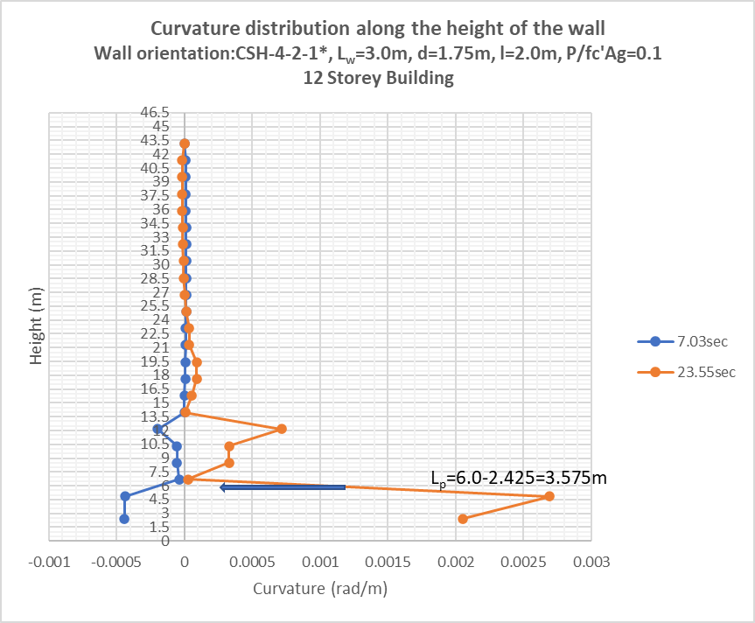
Figure 1. Curvature distribution along the height of the wall, CSH-4-2-1*, Lw=3.0 m, d=1.75 m, P/fc’Ag=0.1, 12 Storey

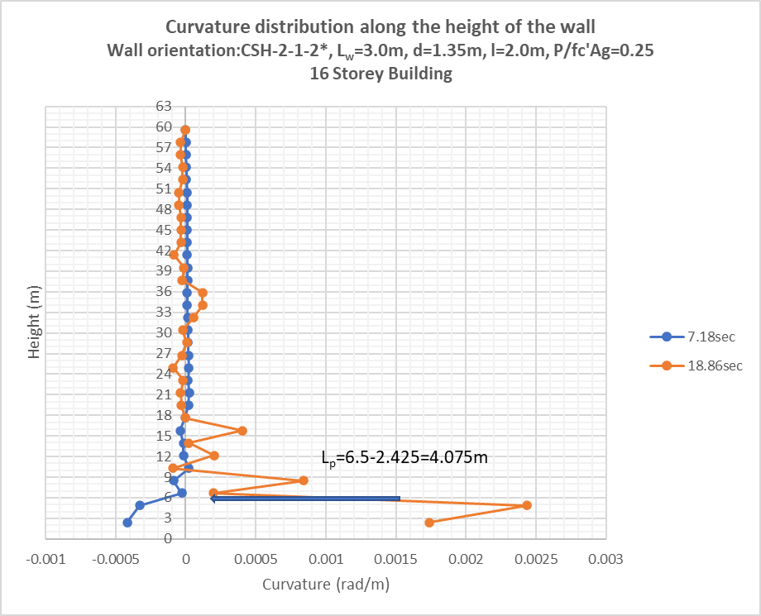
Figure 2. Curvature distribution along the height of the wall, CSH-2-1-2*, Lw=3.0 m, d=1.35m, P/fc’Ag=0.25, 16 Storey

TABLE 2. Wall Parameters
Wall Parameters
 | CSH-4-2-1* | CSH-2-1-2* | CSH-4-2-1*
L_{w} (m) | 2.5 | 2.0 | 3.0
h_{w} (m) | 45 | 45 | 45
SL Ratio | 18 | 22.5 | 15
P/fc’Ag | 0.188 | 0.188 | 0.075
d (m) | 1.6 | 1.8 | 1.6
L (m) | 2.0 | 2.0 | 2.0
d/L Ratio | 0.8 | 0.9 | 0.8

TABLE 3. Analysis results using wall parameters mentioned at Table 2. (Results of 03 walls out of 97 walls)
 | Non-linear Dynamic Analysis |  | CSA-A23.3-04
 | L_{p} (m) | L_{p} in terms of L_{w} | L_{p} =1.5* L_{w}
CSH-4-2-1* | 4.325 | 1.73 | 3.75
CSH-2-1-2* | 4.075 | 2.03 | 3.0
CSH-4-2-1* | 8.075 | 2.69 | 4.5

7 DISCUSSIONS
The present study focuses on estimation of plastic hinge length for couple shear wall. Couple shear wall is one of the effective seismic forces resisting system that have been using all over the World for medium and high-rise buildings. Seismic reinforcement detailing over the hinge regions depends on accurate estimation of plastic hinge length. According to CSA-A23.3-04, the couple shear wall falls under the clause article 21.6.8 and are noted that for those walls, the height of the plastic hinge length shall be taken at least 1.5 times the longest individual element in the direction under consideration.
In general, it is a common practice to assume that the maximum inelastic curvature in a cantilever shear wall is uniform over the plastic hinge length and can be taken from 0.5 to 1.0 times the wall length (L_{w}) for safe estimation. But those estimation formulas are taken basically experimental studies done on beam or column members, Paulay, T. (1986) and Wallace et al. (1992). The structural behavior of shear wall, specifically couple shear wall cannot be even close to the column member actions. As mentioned earlier also, in Canadian code (CSA-A23.3-04), the requirements of plastic hinge length for cantilever shear wall and couple shear wall (clause 21.6.8) are same, i.e., 1.5 times the wall length (L_{w}). But structural action of cantilever wall and couple shear wall are different.
Dynamic time history analyses are done for total 79 numbers different walls having different wall aspect ratio, compressive loads, and different aspect ratio of coupling beams. It needs to be noted that CSH 2-1-2*, CSH-4-2-1*, and CSH-4-2-2* are the bottom level elements of the Couple shear wall of different buildings (08, 12, and 16 stories) along the direction of the earthquake loading is applied.
The maximum deflections are checked at the top the buildings to ensure maximum inelastic rotational demand is less than the maximum rotational capacity and to make sure ductility at the plastic hinge locations. As per CSA-A23.3-04 (clause 21.6.7.2), the inelastic rotation demands are calculated and found within the capacity of inelastic rotational capacity (clause 21.6.7.3). Those are summarized in below Table 4.
Table 4. Max deflection at top of the buildings and inelastic rotational demand and capacity
Building description | Max Deflection at top (mm) | Inelastic Rotational demand | Inelastic rotational capacity
08 storey building | 126 | 0.023 | 0.025
16 storey building | 213 | 0.02 | 0.025
The maximum inelastic rotational demand of coupling beams as per CSA A23.3-04 (clause 21.6.8.4) are calculated also and found within the inelastic rotational capacity, those are summarized in below Table 5.

Table 5. Inelastic rotational demand and capacity of coupling beams
Building description | Wall length (m) | Inelastic rotational demand | Inelastic rotational capacity with diagonal reinforcements
08 storey building | 2 | 0.04 | 0.04
16 storey building | 2.5 | 0.04 | 0.04

The findings from the present studies are:
(1) The maximum inelastic curvatures are not uniform over the plastic hinge length.
(2) The plastic hinge length calculation as per Canadian code (CSA-A23.3-04) for couple shear wall (clause 21.6.8), i.e., 1.5 times the wall length (Lw) is not conservative and underestimation for couple shear wall seismic reinforcement detailing and more critical for slender couple shear walls.
(3) The plastic hinge length for couple shear wall calculation also mostly depends on wall length.
(4) Not significant impacts are found on axial load effect.
(5) Minor effects are noted based on (d/L) ratio of coupling beam.
(6) An expression is proposed for more accurate estimation of plastic hinge length for couple shear wall, with a multiplication factor of 2.0 instead of 1.5 for wall length (L_{w}). Hence, for couple shear wall calculation, the proposed equation shall be 2.0 times the wall length in the direction under consideration.
(7) Similar observations in estimation of inelastic curvature are observed in experimental studies done by Adebar et. al. 2004 (Figure 3) and author’s findings (Figure 4).

8 COMPARISONS OF RESULTS

The author’s findings are compared with one of the experimental studies done by Adebar et. al. 2004; In this figure the curvatures of the wall were measured at numerous locations of the wall experimentally and plotted (rad/km), (Figure 3, Adebar et. al. 2004); Consequently, curvatures are calculated analytically (author’s findings) at numerous points over the height and plotted (rad/km) for 12 storey buildings (Figure 4); The curvature at the 5m height from the experimental results (Adebar et. al. 2004) is approximately 1.5 rad/km and the curvature at level 05 m from analytical results (author’s findings) is approximately 1.6 rad/km, which is very close.

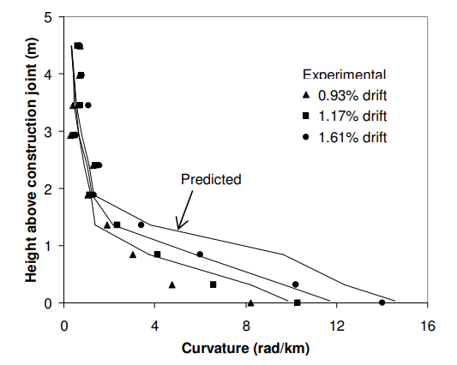
Figure 3. Calibration of analytical model: Comparison with results from a large-scale test (Adebar et. al. 2004)

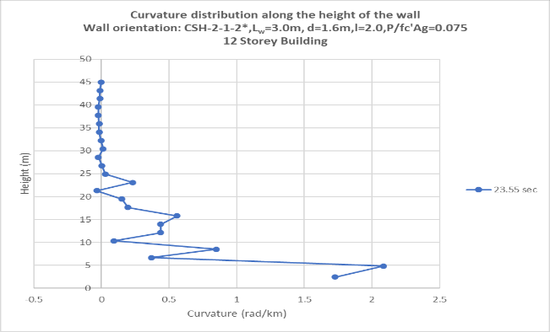
Figure 4. Curvature distribution along the height of the wall, Lw=3.0m, d=1.6 m, P/fc’Ag=0.075, 12 storey wall
9 CONCLUSIONS
Hence, it can be commented that using the proposed multiplication factor to calculate the plastic hinge length calculation shall cover the safe estimation of plastic hinge length calculations and that is very important for seismic reinforcement detailing in cantilever and couple shear walls. In this research buildings with couple shear walls seismic force resisting systems are modeled with simple configurations and distribution of main reinforcements are considered uniform. But in real industry practice the gradual variation of reinforcement are considered due to gradual reduction of bending moment capacity along the height of the walls. The reduction of reinforcements can results further spreading the plasticity in critical regions. That phenomenon can be considered in future research.

References
- The design of ductile reinforced concrete structural walls for earthquake resistance. Paulay, T., Earthquake spectra, V. 2, No. 4, 1986, pp. 783-823.
- Ductility and detailing requirements of Bearing wall Buildings. Wallace, J.W., and Moehle, J.P., Journal of Structural Engineering, ASCE, V.118, No. 6. 1992, pp. 1625-1644.
- Plastic hinge length in high-rise concrete shear walls. M.A.Sc thesis by Alfredo Guillermo Bohl Arbulu, 2006;
- Plastic hinge lengths in high-rise concrete shear walls. Alfredo Bohl and Perry Adebar, ACI Structural Journal. 2011;
- Design of Concrete Structures, CSA A23.3-04;
- Yield curvature for seismic design of circular reinforced concrete columns. M. Neaz Sheikh et. al., Magazine of Concrete Research, 2010, 62, No. 10, October, 741-748;
- Estimation of Yield Curvature for Direct Displacement-based Seismic Design of RC Columns. M. Neaz Sheikh, Hing-Ho Tsang and Nelson T. K. Lam.
- A conceptual design approach of couple shear walls. Dipendu Bhunia, Vipul Prakash, and Ashok D. Pandey, 2013.

