Application of Laser Scanning to Capture Geospatial Information in Soil-Structure Interaction Studies of Instrumented Structures with Geotechnical Arrays
Shakhzod Takhirov¹, Sagynbek Orunbaev², Marco Pilz³, Raiymkul Mendekeev² and Ravshan Shamansurov⁴
¹Department of Civil and Environmental Engineering, University of California, Berkeley, 337 Davis Hall, Berkeley, Berkeley, California 94720, USA
²Scientific-Research Institute of Seismic Construction, State University of Constructions, Transport, and Architecture, Bishkek, Kyrgyzstan
³Helmholtz Center Potsdam – German Research Center for Geosciences, Helmholtzstr. 7, 14467 Potsdam, Germany.
⁴Sigma Innovative Tech, Tashkent, Uzbekistan
Email : takhirov@berkeley.edu, s.orunbaev@gmail.com, pilz@gfz-potsdam.de, shamansurov@rambler.ru

ABSTRACT: Investigating soil-structure interaction problems require an extensive amount of information including material properties of the soil, relief of the ground surface, and locations of buildings, to name a few. Geospatial information is especially invaluable when there is a correlation to the actual performance of the buildings under measured excitations from nearby bore holes. This paper demonstrates an approach to addressing this problem of collecting geospatial data via the utilization of a laser scanner. A terrestrial laser scanner was used to collect the above ground geometry of instrumented structures studied together with a geotechnical array. The spatial locations of the array, the surrounding structures, and the relief features of the ground surface are captured by the laser scanner. The latter information is very important when the ground surface has a large slope or there are large deviations of the ground surface from the horizontal or even sloped surface. The advantages of this approach for structural health monitoring are discussed in a few examples and is scheduled to be utilized for a system in Kyrgyzstan consisting of a geotechnical array and a few instrumented buildings. Major features of the latter system are discussed in this paper.
.
KEY WORDS: Soil-structure interaction; Structural Health Monitoring; Geotechnical array; Instrumented above ground and underground structures; Laser scanning.

Introduction
Investigating soil-structure interaction problems require an extensive amount of information including material properties the of soil, relief of the ground surface, and locations of buildings, to name a few. Geospatial information is especially invaluable when there is a correlation to the actual performance of the buildings under measured excitations from nearby bore holes. This paper demonstrates an approach to addressing this problem of collecting the geospatial data via the utilization of a laser scanner. A terrestrial laser scanner was used in this paper to collect the above ground geometry of instrumented structures studied together with a geotechnical array. The spatial locations of the array, the surrounding structures, and the relief features of the ground surface are captured by the laser scanner. The latter information is very important when the ground surface has a large slope or there are large deviations of the ground surface from the horizontal or even sloped surface.

Application of Laser Scanning to SSI OF BRIDGE Structures

Bridge on Highway 37 in Napa, California
In 2012, a bridge on Highway 37 over the Napa River in California (USA) was extensively instrumented [1]. In addition to the sensors installed on the bridge itself, a geotechnical array of the strong motion instruments was introduced. This instrumentation resulted in a monitoring system (CGS - CSMIP Station 68310) combining the instrumented structure with the geotechnical array that enables the study of a soil-structure interaction of this system. This system is shown in Figure 1 (adapted from [1]).
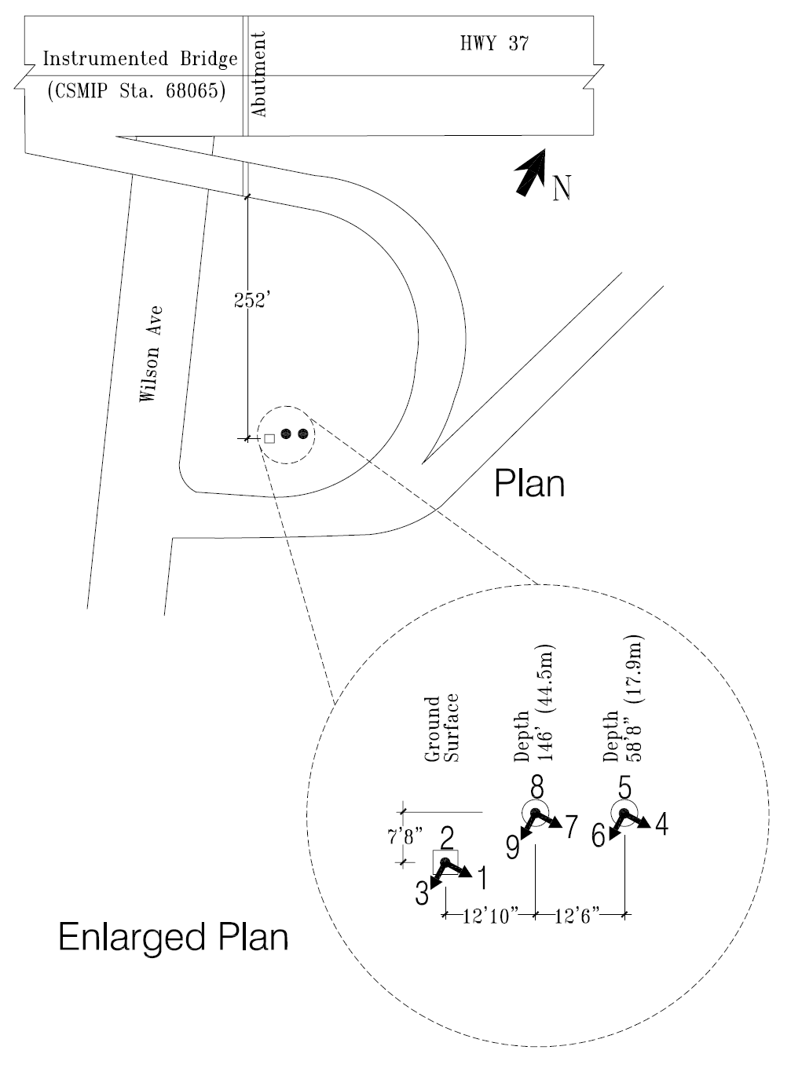
Figure 1. CGS - CSMIP Station 68310 [1].

Laser Scanning in Vicinity of Station 68310
The structural assessment of this bridge was conducted by laser scanning right after the 2014 Napa earthquake [2]. The main goal of this assessment project was to complement the accelerometer data with the measurements of residual displacements captured by the laser scanner. It is well-known that double integration does not lead to a reliable estimate of the residual displacements especially when plastic deformation occurs [3]. Therefore, the residual displacements need to be obtained by other means. For this reason, the laser scanner was deployed in that project as presented in Figure 2 [2]. A terrestrial laser scanner C10 from Leica Geosystems [4] was used for this purpose. The latter study ([2]) was limited to investigation of the bridge’s residual deformation, with the intent to be expanded to the problem of the soil-structure interaction (SSI). During this structural damage assessment, the following geospatial data was captured: (1) the geometry of the ground surface and (2) geospatial locations of the bridge piers in respect to the top of the borehole with the underground instrumentation.

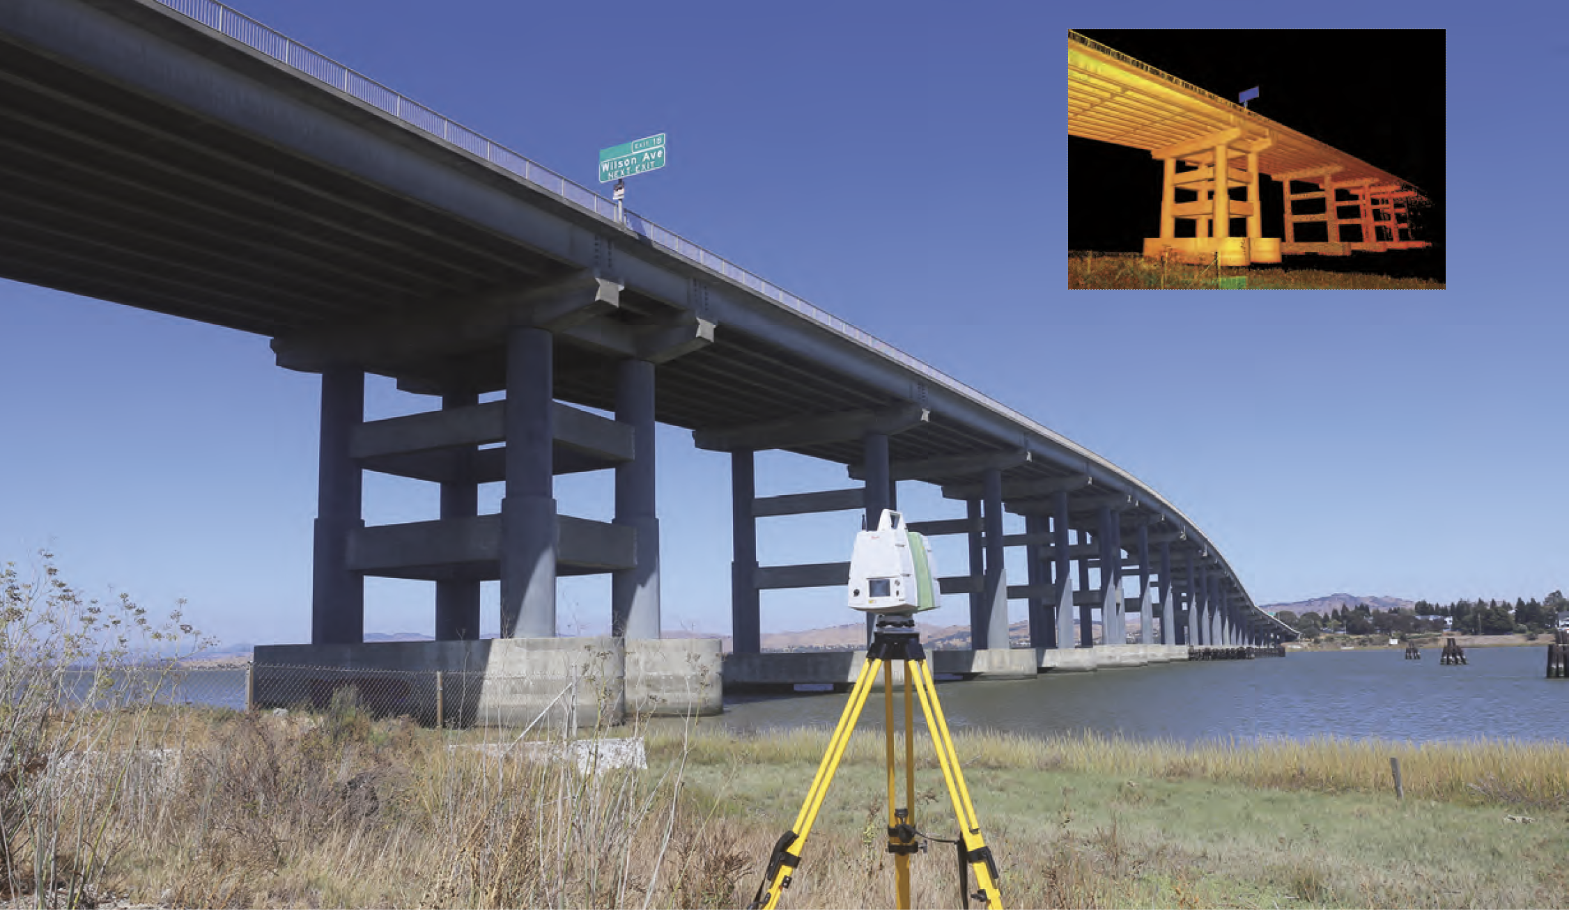
Figure 2. Laser scanning in vicinity of CGS - CSMIP Station 68310.
The site near this bridge has a relatively flat surface. Therefore, the next section discusses the application of laser scanning to a ground surface with a large slope.

Laser scanning of Sloped Ground Surface
Laser scanning of a ground surface with a large slope was conducted earlier [5]. It was conducted in the residential area of the town of Moraga (California, USA). The scanning was conducted to evaluate the proximity of high-voltage power lines to nearby vegetation. The results related to the capturing of the ground surface are discussed herein. A typical result showing a horizontal cross section of a street with a large slope is shown in Figure 3.
A terrestrial laser scanner from Trimble was used in this study [6].

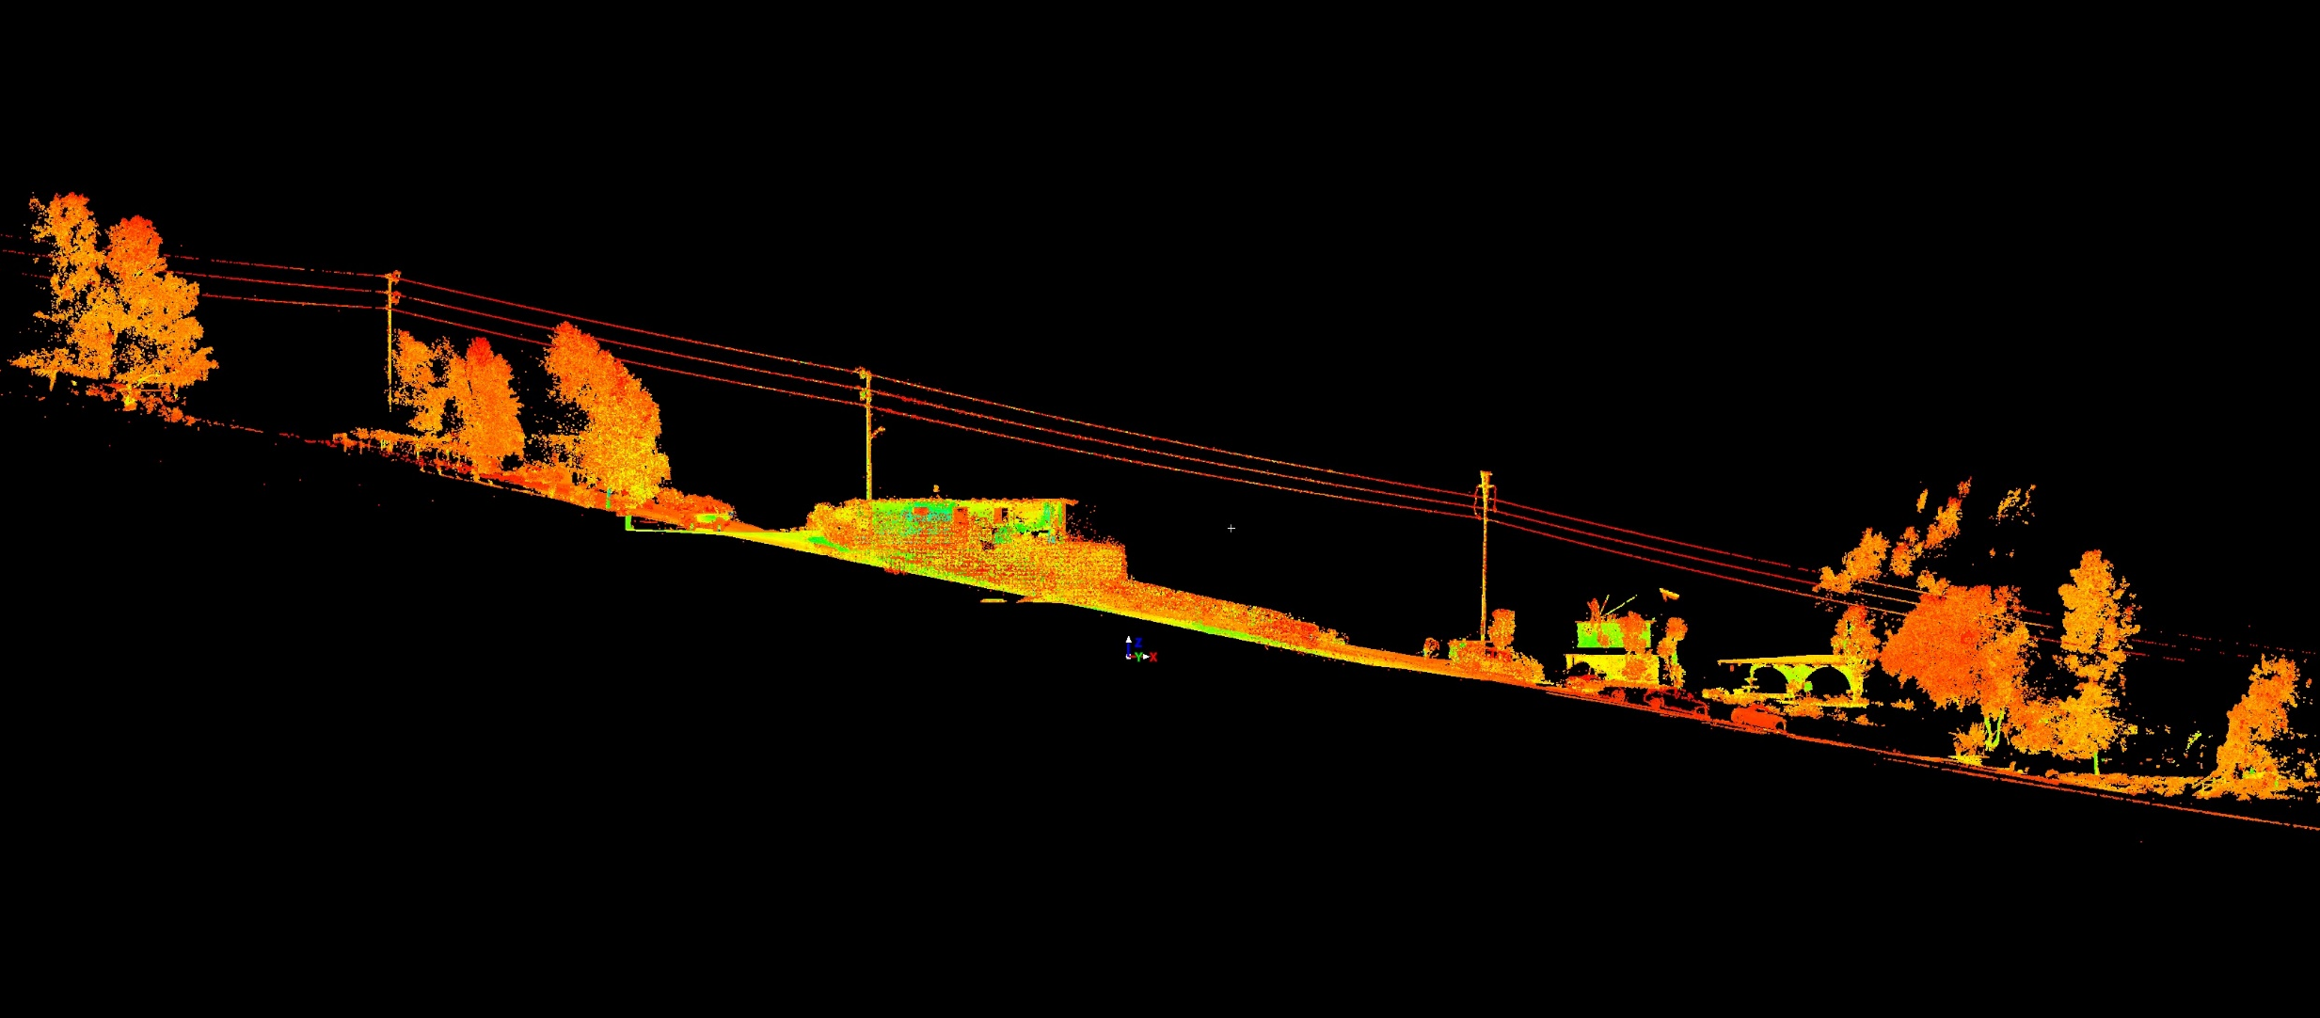
Figure 3. Laser scan of a site with a large slope.
The previous two examples show applications of two different terrestrial laser scanners for collection of geospatial information. The same geospatial information can be captured by a drone, which also can produce a point cloud with an accuracy comparable to that of the terrestrial laser scanner [7].
Figure 4 shows a point cloud of a bridge over a narrow passage. A similar point cloud of the same bridge over the narrow passage collected by a drone is presented in Figure 5.

Figure 4. Laser scan of a bridge over narrow passage (terrestrial laser scanner data) [7].
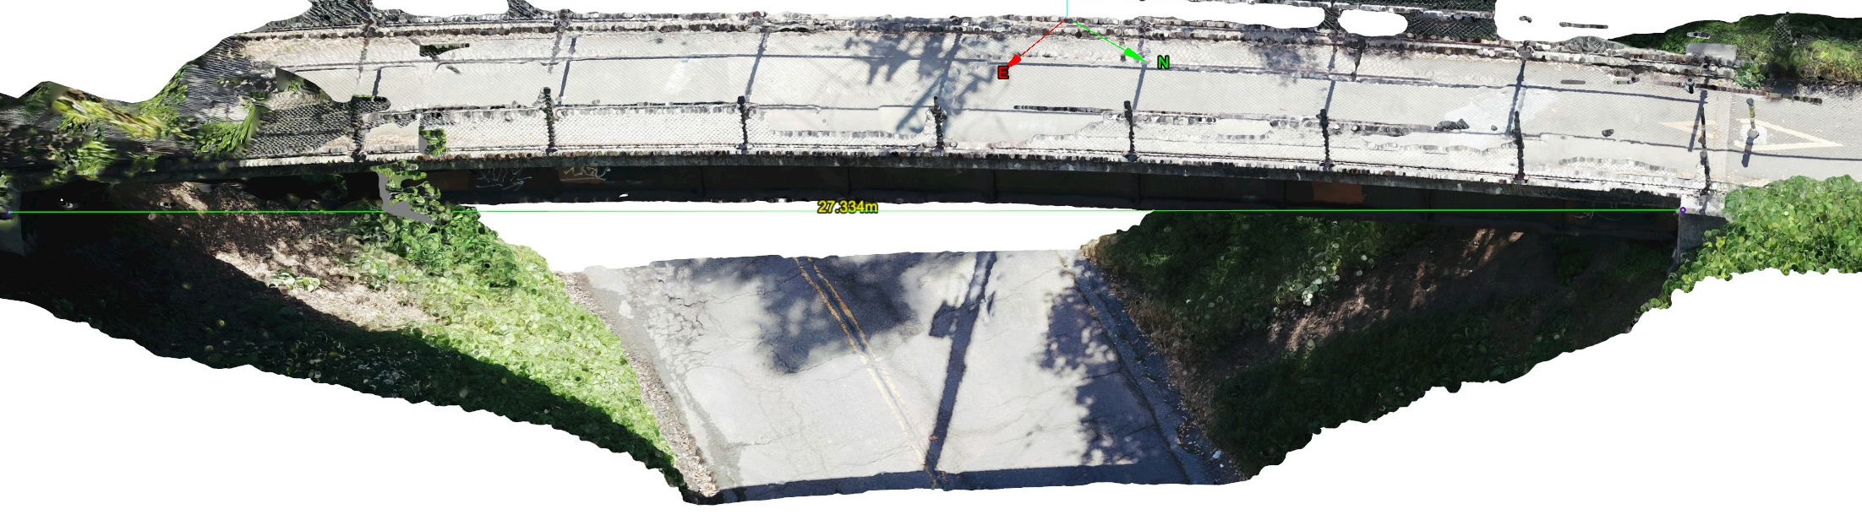
Figure 5. Point cloud collected by a drone [7].

Laser scanning of Underground Tunnels for Inclusion in SSI
The presence of large underground voids can affect wave dynamics in a significant way and as such, knowing their spatial location is essential for SSI problems.
Laser scanning examples of underground tunnels are quite common and an extensive review is discussed in [8]. One representative example is discussed in this paper. An underground tunnel system on the campus of the University of California, Berkeley was laser scanned for assessment and upgrades. The geospatial location of the inner walls of the tunnel was captured as presented in Figure 6. The thickness of the wall was obtained from blueprints and/or by other means. A point cloud of the above ground structures was stitched together with that of the underground tunnel.

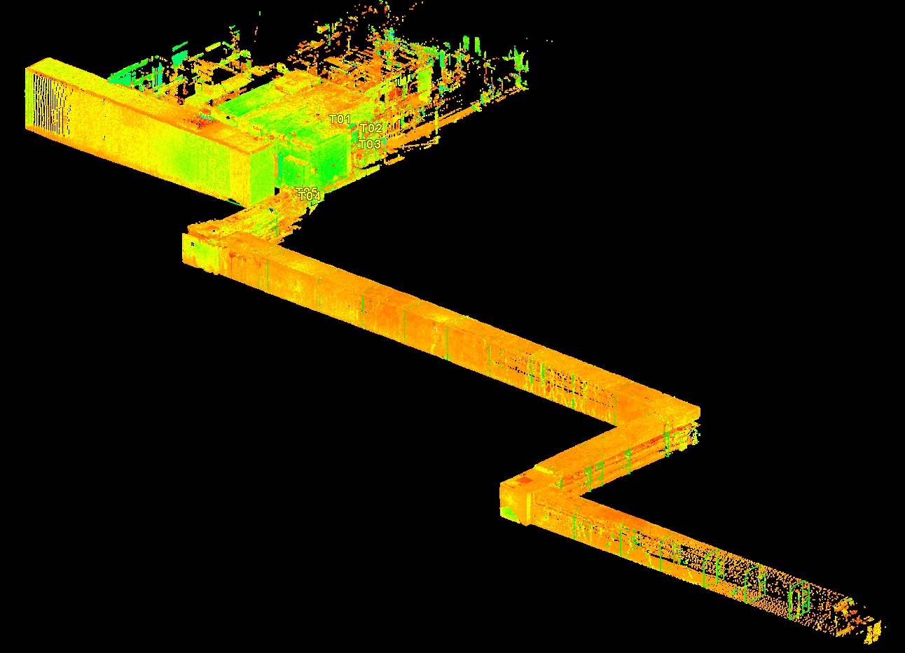
Figure 6. Point cloud of underground tunnel system combined with above ground structures.
Both refraction and diffraction of seismic waves from the wall of the tunnels will occur and this interaction will potentially increase or reduce their impact on the nearby structures (see [9], as an example). For obvious reasons, this interaction will depend on the geospatial location of the above ground and underground structures combined into a single point cloud by laser scanning.

Newly Established Site Aimed at Soil-Structure Interaction
A special monitoring station was established recently in Kyrgyzstan. To measure shaking of the ground and buildings and their interaction during significant earthquakes, four boreholes with a depth of 50 m were drilled in the vicinity of three buildings. In these four boreholes, sixteen accelerometers were installed at different depths, namely 0m, 15m, 30m and 50m to register ground movements. As presented in Figure 7, three nearby buildings were also instrumented. Fifteen accelerometers were installed on different floors to register the shaking of the buildings. The instrumentation details for Building 1 are presented in Figure 8. The respective details for Building 2 and Building 3 are shown in Figure 9.

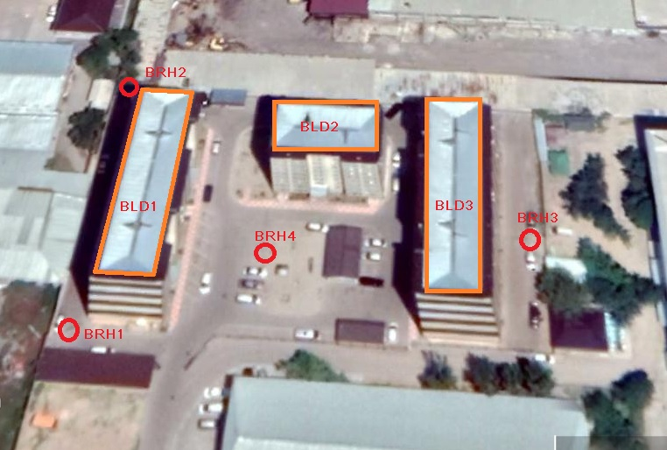
Figure 7. Plan view of instrumented buildings and boreholes.
By the end of 2019, all installation work and Internet data connection was completed. Currently, the system works in test mode and the received data is being processed to verify the ground-building sensors.
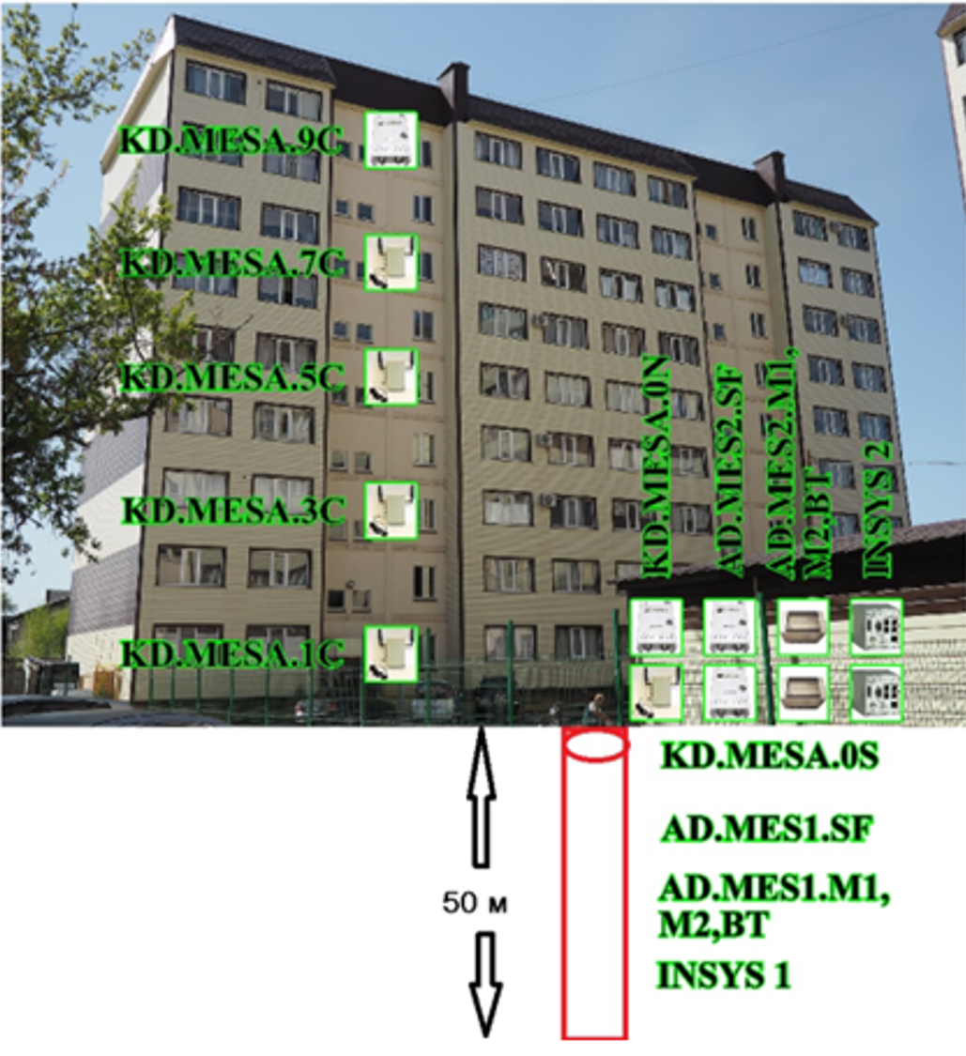
Figure 8. Instrumentation for Building 1 (boreholes are shown as red cylinders).
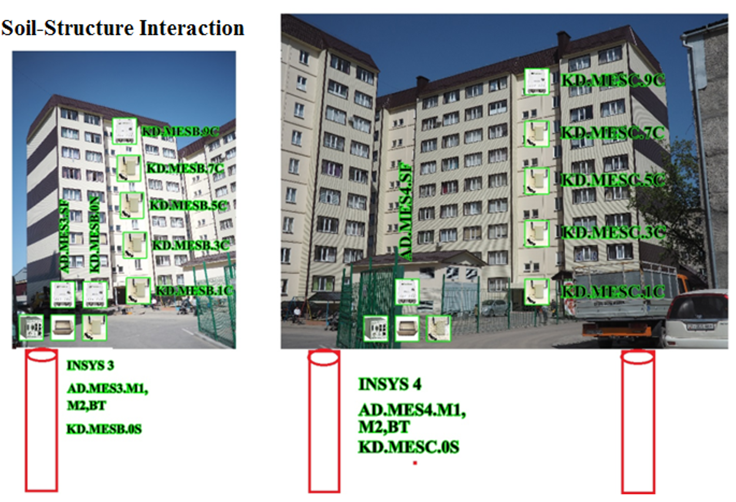
Figure 9. Instrumentation for Building 2 (left) and 3 (right) (boreholes are shown as red cylinders).

The last installation was finished in Spring 2020. Also, in 2021 a testing and optimization phase was carried out in these networks.
In the next phase of the project a terrestrial laser scanner is scheduled to be deployed and to be used for collecting geospatial information of the site. The geospatial data will be used to model the soil-structure interaction and its correlation to the actual response of buildings under measured excitation. The model will be used in the structural health monitoring of the buildings under future seismic impact.

ACKNOWLEDGMENTS
Sensor Fusion and Monitoring Technologies, LLC (California, USA) provided a scanner for laser scanning in the town of Moraga (California, USA), which is greatly appreciated. The point cloud of the Highway 37 Bridge was collected during operations of the nees@berkeley laboratory, the University of California–Berkeley (California, USA) that was funded by the National Science Foundation. Special thanks are due to Ms. Lola Takhirov of UC Berkeley, for her help with editing the paper.

References
- Strong Motion Center (2022). https://www.strongmotioncenter.org. https://www.strongmotioncenter.org/NCESMD/photos/CGS/splayouts/sp68310.pdf, last retrieved on 04/22/2022.
- S.M. Takhirov, A.Gilani, E. Fujisaki,P. Mo, K. Mannino and C. Ahrano. (2012). An Evaluation of Experimental Requirements for Seismic Qualification of Substation Components and Recommendations for New Edition of Test Standard’. Proceedings of 15th World Conference on Earthquake Engineering, September 24-28, 2012, Lisbon, Portugal.
- Mark Yashinsky, Shakhzod Takhirov, Khalid Mosalam, Tara Hutchinson and Falko Kuester (2014). “From a Distance: Inspection of Bridges in the aftermath of the South Napa Earthquake”, Bridge Design & Engineering Magazine, issue 77, pp.52-54.
- Leica Geosystems AG (2011). Leica ScanStation C10. http://w3.leica-geosystems.com/downloads123/hds/hds/ScanStation%20C10/brochures-datasheet/Leica_ScanStation_C10_DS_us.pdf.
- Shakhzod M. Takhirov and Mukhady Sh. Israilov (2020). "Reduction of Wildfire Hazard by Automated Monitoring of Vegetation Interference with Power Lines: Point Cloud Analysis Combined with Cable Mechanics". Journal of Civil Structural Health Monitoring. 10, pages 947–956.
- Trimble Inc. (2016). The Trimble TX6 laser scanner. http://trl.trimble.com/docushare/dsweb/Get/Document-824965/022516-282_TrimbleTX6_DS_US_1016_LR.pdf.
- Shakhzod Takhirov and Robert Kayen (2021). Point Clouds of Bridge Generated by Terrestrial Laser Scanner and Images via Structure from Motion Technique: Comparison Study. HORA-2021, the 3rd International Congress on Human-Computer Interaction, Optimization and Robotic Applications, June 11-13, 2021, Turkey.
- Weixing Wang, Weisen Zhao,Lingxiao Huang,Vivian Vimarlund,Zhiwei Wang (2014). Applications of terrestrial laser scanning for tunnels: a review. Journal of Traffic and Transportation Engineering. Volume 1, Issue 5, October 2014, Pages 325-337.
- Takhirov, S.M. and Rashidov, I.T. (1990). Motion of Two Strip System Due Diffraction of Non-Stationary Wave. Presentations of Uzbek Academy of Science, No 7, 1990 (in Russian).

