ABSTRACT: For the short and medium span bridges (10 – 120 m) it is span of a bridge, velocity of truck, smallest axle spacing of truck and natural frequencies of a bridge will determine the rate of sampling. In this paper the mathematical derivation is used to study the empirical observations and a simple formula is suggested to determine the sampling rate of monitoring a bridge.
Investigation of Sampling Rate to Monitor Bridges under Dynamic Truck Loads

Henry Ling¹, Karim Helmi² and Aftab Mufti³
¹208-5800 Cooney Road, Richmond, BC
²Construction and Building Engineering Department, Arab Academy for Science, Technology, and Maritime Transport,
Abu Qir, Alexandria, Egypt
³SIMTReC Research Group, University of Manitoba, Winnipeg, Manitoba, Canada, R3T 2N2
Email : henry.h.ling@gmail.com

KEY WORDS: sampling frequency; structural health monitoring: data acquisition.

introduction
When designing a continuous structural health monitoring system several decisions must be made, such as the types and locations of sensors, wiring scheme, data acquisition system and the sampling frequency [1,2.3].
A higher sampling frequency will give a better representation of the actual behavior of the bridge; however, it requires larger capacity for data storage, transmission, and handling. A higher sampling frequency may therefore limit the number of sensors installed if there is a limited capacity to store and handle data.
The sampling frequency should therefore be chosen to reduce the amount of data generated by the structural health monitoring system while being able to accurately capture the behavior of the structure being monitored.
This paper presents some observations and suggestions made by the authors on how the sampling rate should be chosen.

mathematical derivation of simulated signal
The forced vibration introduced due to moving loads causes the structure to vibrate at different frequencies. These vibrations are intense at high velocities. Truck loads are faster and heavier whereas modern bridges are built with slender and lighter materials. This increases the dynamic response of a bridge and needs a simple analysis of the problem.

A bridge is modeled as a simple beam, and the mathematical problem of finding an analytical solution for the dynamic deflection due to a concentrated point load moving at constant velocity $v$ was considered, as shown in Figure 1.

$$v$$

$$P$$

$$L_{b}$$

Figure 1: Simple beam subjected to concentrated moving load
The dynamic behaviour of the beam is described by the Euler-Bernoulli differential equation of motion. The beam has a constant cross section and mass per unit length and the velocity of load is constant, moving left to right. Damping effects are neglected. Shear deformations and rotational inertia is neglected due to small height to length ratio of the beam. The solution for the equation in terms of deflection is presented here:
$$w=\frac{2PL_{b}^{3}}{π^{4}EI}\sum_{k=1}^{∞}{\left(\frac{\sin\left(kΩt\right)-\frac{Ω}{kω}\sin\left(k^{2}ωt\right)}{k^{4}-\frac{k^{2}Ω^{2}}{ω^{2}}}\right)\sin\left(\frac{kπx}{L_{b}}\right) (1)}$$

$P$ is the load, $E$ is the elastic modulus, $I$ is the second moment of area, $L_{b}$ is the bridge length, $ω=2πf_{b}$ where $f_{b}$ is the bridge natural frequency, and $Ω=2πf_{t}$ where $f_{t}=v/(2L_{b})$ is the truck frequency.

Empirical Observations
The dynamic signal simulation of equation (1) using a $27.8 m$ long steel concrete Prototype Bridge under a moving point load moving at speeds ranging from $12 km/h$ to $111 km/h$and weighing $40$ tons was obtained using a computer program. The amplitude of the forced vibrations increases as the ratio $r= f_{t}/f_{b}$ increases, as shown in Fig 2. As the velocity decreases, the ratio $r$ tends towards $0$ and the dynamic response approaches the static response curve.

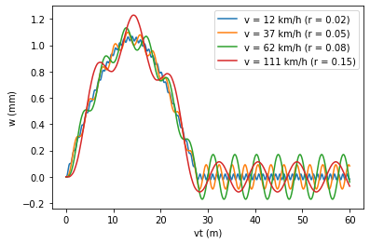
Figure 2: Dynamic response (in terms of deflection at mid-span) due to a point load moving with different velocities
The dynamic response due to a moving truck is modeled by treating each truck axle as a point load, and then superposing the dynamic responses of the individual axles. Deflections are converted to moments by taking the second derivative of the deflection function with respect to $x$. Integrating the area under the moment distance graph will yield the Gross Vehicle Weight of the passing truck. In real continuous monitoring systems, strains are recorded against time. Strains can be converted to moments for known cross sections.

In some cases, the shape of the signal will depend on the axle spacing. For example, this is illustrated in the static response limit by Figure 3, which shows the shear at the right support for a $28 m$ long bridge using CL 625 truck, and by Figure 4, which shows the bending moment resulting from a CL 625 truck for bridges with different spans. Figure 4 also shows that the shape of the signal may also depend on the speed of the truck and length of the bridge for short spans.

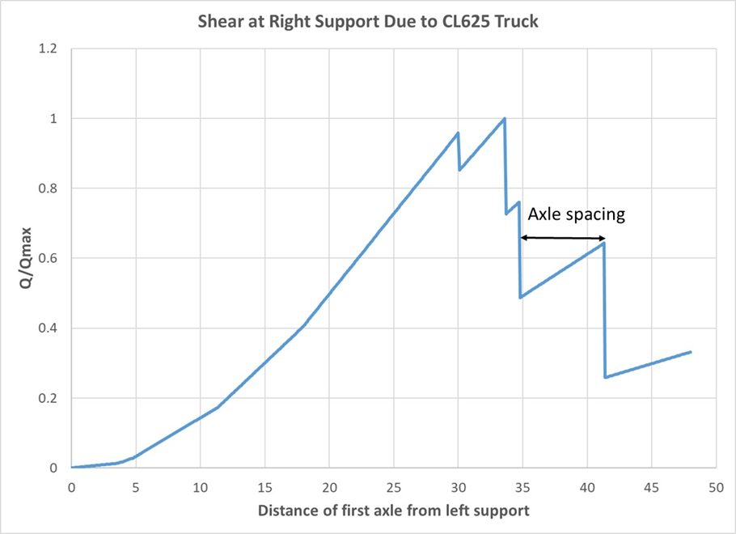

Figure 3: Effect of axle spacing on the shear at right support
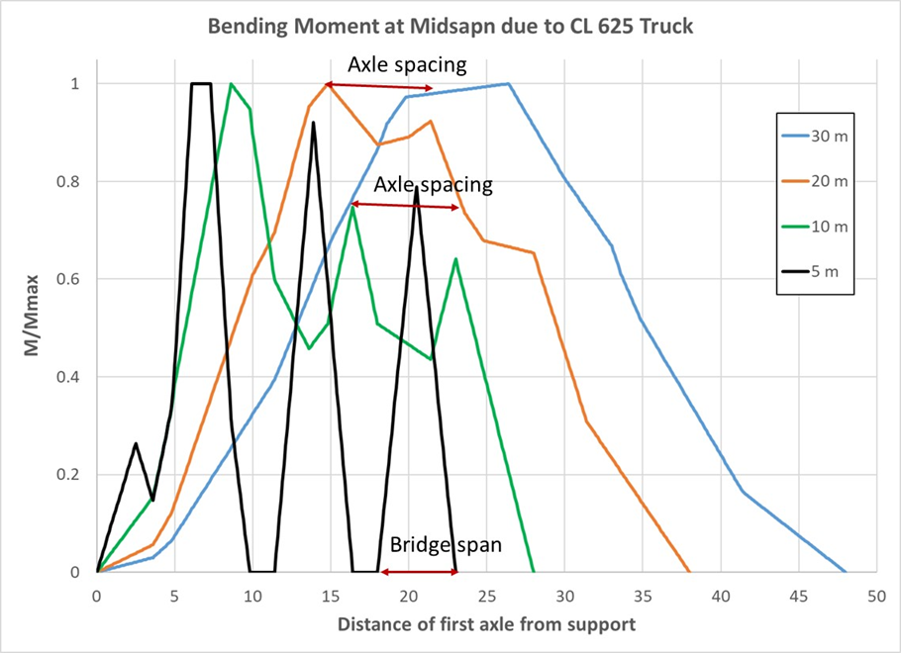
Figure 4: Effect of axle spacing on the moment at mid-span

effect of sampling rate on the signal
As an illustration of the effect of the sampling rate on the signal, consider the following simplified model for the strain signal due to a truck passing over a bridge: a damped driven harmonic oscillator with a natural frequency of $4 Hz$ and a driving force that acts for $1.5$ seconds (between $t=0.5$ and $t=2.0$). This represents a situation where the truck takes $1.5$ seconds to pass over the bridge, and the bridge natural frequency is $4 Hz$.

The signal generated if sampled at $12.5 Hz$ compared to the case of a sampling rate of $200 Hz$ is shown in Figure 5. The figure shows that while the general form of the signal is maintained it is slightly distorted and some of the maximum and minimum values of the signal are less than the ones taken at $200 Hz$.

If the sampling rate is reduced further to $5 Hz$, the shape of the signal generated will be completely distorted and will not represent the behavior of the bridge.

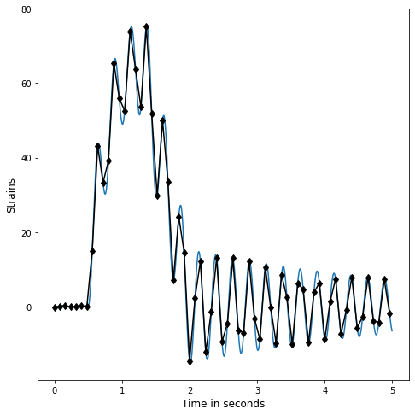
Figure 5: Signal if sampled at $12.5 Hz$ compared to $200 Hz$
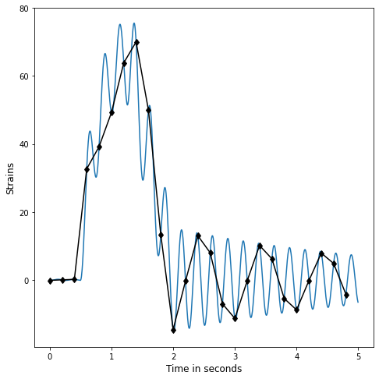
Figure 6: Signal if sampled at $5 Hz$ compared to $200 Hz$
To summarize, if sampling frequency is close to or less than the bridge natural frequency, then the resulting signal does not accurately capture the bridge natural oscillations. As the sampling frequency larger than $3$ times the bridge natural frequency, then natural oscillations of the bridge start to become clearly observable in the signal.

calculation of sampling frequency
Based on the previous sections it is expected that the shape of the signal will depend on the following

- The bridge natural frequency ($f_{b}$)
- The length of the bridge ($L_{b}$)
- The axle spacing ($L_{a}$)
- The velocity of the truck as it passes over the bridge ($v$)

The following formula is proposed for the sampling rate

$$Sampling rate=N/t_{min}$$

where $N$ is the number of points needed to represent the signal accurately, and $t_{min}$ is smallest time scale in the signal and is the least of

${1/f}_{b}$ the cycle time of the bridge natural frequency,
$L_{b}/v$ the time required for a single axle to cross the bridge,
$L_{a}/v$ the time required for two consecutive axles to cross the same point on the bridge.

Observations made in Figure 5 suggest that $N$ could be taken as $4$, however this is based on an ideal signal, in practice the signal will contain noise and vibrations from other sources which need to be filtered and therefore a higher sampling frequency may be required.
Additionally, for cases where abrupt changes in the signal may occur as in the case of measuring shear or reactions a higher sampling frequency may be needed to correctly capture the location of this abrupt change.
When determining the sampling rate some judgment should be made while considering the following

- The natural frequency of the bridge is the most important factor to be considered when choosing the sampling rate.
- The length of the bridge will only be significant for very short span bridges.
- For the case of axle groups like tandems and tridems, the axle spacing will be very small and will produce the largest sampling rates. However, for some cases like when measuring the strains resulting from beam flexure in relatively long bridges the axle spacing of the tandems and tridems will not have a significant effect on the overall signal shape as shown in Figure 4. However, it will be significant in other cases like when measuring the shear or support reaction as shown in Figure 3, especially if these measurements are used to determine truck information like axle numbers and spacings.

References
- G. T. Michaltsos and I. G. Raftoyiannis, Bridges’ Dynamics, Bentham Science Publishers Ltd., 2011
- Myra Lydon, S. E. Taylor, D. Robinson, A. Mufti, E. J. O. Brien, “Recent developments in bridge weigh in motion (B-WIM)”, J Civil Struct Health Monit., 6:69–81, 2016
- Helmi K, Bakht B, Mufti A, “Accurate measurements of gross vehicle weight through bridge weigh-in-motion: a case study”, J Civ Struct Heal Monit 4(3):195–208, 2014

