Study on the distribution law and influencing factors of indoor and outdoor inhomogeneous temperature field in large-span spatial structure
Wei Lu ¹, Xianwei Fang ¹, Jun Teng ¹, Weihua Hu¹
¹Department of Civil Engineering, Harbin Institute of Technology (Shenzhen), 518055, Shenzhen, China
email: lu.wei@hit.edu.cn, 20S154197@stu.hit.edu.cn, tengj@hit.edu.cn, huweihua@hit.edu.cn

ABSTRACT: The effect of temperature is very important in the design and construction of large-span spatial structures. Due to the influence of solar radiation, thermal properties of materials and environmental factors, the temperature field of structural surface is generally non-uniform. At the same time, because of the change of indoor ventilation conditions, the distribution of indoor temperature field also has a certain non-uniformity. When the two kinds of inhomogeneous temperature act together on the structure, the force and deformation of the structure will be greatly affected, and the safety of the structure will be threatened. In this paper, based on Phoenics software and taking Shenzhen Bay Stadium as the background, a simulation method of indoor and outdoor inhomogeneous temperature field considering material properties, solar radiation and environmental factors is proposed, and the influence law of solar radiation ambient temperature and wind speed on the structure of indoor and outdoor inhomogeneous temperature field are summarized. The simulation method proposed in this paper provides a theoretical basis for the study of indoor and outdoor temperature distribution of complex long-span structures in service.
KEY WORDS: Large span space structure, solar radiation, temperature field, Shenzhen Bay Stadium.

INTRODUCTION
There are more and more large-span space steel structure buildings in cities. This kind of building has the advantages of reasonable stress and reasonable structure form. However, due to its large size, under the influence of solar radiation and external environment, uneven temperature field will appear on the surface and inside of the structure, resulting in temperature effect. When the temperature is affected to a certain extent, the safety of the structure will be affected. With the wide application of long-span space structure in the world, the research on the indoor and outdoor uneven temperature field of long-span space steel structure has been paid more and more attention.
At present, most of the researches on structure temperature field are focused on outdoor temperature field, and most of them are about solar radiation. Scholars at home and abroad have proposed several models of solar radiation in clear sky which are suitable for different regions and climate characteristics[1-4]. For the study of indoor temperature field, Li[5] and Stamou[6] et al. used numerical simulation to study the thermal environment of buildings such as stadiums and gymnasiums, and the results showed that building height and air supply angle had a great influence on temperature distribution. Saberian[7] used Fluent to simulate the effects of dynamic solar heat loads on indoor temperatures. Garcia[8] studied the distribution of air temperature in a temperate greenhouse in Almeria, Spain, and the results showed that the distribution of air temperature was uneven in both horizontal and vertical directions. Teitle et al.[9] used CFD method to study the influence of outdoor wind direction on airflow pattern at indoor and vent, and conducted model wind tunnel tests to verify the simulation results. The results showed that wind direction had significant influence on airflow distribution pattern at indoor and vent. However, in terms of design, uniform temperature field is generally used for the indoor temperature field. For example, Shenzhen Bay Stadium (Figure 1), the indoor temperature was set at constant temperature of 25℃ in the design stage, while non-uniform temperature field was used for the outdoor temperature field.
In this paper, the indoor and outdoor temperature field of Shenzhen Bay Stadium is simulated and analyzed in combination with the actual structural environment. The distribution law of indoor and outdoor temperature field under different time, different wind speed and different ambient temperature is studied, and the influence law of these factors on indoor and outdoor temperature field is analyzed.

Figure 1. Shenzhen Bay Stadium.

the temperature field simulation method of indoor and outdoor

The temperature field simulation method of outdoor
In the process of using large-span space structure, because of its huge volume, solar radiation, environmental temperature and other factors will be different in different directions of the structure, which leads to the obvious difference of surface temperature field in different parts[10]. In this study, CFD method and Phoenics software is used to analyze the thermal environment of Shenzhen Bay Stadium, and the distribution law of surface temperature field of Shenzhen Bay Stadium is simulated.
The outdoor temperature field analysis method in this paper for large-span space structures can be divided into the following parts: According to the actual situation, a three-dimensional solid model of the structure can be established in finite element software, and then import the model into Phoenics software. Set the thermal properties of the materials of each part of the structure, the size of the calculation domain, and divide the calculation grid according to the requirements of the calculation accuracy. According to the climatic conditions of the region where the structure is located, solar environment and wind environment are set, and the outdoor temperature field distribution map can be solved by computer. The Phoenics temperature field simulation procedure is shown in Figure 2.
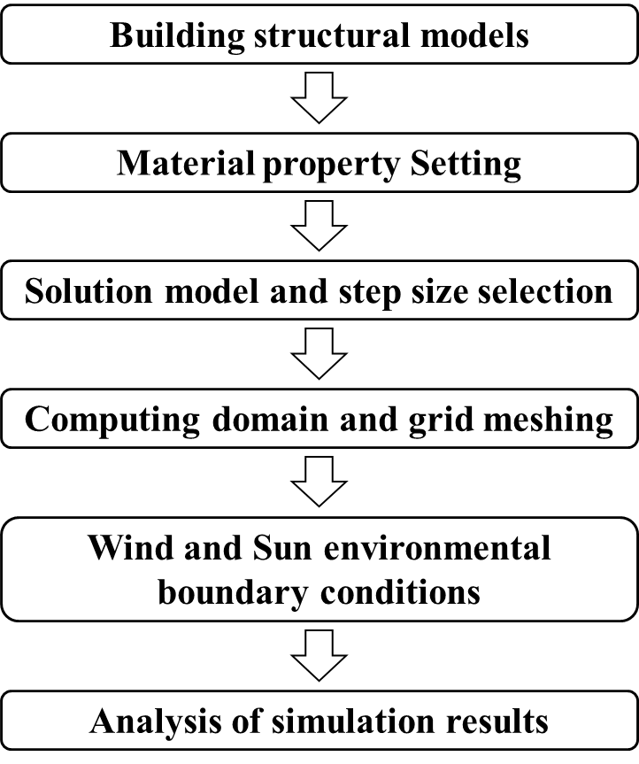
Figure 2. Steps of outdoor temperature field simulation

The temperature field simulation method of indoor
In the process of building structure in service, due to the change of ventilation conditions, the distribution of indoor temperature field will be uneven. This paper comprehensively considers solar radiation, air flow and other factors and simulates the internal temperature field of Shenzhen Bay Stadium, and analyzes the distribution law of indoor temperature field under natural ventilation.

Analyze models and solutions

Finite element model of Shenzhen Bay Stadium
Shenzhen Bay Stadium is located in the central area of Houhai, Shenzhen. It consists of a natatorium, a comprehensive gymnasium, the stadium, the tree square and a prospect bridge. According to the different thermal properties of structural materials, Shenzhen Bay Stadium can be divided into six parts: glass wool roof, double roof, steel structure, column maintenance structure, gymnasium and natatorium maintenance structure, and building platform. In this paper，Midas Gen was used to establish the finite element analysis model of Shenzhen Bay Stadium, and the structural model is shown in Figure 3.
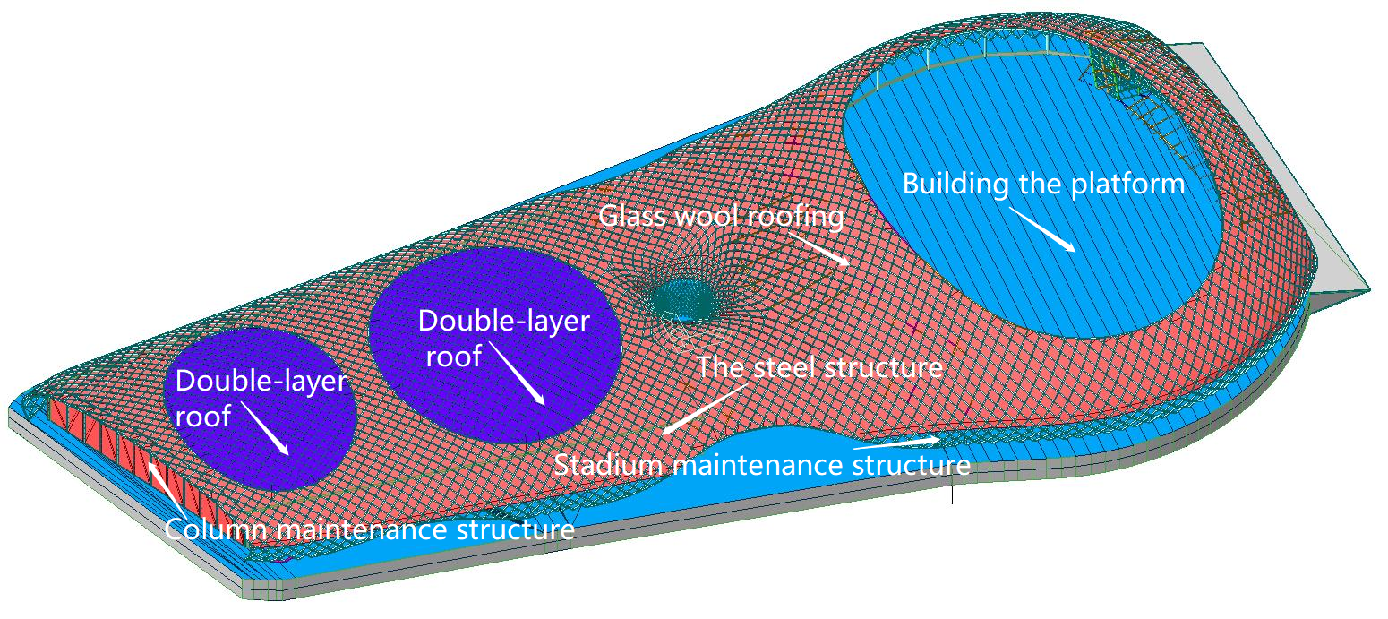
Figure 3. The model of Shenzhen Bay Stadium

Definition of thermal properties and boundary conditions of materials
The structural surface materials of Shenzhen Bay Stadium can be divided into 6 parts. Because of the different thermal properties of each part of the material, its absorption and reflection capacity of solar radiation is also different, so it is necessary to set the material properties separately. The thermal properties of each material are set in Table 1. In order to ensure the accuracy of calculation results and the influence of model boundaries, the calculation domain needs to be 3-5 times larger than the actual structure range. A grid of 100X130X50 is adopted, in which the region where the structure is located is grid encrypted. The structure grid division showed in Figure 4.
Table 1. Thermal parameters of materials
Material | Coefficient of heat transfer  W/($m^{2}∙$K) | Specific heat  J/(kg∙K) | Coefficient of thermal conductivity  W/(m∙K)
Glass wool roofing | 0.9 | 1220 | 0.054
Double-layer roof | 5.7 | 840 | 0.76
The steel structure | 2.8 | 480 | 58.2
Stadium maintenance structure | 1 | -- | --
Column maintenance structure | 4.70 | -- | --
Building the platform | 1 | -- | --
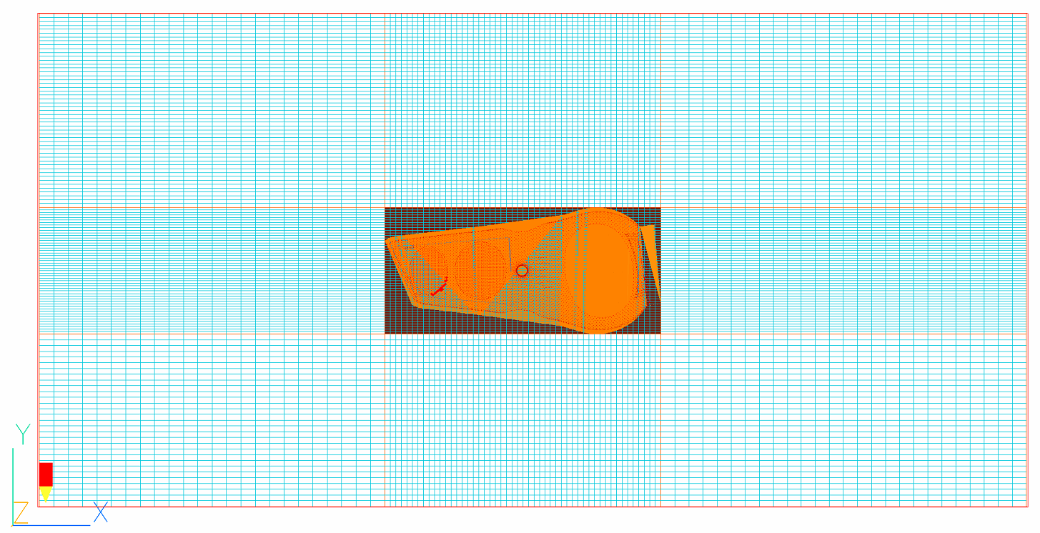
Figure 4. Computational Grid Diagram
For the wind environment, it is necessary to set environmental temperature, wind speed, wind direction and other influencing factors; for thermal environment, it is necessary to set the longitude and latitude of the location of solar radiation, calculation time, direct and scattering intensity, etc. This paper mainly studies the influence of different solar radiation ambient temperature and different wind speed on structure temperature field. Due to the size of the Phoenics software for solar radiation in the local latitude and longitude is based on the structure and the specific date/time to calculate, so here for thermal environment Settings only the calculation time, computing time respectively the vernal equinox, summer solstice, autumnal equinox, winter solstice 2:00pm, the ambient temperature value is the average temperature of the month, and the specific working conditions are set in Table 2.
Table 2. T Temperature simulation condition
Working condition | Simulation time | Temperature  (℃) | Wind speed (m/s)
1 | Mar 20th 14:00 | 19 | 3m/s
2 | Jun 21st 14:00 | 28 | 3m/s
3 | Sep 23rd 14:00 | 27 | 3m/s
4 | Dec 21st 14:00 | 17 | 3m/s
5 | Jun 21st 14:00 | 28 | 3m/s
6 | Jun 21st 14:00 | 28 | 7m/s
7 | Jun 21st 14:00 | 28 | 10m/s

Influence of solar radiation ambient temperature on indoor and outdoor temperature field distribution
The Phoenics software is used to simulate the indoor and outdoor temperature fields. The wind environment variables are controlled unchanged and only the simulation time in the thermal environment is changed. The top view of the structure surface temperature field under various working conditions is shown in Figures 5-8, and the indoor temperature field distribution is shown in Figures 9-12.
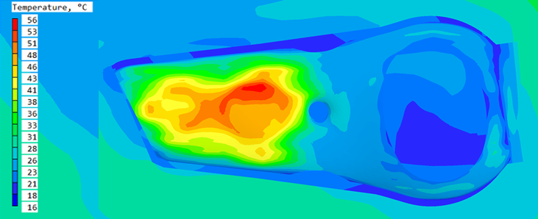
Figure 5. Structure surface temperature field distribution under working condition 1
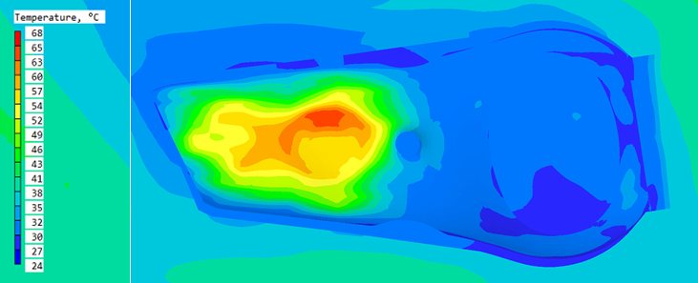
Figure 6. Structure surface temperature field distribution under working condition 2
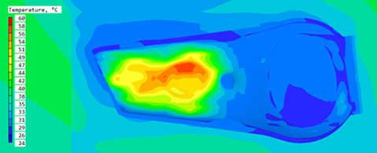
Figure 7. Structure surface temperature field distribution under working condition 3
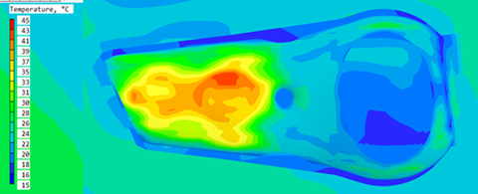
Figure 8. Structure surface temperature field distribution under working condition 4
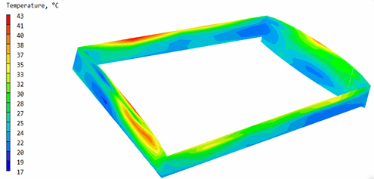
Figure 9. Structure surface temperature field distribution under working condition 1
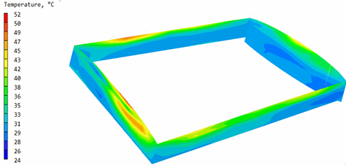
Figure 10. Structure surface temperature field distribution under working condition 2
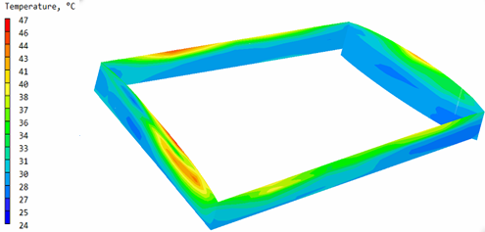
Figure 11. Structure surface temperature field distribution under working condition 3
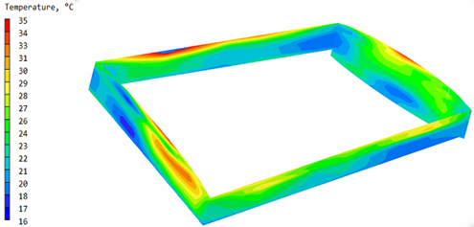
Figure 12. Structure surface temperature field distribution under working condition 4
As can be seen from the temperature field distribution diagram simulated by the above different temperature conditions, when solar radiation and environmental temperature change, the temperature of the structure surface will also change, but the overall distribution trend remains roughly the same. For Shenzhen Bay Stadium, the highest temperature appears at the upper part of the stadium, followed by the upper part of the natatorium and the stadium, and the lowest temperature appears at the building platform. For the four calculation times, the maximum and minimum surface temperatures of the steel structure differ by 30-40 degrees Celsius, indicating that there is a large uneven temperature field on the surface of the structure in any season when solar radiation is the main factor.
As for the indoor temperature field, it can be concluded from the simulation results that the distribution law of indoor temperature field is roughly the same under four different temperature action conditions. There is an obvious temperature gradient at the walls around, and the temperature value increases gradually with the increase of height, and the temperature gradient is about 20-30℃. According to the thermodynamic principle, the high energy of the thermal flow leads to a large distance between gas molecules, resulting in a low density and rising of the thermal flow. In contrast, cold air flow has low energy and high density, and cold air flow sinks. At the same time, because of the high temperature of the building roof, the indoor temperature increases with the increase of height.

Influence of wind speed on indoor and outdoor temperature field distribution
The internal and external temperature field is simulated by Phoenics software. Keep the thermal environment variable unchanged, only change the wind speed. Figures 13-15 shows the top view of the structure surface temperature field under various working conditions, and Figures 16-18 shows the indoor temperature field distribution.
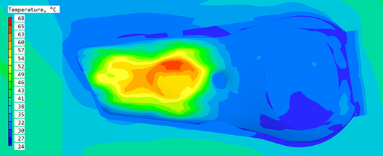
Figure 13. Structure surface temperature field distribution under working condition 5
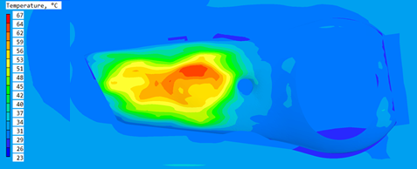
Figure 14. Structure surface temperature field distribution under working condition 6
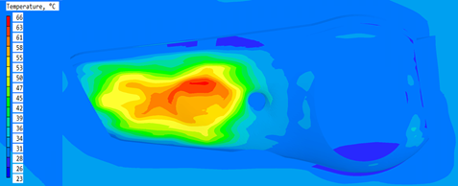
Figure 15. Structure surface temperature field distribution under working condition 7
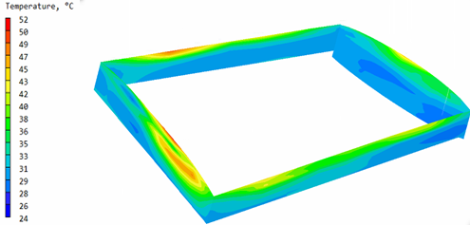
Figure 16. Structure surface temperature field distribution under working condition 5
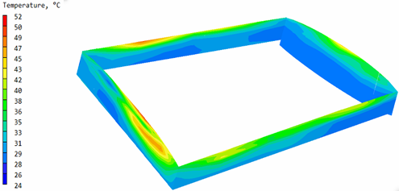
Figure 17. Structure surface temperature field distribution under working condition 6
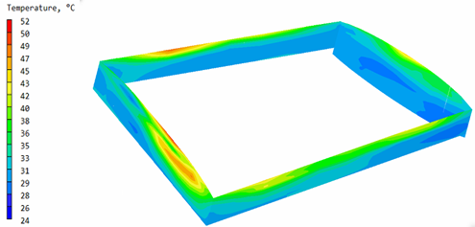
Figure 18. Structure surface temperature field distribution under working condition 7
As can be seen from the above structure temperature field distribution under different temperature conditions, when the simulated wind speed changes, the size of the temperature field on the structure surface does not change significantly, and the overall temperature field distribution trend is basically the same. This indicates that wind speed has little influence on outdoor temperature distribution. For the indoor temperature field, the distribution law of indoor temperature field is roughly the same under the three different temperature action conditions. There is an obvious temperature gradient at the surrounding walls, and the temperature value increases gradually with the increase of height. The temperature gradient of indoor temperature field doesn’t change greatly under different wind speed.

conclusion
Based on the Model of Shenzhen Bay Stadium, this paper analyzes the distribution law of indoor and outdoor temperature field and its influencing factors under different temperature action conditions of the structure.
(1) When solar radiation is the main factor affecting the temperature field calculation, the surface temperature of the structure increases with the increase of solar radiation, but the distribution trend of the surface temperature field, i.e. the position of the maximum temperature and the minimum temperature, has little change.
(2) The temperature field of long-span spatial steel structure has obvious spatial non-uniformity. In general, the non-uniform temperature difference on the outer surface of the structure can reach 30-40℃.
(3) Under the condition of natural ventilation, the indoor temperature field of long-span space steel structure has obvious temperature gradient, and the temperature increases gradually with the increase of height, and the maximum and minimum can differ by 20-30℃.

ACKNOWLEDGMENTS
This work was supported by the National Natural Science Foundation of China [grant numbers 51978214, 52122804, 51878226], the National Major Scientific Research Instrument Development Program of China [grant number 51827811], and the Fundamental Research Funds for the Central Universities [grant number HIT.BRET.202101].

References
- J. Duffie, W. Beckman. Solar engineering of thermal processes. Hoboken, New Jersey, USA, third edition, 2013.
- A. Song, F. Wang. Preliminary study on clear day solar radiation model of Beijing region. Acta Energiae Solaris Sinica, 14(3): 251-255, 1993.
- C. Rigollier, O. Bauer, L. Wald. On the clear sky model of the ESRA-European Solar Radiation Atlas-with respect to the Heliosat method. Solar energy, 68(1): 33-48, 2000.
- P. Ineichen. Validation of models that estimate the clear sky global and beam solar irradiance. Solar Energy, 132: 332-344, 2016.
- Q. Li, H. Yoshino, A. Mochida. CFD study of the thermal environment in an air-conditioned train station building. Building ＆ Environment, 44(7): 1452-1465, 2009．
- A. Stamou, I. Katsiris, A. Schaelin． Evaluation of thermal comfort in Galatsi Arena of the Olympics “Athens 2004” using a CFD model. Applied Thermal Engineering, 28(10): 1206-1215,2008.
- A. Sabean, S. Sajadiye. The effect of dynamic solar heat load on the greenhouse microclimate using CFD simulation. Renewable Energy, 138:722-737, 2019.
- R. García, J. Lopez-Martinez, J. Blanco-Claraco. On air temperature distribution and ISO 7726-defined heterogeneity inside a typical greenhouse in Almería. Computers and Electronics in Agriculture, 151:264-275, 2018.
- M. Teitel, G. Ziskind, O. Liran. Effect of wind direction on greenhouse ventilation rate, airflow patterns and temperature distributions. Biosystems Engineering, 101(3):351-369, 2008.
- C. Lin, Y. Wang, Y. Shi. Analysis of the temperature field of steel members in sunshine. Steel construction, 25(08):38-43, 2010.

