Structural health monitoring of bridge structures in cold climates
Oğuzhan Çetindemir¹, Abdullah Can Zülfikar¹, and Ali Yeşilyurt¹
¹Department of Civil Engineering, Gebze Technical University, 41400 Gebze, Kocaeli, Turkey

Email : ocetindemir@gtu.edu.tr, aczulfikar@gtu.edu.tr, aliyesilyurt@gtu.edu.tr

ABSTRACT: Among every natural factor (such as wind, earthquake, landslide, and flood), the adverse effects that a cold climate may arise are one of the most overlooked or ignored factors in the literature. Although cold climate effects on large structures have not been a concern worldwide, an increasing number of unfavourable incidents due to climate change forced official authorities to take appropriate measures. Numerous methods for preventing and removing ice from bridge structures have been explored during the last two decades, but none have been universally accepted as feasible. In the lack of suitable countermeasures, bridge owners attempt to prevent economically devastating bridge closures through weather monitoring and ice detecting procedures. This paper presents the most effective and widely available technologies for traffic management during icing incidents: ice detection and weather monitoring systems. This is followed by recent experienced incidents and lessons learned from extreme events in cold weather conditions; observations, recommendations, and potential preventative measures in the light of lessons learned will be presented.

KEY WORDS: Bridge monitoring; Ice and snow accretion; Extreme cold events; Cold climate; Lesson learned; Climate change; Sensors; Ice and snow monitoring; Ice detection.

INTRoduCTION
Bridges are a critical component of transportation infrastructure networks, and any disruption to their functioning might have local or regional ramifications. One possible reason for the network closure in a cold environment is atmospheric icing, which has been shown to have a detrimental effect on the performance, serviceability, longevity, and safety of bridges [1]. It is challenging to perceive the failure mode due to cold weather on a bridge because the actual reason might be a combination of factors in the adverse environmental conditions. Therefore, this paper aims to provide a concise review of structural health monitoring (SHM) for bridge structures in a cold climate. In addition, most incidents reported in the literature regarding cold weather are focused on ice accretion and shedding. Thus, different failure mechanisms are provided as a lesson learned for a better understanding of mechanisms lack of that are unreported. The rest of the paper is organized as follows: Section 2 provides a brief literature survey on atmospheric icing and proper measures for each phenomenon observed on a bridge. Section 3 presents monitoring issues in cold climates. Section 4 contributes to two incidents observed during cold weather conditions. Finally, section 5 concludes by offering potential recommendations via field observation and released reports on recent incidents.

Literature Survey
Apart from the common problem of road icing on bridges [2], the accumulation of ice and snow on load-bearing structures above the bridge deck may pose a risk to traversing traffic. The issue arises when accumulated ice or snow falls off the bridge members and onto the bridge deck, posing a risk of damage and injury [1]. While ice accretion might cause certain ice shedding incidents, atmospheric icing on cables also might result in aerodynamic instabilities. However, due to various factors involved, the effects of natural ice and snow accumulation on the aerodynamic stability of bridge cables are not well known at the moment [1].
Although available data on bridge icing incidents is limited, it appears that precipitation icing in the form of freezing rain or wet snow is the most common cause of icing, resulting in dangerous ice shedding from bridge cables [3]. This has resulted in the researchers developing additional icing models for inclined cylinders that are directly applicable to bridge cables [4-7].
Due to performance and safety concerns, as well as the damage caused by ice and snow, substantial research has been conducted on technologies capable of preventing or removing ice formation on various structures and surfaces. Numerous anti- and de-icing technologies have been developed primarily for aircraft wings, wind turbines, overhead power lines, and offshore platforms. Regardless of their efficiency, these solutions are impractical for use on bridge cables due to the size and configuration of these structural components. Kleissl and Georgakis (2010) published the first review of anti- and de-icing solutions for bridge cables, classifying them into three categories: mechanical, thermal, and passive systems [8]. Nims et al. (2014) published another available evaluation that includes a complete list of technologies as part of a report on ice issues on the Veteran's Glass City Skyway in Toledo, Ohio [3]. While both of these evaluations discussed possible anti- and de-icing technology for application in other industries, another very recent review concentrated on existing and planned systems and procedures that have been tested or are explicitly designed for bridge cables [1]. The classification is divided into two broad categories, each of which has three subcategories by Matejicka and Georgakis (2022): (1) Active systems; manual (physical ice removal), mechanical (automated or remotely controlled ice removal), thermal (ice melting), (2) Passive; cable surface modifications and covers, chemicals and coatings, ice detection and monitoring. Utilizing ice detection and monitoring techniques is widely recognized as one of the most effective approaches to addressing extreme cold climate conditions.

Monıtorıng IN COLD CLIMATES
The most reliable and widely accessible technologies for traffic management during icing occurrences in cold climates are ice detection and weather monitoring systems. By predicting or detecting ice development on bridge structures in its early phases, effective countermeasures can be implemented to minimize traffic disruption. In addition, collecting weather data from icing events on affected bridges is critical for the development of ice and snow accretion models [4, 5, 9, 10] and warning systems that can provide bridge operators with the information they need to take appropriate action. Various weather monitoring and warning systems have been installed to collect meteorological data and control harmful ice incidents on bridges worldwide.
After a thorough assessment revealed no viable technology to minimize ice shedding from bridge cables, a well-documented monitoring system was created and deployed on the Veteran's Glass City Skyway [3]. The monitoring system evaluates data collected from various sensors using algorithms informed by prior icing incidents. This information is subsequently made available to the operator via the graphical interface of a custom-built web application, which displays real-time information on the weather and cable quality. The Port Mann Bridge authority eventually adopted the technique [11]. Both incidents demonstrated the need to correctly equip a weather station with sensors capable of recording the controlling factors of atmospheric icing, notably wind speed and direction, temperature, relative humidity, solar irradiation, and maybe a precipitation sensor. Additionally, cameras for visual inspection, temperature probes to monitor the cable surface temperature, and ice detectors or moisture sensors may be included. Numerous bridge authorities take advantage of this data, and some even give drivers real-time weather and traffic updates on their websites [12, 13].
In many circumstances, relying just on weather monitoring technologies to control traffic on bridges with a minimal likelihood of atmospheric icing may be adequate. On the other hand, in locations prone to icing, the adoption of accurate ice detection technologies is necessary for the proper operation of any active de-icing system. Battisti (2015) produced a classification of available ice detecting systems based on their primary measuring concept [14]. While the categorization was designed with wind turbines in mind, most of the measuring concepts are applicable to bridges and other structures. Alternatively, a potential technology based on statistical modeling of the cables' vibration response data may be utilized in the future to identify ice accretion [15].

Lesson learned
Since most cold climate events on bridges result in traffic congestion, they are typically covered by local news organizations. Several more well-known cases are also discussed in the existing literature on the subject [1, 3, 16]. Due to the complex nature of cold regions and the absence of reliable weather monitoring systems on most bridges, weather data is limited. The lessons learned from the past events are critical as they shed light on the measures for future risk mitigation efforts.

Atatürk Bridge (Unkapanı Bridge)
The Atatürk bridge, also known as the Unkapanı Bridge among local people, was opened in 1940 in Haliç Golden Horn and connecting two counties, Fatih and Beyoğlu (Taksim) in İstanbul, Turkey. It is 453.5 meters long and 25 meters wide. The historical Unkapanı Bridge was positioned on 24 pontoons and two side abutments in its construction. The maintenance and repair of 21 pontoons, except for three with good structural conditions, were just carried out in the past years. The Unkapanı (Atatürk) Bridge is a drawbridge and is scheduled to be opened to marine traffic once a week in summer and twice a week in winter, thereby closed to vehicles and pedestrian traffic during such period. The location of six bridge joints is shown in Fig. 1a. A very recent incident during the snowstorm on 11-13th March 2022 in İstanbul was observed three times in a row. The bridge was split into two, causing a gap of about 20 cm at the bridge’s 4th connection points (Fig. 1). Right after the event, there were many questions about whether there was an engineer's fault on the Unkapanı Bridge, separated from the connection points with a one-day break due to heavy snowfall.
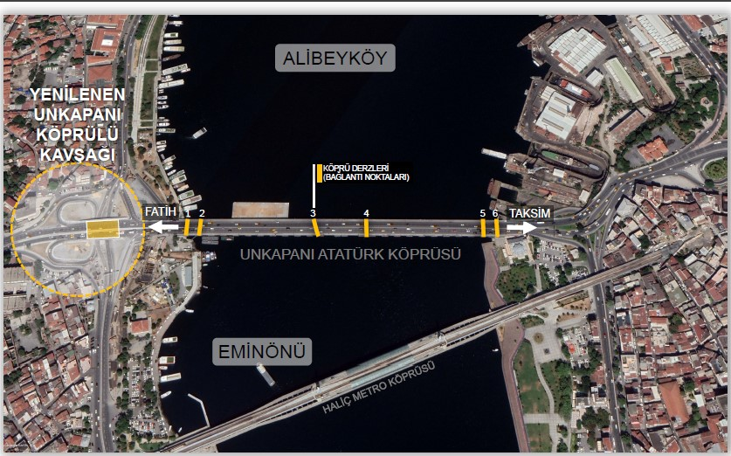
(a)
Bridge joints
1
6
5
3
2
4
ATATURK BRIDGE
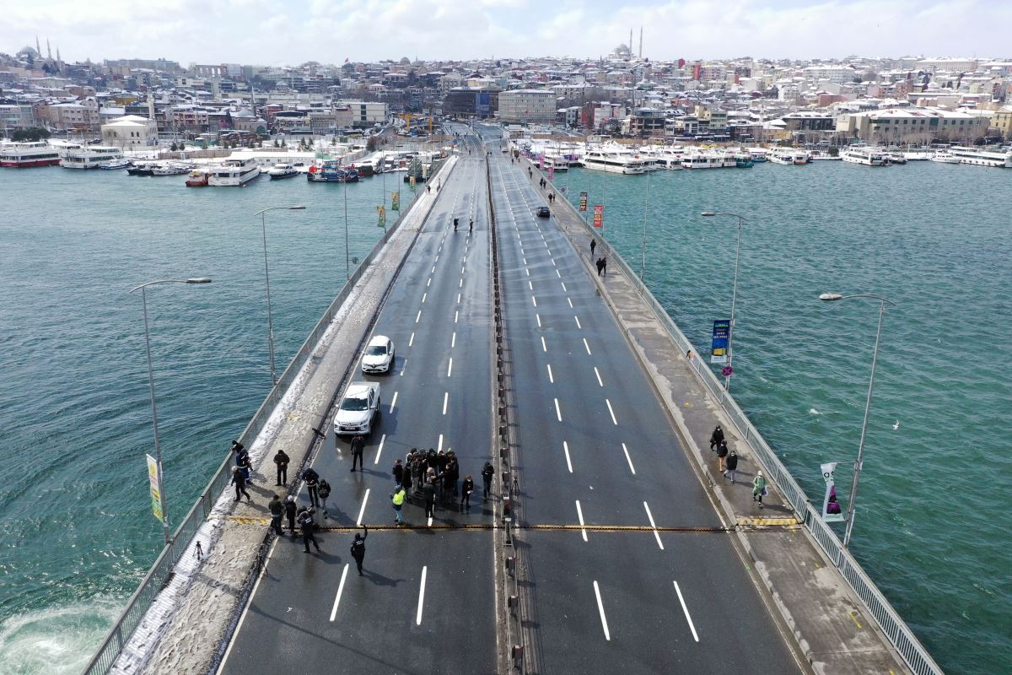
4
(b)
Figure 1. Atatürk Bridge (a) location (b) gap in the deck.

It was stated by Istanbul Metropolitan Municipality (IMM) that it was not the engineers’ fault that caused the separation on the Unkapanı Bridge. While it is said that the bridge was built on pontoons and designed not to prevent the passage of ships, it was officially announced that the drawbridge was divided into two depending on the weather conditions (Fig. 2). As it was stated that the maintenance of the Unkapanı Bridge was carried out recently, it was underlined that the historic bridge has been standing for 82 years.
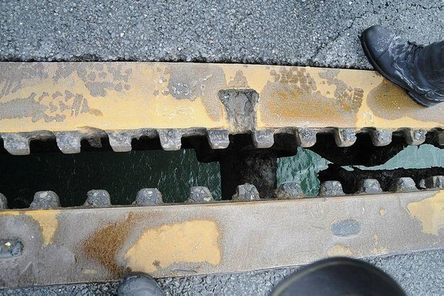
Figure 2. A closeup view of gap at the connection in deck.

According to examinations, the structural conditions of the steel carriers are satisfactory, but they cannot perform their functions due to the time-dependent deformation of the movable expansion joints at the two ends of the bridge and the tension system that allows the bridge to move on the rails. Therefore, severe maintenance and repair projects are being prepared. Although the functional defects detected in the bridge's expansion joints do not pose a significant problem regarding the bridge's structural safety, the project teams continue to determine and project for maintenance and repair.
The services related to the maintenance and repair of the bridge are as follows: (1) connection joints from the upper part of the bridge, dilatations, jack bearings, guardrails, steel barriers, repair of the pontoons at the bottom of the bridge when they are punctured, mechanical locking system, chain tensioning system of the bridge, casting and controls of the bridge anchors (vault), steel constructions, horizontal axis movement control and maintenance of rollers and bearings, (2) electrical installation maintenance and repairs [17].
Due to the opening in the Unkapanı bridge joints, Şişhane - Fatih direction was closed entirely to traffic. After placing pontoons on the bridge roads in the Fatih - Şişhane direction, the traffic will be provided in a single lane in the Şişhane - Fatih direction [18]. After two hours of closure, the Unkapanı Bridge was opened to traffic by applying tensioning process on the chains [19]. As a result of the examinations, it was stated that the inspection is continuing to ensure that the traffic can be processed safely on the Unkapanı Bridge, which is divided into two from the connection points three times. It was stated that the IMM Maritime Services Directorate carried out the operation and routine maintenance of the historic bridge and that the teams instantly followed the mechanisms of the bridge and intervened when necessary.

Nipigon River Bridge
The Nipigon River Bridge is a cable-stayed bridge in Canada that spans the Nipigon River near Nipigon, Ontario. It connects Highways 11 and 17, which are recognized as part of the Trans-Canada Highway. The cable-stayed design for the twin bridges, with two parallel spans carrying four total lanes, is the first example of a cable-stayed bridge in the province of Ontario. It is 252 meters long, the tower rises 75 meters above the river, and the deck width is 37 meters (Fig. 3). The replacement of the 1974 bridge began in 2013 as part of a regional effort to enlarge the Trans-Canada Highway to four lanes. The future westbound bridge opened on November 29, 2015; traffic was switched to the new bridge in both directions to prepare for the removal of the old span. The eastbound span was originally opened in 2017 [20]. The eastbound span was finished in 2018, and the bridge fully opened in November 2018 with two lanes of traffic in each direction [21].
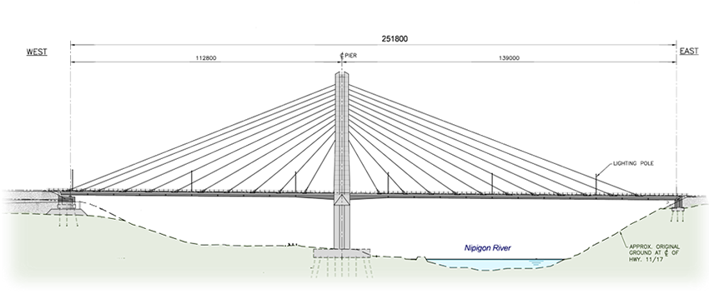
Figure 3. Nipigon River Bridge.

A similar incident to the Atatürk Bridge was observed on the one lane of the Nipigon River Bridge on the 10th of January, 2016, during a snow storm. The separation led the deck to rise around 60 cm, making it impassable to traffic and thus cutting off access to southwestern Ontario. After 17 hours of closure, the bridge was partially reopened to traffic the following day, with one lane alternating between directions. Meanwhile, the Ministry of Transportation evaluated the bridge for additional damage and decided that it would be capable of handling cars and regular-weight transport trucks. To stabilize the deck, 200 metric tons of concrete Jersey barriers were installed [22, 23].

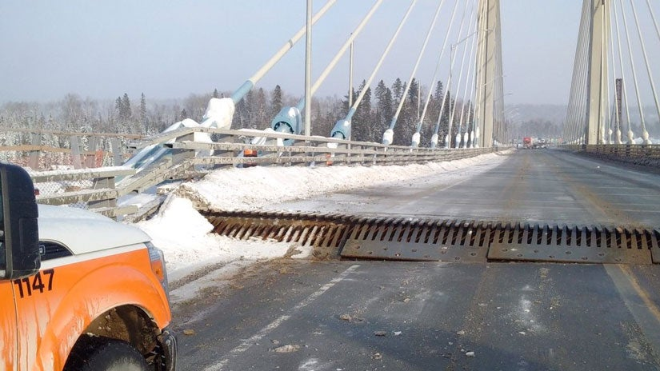
Figure 4. Uplift in the deck due to cold weather.

A temporary repair was implemented, consisting of a hold-down support system that used hangers to secure the steel girders to the bridge structure. On February 25, 2016, the bridge was fully reopened with one lane in each direction; however, the specific cause of the failure was unknown [24]. On September 22, 2016, the Ministry of Transportation released several reports on the technical causes of the January 10, 2016 incident. Reports revealed several causes for the failure as follows: (1) the shoe plate that connects the bearing to the girder was extremely flexible, resulting in "prying action" [25], amplifying the forces acting on certain bolts, (2) the bearings were unable to rotate to meet the non-parallelism between the deck girders and the concrete abutment, resulting in an increase in stress on one bearing end, (3) bolts were not tightened adequately, exposing them to fatigue, (4) the linkage system for the bridge was not functioning properly, allowing for horizontal movement due to thermal expansion and contraction of the bridge superstructure [26].

Conclusions
Ice detection and structural health monitoring technologies assist traffic management during icing incidents. Numerous bridge operators worldwide use such devices to reduce damage and accidents caused by untimely bridge closures. These technologies are the safest alternative for addressing the issue of material expansion and contraction due to extreme temperature differentials and ice accretion on bridges. Thus, they should be utilized in conjunction with appropriate ice and snow mitigation solutions for bridge structures in the future. Significant findings of this paper are listed below:

- Recent research is focused on ice and snow accretion, atmospheric icing effects on ice shedding, and aerodynamic stability of bridge cables. Although numerous research has been carried out in the past two decades regarding aerodynamic instabilities and ice and snow accretion models, the weather data collection from icing events is lacking due to no SHM system employed on most bridges in cold climates.
- Two bridges presented in the Lesson learned section (the Atatürk Bridge and the Nipigon River Bridge) do not have Structural Health Monitoring (SHM) systems. Therefore, the authorities were first forced to rely on early observations in the field immediately after the incident. Actual failure cause and mechanism investigation can take months, and more importantly, actual failure mechanisms may differ from the observations made in the field.
- As it is for the Nipigon Bridge, although the first observations in the field pointed out the cause of failure were from the cold, later reports may reveal that the main reasons are different, cold weather being just one of a few reasons.
- It is difficult to determine the bridge’s actual failure mechanism due to the complex nature of bridge behavior in the cold climate. Thus, structural health monitoring systems may be especially vital in the regions where extreme events (earthquakes, storms, floods, cold weather, etc.) occur more often.
- The Nipigon River Bridge is a single point of failure in Canada's National Highway System; its closure effectively forced vehicles traveling between eastern and western Canada to take an alternate route across the United States. Even for a short period, disruption in the transportation network might cause undesirable costly consequences.
- Considering the advantages of monitoring and ice detection systems in taking real-time measures, expanding the use of these systems in cold regions with the proper methods will contribute to the uninterrupted operation of transportation networks.

References
- Matejicka, L. and C.T. Georgakis, A review of ice and snow risk mitigation and control measures for bridge cables. Cold Regions Science and Technology, 2022. 193: p. 103429.
- Yu, W., et al., State of the art and practice of pavement anti-icing and de-icing techniques. Sci. Cold Arid Reg, 2014. 6(1): p. 14-21.
- Nims, D.K., et al., Ice Prevention or Removal on the Veteran's Glass City Skyway Cables. 2014.
- Mohammadian, B., et al., Experimental and theoretical studies of wet snow accumulation on inclined cylindrical surfaces. Modelling and Simulation in Engineering, 2020. 2020.
- Szilder, K., Snow accretion prediction on an inclined cable. Cold Regions Science and Technology, 2019. 157: p. 224-234.
- Szilder, K., Theoretical and experimental study of ice accretion due to freezing rain on an inclined cylinder. Cold Regions Science and Technology, 2018. 150: p. 25-34.
- Szilder, K., A. D'Auteuil, and S. McTavish, Predicting ice accretion from freezing rain on bridge stay cables. Cold Regions Science and Technology, 2021. 187: p. 103285.
- Kleissl, K. and C. Georgakis. Bridge ice accretion and de-and anti-icing systems: A review. in The 7th Internation Cable Supported Bridge Operators' Conference. 2010.
- Abdelaal, A., et al., Prediction of ice accumulation on bridge cables during freezing rain: A theoretical modeling and experimental study. Cold Regions Science and Technology, 2019. 164: p. 102782.
- Roldsgaard, J.H., et al. Preliminary probabilistic prediction of ice/snow accretion on stay cables based on meteorological variables. in 11th international conference on structural safety & reliability conference. 2013.
- Robertson, S., et al. Port Mann bridge cable stay snow and ice management program. in International Snow Science Workshop. See https://arc. lib. montana. edu/snowscience/objects/ISSW2018_P03. 2018.
- The Forth Bridges, Wind and weather. 26 March 2022; The Forth Bridges]. Available from: https://www.theforthbridges.org/plan-your-journey/wind-and-weather/.
- Incheon Bridge, Real time traffic information. 26 March 2022; Available from: http://www.incheonbridge.com/eng/info/roadinfo.
- Battisti, L., Wind turbines in cold climates: Icing impacts and mitigation systems. 2015: Springer.
- Andre, J., A. Kiremidjian, and C.T. Georgakis, Statistical modeling of time series for ice accretion detection on bridge cables. Journal of cold regions engineering, 2018. 32(2): p. 04018004.
- Matejicka, L., et al., Cable surface for the reduction of risk associated with bridge cable ice accretions. Structural Engineering International, 2019. 29(3): p. 425-432.
- Istanbul Metropolitan Municipality, Marine Services Directorate Atatürk-(Unkapanı) Köprüsü | Deniz Hizmetleri Müdürlüğü. 26 March 2022; Available from: https://denizhizmetleri.ibb.istanbul/neler-yapiyoruz/unkapani-koprusu/.
- Istanbul Metropolitan Municipality (IMM). 26 March 2022; Available from: https://www.ibb.istanbul/arsiv/40122/istanbul-karla-mucadele-bilgi-notu---13-mart.
- Istanbul Metropolitan Municipality (IMM), News archive. 26 March 2022; Available from: https://www.ibb.istanbul/arsiv/40119/imamoglu-ogleden-sonra-icin-uyardi-2-gunun-ta.
- Ontario Reaches Milestone in Construction of Nipigon River Bridge, Ministry of Northern Development and Mines. 26 March 2022; Available from: https://news.ontario.ca/en/bulletin/35119/ontario-reaches-milestone-in-construction-of-nipigon-river-bridge.
- All 4 lanes of Nipigon River bridge now open, CBC News. 26 March 2022]; Available from: https://www.cbc.ca/news/canada/thunder-bay/nipigon-river-bridge-open-1.4919909.
- "Ontario's Nipigon River Bridge Opens to 1 Lane After Piece of Decking Lifts". CBC News. 26 March 2022; Available from: https://www.cbc.ca/news/canada/thunder-bay/nipigon-bridge-transcanada-update-1.3398207.
- McQuigge, M. "Northern Ontario's Nipigon River Bridge Partially Reopens to Traffic". Global News. . 26 March 2022; Available from: https://globalnews.ca/news/2445052/bridge-closure-blocks-trans-canada-highway-in-northern-ontario/.
- "Nipigon River Bridge Now Fully Open, but Remains Construction Zone". CBC News. . 22 March 2022; Available from: https://www.cbc.ca/news/canada/thunder-bay/nipigon-bridge-reopens-today-1.3463517.
- Kulak, G.L., J.W. Fisher, and J.H. Struik, Guide to design criteria for bolted and riveted joints second edition. American Institute of Steel Construction, 2001.
- "Update on the Nipigon River Bridge: Engineering Issues Cause Failure". My Algoma. 26 March 2022; Available from: https://www.myalgoma.ca/2016/09/22/update-on-the-nipigon-river-bridge/.

