ABSTRACT: The results of the dynamic tests carried out on the approach pedestrian bridge to Civita di Bagnoregio are shown. Most of the structural elements were in bad conditions due to the carbonation of concrete. All the external beams were damaged, the phenomenon being amplified by the combined action of rain and wind. Several cracks could be seen in the columns, where the concrete cover was spliced and the reinforcement bars were uncovered. The attention was focused on the highest five piers, which had shown an irregular behavior in a previous experimental campaign. The results of the new experimental campaign allowed to state that the structural behavior of the bridge was quite similar to that we could expect. Under ambient vibrations the structure behaved as a whole, formed by the piers linked at their tops by means of the beams. Also the behavior of the piers was similar to the expected one.

Assessment of a pedestrian bridge by means of experimental vibration analysis
Buffarini G.¹, Clemente P.¹, Giovinazzi S.¹, Ormando C.²
¹ENEA Caasccia Research Center, Rome, Italy
²University of Tor Vergata, Rome, Italy
Email : giacomo.buffarini@enea.it, paolo.clemente@enea.it, sonia.giovinazzi@enea.it, chiara.ormando@enea.it

KEY WORDS: bridges; pedestrian bridges, experimental dynamic analysis; system identification.

Introduction
Civita di Bagnoregio is a small town of Etruscan origin, placed on the top of a tuff hill, 443 m asl and 250 m above the bottom of the surrounding valley. It is administratively part of Bagnoregio, which is connected with Civita by means of a pedestrian bridge running over a narrow saddle (Figure 1). The town was a very important centre during the early middle age. A series of natural disaster, especially landslides and earthquakes, caused the progressive reduction of the population and the decay of the town, which is now called the dying town [1]. In the last 200 years, no new buildings were constructed.
The disasters did not spare the bridge. Its known history starts from the collapse of 1684. Dramatic effects had the earthquake of June 11, 1695, which caused the death of 32 people and also the failure of the bridge. In 1759 and in 1764, landslides caused the collapse of the bridge. Following the continuous interruptions of the approach to Civita, in 1810 the evacuation of the town was decided, but the 400 inhabitants opposed against this decision. In the twentieth century relevant unsettlement movements occurred; finally, the existing masonry arch bridge was destroyed by the retreating German troupes, who blew it up in 1944. The damaged part was substituted by a wooden footbridge, which collapsed in 1963 with the under-scarp wall. The new prestressed concrete bridge was opened on September 12, 1965. Before its inauguration the structure collapsed at its anchorage point on the Civita side and was temporarily substituted by a steel bridge.
Recently, the bridge showed vibrations of high amplitude during a funeral, when it was very crowded. The SGM Engineering S.r.l. of Perugia, Italy, carried out, a series of experimental campaigns on the structure, in order to analyse its static conditions and the dynamic characteristics and to find out any structural damage [2]. The dynamic tests of the structure seemed to reveal a strange behaviour of the piers. The authors, involved in the interpretation of the test results, decided to perform a detailed experimental campaign, in order to better characterise the dynamic behaviour of the piers.

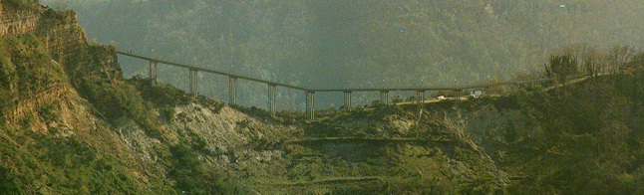
Figure 1 View of the bridge.

the pedestrian bridge
The approach pedestrian bridge to Civita di Bagnoregio is composed of 14 spans, simply supported on the piers. These are spaced by about 19.00 m. The first five span from Civita have a 20% steep slope. The heights of the piers from pier 1 to pier 5 vary from 11 to 15 m; pier 4 is the highest. The viaduct between pier 5 and pier 9 is almost horizontal; from pier 9 to pier 13, it shows a 6% slope. Piers from 6 to 13 are much shorter than the others.
The girder is composed by three pre-stressed concrete beams and a concrete slab, with a total height of 80 cm. The horizontal distance between the beam axes is 90 cm, and the total width of the bridge is 2.50 m, included the two longitudinal parapets. The first span is 16 m, the other ones are about 16.70 m. The beams are supported by the upper plate of the piers through lead pads.
All the piers are composed by 4 circular columns, whose diameter is 50 cm, and by an upper plate of 65 cm height. The columns start from a rectangular foundation plate, supported by concrete piles with a maximum length of 25 m.
The structural elements were in bad conditions due to the carbonation of concrete. All the external beams were damaged, the phenomenon being favoured by the combined action of rain and wind. Several cracks could be seen in the columns, where the concrete cover was split and the reinforcement bars were uncovered. The upper plates of the piers were very damaged too.

Previous investigations
In situ penetration tests, tests on the materials, static loading tests and dynamic tests were carried out by SGM Engineering [2].
Both Cone Penetration Tests (CPT) and Standard Cone Penetration Tests (SCPT) were carried out on the soil. The outcomes confirmed the results of a previous investigations carried out by ENEA [3], and were used to evaluate the load carrying capacity of the piles. The clay basement was quite homogeneous and the soil-piles systems at each pier were able to support the service loads.
Pull-out tests, ultrasonic tests, sclerometer tests and carbonation tests were carried out on the beams, piers and foundation plinths. The tests pointed out the homogeneity of the concrete for each set of structural elements (beams, piers and foundations). Pull-out tests allowed to evaluate the strength of the material, while the carbonation tests pointed out the high level of damage in all the elements.
Laboratory tests were also carried out on concrete specimens. The compression strengths were very similar to those obtained from the pull-out tests. Tension strength of the steel bars was also tested.
The girder showed a linear elastic behaviour under increasing static loading. The experimental deflections were lower than the theoretical ones.
Dynamic impulse tests and traffic-induced vibration tests were also performed on the girder. The resonance frequencies were very similar to the theoretical ones.
We concluded that in spite of the described bad conditions of the bridge, the static and dynamic analyses carried out by SGM Engineering showed a quite good performance of the girder. This occurrence demonstrated that the damages interest only the external surface and therefore the structure could be successfully repaired by means of the usual repair strategies. Instead, the dynamic tests of the piers seemed to point out the irregular behaviour of the piers. Therefore, the experimental campaign by ENEA regarded exclusively this aspect. The highest piers, from pier 1 to pier 5 were tested (Figure 2).

Experimental dynamic analysis
The experimental set-up was composed by eight seismometers Kinemetrix SS1, an HP3566A signal conditioner and a HP laptop. The signals recorded by the eight seismometers, used in synchronised way, were collected by the acquisition system and analysed in real time by HP software in order to have a first glance at the experimental data.
Sensors were deployed in several configurations. Five time-histories lasting 64 s were recorded for each configuration, with a sampling rate of 128 Hz. This was done to show repeatability of the vibrational characteristics and to get average values of this characteristics.
Both ambient and forced vibrations were considered, the latest being caused by the passage of pedestrians or vehicles of small size. The main configurations, used in the present analysis, are shown in figure 3.
The recorded data were first analysed in the time domain, in order to find out the peak values. Then the typical spectral analysis was performed by plotting for each record the power spectral density (PSD) and for each couple of records the cross spectral density (CSD) with the corresponding phase factor and coherence function.

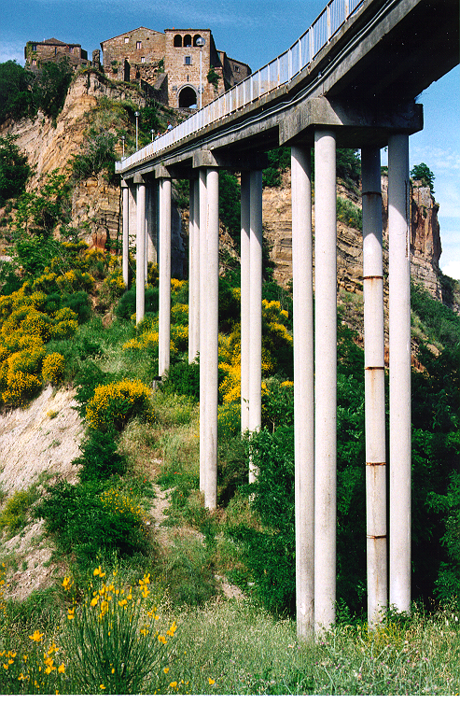
Figure 2 Piers 1 to 5
Configurations A and B allowed to analyse the behaviour of the viaduct, with particular focus on its part between pier 1 and pier 5. Under ambient vibrations, velocity peak values lower than 0.02 mm/s were recorded on the basements in the transversal direction (Figure 4), while values between 0.40 and 1.00 mm/s were recorded at the tops in the same direction. In figure 5 the cross spectral densities between sensors on the basement and sensors at the top of piers 1, 2 and 5, respectively, are plotted.
The following resonance frequencies are particularly apparent in all the PSDs: f₁ = 0.95, f₂ = 1.38, f₃ = 2.07, f₄ = 2.83 Hz. This occurrence suggested that the viaduct behaved as one system. The cross analysis between the records at different piers confirmed this result. In more details, for each pier the record at the basement was in phase with the record at the top, at all the found resonance frequencies. Peaks at the same frequencies are apparent in all the CSDs between the sensors at the tops of the different piers, with significant values of the phase factor and the coherence function (Figure 6).
During the passage of groups of people (forced vibrations), velocity peaks on the basements were lower than 0.03 mm/s, while the maximum velocities at the tops were between 0.5 and 1.5 mm/s (Figure 7). In both cases the amplification factors were between 20 and 50. The analysis of the CSDs confirmed what already said about the dynamic behaviour of the bridge (Figures 8 and 9). The values of the phase factors allowed to find out the modal shapes associated to the mentioned resonance frequencies, which are plotted in figure 10. We concluded that the girder behaved as a beam supported by horizontal elastic restraints at the piers.
In the longitudinal direction, ambient vibrations with velocity peaks values of 0.005 mm/s were recorded on the basements, and of 0.03 mm/s at the tops in the same direction, with an amplification factor equal to 6 (Configuration B). During the passage of people, peaks up to 0.05 mm/s and to 0.15 mm/s were recorded on the basements and at the tops, respectively. The analysis in the frequency domain pointed out the same resonance frequencies of the transversal direction, but also at higher frequencies between 4.5 and 8.5 Hz. The spectral amplitudes were very low in comparison with those of the records in the transversal direction.
A
B
C
D
Figure 3. Sensor deployments in the four configurations.
Figure 4. Time histories sensors 2 and 6, Configuration A, Ambient vibrations.
Figure 5. CSDs sensors 1-5 and 2-6, Configuration A, Ambient vibrations.
Figure 6. CSDs sensors 5-7 and 5-8, Configuration A, Ambient vibrations.

Figure 7. Time histories sensors 2, 4, 6 and 8. Configuration A, Forced vibrations.
Figure 8. CSDs sensors 1-5 and 2-6, Configuration A. Forced vibrations.
Figure 9. CSDs sensors 5-6 and 5-7, Configuration A, Forced vibrations.
Figure 10. Experimental normalised modal shapes.

In other configurations, not shown here, sensors 4 and 8 were on the basement and at the top of pier 4, respectively. The results obtained confirmed what said about the behaviour of the bridge.
Tests of configurations C and D allowed to study the dynamic behaviour of piers 2 and 3 in more details. Transversal velocities were much higher than longitudinal velocities, both on the basement and the top. Vertical velocities on the basement were of the same order of the longitudinal ones.
The already observed resonance frequencies were found. Records relative to sensors 5 and 7, in longitudinal direction, were always in phase at the selected resonance frequencies. As a result, we can state that no torsional modes are associated to these frequencies. In figure 11 the CSDs of records of sensors 5 and 7, relative to configuration C and configuration D, respectively, are plotted.
The experimental results were compared with those obtained from the analysis of a finite element model. The girder was modelled as a spatial beam, having the same geometrical and mechanical properties of the bridge and elastically supported by the piers in the horizontal transversal direction. Vertical displacements and torsional rotations were not allowed in correspondence of the piers. The stiffness of the elastic restraints were equal to the stiffness of the piers. The first four modal shapes of such a model are very similar to the experimental ones. Instead, the resonance frequencies are higher. This occurrence demonstrated that the actual stiffness of the piers are lower than the original ones, relative to the undamaged structure, but the stiffness decrease was almost uniformly distributed along the bridge and not concentrated in a particular element.

Conclusions
The results of this study allowed to state that the structural behaviour of the approach pedestrian bridge to Civita di Bagnoregio was quite similar to the expected one. Under ambient vibrations, the structure formed by the piers linked at their tops by means of the beams, behaved as a whole. We did not find either any unpredictable behaviour of one pier with comparison with the others nor proofs of bad conditions of the foundation structures. It is worth to remind that the penetration tests carried out by SGM Engineering had given quite good results.
The structure showed a very high deformability, more evident in the part where are the highest pier. This characteristic, due to the slenderness of the vertical elements, was emphasised by the structural damage, which resulted in a reduction of the effective cross-sections of the columns. Therefore, the viaduct was very vulnerable to wind actions, which are particularly insidious in the area. Besides, when the bridge is very crowded the natural wind flow is obstructed, the vertical structures very stressed and the vibrations could be amplified very much.

Figure 11. CSD sensors 5-7 in Configuration. C and Configuration D.

We suggested to repair all the piers, in order to make them able to support the vertical and horizontal loads that can act on the structure. In more details the columns should be stiffened without changing their behavior from a qualitative point of view. The intervention was very urgent for the highest piers. The effective cross-section diameter of these should be incremented by 5-10 cm and new reinforcing bars should be placed.
The foundation plinths should be enlarged in order to anchor the new parts of the columns to them. It was obviously not useful to make the pier upper plates heavier. The intervention on them should be made by keeping the previous size. No works were needed on the foundation structures. These may be damaged in the future because of the landslides and the continuous erosion of the soil surface. Therefore, they should be monitored or frequently tested.

Acknowledgements
The study described in this paper is part of the activities of ENEA and Consorzio Civita in the field experimental laboratory at Civita di Bagnoregio. The authors wish to acknowledge Dr. Claudio Margottini, coordinator of the project.

References
- Focardi P., Margottini C., Ogliotti C., Sciotti M. & Serafini S. (1998). “Civita di Bagnoregio: the dying town”. Proc., X ECSMEF (Florence), AGI, Roma.
- SGM Engineering (1997). Indagini sperimentali sul viadotto di accesso a Civita di Bagnoregio. Report to Bagnoregio Town, (in Italian).
- Margottini C & Serafini S. (Editors) (1990). Civita di Bagnoregio. Osservazioni geologiche e monitoraggio storico dell’ambiente. Una ricerca ENEA. Associazione Progetto Civita, Roma (in Italian).
- Clemente P., Buffarini G. (1999). “Dynamic test of a pedestrian bridge as part of safety assessment”. IABSE Report “Structures for the Future. The Search for Quality” (Proc. of the IABSE Symposium, Rio de Janeiro, 25-27 Aug 1999), Vol. 83, 540-547, IABSE International Association for Bridge and Structural Engineering, Zurich, ISBN 3-85748-100-6.

