Long-term structural health monitoring of long-span suspension bridges and anomaly detection using statistical indicators
Oğuzhan Çetindemir¹, Esra Tepe ², Abdullah Can Zülfikar ¹, Ali Yeşilyurt¹, and Nurdan Memişoğlu Apaydın^{3, 4}
¹Department of Civil Engineering, Gebze Technical University, 41400 Gebze, Kocaeli, Turkey
²Department of Computer Engineering, Istanbul University-Cerrahpaşa, 34320, İstanbul, Turkey
³Department of Civil Engineering, Istanbul University-Cerrahpaşa, 34320 Avcılar, Istanbul, Turkey
⁴Ministry of Transport and Infrastructure, 34668 Uskudar, Istanbul, Turkey

Email : ocetindemir@gtu.edu.tr, esratepe@iuc.edu.tr, aczulfikar@gtu.edu.tr, aliyesilyurt@gtu.edu.tr, nurdan.apaydin@iuc.edu.tr

ABSTRACT: Some research has been conducted on structural health monitoring (SHM) utilizing raw data to discover structural behavior changes, anomalies, or damage assessment. However, few of them employed statistical indicators represented as input data. Long-term monitoring has several advantages (before/after event comparison, detecting/tracking abrupt changes or aging effects), while the data collection process may have disadvantages (data storing issues, impractical computationally expensive analyses). Thus, the current work proposes two unsupervised machine learning techniques for detecting anomalies using statistical indicators extracted from long-term raw dynamic measurements recorded from a three-dimensional accelerometer installed on the midspan of the Osman Gazi Bridge built in Turkey. For this purpose, one-class Support Vector Machine (SVM) and Local Outlier Factor (LOF) are used as machine learning algorithms to detect anomalous instances. Comparison between these two machine learning revealed similar anomalies. The acquired results support the development of computational methods for assessing structural anomalies based on statistical indicators of acceleration measurements.
KEY WORDS: Long-term SHM; Long-span bridges; Suspension bridges; Anomaly detection; Machine learning algorithms; Statistical indicators; One-class SVM, Local outlier factor (LOF).

Introductıon
Large span bridges are typically located in strategic positions within modern transportation networks, which are vital for regional economic development [1-3]. Due to the size and concealment of hazards inherent in large-span bridge structures, anomaly detection is a critical challenge for large-scale civil structures [4]. Long-term monitoring enhances the benefits of structural health monitoring (SHM) by allowing for an investigation of the structure's complete history, which is critical for rapidly recognizing any structural anomalies.
Several benefits of long-term monitoring include the following: (1) comparing the structural parameters identified before and after a potentially damaging event, such as an earthquake, storm, flood, collision, etc., enables the engineer to determine whether damage occurred or locate the structural elements affected and quantify the extent of the damage, (2) tracking changes in a bridge’s modal and structural parameters over its service life makes structural aging visible and quantifiable. Aging may be expected to produce small progressive shifts in the bridge’s dynamic characteristics associated with gradual decrements of structural stiffness over the structure’s life, (3) detecting abrupt changes of bridge modal parameters compared to the baseline may unveil structural deterioration that could not be observable utilizing only visual inspection, enabling timely adoption of corrective measures before deterioration expands further. This results in greater structural safety and the potential for cost savings if more substantial repairs are required in the future. By doing so, long-term SHM may ultimately help transition from a reactive maintenance regimen to a preventative one, which is crucial to improving the condition of aging bridges [5]. The data obtained over the service life of a bridge enables the assessment of the structure's residual capacity. This enables asset managers to make more educated decisions about structural rehabilitation, estimating the remaining service life of the bridge, assessing whether load posting should be applied, and deciding whether to decommission an aging bridge. In addition, from the perspective of a monitored network of bridges, this may allow reasonable prioritization of interventions and more effective financing. Also, it is essential to note that records from multiple datasets collected over a long period yield more reliable baselines than those obtained from short-term monitoring campaigns with only a few records. This is because the parameters identified through each set of measurements are affected by the specific operational conditions when the vibration data are collected. By combining several datasets, one may calculate statistics for the parameters identified in each set and create a statistical baseline model of the bridge that takes into consideration the effect of specific operational conditions or anomalies. Although long-term monitoring has certain advantages, collecting the data might have several drawbacks. For instance, data takes up much space; therefore, storing all vibration-based data for the long term is not cost-effective. In addition, dealing with a significant data load is impractical and computationally expensive for analyses. Therefore, using statistical indicators (SI) for SHM overcomes these problems. However, limited research has been conducted on damage identification utilizing SI derived from SHM data and machine learning approaches [6, 7]. In addition, to the best knowledge of the authors, anomaly detection using SI extracted from SHM data is lacking in the literature.
Machine learning techniques have the ability to automate the process of detecting data anomalies. A data anomaly occurs when sensors are capable of recording data yet the values recorded are inaccurate/incorrect, i.e., anomalous [8]. In certain circumstances, data anomalies such as data loss, spikes, drift, and excessive noise may be a short-term occurrence caused by electronic equipment flaws such as DC offsets, power instability, and calibration errors [9]. These temporary data anomalies might create significant problems for data processing, potentially rendering the entire monitoring operation ineffective. Data anomalies such as baseline shift, linear/nonlinear trend, and spikes produced by sensor system failure may be easily discovered via manual inspection. However, manually detecting data anomalies is challenging due to the massive amounts of monitoring data generated. As a result, developing automatic identification of data anomalies caused by sensor system failure is crucial for assuring the integrity of SHM-based investigations. Hence, to tackle the issues mentioned above in the literature, In this paper, statistical long-term SHM data are analyzed on a long-span suspension bridge, the Osman Gazi Bridge (OGB), to evaluate data anomalies.
The remaining sections are organized as follows: Section 2 provides common machine learning methods used in the literature for anomaly detection. Section 3 briefly introduces the SHM system of the Osman Gazi Bridge and the SHM data. The same section also presents machine learning methodologies for data anomaly detection by explaining the preparation procedure of data and anomalous evaluation utilizing SHM data of a long-span suspension bridge. Section 4 provides alternative methods for future work. Finally, section 5 concludes the paper by sharing significant findings and recommendations.

machıne learnıng methods for anomaly detectıon
In machine learning, the anomaly detection technique is dependent on the problem statement, input data (data type), input data labels (labeled-supervised/unlabeled-unsupervised), desired outputs (score/label), and response to anomalies (proactive/reactive). In general, there are seven anomaly detection techniques in the literature such as classification-based (ANN-based, Bayes network-based, SVM, rule-based, etc.), nearest neighbor-based (kNN, relative density, the computational complexity of nearest neighbor-based techniques, etc.), clustering-based (density-based cluster, the computational complexity of clustering-based techniques), statistical distribution-based (parametric techniques, non-parametric techniques, and computational complexity of statistical-based techniques), information-theoretic based, spectral-based, and graph-based [10]. In general, although supervised approaches are effective in detecting data anomalies, two unresolved issues reduce the accuracy of anomaly detection: (1) class imbalance and (2) the incompleteness of the training dataset's anomalous patterns [8]. While unsupervised approaches can overcome these issues, they must be improved to handle massive monitoring data. Considering each technique has its pros and cons, regarding the lack of implementation of machine learning algorithms using SI in the literature for anomaly detection and not knowing abnormal and normal labels, a one-class SVM algorithm was proposed to evaluate data anomalies. The same dataset was used to compare another anomaly detection method called the local outlier factor (LOF).

a case study
The Osman Gazi Bridge (OGB) is a vital transportation link between Istanbul and Izmir Motorway to shorten the distance traveled. It was built at Izmit Bay in 2016, relatively close to one of the largest metropolitan, İstanbul. It is currently the seventh longest suspension bridge globally, with its main span length of 1550 m. One of the active fault segments of the North Anatolian Fault (NAF) intersects the bridge. Moreover, the bridge is critically vulnerable to strong earthquakes in the far-field. Moreover, unfavorable environmental effects are relatively high because the bridge’s location is the primary basis for the heavy chemical industry of Turkey.

A brief introduction to the SHM system of the Osman Gazi Bridge
A preliminary SHM system that achieves all requirements for monitoring the bridge was mounted. In total, 386 sensors are used to understand better the bridge’s response to extreme events and environmental aging effects. Sensor types and locations are shown in Fig. 1. The OGB is an ideal candidate for long-term SHM research since it was built in a region with a chemical industry that might have an adverse effect in the long run.
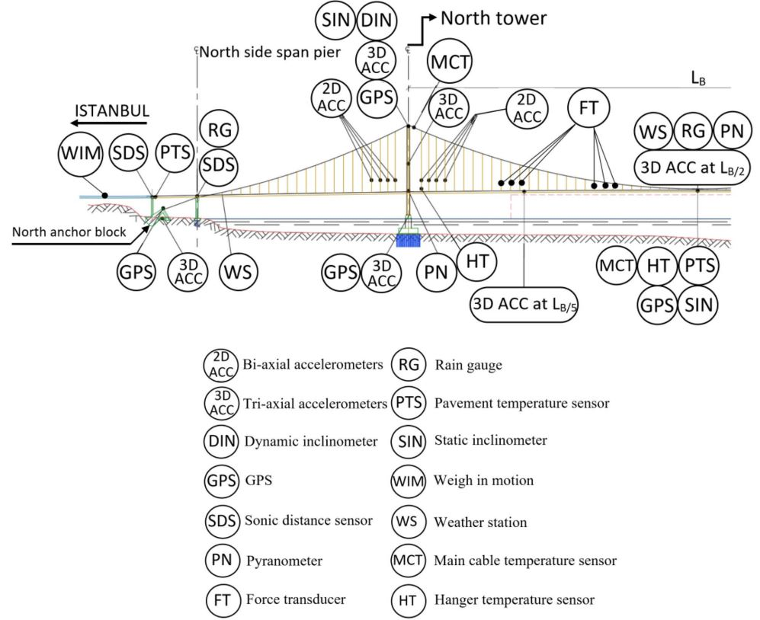
Figure 1. Sensor arrangement on Osman Gazi Bridge [11]

SHM data
The selection of input variables for machine learning methods is critical for the classification of various structural conditions successfully. It is vital to use data that provide representative information about dynamic signals since classification algorithms learn by mapping datasets. Farrar and Worden (2012) assert that time series analysis of structural responses enables the extraction of signal parameters more easily than modal analysis [12]. This study focused on five statistical indicators that interact directly with time-domain dynamic measurements (Table 1). The first statistic is the peak amplitude, which indicates the signal's greatest oscillation magnitude. The mean and root mean square indicate the data's central tendency, but the standard deviation and variance indicate the data's dispersion around the mean value. A long-term monitoring dataset was recorded from 1st January 2019 to 1st December 2019. Only dataset recorded by three-dimensional accelerometer positioned mid-span was used for three directions. Statistical indicators were derived from raw data and recorded for every hour, about 11 months.
Table 1. Formulations used for input data.
Statistical indicators Equations
Peak (SI1) $x_{peak}=Max\left|x\right|$
Mean (SI2) $\overline{x}=\frac{1}{n}\sum_{i=1}^{n}{x_{i}}$
Root mean square (SI3) $rms = \sqrt{\frac{1}{n}\sum_{i=1}^{n}{{{(x}_{i})}^{2}}}$
Variance (SI4) $σ^{2}=\frac{1}{n}\sum_{i=1}^{n}{{(x_{i}-\overline{x})}^{2}}$
Standard deviation (SI5) $σ=\sqrt{ \frac{1}{n}\sum_{i=1}^{n}{{(x_{i}-\overline{x})}^{2}}}$

Anomaly detection
Two machine learning algorithms are proposed to detect anomalous data: (1) SVM is frequently used to solve multi-class classification problems. In addition, SVM is increasingly being utilized to solve one-class problems, in which all data are classified into a single class. One-class support vector machine is an unsupervised model for anomaly or outlier detection. Unlike the regular supervised SVM, the one-class SVM does not have target labels for the model training process. Instead, it learns the boundary for the normal data points and identifies the data outside the border to be anomalies. (2) The local outlier factor is based on the concept of a local density, where locality is defined as the distance between k nearest neighbors. By comparing an object's local density to that of its neighbors, one can discover regions with similar densities and spots with much lower densities than their neighbors. These are regarded as outliers or anomalies. The experiment is conducted on the SHM dataset, which contains 8001 instances and five attributes using the one-class SVM and Local Outlier Factor method. Advanced libraries, such as Scikit-learn and Matplotlib in the Python programming language, are used for anomaly detection [13, 14]. Details of algorithms for both methods can be found as follows:

Algorithm 1 : One-class SVM
Inputs: X - input data
Output: outlier data index
1 : kernel=’rbf’ , gamma= 0.001, nu=0.03
2: svm=OneClassSVM
3: pred = svm.predict(X)
4: anom_index = where(pred==-1)
5: return anom_index

Algorithm 2 : Local Outlier Factor
Inputs: X - input data
Output: outlier data index
1 : n_neighbors=20, contamination=.03
2: lof = LocalOutlierFactor
3: pred = lof.predict(X)
4: anom_index = where(pred==-1)
5: return anom_index
Fig. 2-4 and Fig. 5-7 illustrate anomalies (in red) detected by SVM and LOF, respectively. The comparison between results shows that the number of anomalies is compatible (see Table 2.).
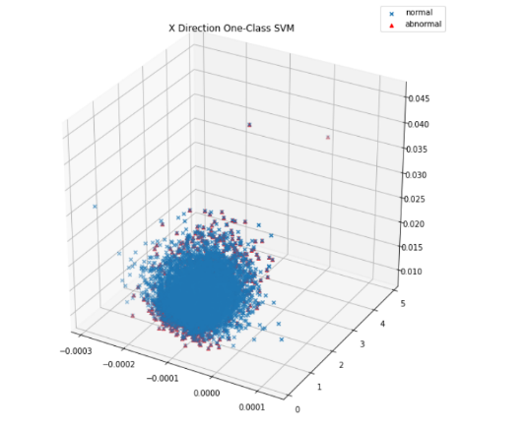
Figure 2. Anomalies using one-class SVM (X-direction)
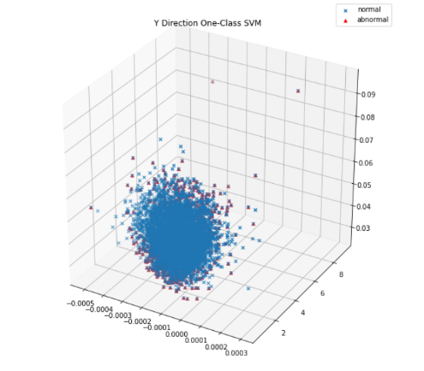
Figure 3. Anomalies using one-class SVM (Y-direction)
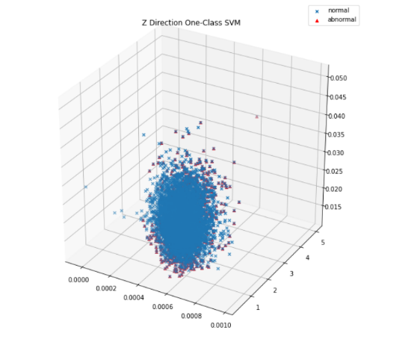
Figure 4. Anomalies using one-class SVM (Z-direction)
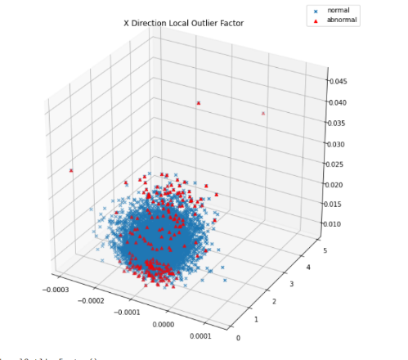
Figure 5. Anomalies using LOF (X-direction)
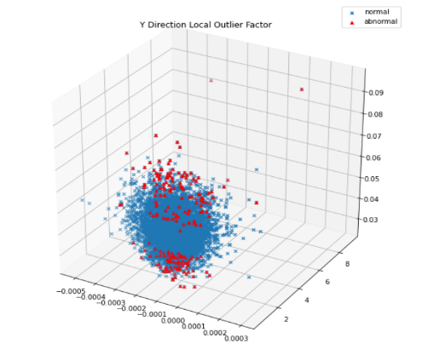
Figure 6. Anomalies using LOF (Y-direction)
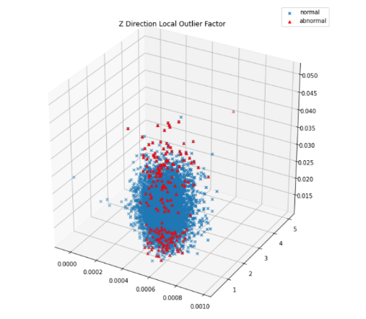
Figure 7. Anomalies using LOF (Z-direction)
Table 2. Anomaly comparison
Method | X-direction |  | Y-direction |  | Z-direction
Method | A | N | A | N | A | N
SVM | 239 | 7762 | 241 | 7760 | 239 | 7762
LOF | 240 | 7761 | 240 | 7761 | 240 | 7761
A: Abnormal, N: Normal

future work
Anomaly detection can be done by applying several methods in data analysis such as Isolation Forest, Elliptical Envelope, the density-based spatial clustering application with noise, gaussian mixture, the K-means, and kernel density methods. The current work might be explored in the future by employing these different machine learning algorithms. It is projected that having analyzed acquired data from various locations on the bridge (such as towers and anchorage) would provide more reliable remarks regarding detecting anomalies. Therefore, the authors are currently analyzing the data to publish in the near future. Some statistics indicators such as mean square, skewness, kurtosis, crest factor, k-factor can be used to investigate the ability of detecting anomaly instances.

Conclusıons
Significant findings of this paper can be drawn as conclusions and specified as follows:

- In practice, the primary benefit of the adopted method is that it allows for the handling of dynamic data without the requirement for a modal identification procedure. Although the statistical characteristics may not always exhibit substantial visual variation, they can represent minor variances in the vibration signals, allowing machine learning approaches to detect anomalies induced by various factors such as traffic, wind, earthquake, etc.
- Despite the reliable results between two machine learning methods (one-class SVM and LOF), unsupervised methodologies have certain drawbacks. For instance, evaluation is challenging since there is no information about labels and cannot create a confusion matrix. In this case, a visualization is a beneficial tool for evaluating the results.
- Having this work focuses on an approach that does not require any data filtering saves significant time during complex preprocessing. Since statistical data extracted from raw dynamic measurements is used, less data storage is needed. Moreover, still reasonable results are able obtained by anomaly detection methods.
- Some anomalies can be masked by high dimensionality during analyses (see Fig. 2-7). This visualization problem might be solved by plotting 5-dimensional graphs. In addition, in a future study, the dataset should be subjected to feature extraction to determine the most relevant features (attributes).

References
- Xu, X., et al., Condition evaluation of suspension bridges for maintenance, repair and rehabilitation: a comprehensive framework. Structure and Infrastructure Engineering, 2019. 15(4): p. 555-567.
- Zhou, G.-D., et al., Wireless sensor placement for structural monitoring using information-fusing firefly algorithm. Smart Materials and Structures, 2017. 26(10): p. 104002.
- Wang, W., et al., Time synchronization for acceleration measurement data of Jiangyin Bridge subjected to a ship collision. Structural Control and Health Monitoring, 2018. 25(1): p. e2039.
- Xu, X., et al., Anomaly detection for large span bridges during operational phase using structural health monitoring data. Smart Materials and Structures, 2020. 29(4): p. 045029.
- The American Society of Civil Engineers (ASCE), 2021 Report Card for America’s Infrastructure.
- Finotti, R.P., A.A. Cury, and F.d.S. Barbosa, An SHM approach using machine learning and statistical indicators extracted from raw dynamic measurements. Latin American Journal of Solids and Structures, 2019. 16.
- Andrade Nunes, L., et al., A hybrid learning strategy for structural damage detection. Structural Health Monitoring, 2021. 20(4): p. 2143-2160.
- Mao, J., H. Wang, and B.F. Spencer Jr, Toward data anomaly detection for automated structural health monitoring: Exploiting generative adversarial nets and autoencoders. Structural Health Monitoring, 2021. 20(4): p. 1609-1626.
- Abdelghani, M. and M.I. Friswell, Sensor validation for structural systems with multiplicative sensor faults. Mechanical Systems and Signal Processing, 2007. 21(1): p. 270-279.
- Toshniwal, A., K. Mahesh, and R. Jayashree. Overview of anomaly detection techniques in machine learning. in 2020 Fourth International Conference on I-SMAC (IoT in Social, Mobile, Analytics and Cloud)(I-SMAC). 2020. IEEE.
- Memisoglu Apaydin, N., A. Zulfikar, and O. Cetindemir, Structural health monitoring systems of long-span bridges in Turkey and lessons learned from experienced extreme events. Journal of Civil Structural Health Monitoring, 2022: p. 1-38.
- Farrar, C.R. and K. Worden, Structural health monitoring: a machine learning perspective. 2012: John Wiley & Sons.
- Pedregosa, F., Varoquaux, Gael, Gramfort, A., Michel, V., Thirion, B., Grisel, O. et al. 2011. « Scikit-learn: Machine learning in Python”, Journal of Machine Learning Research, 12(Oct), 2825–2830.
- J. D. Hunter 2007. "Matplotlib: A 2D Graphics Environment", Computing in Science & Engineering, vol. 9, no. 3, pp. 90-95.

