ABSTRACT: Buckling of Continuous Welded Rail (CWR) remains a concern for railway operators, due to the associated negative consequences of derailments. CWR buckling usually occurs at locations where the rail stress exceeds a critical stress value that is largely dependent on the temperature change from the rail neutral temperature (RNT), the rail eccentricity, and the lateral support. Currently, no techniques exist to monitor these features along the length of the rail without disturbing rail traffic. This paper deals with the use of distributed fibre optic sensors (DFOS) to monitor the progression of rail buckling under mechanical and thermal loading in controlled lab experiments and the application of this technique for real-time monitoring of the rail thermal response during normal operations. The results indicate that DFOS can be used to enable the accurate evaluation of the distributed axial strain and lateral displacement along the monitored rail length in both the lab and field evaluation.

Distributed Monitoring of the thermal response of Continuous Welded Rail (CWR) using fiber optic sensors
Fuzheng Sun¹, Neil A. Hoult¹, Liam J. Butler², Merrina Zhang³
¹ Department of Civil Engineering, Queen’s University, 58 University Ave., Kingston, ON K7L 3N6, Canada
²Department of Civil Engineering, York University, 4700 Keele St., Toronto, ON M3J 1P3, Canada
³National Research Council Canada, Automotive and Surface Transportation Research Centre, Ottawa, ON, Canada

Email : fuzheng.sun@queensu.ca, neil.hoult@queensu.ca, Liam.Butler@lassonde.yorku.ca, merrina.zhang@nrc-cnrc.gc.ca
KEY WORDS: Rail monitoring, Distributed fiber optic sensors, Thermal buckling, Axial strain and displacement

introduction
The use of continuous welded rail (CWR) for railways offers great advantages over jointed track including higher speed, lower maintenance costs, increased passenger comfort, and noise reduction [1]. However, due to the elimination of expansion joints in CWR, thermal stress can be developed when the track temperature deviates from the temperature at which the rail is stress free, known as the rail neutral temperature (RNT). These thermal stresses can lead to the rail breaking (on cold days) or rail buckling (on hot days) [1]. The challenge in both cases is to determine at what point the critical stress level is about to be exceeded so that action can be taken in advance (e.g., line closure, maintenance). Although rail fracture is a serious issue, it is still possible for trains to pass over a fractured rail [2, 3]. In comparison, thermal buckling mainly occurs in the horizontal plane and can significantly change the track gauge and/or the rail alignment. Thermal buckling can therefore lead to the derailment of trains running at normal speeds [1], resulting in financial losses, potential environmental damage in the event of hazardous materials being spilled, and in the worst-case scenario, the loss of passenger lives.
Currently, a few approaches have been proposed to directly assess the rail stress, including rail lifting and cutting, vibration-based vibrometer, and ultrasonic wave. However, those approaches either cause interruption to the rail network or have low accuracy and poor repeatability. In comparison, strain-based measurement provides a minimally disruptive and reliable way to evaluate rail stress. A limitation of many traditional strain-based methods is that they can only provide discrete measurements, and thus limited locations along the rail can be monitored. This is a challenge since due to the variation of RNT, track support conditions, track lateral variation and lateral resistance, the buckling potential at different locations differs. Distributed fiber optic sensors could potentially be used to monitor track buckling over a long distance as when placed correctly, the DFOS strain measurement system can be used to evaluate the distributed axial stress level, lateral bending curvature, and displacement profile.
DFOS interrogators have previously been used to monitor the strain in the railway track. Yet most of the applications are limited to measuring the rail response in the vertical direction under vertical axle loads. Gu et al. for the first time investigate the feasibility of using the Brillouin Optical Time Domain Analysis (BOTDA) system to monitor the thermal strain in an unrestrained 61 cm long steel rail section [4]. Barker et al. investigated the feasibility of using both the BOTDA and Optical Frequency Domain Reflectometry (OFDR) systems to evaluate the distributed thermal axial strain of a 1.65 m long rail section subjected to both mechanical and thermal loads [5]. Those two research projects proved the feasibility of using DFOS to evaluate distributed rail thermal strain along the rail length, however, the rail response was limited to the longitudinal direction and the lateral response was not a concern due to the size and length of their tested rail samples.
To the author’s knowledge, the monitoring of rail lateral buckling under longitudinal loads has never been investigated before the tests presented in this paper. Thus the objectives of this research program were to i) evaluate the ability of BOTDA systems to measure distributed strain due to the progression of rail thermal buckling in controlled lab tests, ii) investigate the use of BOTDA measurements to assess the rail stress, lateral bending curvature, and lateral displacement in controlled lab tests, iii) investigate the performance of using BOTDA to monitor the long-term response of CWR track in the field under thermal loading arising from ambient temperature variation.

Experimental methods

DFOS overview
DFOS interrogators measure the shift in the central frequency of the backscattered light signal along an optical fiber, which is in proportion to the change of strain amplitude in the fiber. Rayleigh backscattering and Brillouin backscattering are typically used to evaluate the strain. Rayleigh-based DFOS has advantages in terms of high sensor resolution down to 1.0 mm and high sensing precision (±30 microstrain), yet the measurement length is usually limited. In comparison, Brillouin-based scattering has lower sensor resolution and precision, but the measurement length can be up to 100 km. The BOTDA system is more practical for rail monitoring considering the longer measurement length, hence this paper will focus on the performance of a BOTDA system (NBX-6050A, Neubrex, Japan) for rail buckling monitoring. The NBX-6050A has a static measurement accuracy of ±15 microstrain using a gauge resolution of 50 mm.

Experimental campaign
A series of tests were conducted to investigate the suitability of using DFOS to monitor the rail lateral response under axial loads, including:
- Compressive buckling tests, with pin-pin boundary conditions.
- Thermal buckling tests under increasing thermal load, with pin-pin boundary conditions.

Lab experiment
A 3.048 m long ASCE 12 lbs/yd mining rail (Hammer Steel Products) was used as the test specimen in the lab tests to limit the rail buckling load to an achievable level based on the available lab space and actuator capacity. The rail was manufactured using carbon steel with the mechanical and thermal properties in Table. 1. The tests presented in this paper were limited to the first buckling mode about the weak axis.
Table. 1 Material properties of the tested rails
 | ASCE12lbs/yd | ASCE 115 lbs/yd
Elastic Modulus (E) | 207 GPa
Thermal expansion coefficient ($α$) | 11.6 × 10⁻⁶ $/ ℃$
Area (A) | 7.61 cm² | 72.6 cm²
Second Moment of Area (I_{min}) | 5.3 cm⁴ | 449.5 cm⁴

The distributed strain measurements were obtained using nylon-coated single-mode optical fiber cables. The fiber was attached using a structural adhesive (Loctite 4861). A total of 35 m of fiber was installed along eight different paths on the rail surface. The fiber locations on the cross-section and along the rail length are shown in Figure. 1a) and b). Two linear potentiometers (LPs) were installed on either side of the rail at the mid-length to measure lateral displacement. The axial loads were applied through a hydraulic jack and recorded by a Strainsert universal flat load cell with a 222 kN capacity. Three thermocouples (TC) were installed at different locations to measure the absolute rail temperature in the thermal buckling test. The LPs, load cell, and thermocouple readings were recorded using a data acquisition system (DA) at a frequency of 1 Hz. In the compressive buckling tests, the DFOS measurements were taken every 1 kN. In the thermal buckling test, the thermal loads were applied by allowing the rail to freely expand under a temperature increase ($∆T$) and then applying the equivalent mechanical load ($EAα∆T$) to push the rail back to its initial length. More details about the compressive buckling tests can be found in Sun et al. [6].
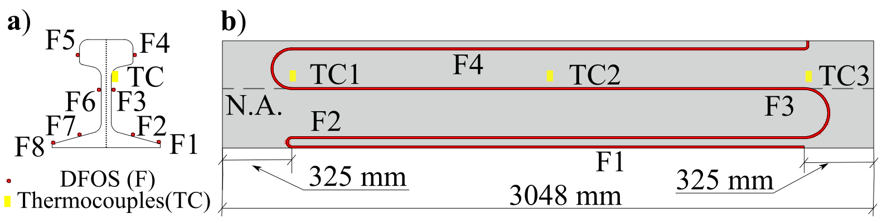
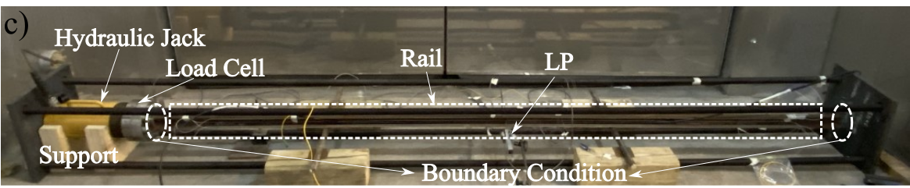
Figure 1. Experimental test setup a) schematic fiber location on cross-section, b) along the rail length, c) load frame and specimen

Field evaluation
An active tangent CWR track located in the Bellamy subdivision in Ontario, Canada (44° 42′ 16″N, 75° 47′ 36″W) was monitored during the fall of 2020 and the summer of 2021. The monitored 20 m long section of rail is a standard cross-section of ASCE 115 lbs/yd rail, with the material properties in Table. 1. As seen in Figure. 2, this section of rail was instrumented with three polymer-coated fibres at different locations on the cross-section to measure the distributed strain.
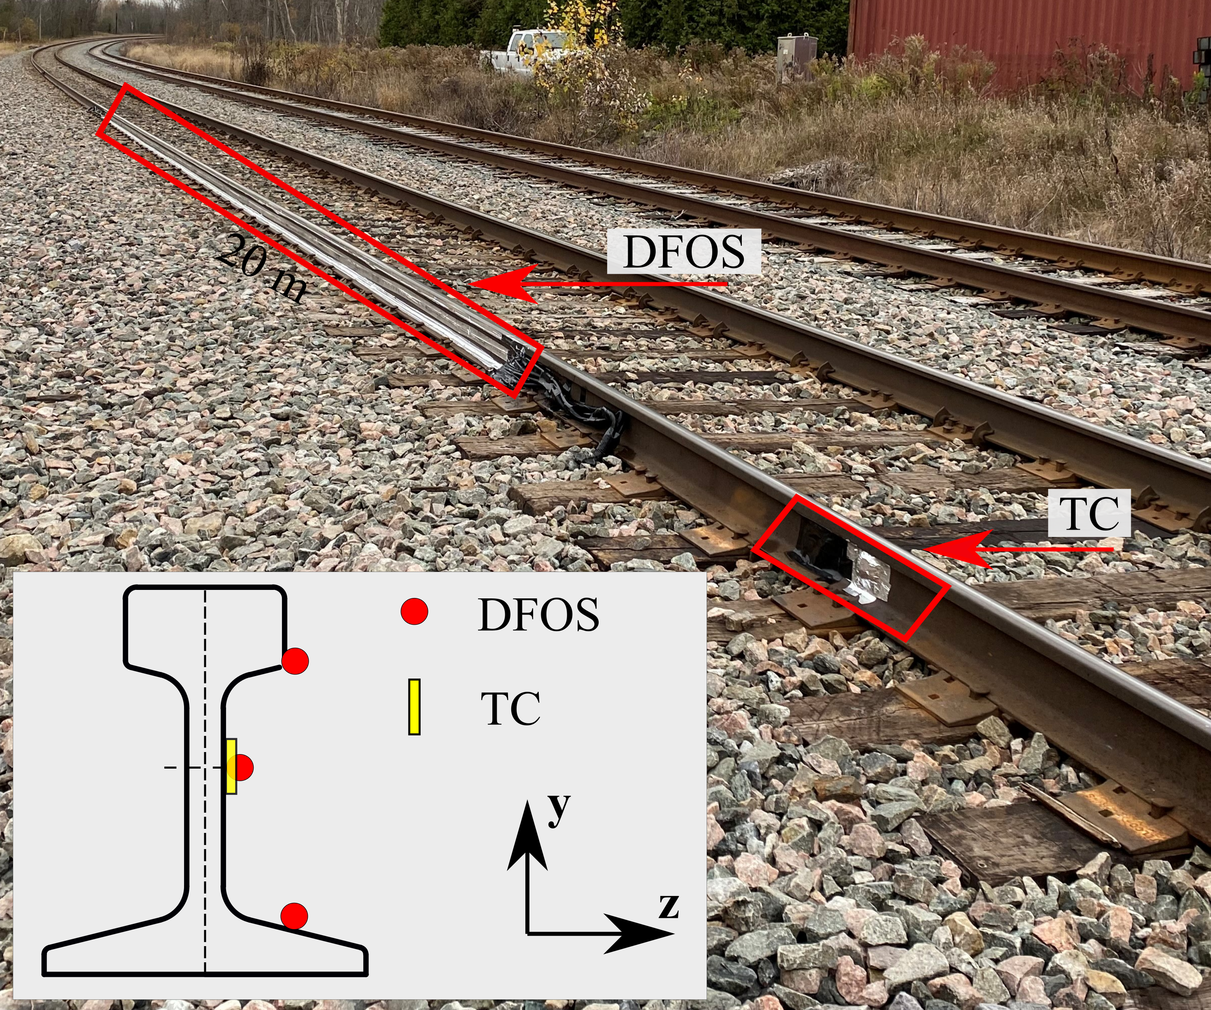
Figure 2. Field monitoring setup
A thermocouple was installed at the mid-height of the rail at one end of the DFOS installation to measure the rail temperature, and another three thermocouples were installed one meter away from the track to measure the ambient temperature. All sensors, including the fibre optic cables and thermocouples, were covered with aluminum foil to mitigate the influence of solar radiation on the DFOS measurements. Both the DFOS and thermocouples measurements were taken every 30 minutes. The rail was monitored in two sessions, one being the late fall from 11/16/2020 to 12/16/2020 and the other being the summer from 07/27/2021 to 08/24/2021.

Results and discussion

Lab tests
For both the compressive buckling and the thermal buckling tests conducted in the lab, there are three stages to the behaviour. First, the lateral deflection increased linearly as the axial loads increased. After the axial load reached a certain level, the rail response entered the nonlinear phase where the mid-length deflection increased substantially more for a given load increment versus the linear response. Finally, the rail entered the buckling stage where the lateral displacement increased dramatically while the axial load remained constant or experienced a sudden drop.
The DFOS measurements were fitted to a linear strain plane along the instrumented rail length to obtain the distributed rail axial strain and curvature profiles (further details in [6]). The raw DFOS measurements in the compressive buckling test were directly used in this fitting process, while the raw DFOS measurements in the thermal buckling test need to be thermally calibrated by applying thermal correction coefficients (see [5] for further details). Figure. 3 presents the distributed axial strain profile for the compressive buckling test and the thermal buckling test obtained through fitting the linear strain plane.
In Figure. 3, it can be seen that the axial strain profile obtained from DFOS strain measurements agreed well with the theoretical strain calculated using the axial loads recorded by the load cell. In comparison, the axial strain profile in the thermal buckling test stayed around zero as the temperature increased and jumped to a positive value after the rail buckled. This is because the rail experienced the longitudinal compression due to the mechanical load in the compressive buckling test leading to strains, while the longitudinal movement was constrained in the thermal buckling test. The distributed lateral deflection profiles given in Figure. 4 were obtained by double integrating the distributed curvature profiles. The lateral deflection profiles for the two tests increased as the mechanical/thermal loads increased. After the rail buckles, the rail deflection increased significantly.

a)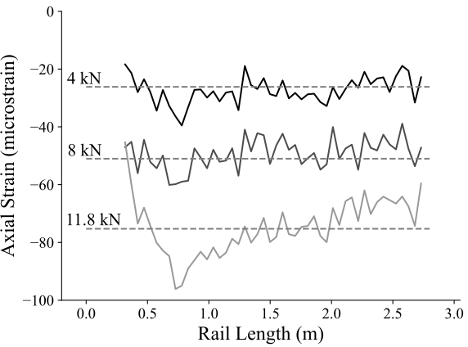
b) 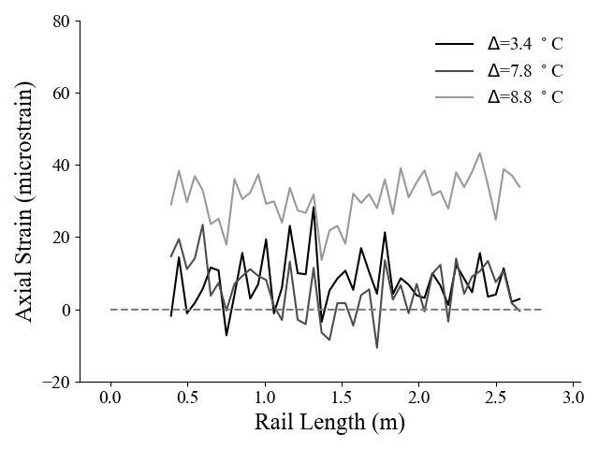
Figure 3. Axial strain a) compressive buckling test, b) thermal buckling test
a)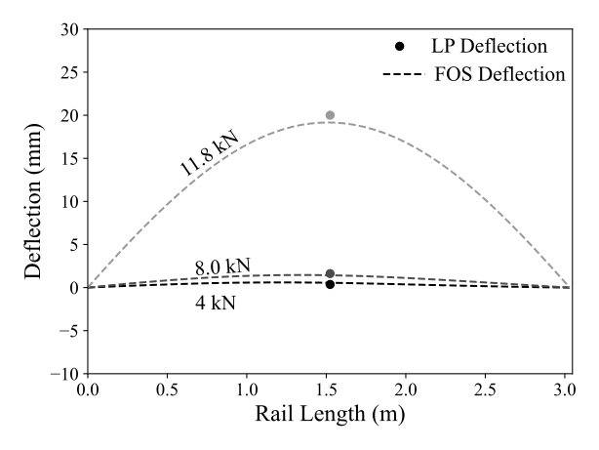
b)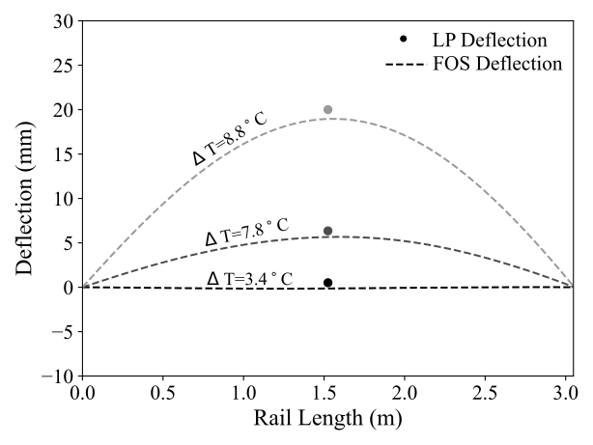
Figure 4. Lateral displacement profile estimated using DFOS data in a) compressive buckling test, b) thermal buckling test

Field test
The DFOS strain measurements were thermally calibrated using the temperature measurement from the thermocouples before they were decomposed into the distributed axial strain and curvature. The rail temperature was considered to be uniform across the rail cross-section. The strain measurements at 4:00 am were chosen to evaluate the axial strain and lateral displacement as the solar radiation effect on the DFOS measurements at this time would be minimal. Figure. 5 presents the distributed axial strain along the monitored rail length. The axial strain is approximately zero, indicating there was no significant axial movement along the monitored rail length and the rail neutral temperature largely remained constant over the monitored period. The thermal stress developed inside the track due to the temperature change ($∆T)$from RNT can be evaluated as $Eα∆T$, where the value of E and $α$ can be found in Table. 1. The maximum track temperature during the monitored period was 53.9$℃$ in summer and -10.7$℃$ in the winter, corresponding to around 30.9$℃$ and -33.7 $℃$ differences from the RNT, respectively (assuming an RNT of 23 $℃$). This temperature variation is well below the allowable temperature increase of 50 $℃$, indicating the rail is at a low risk of buckling.
Figure. 6 presents the lateral displacement obtained by double integrating the distributed curvature profile derived from the DFOS measurements at 4:00 am. The maximum/minimum lateral displacement at night during the winter is 2.7 mm/-3.4 mm, while in summer is 2.0 mm/-5.6 mm. Those deflections are below the allowable lateral deflection (8 mm) specified by Kish et al. [7], also indicating the rail has a low risk of buckling during the two monitored periods.
a)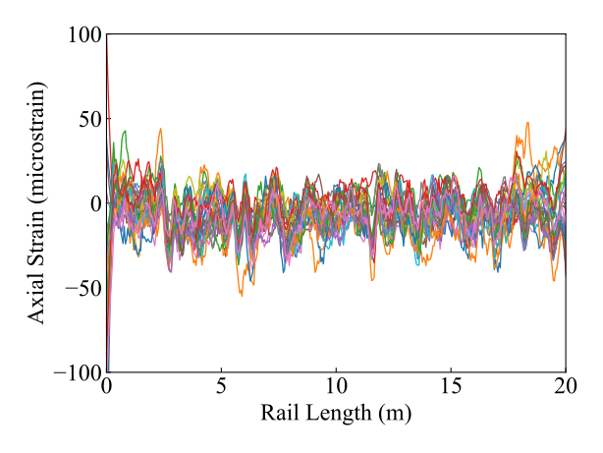
b) 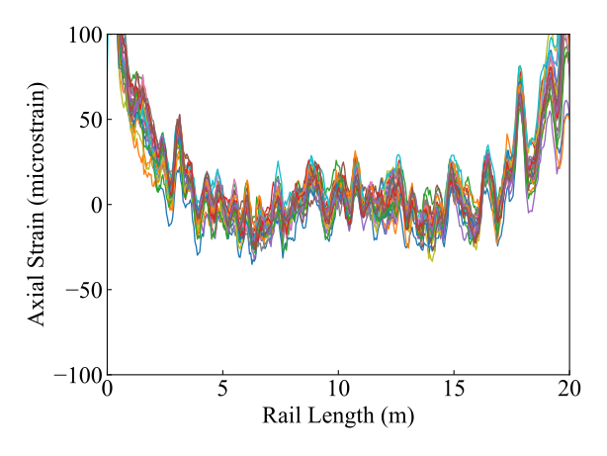
Figure. 5 Axial strain at 4:00 am for a) 27 days in fall, b) 26 days in summer
a)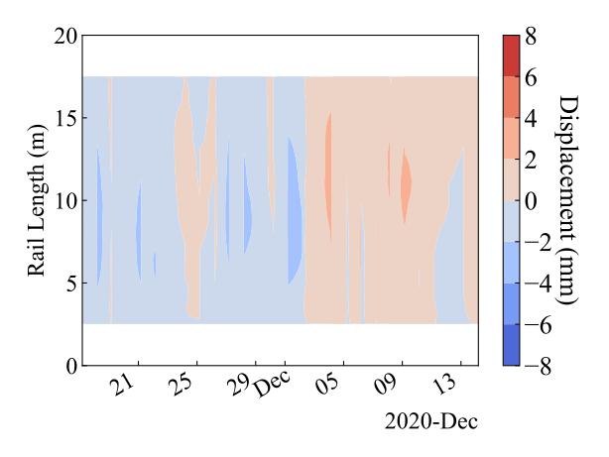
b) 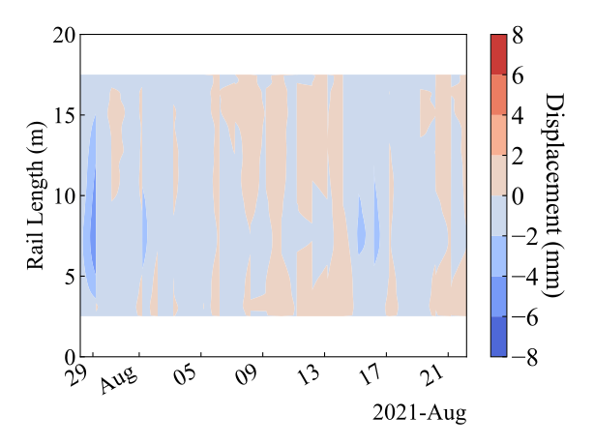
Figure. 6 Lateral displacement at 4:00 am in a) fall, b) summer

ConclusionS
The feasibility of using DFOS for rail lateral response monitoring under both mechanical and thermal axial force has been evaluated in both controlled lab experiments and field tests. Using the fitting strain plane approach, the distributed axial strain and curvature can be derived. The axial strain together with the temperature measurements can be used to monitor the axial stress and the distributed curvature can be used to monitor the lateral deflection as part of long-term monitoring of rail response. Both features are critical for evaluating the risks of rail buckling. The results show that DFOS enables the accurate estimation of distributed rail axial stress and lateral deflection.
Future work in this area involves investigating the use DFOS for long-term monitoring during the daytime by accounting for the effect of solar radiation. Due to the different locations of the sun, the fibers at different locations on the rail experience different level of solar radiation, resulting in a temperature difference in the fibers. Failing to consider this temperature difference will result in unrealistic estimations of lateral deflection.

AcknowledgeMents
This project was supported in part by collaborative research funding from the National Research Council of Canada’s Artificial Intelligence for Logistics Program. This research was also supported by the Natural Sciences and Engineering Research Council of Canada and Transport Canada. The authors also appreciate the support of Paul Charbachi from VIA, Canada for providing the site access and Heshan Fernando from Queen’s University for the assistance in preparing the experiments.

Reference
- Kish, A. and Samavedam, G., 2013. Track buckling prevention: theory, safety concepts, and applications (No. DOT/FRA/ORD-13/16). John A. Volpe National Transportation Systems Center (US).
- González, F.J., Suarez, B., Paulin, J. and Fernández, I., 2008. Safety assessment of underground vehicles passing over highly resilient straight track in the presence of a broken rail. Proceedings of the Institution of Mechanical Engineers, Part F: Journal of Rail and Rapid Transit, 222(1), pp.69-84.
- Suárez, B., Rodriguez, P., Vázquez, M. and Fernández, I., 2012. Safety assessment of underground vehicles passing over highly resilient curved tracks in the presence of a broken rail. Vehicle system dynamics, 50(1), pp.59-78.
- Gu, L., Zhang, L., Bao, X., Zhang, M., Zhang, C. and Dong, Y., 2018. Detection of thermal strain in steel rails with BOTDA. Applied Sciences, 8(11), p.2013.
- Barker, C., Hoult, N.A. and Zhang, M., 2021. Development of an axial strain measurement system for rails. Journal of Performance of Constructed Facilities, 35(1), p.04020145.
- Sun, F., Hoult, N.A., Butler, L.J. and Zhang, M., 2021. Distributed monitoring of rail lateral buckling under axial loading. Journal of Civil Structural Health Monitoring, pp.1-18.
- Kish, A., Samavedam, G. and Wormley, D., 1998. Fundamentals of track lateral shift for high-speed rail applications.

