ABSTRACT: Currently, traffic loading data collected on UK’s railway network is incomplete, and the understanding of its actual characteristics is mainly qualitative and empirical in nature. This has an adverse impact on many applications such as design, assessment, maintenance and preservation of transportation infrastructure. This paper presents a case study conducted on a railway bridge in an effort to set up a real-time train load monitoring system using Bridge Weigh-in-Motion (B-WIM) technology. A B-WIM system uses deformations from sensors on an instrumented bridge during the passage of vehicles to transform the bridge into a system to determine actual traffic loading. The instrumented bridge in this study is located on the West Coast Mainline in Staffordshire, UK and was instrumented with fiber-optic sensors during construction in 2015. Recently, the authors upgraded the existing sensing system by adding additional sensors to set up a B-WIM system to monitor actual traffic loading. Initially, the system was calibrated using the deformation response of the bridge to a train of known axle weights and axle configuration. Subsequently, axle and gross weights of three different trains were predicted using the B-WIM system to validate the system accuracy against the gross train weight information available online. Overall, the results show that the errors in gross train weight predictions are less than +/- 2.5%.

Setting up a real-time train load monitoring system in the UK using Bridge Weigh-In Motion technology - A case study
F. Huseynov^{1,2}, P.R.A. Fidler^{1,2}, M. Bravo-Haro^{1,2}, V. Vilde^{1,2}, J.M. Schooling^{1,2}, C.R. Middleton^{1,2}
¹ Department of Engineering, University of Cambridge, Civil Engineering, 7a JJ Thomson Ave., Cambridge CB3 0FA, U.K
² Centre for Digital Built Britain, University of Cambridge, 21 JJ Thomson Ave., Cambridge, CB3 0FA
Email : fh392@cam.ac.uk, praf1@cam.ac.uk, mab261@cam.ac.uk, vlmv2@cam.ac.uk, jms33@cam.ac.uk, crm11@cam.ac.uk

KEY WORDS: Bridge Weigh-In-Motion; Traffic loading; Railway Live Load Monitoring; Fiber-optic sensing.

Introduction
Bridges, connecting communities and serving as regional lifelines, are vital components of transport infrastructure. They are designed to maintain their functionality for 75 to 100 years of service life. In most developed countries, the majority of bridges are nearing the end of their designed service lives [1], while the weights and frequencies of freight transport vehicles are increasing. Further, many bridges are being kept in service much longer than they were originally designed for. Therefore, bridge owners are particularly interested in accurate methods of assessing vehicle weight and verifying load carrying capacity of their aging structures. This can be achieved by installing a Bridge Weigh-In-Motion (B-WIM) system.
A B-WIM system, first proposed by Moses [2], uses the response of a bridge to a traversing vehicle to predict its axle weights. It consists of a system of sensors to measure deformations induced by traversing vehicles, axle detectors to identify the presence of axles entering and leaving a bridge and a data acquisition unit to store the recorded data.
Broadly speaking, a B-WIM system solves an inverse-type problem where bridge deformations induced by live loading are measured, and the gross and axle weights of traversing vehicles are back-calculated. The algorithm is based on influence lines. An influence line is a structural property representing the deformation response of a bridge to a moving unit load. A B-WIM installation typically involves a system calibration where the influence lines at the sensor locations are first derived using measured deformations induced by a test vehicle with a known axle weight and axle configuration. Once the influence lines are known then, during the operation phase, the algorithm separates the contribution of individual axles of an arbitrary vehicle from the total measured response and predicts the axle loads based on the fact that a moving load on a bridge will cause stresses in proportion to the product of the value of the influence line and the axle load magnitude.
Section 2 provides a brief overview of the structural configuration of the instrumented bridge, while Section 3 summarizes the sensing system required by the B-WIM system. Section 4 describes the B-WIM installation and calibration process. Finally, Section 5 presents the weight prediction results obtained during the passage of three different trains to validate the accuracy of the system.

Description of the Bridge
The railway bridge, named Intersection Bridge 5 (IB5), was built in 2015 and is located on the West Coast Mainline in Staffordshire, UK. It is a single-span composite structure made of two steel I-shaped plate girders and a cast-in-situ reinforced concrete (RC) deck slab, spanning 26.8 m over a railway line. The main girders are linked by cross beams near the bottom flanges to form a half-through structural configuration, a common bridge type in railways that allows wider clearance between the overhead lines of the railway beneath and the soffit of the bridge. The superstructure is 2.2 m deep and 7.3 m wide, carrying two railway tracks and rests on two cantilever type abutments skewed by 22.6 degrees with respect to the bridge span. The connection between superstructure and substructure is provided with rocker type bearings designed to provide pin-roller type support conditions. Figure 1 shows a photo of the bridge site.

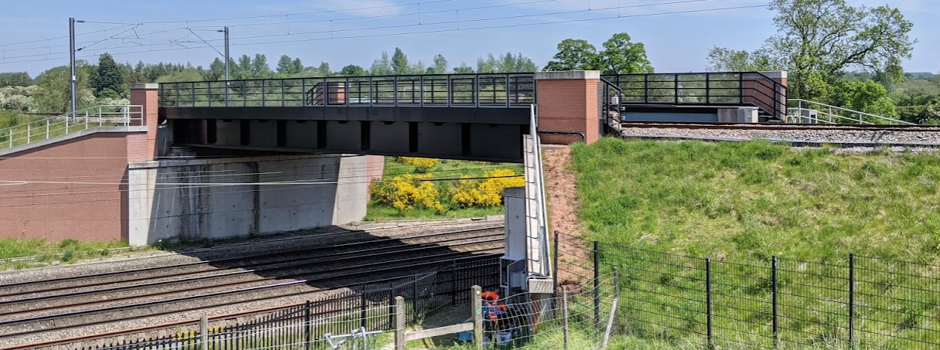
Figure 1. Bridge IB5 in Staffordshire, UK

Instrumentation
Bridge IB5 was instrumented during construction with a discrete fiber-optic sensing system based on fiber Bragg grating (FBG) technology that measures dynamic strain and temperature data. Fiber-optic cables with FBG sensors at 1 m intervals were attached to main girders, crossbeams, and a web stiffener and were embedded into the RC deck slab and prestressed precast (PCC) sleepers (see Figure 2). Both main girders were instrumented with 20 FBGs at the top and bottom flanges. Three cross beams, located near the midspan and bridge support, were instrumented with 7 FBGs at the top and bottom flanges. RC decks slab were embedded with an array of 7 FBGs at the top and bottom fibers at the midspan and quarter span locations. Three prestressed sleepers placed near the midspan were instrumented at the precast facility before being brought to the site for installation.

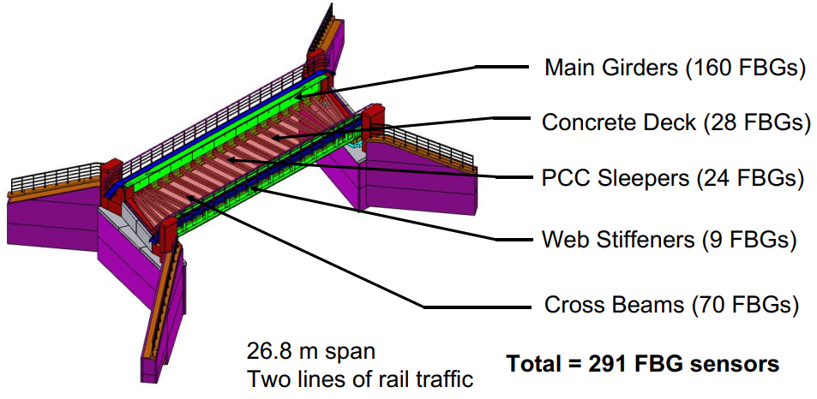
Figure 2. FBG sensor layout
The data acquired from the FBG sensors has been used in several studies [3]–[7] to investigate the bridge performance during construction and early service life. Recently, Network Rail provided permanent power to the site, which has allowed the authors to build a continuous monitoring system. During an overnight track closure, additional sensors were installed in order to set up a real-time train load monitoring system using B-WIM technology. In addition to measured deformations, the B-WIM system requires axle position information as an input into the algorithm to perform weight predictions, which was missing in the original sensing system. Therefore, a new-axle detection system was developed and installed on the bridge based on laser range finder (LRF) sensors. An LRF sensor measures distance by beaming light to a surface of interest at a high frequency and measures distance from the time taking the light to travel and reflect off the target’s surface. As shown in Figure 3 a), the sensors were attached at both ends of the bridge pointing to the railway tracks. Figure 3 b) shows a close view of the sensor. The idea is that when an axle crosses the sensor location, it cuts the beam, which results in spikes in the time history signal, and it is used to identify the presence of axles entering and leaving the bridge. Since the distance between the axle detectors at both ends of the bridge is known, it is then possible to determine the speed and axle configuration of passing trains and accurately locate their position on the bridge during the entire period of a train crossing. A typical time history signal from an axle detector captured during a passage of a train with eight carriages is depicted in Figure 3 c).

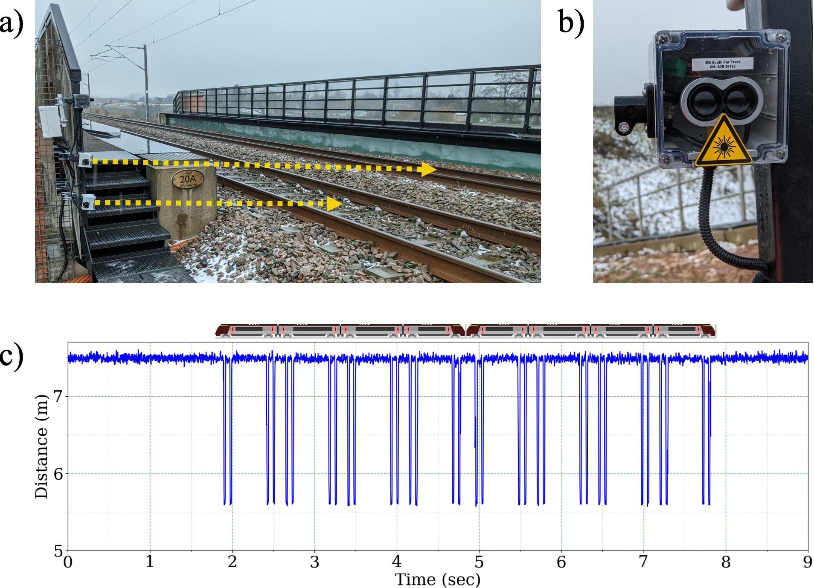
Figure 3. Axle Detection system a) axle detectors pointing to the railway tracks b) close view of an LRF sensor c) a typical time history signal acquired during a train crossing.

B-WIM Calibration and testing
The process for calibrating a B-WIM system requires a deformation response of a bridge induced by a vehicle of known axle weights and axle configuration. For this purpose, the authors used the data acquired on 9th December, 2021, during the New Measurement Train (NMT) passage. The NMT is a train instrumented by Network Rail that regularly travels across the network to assess the condition of railway tracks. It has fixed axle weights which are known to NR and were provided to the authors. The train consists of two diesel-powered locomotives located at both ends with four specialist carriages in between.
Typical time history signals recorded during the NMT crossing are presented in Figure 4. Figure 4 a) shows the axle detection results obtained from both bridge ends, which are used to determine the train speed and axle configurations. Figure 4 b) depicts a typical strain time history signal obtained from an FBG sensor on the bottom flange of the West main girder at the midspan location. The red and blue data markers in the figure are the projection of axle detection results and represent the timestamps of axles entering and leaving the bridge, respectively.
The strain influence lines at each sensor location were obtained using the procedure developed by O’brien et al. [8]. Figure 5 shows the strain influence line calculated over 40.6 m length using the data from the sensor on the bottom flange of the west main girder at the midspan location. It shows the bridge response to a moving 1 tonne point loading. It is shown that when an axle enters and leaves the bridge, it results in hogging action, likely due to the skew effect. The maximum amplitude of stresses occurs when a point load is at the sensor location (i.e., midspan)
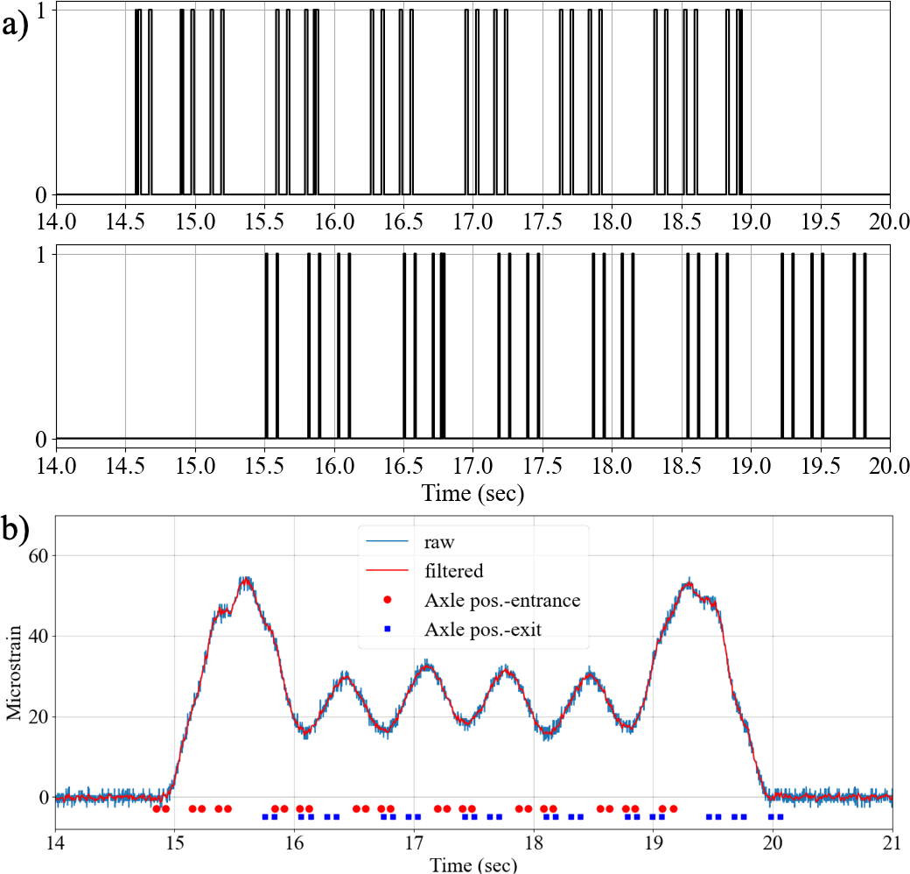
Figure 4. Time history signals recorded during the NMT crossing. a) axle detection results b) strain time history signal from the west main girder bottom flange at the midspan location.
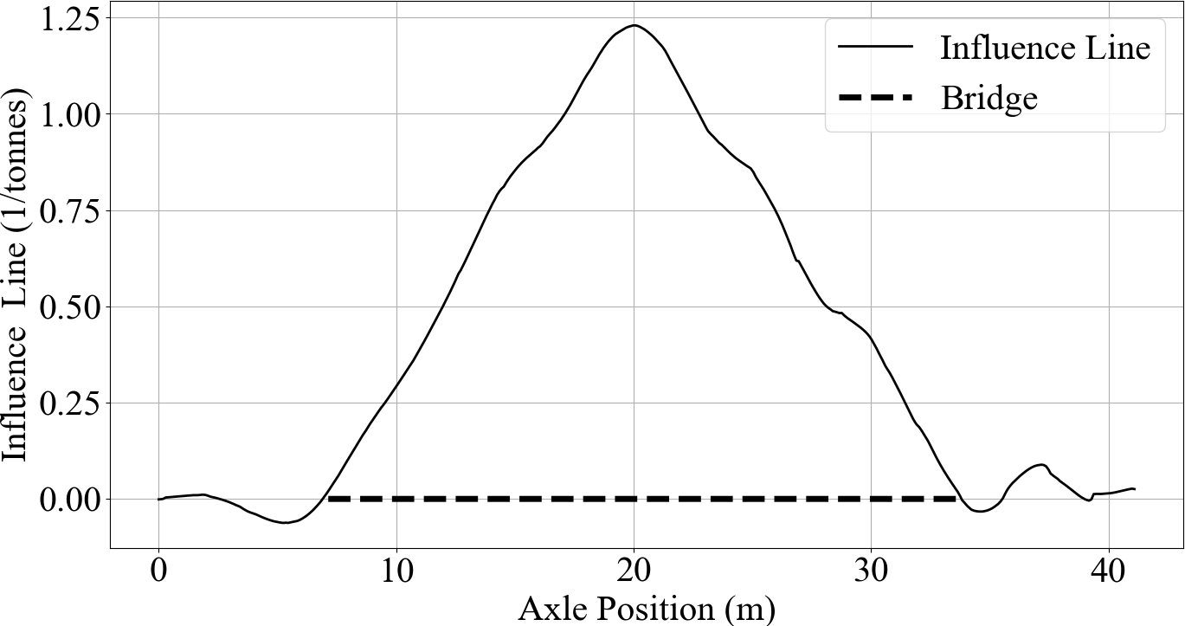
Figure 5. IB5 Bridge strain influence line of the west main girder bottom flange at the midspan location.

Results and Discussion
This section presents weight prediction results from the B-WIM system obtained during the passage of three trains with total gross weight information available online in an attempt to validate the accuracy of the live load monitoring system presented in this study. Table 1 tabulates the train types and configurations and summarizes the actual and predicted gross train weights. The first and the second trains are passenger trains that crossed the bridge site on a Sunday morning and were assumed to be mostly empty. The third train is a tamping machine used by Network Rail to maintain railway tracks and has a fixed gross weight.
Table 1. Train crossings.
No | Type | Number of |  | Gross Weight  (tonnes) |  | Error  (%)
No | Type | Axles | Cars | Actual | Predicted | Error  (%)
1 | Class 221 | 20 | 5 | 281.9 | 275.9 | 2.1
1 | Class 220 | 16 | 4 | 185.6 | 190.5 | 2.3
2 | Class 350 | 16 | 4 | 175 | 178 | 3
3 | Tamping Machine | 6 | 1 | 100 | 101 | 1
The first train consists of British Rail Class 221 (5-car set) and Class 220 (4-car set) trains, coupled together to form a passenger train with nine carriages. Both Class 221 and Class 220 belong to the Super Voyager Class and are diesel-electric multiple unit express passenger trains built by Bombardier Transportation. The total weights of Class 221 and Class 220 trains are 281.9 tonnes and 185.6 tonnes, respectively. The axle weight prediction results from the B-WIM system are provided in Figure 6 a). The total train weights estimated for Class 221 and Class 220 are 275.9 tonnes and 190.5 tonnes, which deviated from the actual gross weights by 2.1% and 2.3%, respectively. Figure 6 b) depicts the strain response recorded during the train crossing using an FBG sensor on the west main girder midspan and the corresponding predicted response obtained from the B-WIM system. The predicted response is calculated by adding the responses due to individual axles (black dashed lines). It is shown in the figure that the measured and predicted responses align well, suggesting high confidence in the accuracy of weight predictions.

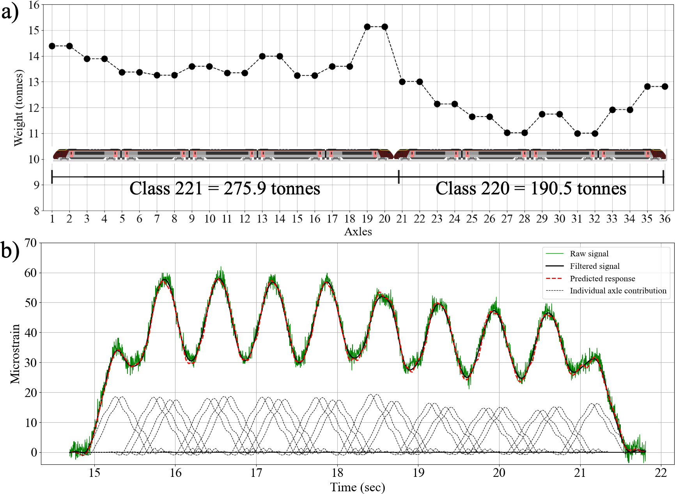
Figure 6. B-WIM results for a passenger train crossing a) axle weight predictions b) measured vs. predicted strain response.
The second train, designated by Network Rail as the British Rail Class 350, is an electric-multiple-unit (EMU) passenger train built by Siemens Transportation Systems. It comes in a 4-car set formation and has a total weight of 175 tonnes. As shown in Figure 7 a), each car consists of two bogies with double axles spaced at 2.59 m apart. Figure 7 b) presents the axle weight predictions from the B-WIM system. The predicted train weight is 178.6 tonnes, 2.1% different from its actual gross weight. Figure 7 c) shows the measured and predicted total strain response on the west main girder midspan and corresponding individual axle contributions to the total response. As shown in the figure, there is a good alignment between the measured and predicted signals.
Finally, the third train used in this study is a Unimat 08-4x4/4s-RT model universal tamping machine built by Plasser. The train consists of a single locomotive with three bogies, as shown in Figure 8 a), and it has a total weight of 100 tonnes. Figure 8 b) depicts the axle weight predictions. The first two bogies are twice the load of the final bogie, and the total gross weight is estimated as 101.3 tonnes, only 1.3% different from the actual gross weight. Measured and predicted strain responses are presented in Figure 8 c).
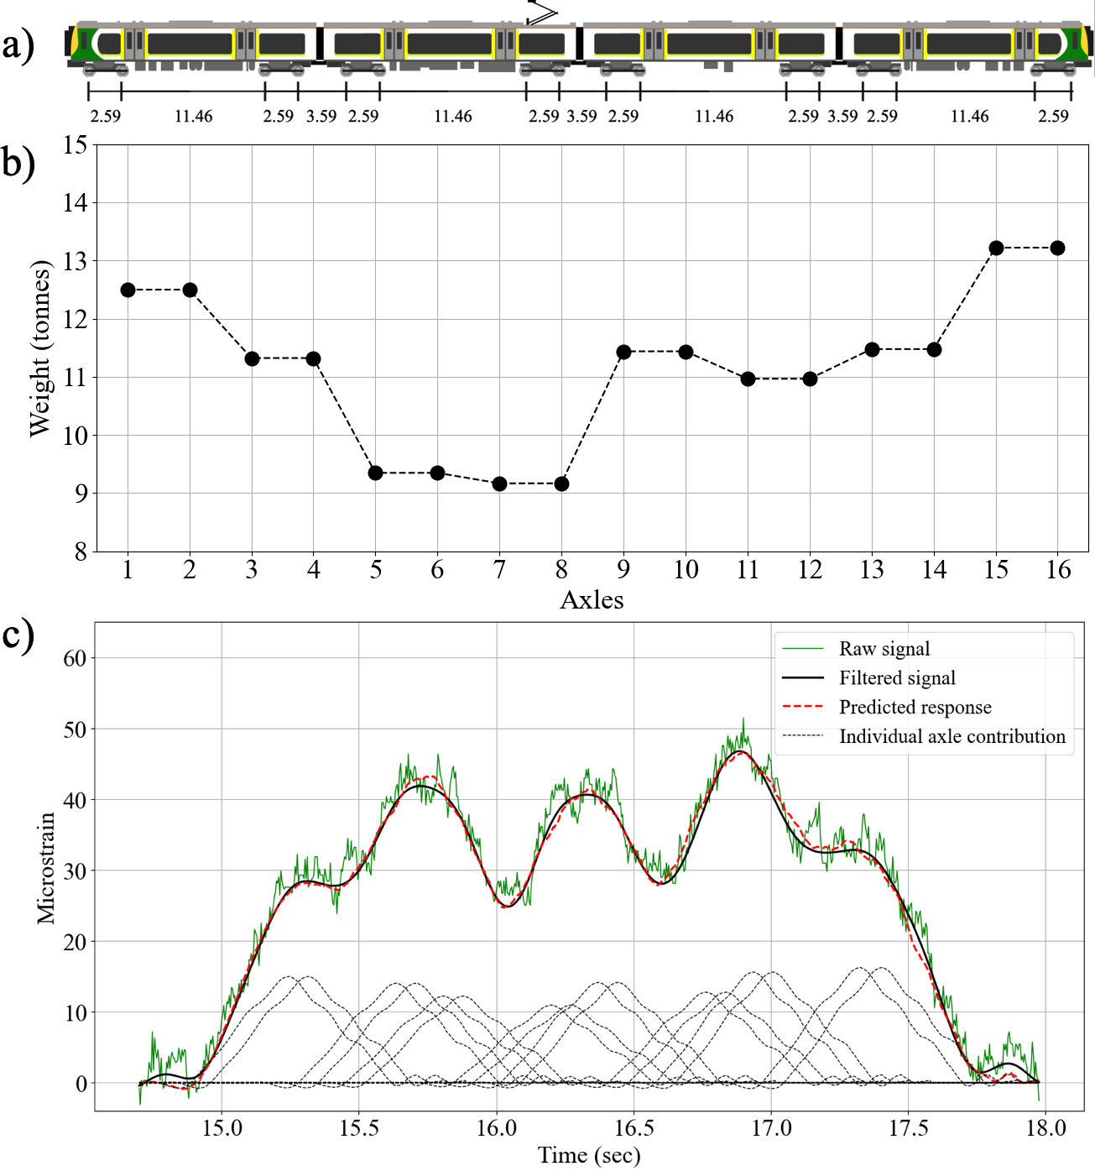
Figure 7. B-WIM results for a passenger train crossing a) axle weight predictions b) measured vs. predicted strain response.

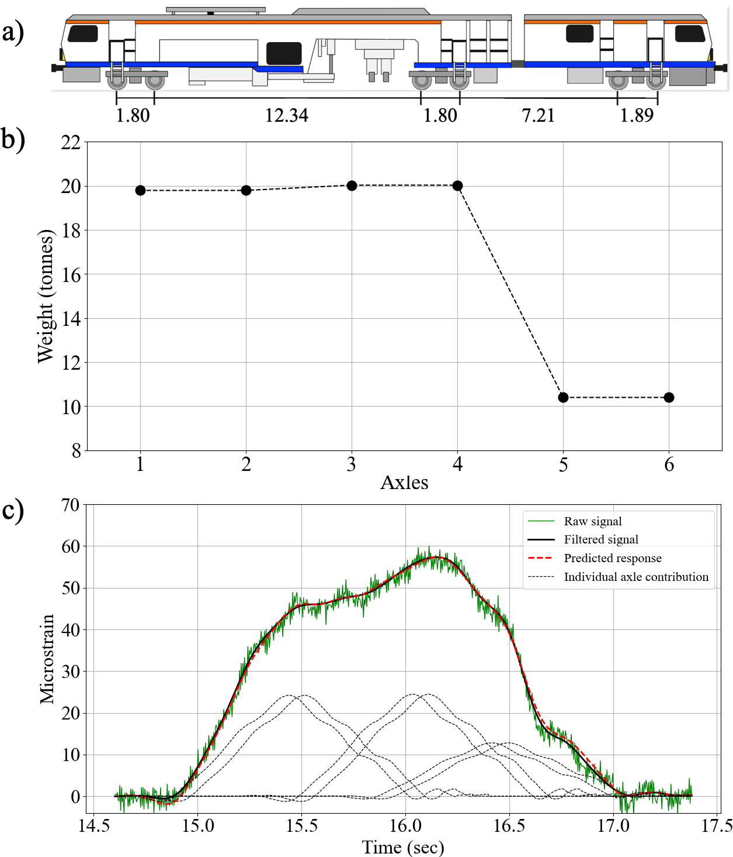
Figure 8. B-WIM results for tamping machine crossing a) axle weight predictions b) measured vs. predicted strain response.

Conclusions
This paper presents a case study of setting up a real-time train load monitoring system on the UK’s railway network based on Bridge Weigh-In-Motion technology. Initially, the deformation response of an instrumented bridge to a train loading of known axle weights and axle configuration was used to calibrate the B-WIM system. Subsequently, weight prediction results obtained for three different train crossings were used to validate the system accuracy. Overall, the results show that the B-WIM system presented in this study is able to predict the gross weights of passing trains with less than +/- 2.5% error.

ACKNOWLEDGMENTS
This research forms part of the Centre for Digital Built Britain’s (CDBB) work at the University of Cambridge. It was enabled by the Construction Innovation Hub, of which CDBB is a core partner, and funded by UK Research and Innovation (UKRI) through the Industrial Strategy Challenge Fund (ISCF).
For the purpose of open access, the author has applied a creative commons attribution (CC BY) license to any author accepted manuscript version arising.

References
[1] A. Žnidarič, V. Pakrashi, E. O’Brien, and A. O’Connor, “A review of road structure data in six European countries,” Proceedings of the Institution of Civil Engineers: Urban Design and Planning, vol. 164, no. 4, pp. 225–232, Dec. 2011, doi: 10.1680/udap.900054.
[2] F. Moses, “Weigh-in-Motion System Using Instrumented Bridges,” Transportation Engineering Journal of ASCE, vol. 105, no. 3, pp. 233–249, May 1979, doi: 10.1061/TPEJAN.0000783.
[3] E. Febrianto, L. Butler, M. Girolami, and F. Cirak, “A Self-Sensing Digital Twin of a Railway Bridge using the Statistical Finite Element Method,” pp. 1–15, 2021, [Online]. Available: http://arxiv.org/abs/2103.13729
[4] L. J. Butler, N. Gibbons, C. Middleton, and M. Z. E. B. Elshafie, “Integrated fibre-optic sensor networks as tools for monitoring strain development in bridges during construction,” IABSE Congress Stockholm, 2016: Challenges in Design and Construction of an Innovative and Sustainable Built Environment, no. September, pp. 1762–1770, 2016.
[5] W. Lin, L. J. Butler, M. Z. E. B. Elshafie, and C. R. Middleton, “Performance Assessment of a Newly Constructed Skewed Half-Through Railway Bridge Using Integrated Sensing,” Journal of Bridge Engineering, vol. 24, no. 1, p. 04018107, Jan. 2019, doi: 10.1061/(ASCE)BE.1943-5592.0001334.
[6] L. J. Butler, W. Lin, J. Xu, N. Gibbons, M. Z. E. B. Elshafie, and C. R. Middleton, “Monitoring, Modeling, and Assessment of a Self-Sensing Railway Bridge during Construction,” Journal of Bridge Engineering, vol. 23, no. 10, pp. 1–32, 2018, doi: 10.1061/(ASCE)BE.1943-5592.0001288.
[7] J. M. Davila Delgado, L. J. Butler, I. Brilakis, M. Z. E. B. Elshafie, and C. Middleton, “Structural Performance Monitoring Using a Dynamic Data-Driven BIM Environment,” Journal of Computing in Civil Engineering, vol. 32, no. 3, p. 04018009, May 2018, doi: 10.1061/(ASCE)CP.1943-5487.0000749.
[8] E. J. O’Brien, M. J. Quilligan, and R. Karoumi, “Calculating an influence line from direct measurements,” Proceedings of the Institution of Civil Engineers - Bridge Engineering, vol. 159, no. 1, pp. 31–34, Mar. 2006, doi: 10.1680/bren.2006.159.1.31.

