ABSTRACT: The corrosion-resistant characteristics of glass fibre-reinforced polymer (GFRP) reinforcing bars make them a suitable alternative for steel reinforcements in structural applications subjected to harsh environmental conditions, such as bridges and parking garages. Despite much research on the performance of GFRP reinforced concrete (RC) elements under static loading, there is a lack of experimental data on the fatigue performance of GFRP RC flexural elements. This paper discusses the stiffness degradation of a ribbed GFRP RC beam tested under high cyclic fatigue. Based on the results, the fatigue and the importance of structural health monitoring applied on bridges are described.

**Stiffness Degradation of GFRP Reinforced Concrete Beam Under High-Cyclic Fatigue Loading**

Islam Elsayed Nagy1,2, Alireza Asadian1, Khaled Galal1

1Building Civil and Environmental Engineering Department, Gina Cody School of Engineering and Computer Science, Concordia University, Montreal, Quebec, Canada, H3G 1M8

2Structure Engineering Department, Ain Shams University, Cairo, Egypt

Email: islam.elsayednagy@concordia.ca, [alireza.asadian@concordia.ca](mailto:alireza.asadian@concordia.ca), khaled.galal@concordia.ca.

KEY WORDS: High cyclic, Fatigue, Ribbed GFRP bars, GFRP RC elements, Structural health monitoring.

# INTRODUCTION

Glass fibre-reinforced polymer (GFRP) is currently used as internal reinforcement in several structural applications. Many research studies are available on the performance of GFRP reinforced concrete (RC) elements under static loading. Although the use of GFRP is increasing in bridge applications, testing data are scarce on the long-term behavior of GFRP bars under fatigue loading [1].

Several design codes and guidelines addressing FRP bars as a primary reinforcement for structural concrete have been published [2]–[5]. The fatigue design provisions incorporated in these design codes and guides are still empirical and not based on experimental or field results. This research presents and discusses the test setup and testing of the GFRP RC beam tested under high cyclic fatigue.

Adimi et al. [6] tested carbon fibre-reinforced polymer (CFRP) rods fully encased with concrete under tension and cyclic loading. Their experimental results suggested a maximum fatigue stress limit of 35% of the tensile strength with a stress ratio of 0.1 to reach 4 million fatigue life cycles. Moreover, they concluded that the testing frequency has a considerable effect on the results; the life of the specimen could decrease by ten times if the frequency increased from 1 Hz to 5 Hz. This reduction in life was attributed to the high temperatures induced in the bar with high frequencies.

El-Ragaby et al. [7] tested six concrete deck slabs reinforced with steel and GFRP rebar. Although punching shear was the failure mode, the accumulated damage was assessed based on the residual deflection and strains of the slabs. Concrete deck slabs reinforced with GFRP sustained two and half times longer fatigue life than deck slabs reinforced with steel reinforcement.

Noёl & Soudki [8] tested GFRP reinforcing bars under uniaxial tension and bending in concrete beams. They were ground in the middle to avoid premature failures of the GFRP bars in the uniaxial tension test. Due to the bond-slip abrasion and stress gradient in the reinforcement, they concluded that the bars embedded in the concrete have a shorter fatigue life than those embedded in the air. To account for those factors, a fatigue stress factor was introduced.

Noёl & Soudki [9] tested sixteen slab strips reinforced with GFRP and posttensioned CFRP, with and without headed bars. They recommended further study of the fatigue behaviour considering bar types, material composition, mechanical properties, surface treatment and bar diameter.

Janus et al. [10] performed an experimental study by testing eighteen bare sand-coated GFRP bars and twelve GFRP bars embedded in concrete under fatigue loading at a frequency of 4 Hz. They observed some degradation to the bar surface of the bars due to friction with the concrete. The tests were under 40, 50 and 60% of the ultimate stress of the bars. Ondrej et al. concluded that the bars encased in concrete have better fatigue than those tested in air. Based on the S‒N diagram Ondrej et al. drew, the bars tested in air will not reach two million cycles, while the bars tested in concrete can reach two million cycles of fatigue life at approximately 17.5% maximum ultimate stress.

In 2021, Janus et al. [11] tested four sand-coated GFRP reinforced beams under fatigue loading. One beam was tested under constant fatigue loading to induce maximum stress in the GFRP bars at 20% of the ultimate stress and stress ratio of 0.1. This beam reached two million cycles and was then tested under monotonic loading for comparison with the static beam. After two million cycles, there was a slight difference in capacity between the fatigued beam and the statically loaded beam. The other three beams were tested under gradual loading until failure. Ondrej et al. used Miner’s rule to predict the fatigue life, but it underestimated the experimentally tested fatigue life of the tested beams.

Mousa et al. [12] performed a review study about the application of digital image correlation for health monitoring structural bridges. This is considered an accurate, nondestructive way to monitor cracks, strains and many other readings on bridges.

In the next sections, a high cyclic fatigue test performed at Concordia University is described. The test is conducted on a concrete beam reinforced with ribbed GFRP bars. Only 445 thousand cycles are presented in this paper, and the test is still ongoing. The test setup described along with dimensions of the beam and material mechanical properties of the concrete and GFRP bars. Furthermore, the static and fatigue loading are illustrated, then some results of the beam are shown with discussion.

# TEST SETUP

A test setup is constructed at Concordia University to test reinforced concrete beams under fatigue loading with a dynamic actuator of 160 kN capacity (see Fig. 1). The beams are simply supported on a hinge that allows the rotation and roller support to allow the horizontal movement of the beam with free rotation.

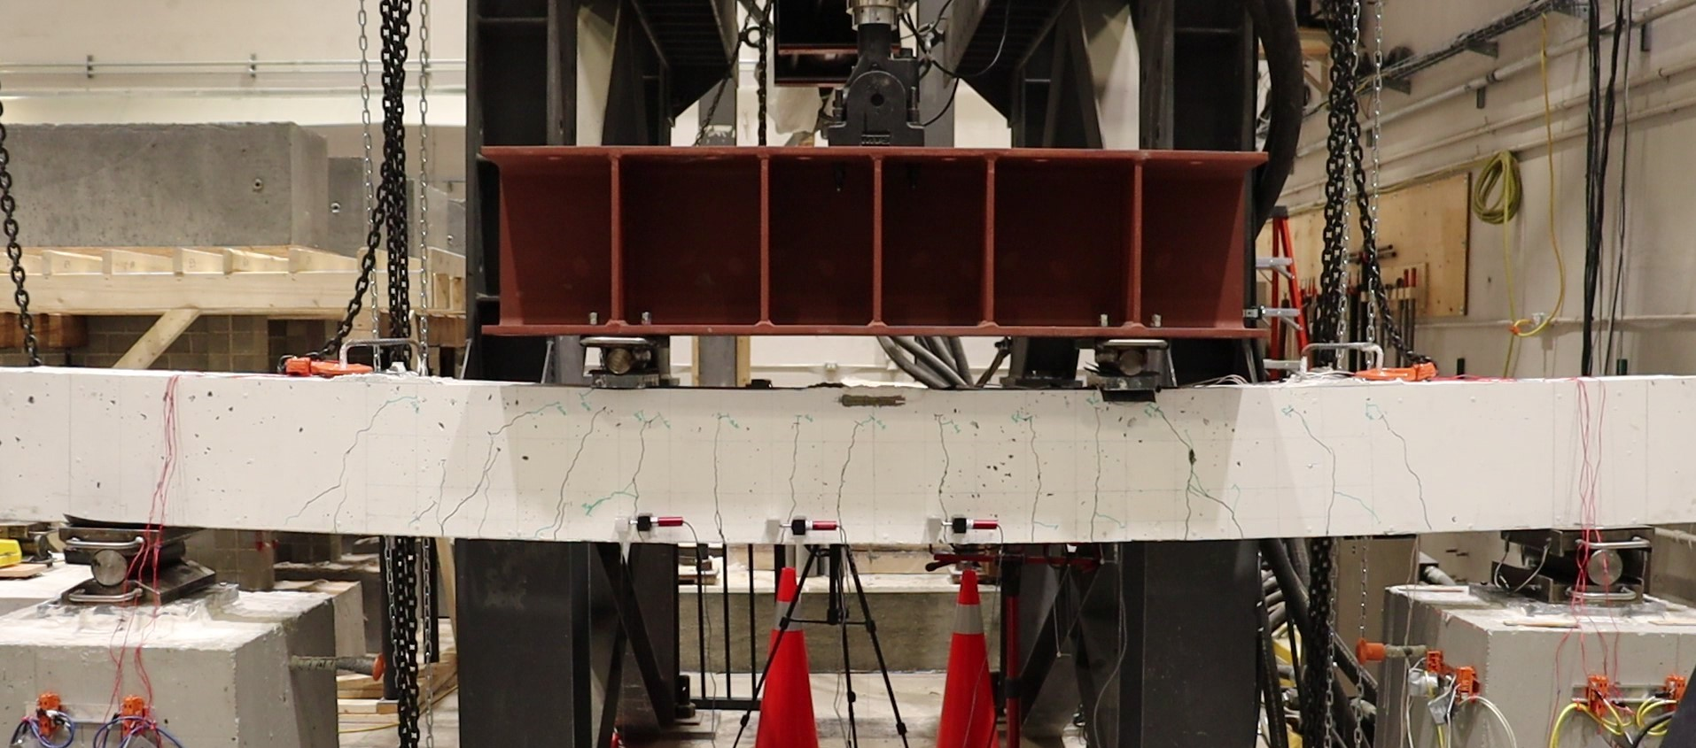

Figure 1. Test setup.

The beam dimensions and concrete compressive strength are as shown in Table 1.

Table 1. Beam dimensions and concrete compressive strength.

|  |  |  |  |
| --- | --- | --- | --- |
| Width (mm) | Depth (mm) | Length (mm) | Average Concrete Compressive Strength (MPa) |
|
| 200 | 300 | 3000 | 57.5 |

The concrete beam is reinforced with three #5 GFRP ribbed bars with a 30 mm clear cover. 10 M steel stirrups resist the shear stress with 10 cm spacing in the shear spans and 30 cm spacing in the mid 1 m moment span, see Fig. 2.



Figure 2. Beam Elevation.

The nominal mechanical properties for the GFRP bars are shown in Table 2.

Table 2. Properties of GFRP bars.

|  |  |  |
| --- | --- | --- |
| Bar Nominal Diameter (mm) | Average Tensile strength (MPa) | Average Modulus of Elasticity (GPa) |
|
| 15.9 | 1149 | 57.3 |

# load protocol

A dynamic actuator with a 160 kN capacity applies the load. The load is then distributed using a steel beam to load the beam on two-point loads with 1 m spacing.

The load is applied statically at a rate of 1.2 mm/min until the load reaches the maximum fatigue load (91.75 kN); then, the load is decreased at the same rate to the minimum fatigue load is reached (36.75 kN).

Fatigue loading is then applied on the beam at a frequency of 2 Hz. For safety reasons, an algorithm was developed to apply the load using displacement control, while maintaining the maximum and minimum fatigue loads within 1.5% of desired force. In other words, the actuator loads the beam between two displacements to reach the desired fatigue forces. The displacements are adjusted automatically to determine the forces when the beam loses its stiffness after a certain number of loading cycles.

The test is still undergoing at Concordia University, the beam has not yet failed, after 445 thousand cycles.

The beam is designed so that when it is loaded by the maximum fatigue load (Pmax= 91.75 kN), the maximum tensile stress in the bar is 30% of the ultimate tensile stress. Additionally, the ratio between the maximum fatigue load Pmax and the minimum fatigue load Pmin equals 0.4.

# results

This section represents and discusses the results of the tested beam under fatigue loading after 445 thousand cycles. During the first few thousand cycles, the beam lost a considerable value of its initial relative stiffness. This can be clearly shown from the crack propagation (see Fig. 3).

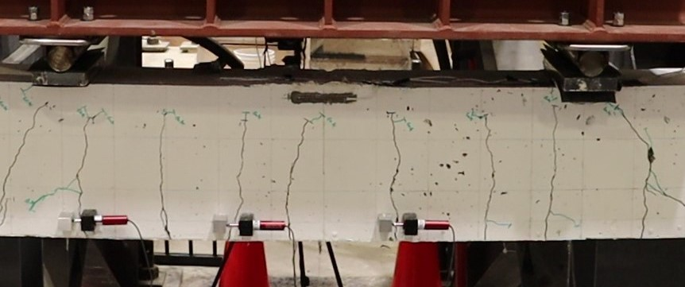

Figure 3. Crack propagation.

The relative stiffness of the beam is calculated based on the potentiometer readings, as shown in the equation below:

$Relative stiffness=\frac{Pmax-Pmin}{Dmax-Dmin}$ (1)

where Pmax and Pmin are the maximum and minimum fatigue forces acting on the beam, respectively. Dmax and Dmin are the maximum and minimum displacements measured at the mid-section of the beam. The trend of the stiffness degradation is shown in Fig. 4.

Figure 4. Stiffness degradation trend.

As shown in Figure 4, in the tested cycles, the relative stiffness decreased. The stiffness decreased approximately 84% of its initial value. Most of this reduction happened in the first hundred thousand cycles, representing the first stage of the fatigue life cycle.

The reduction in stiffness will affect the serviceability of the bridge. For example, the deflection of the bridge will increase with time. Additionally, the vibrational acceleration of the bridge will be higher. The continuing change in inertia and response show the importance of health monitoring on structural bridges. It should be noted that the results presented herein are preliminary and part of an extensive research program at Concordia University.

# conclusions and recommendations

In conclusion, the GFRP reinforced concrete beam survived 445 thousand cycles under fatigue. The maximum stress acting on the GFRP bars in the beam is 30% of the ultimate tensile strength, and the stress ratio is 0.4.

The relative stiffness of the GFRP reinforced beam at the middle section was reduced by approximately 84% in the tested cycles, which also appeared as crack propagation and increased deflection readings.

It is recommended to add structural health monitoring systems to structural bridges to monitor cracks, deflection and vibrational acceleration.

# References

[1] A. El-Ragaby, E. El-Salakawy, and B. Benmokrane, “Fatigue analysis of concrete bridge deck slabs reinforced with E-glass/vinyl ester FRP reinforcing bars,” *Compos. Part B Eng.*, vol. 38, no. 5–6, pp. 703–711, Jul. 2007, doi: 10.1016/j.compositesb.2006.07.012.

[2] Canadian Standards Association, “Canadian Highway Bridge Design Code (CSA S6-19 ),” *CSA S6-19*. CSA Group, Toronto, Ontario, Canada, p. 875, 2019.

[3] CSA S806-17, *Design and construction of building structures with fibre-reinforced polymers*. 2017.

[4] ACI 440.1R, *Guide for the Design and Construction of Structural Concrete Reinforced with Fiber-Reinforced Polymer Bars*. 2015. doi: 10.1016/0011-7471(75)90030-3.

[5] AASHTO, *AASHTO LFRD Bridge Design Guide Specifications for GFRP-Reinforced Concrete*. 2018.

[6] M. R. Adimi, A. H. Rahman, and B. Benmokrane, “New Method for Testing Fiber-Reinforced Polymer Rods under Fatigue,” *J. Compos. Constr.*, vol. 4, no. 4, pp. 206–213, Nov. 2000, doi: 10.1061/(ASCE)1090-0268(2000)4:4(206).

[7] A. El-Ragaby, E. El-Salakawy, and B. Benmokrane, “Fatigue Life Evaluation of Concrete Bridge Deck Slabs Reinforced with Glass FRP Composite Bars,” *J. Compos. Constr.*, vol. 11, no. 3, pp. 258–268, Jun. 2007, doi: 10.1061/(ASCE)1090-0268(2007)11:3(258).

[8] M. Noël and K. Soudki, “Fatigue Behavior of GFRP Reinforcing Bars in Air and in Concrete,” *J. Compos. Constr.*, vol. 18, no. 5, p. 04014006, Oct. 2014, doi: 10.1061/(ASCE)CC.1943-5614.0000468.

[9] M. Noël and K. Soudki, “Fatigue Behavior of Full-Scale Slab Bridge Strips with FRP Reinforcement,” *J. Compos. Constr.*, vol. 19, no. 2, p. 04014047, Apr. 2015, doi: 10.1061/(asce)cc.1943-5614.0000514.

[10] O. Januš, F. Girgle, I. Rozsypalová, V. Kostiha, L. Bodnárová, P. Štěpánek, and J. Prokeš, “The fatigue behaviour of gfrp bars - experimental study,” in *Acta Polytechnica CTU Proceedings*, Jul. 2019, vol. 22, pp. 38–47. doi: 10.14311/APP.2019.22.0038.

[11] O. Janus, F. Girgle, V. Kostiha, J. Prokes, and P. Stepanek, “Fatigue behaviour of gfrp reinforced beams,” in *Solid State Phenomena*, 2021, vol. 322 SSP, pp. 163–169. doi: 10.4028/www.scientific.net/SSP.322.163.

[12] M. A. Mousa, M. M. Yussof, U. J. Udi, F. M. Nazri, M. K. Kamarudin, G. A. R. Parke, L. N. Assi, and S. A. Ghahari, “Application of digital image correlation in structural health monitoring of bridge infrastructures: A review,” *Infrastructures*, vol. 6, no. 12, 2021, doi: 10.3390/infrastructures6120176.