ABSTRACT: In this paper, the modal parameters of a reinforced concrete beam are extracted using vibration tests. This research used a concrete beam of 200 mm in width, 250 mm in depth, and 2200 mm in length. Experimental modal analysis (EMA) was carried out at undamaged and different damage levels. The effectiveness of EMA was investigated through different support conditions, various hammer tips, position of the reference points, level of excitation and required averaging of excitations. The EMA method measured natural frequencies, damping ratios, and complex mode shapes by a frequency-domain technique applying the least-squares complex exponential method. The best setups for the dynamic tests based on the investigated parameters were proposed for the EMA method. The effect of damage in the concrete beam on the extracted natural frequencies and mode shapes was presented and discussed.

Experimental Modal Testing of Damaged Reinforced Concrete Beams
Kianfar, Ehsan¹, Arjomandi, Kaveh², Lloyd, Alan³
¹ PhD Candidate, Department of Civil Engineering, University of New Brunswick, Canada
² Associate Professor, Department of Civil Engineering, University of New Brunswick, Canada
³ Associate Professor, Department of Civil Engineering, University of New Brunswick, Canada
Email : ekianfar@unb.ca

KEY WORDS: Modal Analysis, Structural Health Monitoring, EMA, Reinforced Concrete Beam.

Introduction
Frequent condition assessment is mandatory to ensure the safety and serviceability of structures, especially brittle ones such as concrete structures. Among different SHM methods, vibration analysis tests are widely used for damage detection of various systems. The structure's modal parameters such as natural frequencies, mode shapes, and damping ratios are extracted in vibration-based tests. The frequency response function (FRF), which is used to characterize the dynamic structural properties, can also be calculated using vibration analysis. Damage is identified by comparing the specific dynamic properties of the damaged structure with its undamaged condition [1–5].
The vibrational assessment method is an effective and convenient method based on measuring modal parameters of structures. It has been found that the damping ratio is not a reliable damage index among the modal parameters, as it is sensitive to environmental conditions. However, natural frequencies can be extracted easily and, depending on the structure's stiffness, are applicable for damage detection in vibration analysis [1,2].
The modal parameters extracted by modal analysis can be directly used as damage indicators (as shown in the above literature review) or to calibrate a parametric FE model representing a structure's physical properties. Therefore, they can assess possible degradation within the structure.
It is commonly accepted that the changes in modal parameters are good indicators for damage detection in structures. The basic modal parameters are natural frequencies, modal damping ratios and mode shapes. Other than the natural frequencies as one of the basic modal parameters, some derived coefficients from the other basic modal parameters can also be used for damage detection of the structures [6,7].

Methodology

The Estimation of FRF Functions And Modal Parameters
This research deals with different parameters affecting the modal analysis of concrete beams using experimental modal analysis (EMA). Frequency-response functions for modal analysis were estimated from the excitation signals (forces) and the response signals (accelerations).
The FRFs were estimated by the H1 method, which is applicable when the noise and excitation signals are uncorrelated and is given by:
$$H_{1}(f)=\frac{G_{yx}(f)}{G_{xx}(f)}$$ | (1)
where G_{yx} is the cross power spectral density of input and output signals, and G_{xx} is the power spectral density of the input signal. This study used the least-squares complex exponential method modal parameters from frequency response functions to find the modal parameters. This method fits the reconstructed response by using Prony's fitting method to the FRF function.

The Complexity of Mode Shapes
The complexity of the mode shapes is a good indicator for measuring the noise in the dynamic tests and nonproportional damping. This parameter has also been used as an indicator of damage [8,9]. This research uses the modal phase collinearity (MPC) methods to measure the mode shapes' complexity after each loading stage. This parameter varies between one and zero, in which one is being used for the real modes. This factor can be calculated by computing the Modal Assurance Criterion (MAC) between each mode and its conjugate value [10].
$${MPC}_{i}=1-{Complexity}_{i}=MAC \left( ∅_{i},∅_{i}^{*}\right)$$ | (2)

Experimental Test
In this research, a reinforced concrete beam specimen was tested in the civil laboratory of the University of New Brunswick. The dimensions and reinforcement details of the beams are shown in Figure 1. The beam was under-reinforced with a longitudinal reinforcement ratio of 0.8% in order to have sufficient ductility up to the failure.
Figure 1. Detail of reinforced concrete beam

Material
The specified compressive strength of concrete was 44 MPa based on the tests on five concrete cylindrical specimens. The yield strength of 10M and 15M bars was 420 MPa and for 6M bars used as stirrups was 300 MPa.

Loading Stages
The simply-supported beam specimens were subjected to increasing static loads under four-point bending tests to stimulate different damage levels. The considered loading stages are shown in Table-1. After each loading stage, the beam was unloaded, and vibration tests were performed on the beam.
Table 1. Loading Stages.
Designation | Description | Total Force (kN)
L0 | Self-weight | -
L1 | Crack | 30
L2 | Crack-Yield (Step 1) | 50
L3 | Crack-Yield (Step 2) | 70
L4 | Yield | 95
L5 | Yield-Failure | 115
L6 | Failure | 130

Supports
Three different supports were used in the vibration tests. The first condition was testing the beam over the rigid supports at both ends to act like a simply-supported beam. The second one was to put the beam on the timber supports with significantly lower stiffness than concrete. The third one was hanging the beam from both ends to be a free-free boundary condition.

Sensors' Location and Excitation Points
The authors considered 2 accelerometers called reference points (2 reference points). They also performed the EMA tests by exciting 23 different excitation points along the beam. The locations of sensors were considered based on the first 5 analytical modes of the beams. The reference points in the EMA method were selected using the following steps.
A simple FEM using the beam element was created and analyzed in SAP 2000 program with the material properties. FEM was used to capture the beam's first 5 modes frequencies and mode shapes on rigid steel supports and under free-free conditions. The elastic modulus used in the FE program was based on ACI 318-19 [11] as follows:
$$E_{c}=4700\sqrt{f_{c}^{'}}$$ | (3)
where E_{c} is the concrete elastic modulus, and f'_{c} is the compressive strength of concrete taken 44 MPa.
The effective independence method presented was used to select the measuring locations. In this method, matrix A is formed by multiplying the modal matrix's transpose $∅$ into the modal matrix. Then the idempotent matrix E is formed as follows:
$$A=∅^{T}∅$$ | (4)
$$E=∅A^{-1}∅$$ | (5)
The terms on the diagonal of matrix E show each point's contribution, and the points with the most outstanding values are the best to consider as the reference point. Here, the first 5 analytical modes were considered. The mode shapes then were scaled, so the maximum value of each mode shape was equal to unity. After a few iterations, it was concluded that the points at the 410 and 685 mm distances from the ends are the most favourable.
Figure 2. Location of Sensors and Excitation Points in EMA method

Results
The load versus midspan deflection curves for different load stages are plotted in Figure 3. In the first loading cycle, the beam was loaded up to the cracking load (approximately 30 kN). There was evidence of visual cracks through the beam's constant moment area. Then the beam was unloaded and hung to do the vibration tests. After that, the beam was moved again to the rigid steel support for the subsequent four-point bending tests. This scenario was repeated for the other loading stages, and the results are depicted in Figure 3. The existing cracks grew by increasing the mid-span deformation during the following steps, creating new cracks through the beam length.

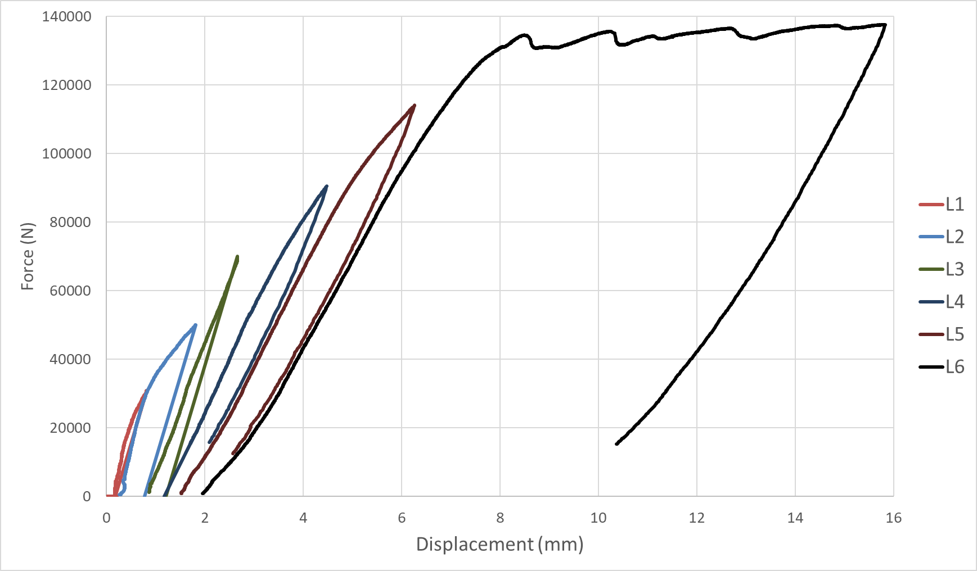
Figure 3. loading history: load versus mid-span deflection

Effect of Different Supports
Three different support conditions were investigated in this research. The undamaged beam was used in these comparison tests. First, the beam was subjected to vibration tests on timber supports with a lower stiffness than the concrete specimen. Then, the vibration tests were conducted on the beam rested on rigid steel supports. Finally, the beam was hung from low stiffness nylon straps from the crane to represent the free-free support condition, and the vibration tests were performed in this situation.
The comparison of the natural frequencies in different support conditions is presented in Table 2. The FEM results of free-free conditions are in good agreement with vibration tests. While the difference between analytical natural frequencies and extracted modal frequencies using the vibration tests is noticeable, the beam was supposed to be a simply-support condition. It shows that the assumed simply-support boundary conditions may not be accurate enough due to support distortion. Meanwhile, the vibration tests were susceptible to the support's imperfection and the beam's bottom surface and may not be considered an ideal simply-support condition.
Table 2. Natural frequencies for various supports (Hz)
Mode No. | Free-free support |  | Simply-support  on rigid plates |  | Simply-support  on timber plates
Mode No. | FEM | EMA | FEM | EMA | FEM | EMA
1 | 183 | 186 | 100 | 204 | 193 | 200
2 | 483 | 479 | 381 | 530 | 492 | 503
3 | 890 | 907 | 796 | 896 | 899 | 904
4 | 1362 | 1363 | 1295 | 1327 | 1369 | 1322
5 | 1868 | 1846 | 1841 | 1805 | 1873 | 1862

Effect of Hammer Tips
The other important parameter investigated in this research was the type of excitation hammer tip. As stated before, 4 different hammer tips with different stiffness called "Hard", "Medium", "Soft" and "Super Soft" were studied here. The undamaged beam under free-free support was used for this comparison study. The results of the Frequency Response Function for different tips showed that the hard tip gives better results with a cleaner FRF function up to the fifth natural frequency. As the stiffness of the hammer decreased, the noise at lower frequency increased. The extracted mode shapes' complexity was more significant in the lower stiffness hammer tips than in harder ones. Hence, it was concluded that the hard tip gives the most precise outcomes, and this tip was used in further tests.
Table 3 presents the extracted modal frequencies and the complexity of the first 4 mode shapes using the different hammer tips. As the hammer tip's softness increases, the mode shapes' complexity rises. It is concluded that the softer tips can not be used to find the high-frequency modal parameters.
Table 3. Comparison of different hammer tips
Mode | Hard |  | Medium |  | Soft |  | Super Soft
Mode | Freq. (Hz) | MPC  (%) | Freq. (Hz) | MPC  (%) | Freq. (Hz) | MPC  (%) | Freq. (Hz) | MPC  (%)
1 | 186 | 98 | 187 | 98 | 187 | 98 | 187 | 98
2 | 476 | 93 | 478 | 92 | 476 | 96 | 476 | 94
3 | 908 | 86 | 909 | 38 | 902 | 59 | 907 | 61
4 | 1365 | 77 | 1351 | 46 | 1351 | 65 | 1357 | 13

Figure 4 shows the magnitude of the frequency response function matrix for the excitation point 16 using reference point 1 at loading stage L0. The reconstructed (fitted FRF) is shown in thick red lines in that figure two. It is clear that the FRF of the hard tip is cleaner to a higher frequency and can capture the modal parameters better than the other types of hammer tips.

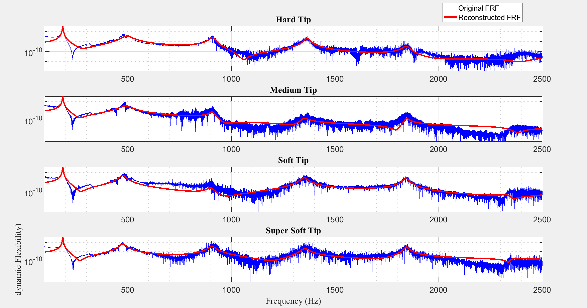

Figure 4. FRF and fitted FRF at point 16 for different hammer tips at loading stage L0

Natural Frequencies
The damage to concrete structures will change their overall stiffness and affect their natural frequencies and other modal characteristics. As the frequency is primarily proportionated to the stiffness, any damage decreases the stiffness and, consequently, the natural frequencies. Here, the first 4 natural modes were investigated, and their natural frequencies are reported in Table 4.
Table 4. Frequency Change
Loading Stage | Mode 1  (Hz) | Mode 2  (Hz) | Mode 3  (Hz) | Mode 4  (Hz)
L0 | 186.8 | 472.8 | 907.4 | 1363
L1 | 171.8 | 463.6 | 884.5 | 1305
L2 | 152.2 | 423.1 | 8491 | 1244
L3 | 136.7 | 378.2 | 742.5 | 1137
L4 | 132.4 | 363.5 | 701.7 | 1085
L5 | 131.8 | 367 | 703.8 | 1083
L6 | 112 | 312.6 | 658.2 | 945.5

Modal Damping Ratios
The modal frequencies and mode shapes are good indicators for damage detection and structural health monitoring from the extracted modal parameters. Modal frequencies are dependent on the system's stiffness, which decreases by the induced damage in the structural members. The mode shapes are also affected by the change in the structural stiffness and the damage. However, the changes in the modal damping ratios depend on the energy dissipation and may not be correlated with the damage to the beam. Table 5 shows the modal damping ratios for the different modes in various loading stages. It can be seen that modal damping ratios are not sensitive enough to the damage.

Table 4. Modal Damping Ratio Change
Loading Stage | Mode 1  (%) | Mode 2  (%) | Mode 3  (%) | Mode 4  (%)
L0 | 0.7 | 5.1 | 1.1 | 0.7
L1 | 1.2 | 2.2 | 2.0 | 0.9
L2 | 2.6 | 2.1 | 3.7 | 1.5
L3 | 8.6 | 3.7 | 2.5 | 2.0
L4 | 3.3 | 2.7 | 2.5 | 4.2
L5 | 2.9 | 2.6 | 2.5 | 2.4
L6 | 1.1 | 4.9 | 2.3 | 1.9

Stabilization Diagram
The extracted modal parameters are usually verified by employing a stabilization diagram. The Stabilization diagram is generally a plot of frequencies for different curve-fitting model sizes. It can be used to determine the fundamental modes in a frequency band and confirm the frequency estimations. Figure 5 shows the stabilization diagram using EMA methods for B1 after loading stages L6. The least-squares complex exponential method modal parameters from the estimated frequency response functions are used to construct the stabilization diagram.
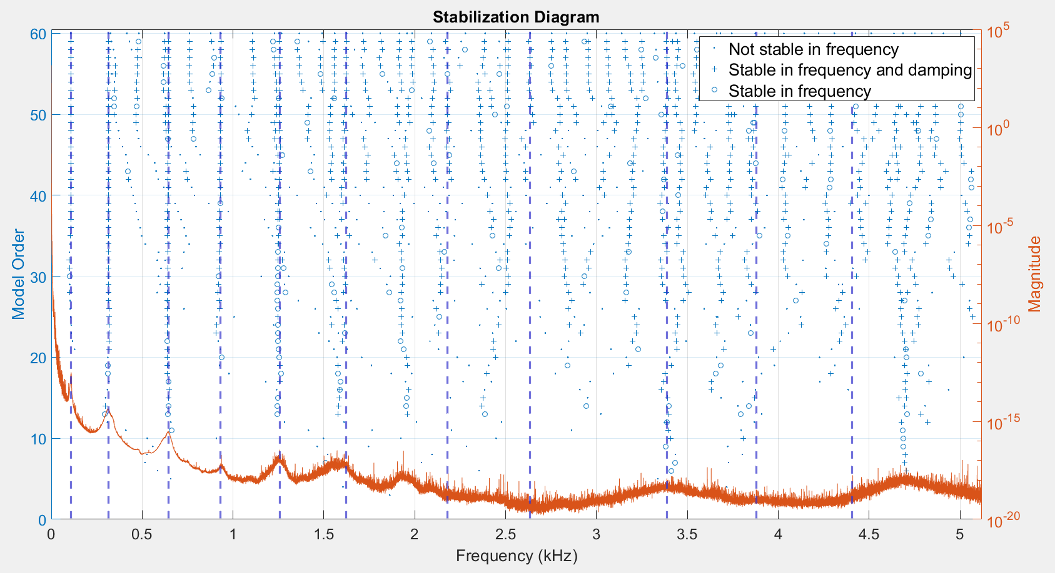
Figure 5. Stabilization diagram at loading stage L6

Mode Shape Extraction
Comparing EMA and analytical mode shapes shows that the extracted mode shapes from vibration tests are very close to the analytical mode shapes. The first three mode shapes of the beam for load cases L0 and L6 are shown in Figure 6 as a sample. The changes in the mode shape resulting from damage are also evident in this figure. It proves that this method can be used effectively to find the modal parameters of concrete specimens.
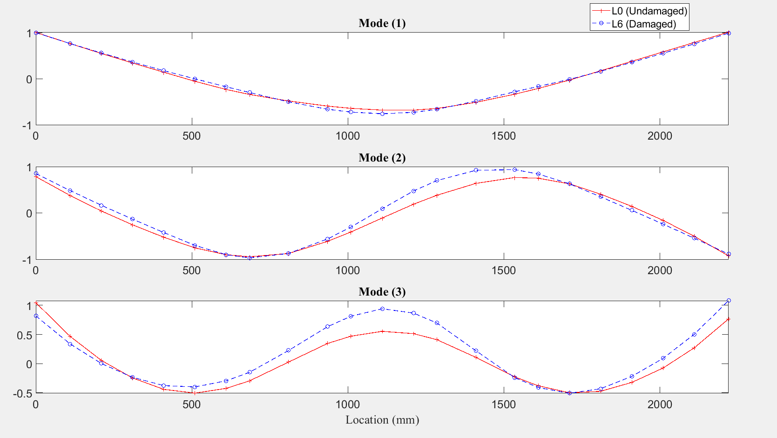
Figure 6. Mode shapes for undamaged and damaged conditions

Conclusion
In this study, two reinforced concrete beams were subjected to 4-point loading tests to induce damage. Meanwhile, various vibration tests using EMA methods were conducted at different damage levels. Based on the outcomes of the performed tests following conclusions are drawn:
- The extracted natural frequencies are in coloration with damage, and they decrease as the damage level increases.
- The damping ratios are not a good indication as they are not much affected by the damage.
- The EMA method could capture natural frequencies and mode shapes of structures. The results of this method were in good agreement with analytical and FEM.
- The free–free support condition gives cleaner results, eliminating the supports' distortions.
- Good hammer tip, excitation load, and the number of averages significantly affect the EMA test results. A hammer tip with a broad excitation frequency range gives less noisy FRF and cleaner mode shapes.

ACKNOWLEDGMENTS
This work was supported by the Natural Sciences and Engineering Research Council of Canada (NSERC). The authors would like to thank NSERC for supporting this research.

References
[1] B. Bonfiglioli, G. Pascale, S.M. de Mingo, Dynamic testing of reinforced concrete beams damaged and repaired with fiber reinforced polymer sheets, J. Mater. Civ. Eng. 16 (2004) 400–406. https://doi.org/10.1061/(asce)0899-1561(2004)16:5(400).
[2] N. Baghiee, M.R. Esfahani, K. Moslem, Studies on damage and FRP strengthening of reinforced concrete beams by vibration monitoring, Eng. Struct. 31 (2009) 875–893. https://doi.org/10.1016/j.engstruct.2008.12.009.
[3] R. Capozucca, Vibration analysis of damaged RC beams strengthened with GFRP, Compos. Struct. 200 (2018) 624–634. https://doi.org/10.1016/j.compstruct.2018.05.112.
[4] R. Capozucca, Vibration of CFRP cantilever beam with damage, Compos. Struct. 116 (2014) 211–222. https://doi.org/10.1016/j.compstruct.2014.04.027.
[5] V.B. Dawari, G.R. Vesmawala, Modal curvature and modal flexibility methods for honeycomb damage identification in reinforced concrete beams, Procedia Eng. 51 (2013) 119–124. https://doi.org/10.1016/j.proeng.2013.01.018.
[6] D.M. Prado, I.D.G. Araujo, V.G. Haach, R. Carrazedo, Assessment of shear damaged and NSM CFRP retrofitted reinforced concrete beams based on modal analysis, Eng. Struct. 129 (2016) 54–66. https://doi.org/10.1016/j.engstruct.2016.09.058.
[7] K. Samir, B. Brahim, R. Capozucca, M. Abdel Wahab, Damage detection in CFRP composite beams based on vibration analysis using proper orthogonal decomposition method with radial basis functions and cuckoo search algorithm, Compos. Struct. 187 (2018) 344–353. https://doi.org/10.1016/j.compstruct.2017.12.058.
[8] E. Lofrano, A. Paolone, G. Ruta, Dynamic damage identification using complex mode shapes, Struct. Control Heal. Monit. 27 (2020) 1–24. https://doi.org/10.1002/stc.2632.
[9] S. Greś, M. Döhler, P. Andersen, L. Mevel, Uncertainty quantification for the Modal Phase Collinearity of complex mode shapes, Mech. Syst. Signal Process. 152 (2021). https://doi.org/10.1016/j.ymssp.2020.107436.
[10] M.G. Masciotta, D. Pellegrini, Tracking the variation of complex mode shapes for damage quantification and localization in structural systems, Mech. Syst. Signal Process. 169 (2022) 108731. https://doi.org/10.1016/j.ymssp.2021.108731.
[11] ACI (American Concrete Institute), ACI 318-19 & ACI 318R-19: building code requirements for structural concrete and commentary. Michigan, USA: American Concrete Institute. 2019., n.d.

