Probabilistic Finite Element Model Updating by Data Fusion of Acceleration and Angular Velocity
Jaebeom Lee¹, Hyunjun Kim²
¹Department of Urban and Environmental Engineering, Ulsan National Institute of Science and Technology (UNIST), Ulsan, South Korea
²Department of Civil and Environmental Engineering, University of Illinois at Urbana-Champaign, Urbana-Champaign, United States
Email : boom@unist.ac.kr, hyunjun@illinois.edu

ABSTRACT: In a finite element model updating (FEMU), a modal analysis with acceleration data has been widely employed. However, the rotational responses may be difficult to be measured by accelerometers; thus, boundary conditions of structures which are associated with both translational and rotational degrees of freedom might be not easily calibrated with acceleration data. To this issue, this study introduces a data fusion method of acceleration and angular velocity to improve an updating accuracy by employing not only accelerometers but also gyroscopes. In addition, the proposed method also deals with uncertainties in structural properties and boundary conditions based on a maximum likelihood method. Here, a First Order Reliability Method, which is a cost-efficient structural reliability method, is utilized to reduce the computational cost for probabilistic inference. Numerical verification has been carried out, and it has been confirmed that the proposed method shows a great updating accuracy and cost-efficiency.
KEY WORDS: Data fusion; Finite element model updating; Acceleration; Angular Velocity; Maximum likelihood method; First order reliability method.

INTRODUCTION
A finite element model updating (FEMU) has been widely studied in a civil engineering field, because of its applicability to system identification, damage detection, and model calibration. Many studies have introduced a modal analysis based on acceleration data, but it would have a limitation to calibrate the parameters for boundary conditions. It is because the rotational responses may be difficult to be measured by accelerometers, but the boundary conditions are associated with both translational and rotational degrees of freedom. To this issue, several researchers developed a data fusion based FEMU which incorporate not only the accelerometers but other sensors.
Civil infrastructures including bridges are associated with uncertain material properties because of randomness in manufacturing and deterioration; thus, the uncertainty in material properties could be considered in the FEMU as well. Many of researchers have focused on deterministic FEMU to find only the optimal material properties, and some have studied probabilistic FEMU to infer probabilistic properties, such as mean and variance, of the material properties, as well. Main two streams are a maximum likelihood estimation- and Bayesian estimation-based FEMU [1] where the likelihood function is needed to be expressed sometimes unfeasible.
This study suggests a new FEMU method for dealing with two issues mentioned above: limitation in acceleration-based updating and difficulty in likelihood inferring. First issue is considered by introducing a well-developed data fusion-based method, and the second issue is dealt with a newly developed likelihood estimation method based on a first order reliability method, which is a cost-efficient structural reliability method.

PROPOSED METHOD

Data fusion based FEMU
As the acceleration based modal analysis is not proper to measure rotational responses, Kim et al. (2016) suggested a new method for FEMU with a data fusion of acceleration and angular velocity to improve an ability of a model updating in terms of boundary conditions [2]. This study introduces the data fusion based FEMU method that utilizes both the accelerometers and the gyroscopes, where the details can be found in the literature of Kim et al. (2016) [2].

Maximum likelihood estimation for probabilistic FEMU
The FEMU is a problem to find values of input parameters, such as elastic modulus, which make a model much properly explain a given measurement (i.e., output). In a probabilistic view, the values to be found are the statistical properties including mean and variance, and one approach is the maximum likelihood estimation (MLE). When the input-output relationship is $output=f(input)$ and the inputs have a random property, the outputs can be expressed as any probability distribution (e.g., red bell-shaped graphs in Figure 1). Here, the probability density can be considered as the likelihood for a specific value. Larger the likelihood for a given output d₀ means that the data is much likely measurable, thus, the input parameters that make the larger likelihood for the d₀ are more acceptable. Therefore, the MLE based probabilistic FEMU is just an optimization problem to find optimal values that maximize the likelihood. A problem here is inferring the probability density function is sometimes costly.
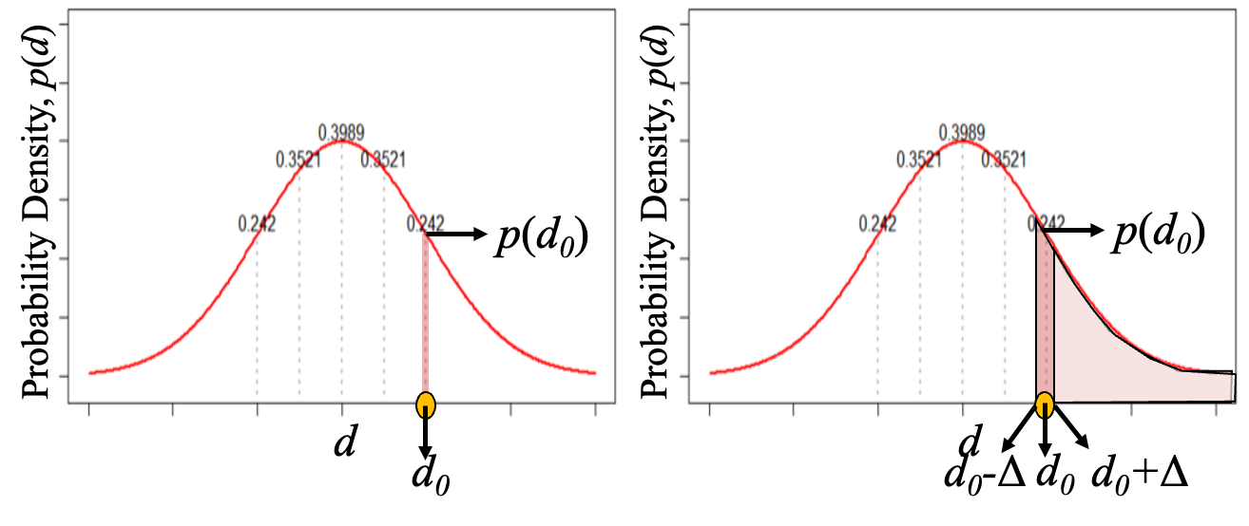
Figure 1. Monte Carlo simulation-based (left) and first order reliability method-based likelihood estimation (right)

Monte Carlo simulation-based likelihood estimation
One of intuitive way to estimate the likelihood is Monte Carlo simulation (MCS). In this method, lots of samples of probabilistic inputs and outputs are randomly generated, then likelihood can be estimated using a kernel density estimator [3]. It is simple but may require many samples which make the FEMU process unfeasible.

FORM-based likelihood estimation
A proposed method in this study to estimate the likelihood is a first order reliability method (FORM)-based estimation, where the FORM is an algorithm to efficiently calculate the probability where variables are larger than certain value [4]. As described in Figure 1, the likelihood p(d₀), which is a probability density at the d₀, is proportional to the probability that d is larger than d0+Δ minus the probability that d is larger than d0-Δ, when the Δ is very small perturbation. Because estimating the probability using the FORM algorithm requires much smaller number of sampling than the MCS, this two-step calculation (i.e., p(d>d₀+Δ) and p(d>d₀-Δ))-based likelihood estimation is much cost-efficient method.

NUMERICAL EXAMPLE
To verify the accuracy and cost-efficiency of the proposed method, a simply supported beam with 2-meter length is introduced as a numerical example. The finite element model that has 20 Euler-Bernoulli beam elements with rectangular meshes has been constructed using MATLAB as shown in Figure 2, where the width and height of each mesh are 0.08 and 0.01 meters. Updated parameters are elastic modulus and rotational stiffness at two supports, measured sensor data are acceleration and angular velocity where the locations of gyroscopes and accelerometers are as described in Figure 2. A random excitation is applied at the next node of the beam center, and the simulated responses are generated with 5% noise.

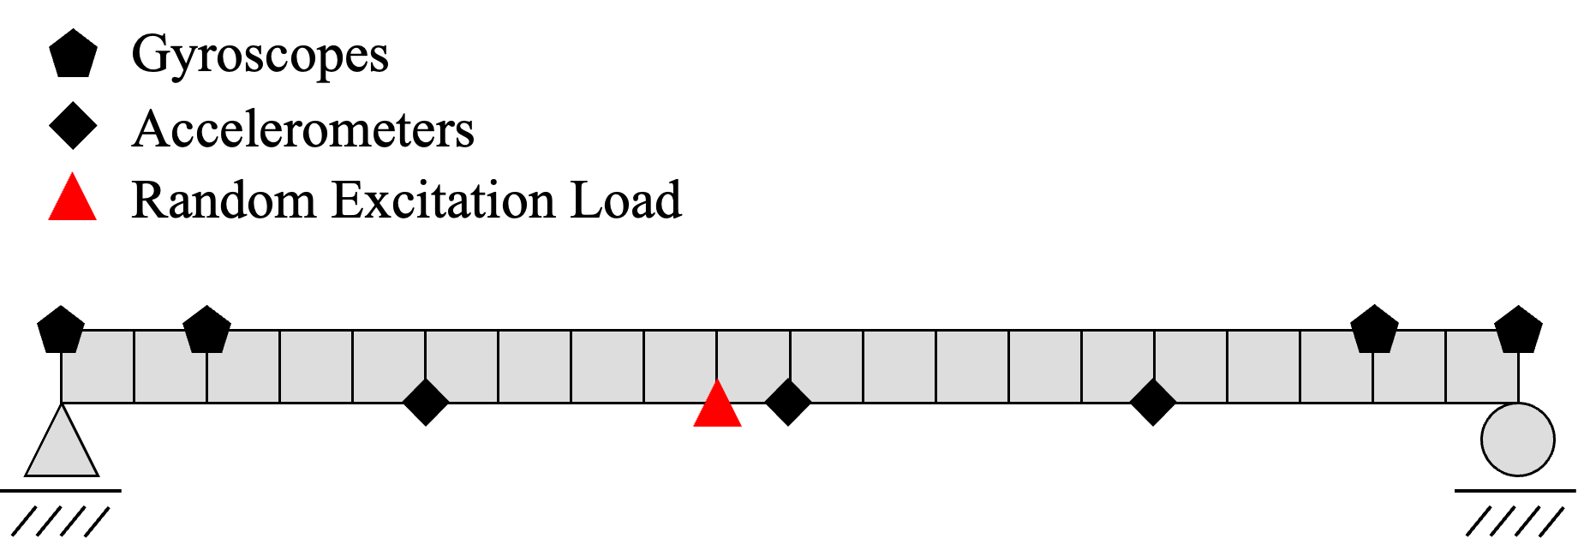
Figure 2. Simply supported beam model and sensor locations for numerical verification
The probabilistic FEMU has been conducted by the FORM- and MCS-based methods, and the results are summarized in Figure 3, where an X-axis denotes the number of simulations, and a Y-axis is a root-mean-squared error for mean and variance of three updated parameters (i.e., elastic modulus and rotational stiffness at two supports). As described, the FORM-based method has been confirmed to require less computational cost than the MCS-based method where the error converges to a small value with much larger number of simulations. From this view, the authors concluded that the FORM-based method is much cost-efficient MLE method for the FEMU.
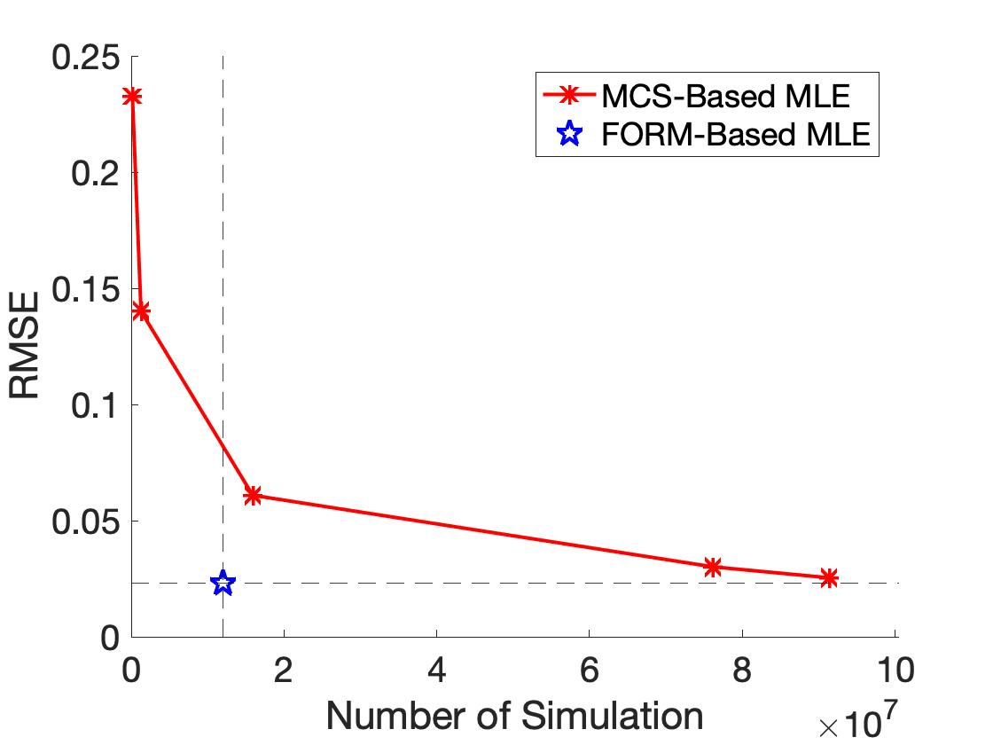
Figure 3. Performance comparison of two methods

CONCLUSIONS
In this study, a new probabilistic finite element model updating method has been suggested. First, a data fusion method which utilizes both accelerometers and gyroscopes is introduced to improve the updating accuracy for boundary conditions of structures. Second, the FORM-based likelihood estimation method is developed to efficiently infer the likelihood function, so that a cost-efficiency of the maximum likelihood estimation can be improved. Numerical verification has been carried out, and it has been confirmed that the proposed method shows a great updating ability in terms of accuracy and cost.

ACKNOWLEDGMENTS
This work was supported by the National Research Foundation of Korea (NRF) grant funded by the Korea government (MSIT) [NRF-2021R1C1C2008770].

References
- S.-S Jin, Y.-S. Park, S. Kim, and Y.-H. Park. Model updating based on mixed-integer nonlinear programming under model-form uncertainty in finite element model. Engineering with Computers 37(4), 3699-3725, 2021.
- H. Kim, S. Cho, and S.-H. Sim. Data fusion of acceleration and angular velocity for improved model updating. Measurement 91, 239-250, 2016.
- J. R. Fonseca, M. I. Friswell, J. E. Mottershead, and A. W. Lees. Uncertainty identification by the maximum likelihood method. Journal of Sound and Vibration 288(3), 587-599, 2005.
- A. Der Kiureghian. First- and second-order reliability methods, Engineering Design Reliability Handbook, (Eds., E. Nikolaidis, D. M. Ghiocel, and S. Singhal), CRC Press, Boca Raton, FL, USA, Chapter 14, 2005.

