ABSTRACT: Reinforced concrete (RC) shear walls are important for the lateral resistance system of high-rise buildings. However, it remains a challenging task to evaluate the damage condition of shear walls. Recently studies show that structural health monitoring (SHM) is a promising technology for seismic damage assessment, which adopts the measurement data obtained from instrumented structures to infer the damage of the structures. In this study, a methodology to reconstruct the shear-displacement and the moment-rotation hysteretic loops is proposed via the vibration data measured by the embedded sensors. And through empirical mode decomposition (EMD), the regularity of hysteretic loops is further improved. A damage index formed by the linear combination of two normalized terms, which respectively characterize the perk and cumulative damages of the structures in a data-driven manner, is proposed to track and quantify the damage condition of the shear walls based on the two reconstructed hysteretic loops. Through the proposed damage index applied to analyze the experiment of the shaking table test of the UCSD full-scale seven-story RC shear wall building, the correlation between the damage index and the visible physical damage of the shear wall is studied. And the tracking performance of the damage index is further validated at both the substructure level and the story level. Analysis suggests that the proposed damage index could quantify the progression of shear and flexural damages, which potentially supports the post-event structural safety management.

Data-driven nonlinear damage tracking and evaluation of RC shear wall under seismic excitations
Jiazeng Shan^{1, 2}, Luji Wang¹
¹Department of Disaster Mitigation for Structures, Tongji University, Shanghai, China, 200092,
² Shanghai Engineering Research Center for Resilient Cities and Intelligent Disaster Mitigation, Shanghai, China, 200092
Email : jzshan@tongji.edu.cn, wlj_9491@tongji.edu.cn

KEY WORDS: Data-driven damage index; shear wall; damage evaluation; structural health monitoring; shaking table test.

introduction
Earthquake is one of the most frequent disaster that threats the security of the engineering structures. The premise of performance-based earthquake engineering allows a structure under a seismic excitation to tolerate certain levels of control damage [1]. This brings the needs of rapid safety assessment and repair for the damaged structures. The advent of structural health monitoring (SHM), that adopts the measurement data obtained from instrumented structures, has become a promising alternative for seismic damage assessment [2]. In contrast to conventional visual-based post-earthquake investigation which may be inherently subjective and labor-intensive [3], the measured data from SHM can be employed to infer the structural damage timely.
In the case of the real-world damage diagnosis, significant progress has been made in the modal analysis on the recorded response signals of the structure [4]. Representative study includes the modal frequency, modal shape and modal curvature, etc. However, the modal-based method to quantify the nonlinear damage may suffer from the conceptual drawback because only a linear system has the conceptual modal information, in the strict sense [5]. As an alternative, the response-oriented damage evaluation method in time domain might be a more preferable.
In the traditional seismic analysis study, the hysteresis loops are regard as informative about the degree of nonlinear and the damage of the structure. Many damage indexes, such as Park-Ang, and other relevant damage indices [6], were proposed to correlate with observed damage and performance level. Furthermore, the SHM-based hysteresis loops analysis may reveal the nonlinear behavior of structures such as stiffness degradation, strength degradation, etc. under the earthquake-induced damage, and even be used to predict the residual capacity of the structure. However, the mechanical-oriented indices may fail to apply to real-world structures which the prior-knowledge is required. The damage quantification in data-driven manner with little prior knowledge about the hysteretic behavior is more feasible.
In this study, a methodology to reconstruct the hysteretic loop of the structure at both substructure level and story level is introduced. Then, a novel damage index formed by the linear combination of two normalized terms, which respectively characterize the perk and cumulative damages of the structures in a data-driven manner, is proposed. To validate the feasibility of the proposed method in quantifying and localizing the damage, an experiment of the full-scale 7-story shear wall slice under four earthquake excitations is analyzed.

Methodology
Suppose that the structure can be analyzed via a lumped mass model and the absolute acceleration of the $i$th story ${\ddot{U}}_{abs, i}={\ddot{U}}_{i}+{\ddot{U}}_{g}$ can be measured by the accelerometers embedded in the structure. Given the information regarding the mass, height, and axial load of the structure which could be estimated according to the design drawings and the building function. And it can be deduced that the shear force $V_{i}$ and the bending moment $M_{i}$ at the $i$th story can be respectively estimated via Eqs. (1) and (2) as:
$$V_{i}=-\sum_{j= i}^{N}{F_{j}}=-\sum_{j= i}^{N}{m_{j}{\ddot{U}}_{abs,j}}$$ | (1)
$$M_{i}=-\left(\sum_{j= i}^{N}{\left(H_{j}-H_{i-1}\right)m_{j}{\ddot{U}}_{abs,j}+} \left(U_{j}-U_{i-1}\right)P_{j}\right)$$ | (2)
The Eqs. (1) and (2) are proposed by the [], where $m_{j}{\ddot{U}}_{abs,j}$ denotes the inertia force caused by the mass $m_{j}$ and the absolute acceleration ${\ddot{U}}_{abs,j}$ at the $j$th story, respectively. $H_{j}$ is the story height with respect to the ground. $P_{j}$is the axial load acting on that story.
The deformation of the structure such as interstory drift or chord rotation (here defined as ratio of the interstory drift and the height of the story) both in substructure-level or story level could be estimated by the double-integration of the acceleration data which are filtered by a bandpass filter, and if available, monitored and recorded by LVDT. The reconstructed hysteresis curves could be further used to identify and to quantify the damage of the structure.
This study adopts the damage index $DI$ proposed by [7] which is fully calibrated using a generalized nonlinear system with approximated linear relationship with the Park-Ang model. The basic conception of the proposed damage index is to quantify the deviation of the nonlinear system from the linear status. And detailed formulation of the data-driven damage index is presented in the following Eqs. (3) and (4):
$$DI={\left[α_{d}{\left(1-\frac{K_{eff}}{K_{linear}}\right)}^{R^{2}}+β_{d}{\left(\frac{r_{RMS}}{x_{RMS}}\right)}^{R^{2}}\right]}^{n_{d}}$$ | (3)
$$r_{ }=\frac{f}{K_{linear}}-x$$ | (4)
where $K_{linear}$ is the linear stiffness coefficient that determined either from the prior information of the structure or the “force-displacement” loops constructed from the data measured during pre-yielding vibration. $K_{eff}$ is the secant stiffness coefficient evaluated at the force $f{\left.​\right|}_{x_{max}}$with the maximum displacement $x_{max}. x_{RMS}$ is the root-mean-squared (RMS) measured displacement. $r_{RMS}$ is the RMS value of the tracking error $r$ between the measured displacement and the displacement approximated from the ratio of reconstructed force $f$ and the linear stiffness coefficient $K_{linear}$and formulation is presented in Eq (4). The coefficient of determination $R^{2}$ is the statistic quantifying the linear correlation between the measured and the regressed response from the peak force-displacement loops when the displacement reaches its maximum value. Generally, the decrease of the statistic indicates the deviation of the model status as referenced to the linear model with $R^{2}=1$ . $α_{d}$, $β_{d}$and $n_{d}$are the three model parameters controlling the weighting balance between the peak and cumulative terms and the overall increase tendency and for a flexural behavior dominated structure, these parameters are recommended to set as: $α_{d}=0.85,$ $β_{d}=0.15$ and $n_{d}=2.5$ according to [7]. Note that the proposed damage evaluation method is focused on tracking and evaluation for the earthquake-excited RC shear wall buildings in a data-driven manner.

Real world case study
The full-scale 7-story RC building with shear wall slice was utilized to examine the feasibility of the proposed methodology for tracking and evaluating the flexural and shear damage in real-world structures. The tested building was 19.2 m in height and consisted of a rectangular web wall. The web wall thickness was 0.203 m on the first and seventh floor and 0.152 m elsewhere. The total mass of the building was 226×10³ kg. and its fundamental period before the earthquake excitation was 0.59 s. Other detailed information regarding the structure can be found in [8].

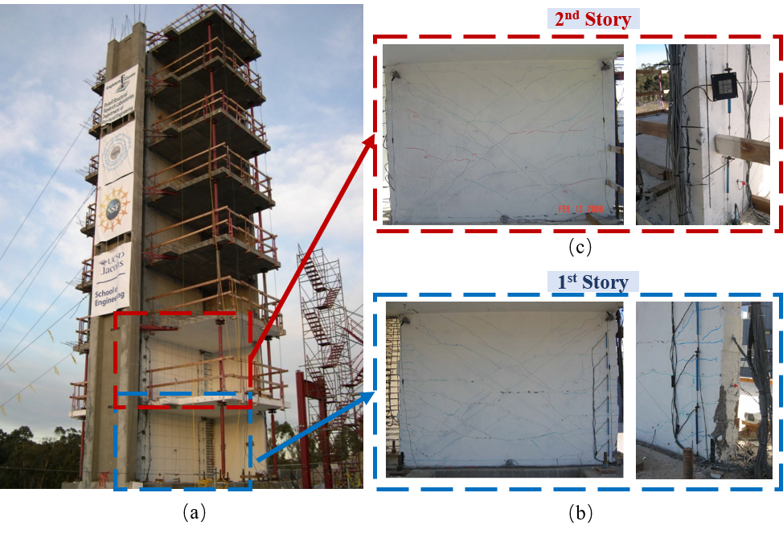
Figure 1 Seven story RC shear wall slice (a) side elevation of the tested building; (b) damage about limited spalling of the concrete observed in the first story; (c) damage about splitting crack observed in the second story.

The shear wall was tested on a unidirectional shake table at NEES-UCSD. Four ground motions (EQ1 to EQ4), with PGAs of 0.15g, 0.27g, 0.35g, and 0.91g, respectively, were selected to excite the building. The EQ1 and EQ4 were selected to test the performance level of Immediate Occupancy (IO) and Life Safety (LS), respectively. The EQ2 and EQ3 were employed to provide information for damage progression and model calibration. The final state of the tested building after the experiment I has been shown in the Figure 1. After the severe earthquake EQ4, widely spread flexural-shear cracks could be found at the first story and the second story. And the cracks rise up to the fourth story. Limited spalling of the cover concrete could be observed at the first story, which may potentially indicate that the building reached the performance level of LS defined by the ASCE technical report [1]. At the end of the excitation, the fundamental period of the building dropped to 1.12s, which indicates the significant loss of the stiffness of the structure.
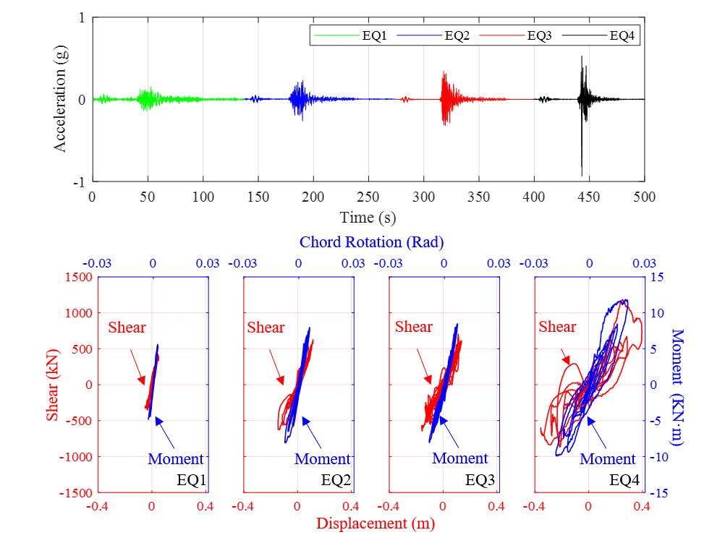
Figure 2 Time history of earthquake acceleration and reconstructed hysteretic curves.

To evaluate the damage condition of the building, the hysteretic loops constructed by [8] were utilized to quantify the degree of flexural and shear damage of the structure. Figure 2 shows the ground motion input to the shake table and the four corresponding hysteretic loops. During the EQ1, the structure mostly remained in a linear state according to the reconstructed hysteresis curve and the linear hysteresis curve was utilized to determine the linear stiffness coefficient $K_{linear}$. During the EQ2 and EQ3, limited nonlinear developed. And in the EQ4, the strong hysteresis indicates that the structure was deviated from the linear initial state and the damage might be severer.
Figure 3 further shows the variation of the damage indices of the structure under EQ1 to EQ4. The structure behaved linearly during EQ1, cracking of the wall was widespread while residual cracks were barely noticeable. The damage indices determined from the response during EQ1 are less than 0.1. In the moderate excitations, such as EQ2 and EQ3, some yielding of longitudinal reinforcement occurred in the web walls and the damage indices raise from 0.2 to 0.3. For the performance target of LS, the intensity excitation generates strong nonlinear behavior of the structure, significant yielding in the longitudinal reinforcing bars occurred. And the damage index values increase to 0.65 for shear and 0.58 for flexural-based damage evaluation, respectively. Results shows that the shear damage manifested by the proposed damage index is severer than flexural damage, probably because of the kinematic overstrength and the effects of higher vibration mode.
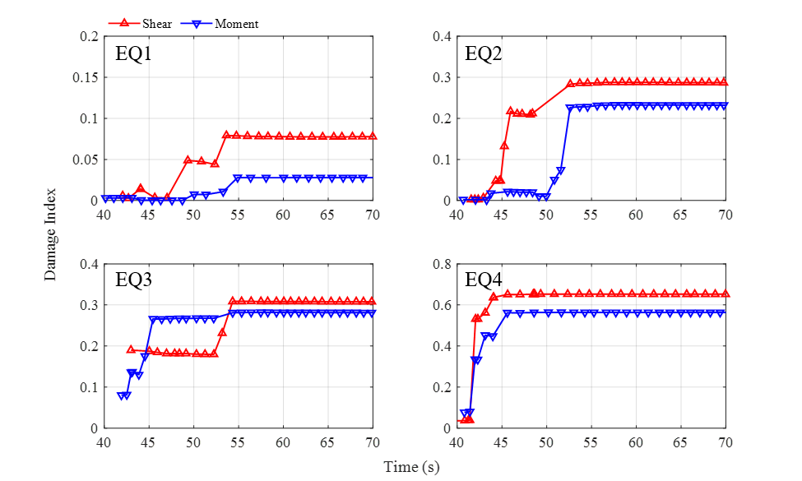
Figure 3 The time histories of the proposed damage index during four earthquake excitation
Damage evaluation at substructure-level provides averaged results regarding the global damage state of the structure, while that at interstory-level may potentially localize the damage and offer more accurate diagnosis on the damage development. The relative displacement of each floor is calculated from the recorded absolute accelerations processed with a band-pass filter with a frequency band ranging from 0.2 Hz to 25 Hz and double integration. The seismic masses per floor from the base to the roof are adopted from [9]. Each interstory shear force and moment are determined following Eqs. (1) and (2), respectively.
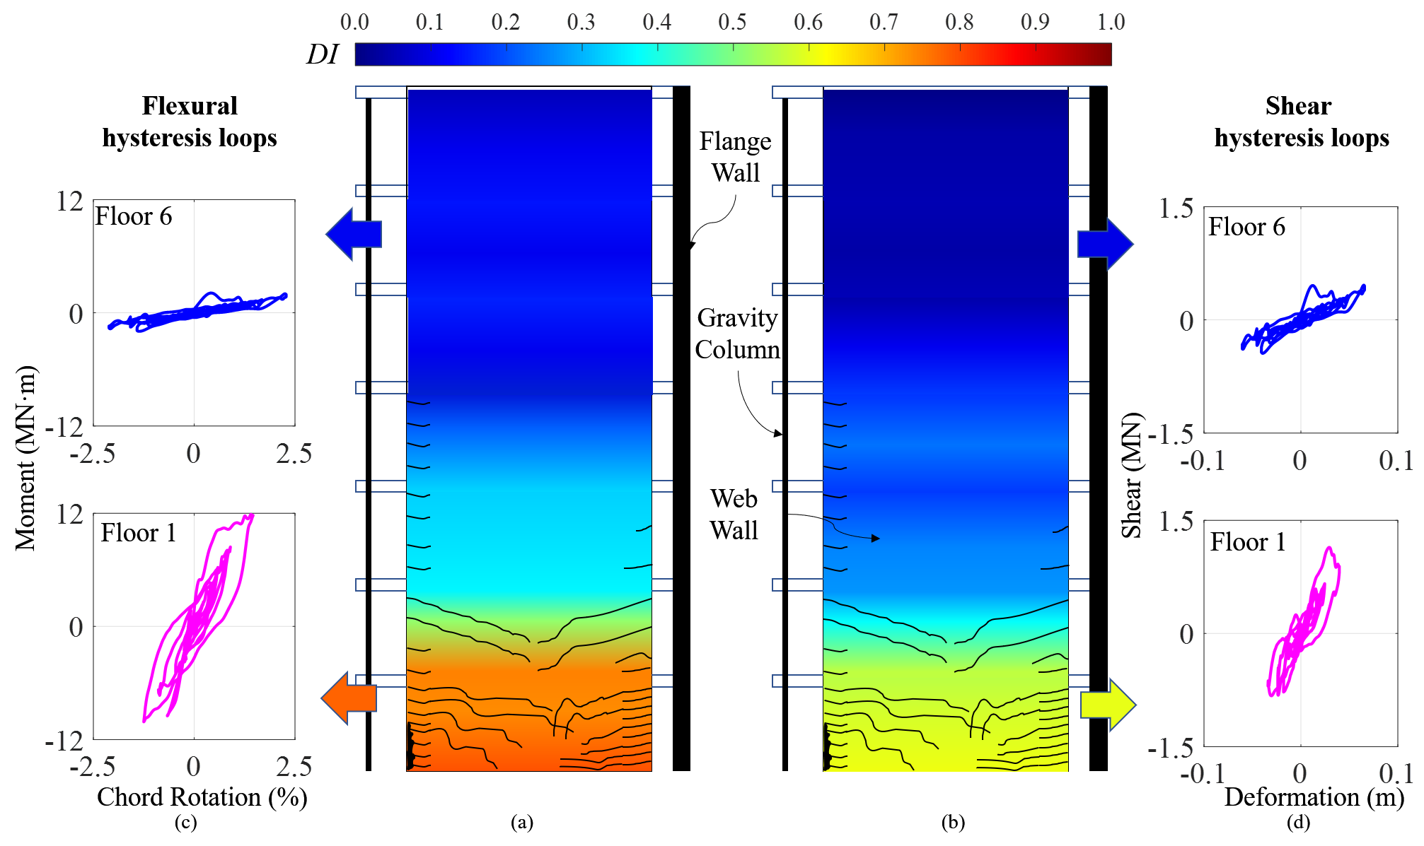
Figure 4 Variation of interstory-level damage index over the height of the shear wall under EQ4
The reconstructed hysteretic loops based on the bending-moment-chord-rotation relationship and shear-force-deformation relationship are shown in Figure 4(c) and 4(d), respectively. The hysteresis behavior is quite regular at the first story compared to the result in substructure level, and the damage indices reach 0.74 for flexural-based and 0.60 for shear-based damage evaluation. Comparing to the shear damage, the shape of hysteretic loops for flexural damage is relatively full, which results in a lower coefficient of determination ($R^{2}$ =0.64). The degree of damage is higher at first two stories, while the moderate flexural damage is on the third floor, where the flexural cracks spread upward to the fourth story. The superstructure above the fourth story remained approximately linear-elastic, and the damage index ranges below 0.1. Overall, results show that the proposed damage index could quantify the progression of shear and flexural damages, which potentially supports the post-event structural safety management. Note that to obtain such denser diagnosis for this structure, one accelerometer per floor at least is required.

Conclusion
A response orientation damage tracking and evaluation method with a novel data-driven damage index is applied for the shear wall structure. The feasibility for quantifying and distinguishing the damage of realistic structure has been further examined in a full-scale seven-story RC shear wall slice by the NEES-UCSD shake table. The damage tracking performance in time-domain is successfully examined under the four earthquake excitations with well agreement with the observed damage development.
Furthermore, to implement the damage localization, the hysteresis loops in the story-level are reconstructed and used to quantified the damage. Results indicate that the evaluation in the story level might provide denser and more accuracy information about the damage and which potentially supports the post-earthquake structural safety management.

References
[1] ASCE, Seismic evaluation and retrofit of existing buildings. Seismic Evaluation and Retrofit of Existing Buildings. 2013: ASCE/ SEI 41-13, American Society of Civil Engineers.
[2] Limongelli, M.P. (2020) SHM for informed management of civil structures and infrastructure. Journal of Civil Structural Health Monitoring. 10(5). 739-741.
[3] DeVore, C., Jiang, Z., Christenson, R.E., Stromquist-LeVoir, G., and Johnson, E.A. (2016) Experimental verification of substructure identification for damage detection in shear buildings. Journal of Engineering Mechanics. 142(1). 04015060.
[4] Rodríguez, R., Escobar, J.A., and Gómez, R. (2010) Damage detection in instrumented structures without baseline modal parameters. Engineering Structures. 32(6). 1715-1722.
[5] Pan, H., Kusunoki, K., and Hattori, Y. (2019) Capacity-curve-based damage evaluation approach for reinforced concrete buildings using seismic response data. Engineering Structures. 197. 109386.
[6] Jiang, H., Fu, B., Lu, X., and Chen, L. (2015) Seismic Damage Assessment of RC Members by a Modified Park-Ang Model. Advances in Structural Engineering. 18(3). 353-364.
[7] Shan, J., Gong, Y., Liu, J., Shi, W., and Zhang, H. (2022) Damage tracking and evaluation of RC columns with structural performances by using seismic monitoring data. Bulletin of Earthquake Engineering (in press).
[8] Panagiotou, M., Restrepo, J.I., and Conte , J.P. (2011) Shake-table test of a full-scale 7-Story building slice. Phase I: Rectangular Wall. Journal of Structural Engineering. 137(6). 691-704.
[9] Panagiotou, M., and Restrepo, J.I. (2011) Displacement-based method of analysis for regular reinforced-concrete wall buildings: application to a full-scale 7-story building slice tested at UC-San Diego. Journal of Structural Engineering. 137(6). 677-690.

