ABSTRACT: A structural health monitoring (SHM) system involves the collection of large amounts of data and data transmission. However, sensors installed on civil infrastructures can get malfunctioned due to normal aging, exposure to outdoor weather conditions, and delayed replacements, resulting in the collection of multiclass anomalies in measured data. It is often combined with imbalance issues where most of the collected data remained biased to a certain type of anomaly. This paper proposes a convolutional neural network (CNN) with hyperparameter tuning using random search to optimize the performance. The proposed model is examined with a multiclass time-series of anomaly data obtained from a real-life cable-stayed bridge. The study concludes that balancing the database with a time shift window to increase the database has generated the optimum results, with an overall accuracy of 97.74%.

Deep Learning-based Anomaly Detection in Structural Health Monitoring
Mengchen Zhao¹, Ayan Sadhu², Miriam Capretz³
¹MESc Student, Department of Electrical and Computer Engineering, Western University, London, Ontario, Canada. N6A 3K7
²Corresponding Author: Associate Professor, Department of Civil and Environmental Engineering, Western University, London, Ontario, Canada. N6A 3K7
³ Professor, Department of Electrical and Computer Engineering, Western University, London, Ontario, Canada. N6A 3K7
Email : mzhao247@uwo.ca, asadhu@uwo.ca, mcapretz@uwo.ca.
KEYWORDS: Structural Health Monitoring; Anomaly Detection; Convolutional Neural Network; Imbalanced Dataset; Hyperparameter Tuning.

Introduction
Civil infrastructure is rapidly aging worldwide due to increasing natural calamities, population, and operational loads. Structural health monitoring (SHM) system [1] is a valuable data-driven technology that involves the integration of sensors, data transmission, data analysis, and decision-making to protect these structures. However, being exposed to outdoor environments, SHM systems of civil infrastructure face significant implementation challenges from environmental and measurement noises, sensor faults, data acquisition malfunctions, and operational conditions during the data collection stage. This often leads to the collection of anomalous data, requiring anomaly detection (AD) techniques such that only good quality data is used for structural diagnostics and decision-making.
AD is an essential step for data cleaning and preparation purposes of SHM before any diagnostic algorithms are implemented. The lifetime of SHM sensors is typically much shorter than that of the infrastructure [2], resulting in the normal aging and the need for the replacement of sensors. Installed sensors are often exposed to various weather conditions [3] and accidental incidences, which causes the sensors to lose connectivity, resulting in a hindrance to the measurement for key feature extraction. Sensor malfunctioning and faulty signals may potentially cause destabilization to the entire system and provide misleading information about the current condition of the structures [4]. Without proper data cleaning processes, the SHM technology will not provide useful insights even if advanced damage diagnostic techniques have been applied. With the rapid growth of computational power, algorithm improvements, and data collection, various machine learning (ML) and deep learning (DL) methods have been applied to the realm of SHM and AD.
AD can be viewed as a data cleaning process for purposes such as data compression and data reconstruction. Ni et al. [5] focused on finding an efficient unsupervised method for SHM data compression. They proposed a one-dimensional convolutional neural network (1D-CNN) with Adam Algorithm and mini-batch gradient descent for AD. Data were defined as abnormal when the measurements showed unacceptable deviations from the true values of the measured variables in either time or frequency domain. Jeong et al. [6] proposed a bidirectional recurrent neural network for sensor data reconstruction based on spatiotemporal correlation. For a system with N sensors, one of the sensors was treated as the targeted output data, while sensors with high spatial correlations with the output sensor were treated as input sensors, resulting in an N combination. The reconstruction error was used as an indicator to detect potential anomalies of the output sensor. The faulty sensor was isolated based on the idea that the faulty sensor only causes local effects.
Recently, Mao et al. [7] argued that supervised learning methods of AD had two unresolved challenges: imbalanced dataset and incompleteness of anomalous patterns for the training dataset. They proposed to use deep convolutional generative adversarial networks with autoencoders. The input for the network was transformed Gramian Angular Field images from time-series data, while the output was classified as either normal or anomalous data. Sarmadi and Karamodin [8] also proposed using unsupervised learning since it only required information on a single known structural state. They introduced an adaptive Mahalanobis-squared distance and one-class kNN rule to formulate a new multivariate distance. The proposed method improved the conventional Mahalanobis-squared distance technique for non-Gaussian or heavy-tailed distribution. The algorithm was tested in a lab truss structure.
Similar to machine learning techniques, researchers also explored various deep learning techniques for AD. Bao et al. [9] explored data visualization by converting the time-series signals into images. This was achieved by splitting the data into sections and plotting it in grayscale images. They trained a deep neural network with greedy layer-wise pre-training and a fine-tuning stage. The proposed model was tested on acceleration data that were divided into six patterns: missing, minor, outliers, squares, trends, and drifts. It resulted in a total accuracy of 87% for one-year test data using a real-life cable-stayed bridge. Tang et al. [10] presented a two-dimensional CNN (2D CNN) with a combination of time-domain response and frequency-domain response as input images. The frequency-domain response was obtained through Fast Fourier Transform. Using a balanced dataset, the proposed model was verified on a long-span cable-stayed bridge, which achieved an overall accuracy of 93%. Arul and Kareem [11] presented to use a relatively new time-series representation named “Shapelet Transform” in combination with a Random Forest classifier to autonomously identify anomalies in SHM data. Jana et al. [12] proposed CNN for detecting the presence of a sensor fault and convolutional autoencoder to reconstruct sensor data based on its identified type. The proposed model was tested using simulated and experimental datasets to demonstrate its performance. However, the model was designed to train data with single fault types using a simulated balanced dataset. Liu et al. [13] proposed to use a generative adversarial network and CNN-based AD technique. The model contains a three-channel input by combining time-series data with its fast Fourier transform and Gramian angular field output. The proposed model used a generative adversarial network for addressing class-imbalance issues, followed by CNN for classification tasks.
Despite a large amount of work on AD using ML and DL, SHM data still has several implementation challenges associated with the availability of balanced training data. Success in the implementation of DL depends predominately on access to large amounts of data [14]. Recently, AD techniques were also explored to imbalance datasets in different disciplines [15]. However, these studies were mostly focused on a single type of anomaly, which often results in poor accuracy for multiple anomalies [16]. To the authors’ knowledge, there exist limited studies on multiclass AD of SHM data using imbalance datasets. Besides the size and imbalance issues of the sensor data, each ML algorithm has a hyperparameter setting. Including the tuning process to find the optimal combination of hyperparameters in the DL models for SHM will improve the overall accuracy and minimize the loss function effectively. This paper proposes a hyperparameter-tuned CNN for multiclass imbalanced anomaly detection modelling. The proposed model is tested using both balanced and imbalanced datasets with various sample sizes.
The paper is structured as follows: Section 2 presents the proposed model with an overview of the CNN methodology and hyperparameter tuning processes; Section 3 presents an example using the proposed model on a real-life cable-stayed bridge; Section 4 discusses the analysis and results of the application. Section 5 presents the key conclusions and outcomes of the proposed research.

Proposed approach

Background of CNN
CNN has been highlighted in computer vision, image recognition, and classification tasks due to the developments in computing power and the advent of large amounts of labelled data. During the training of a convolutional model, it learns the spatial relationships between features within the target dataset. The 2D convolution function is applied to the input image in each convolutional layer, followed by a pooling layer to save the spatial information and reduce the computational cost. The fully connected layers are used to get the probabilities of the input being in a particular class for classification tasks.
Performance of every ML system is optimized through hyperparameter optimization. Critical hyperparameters include:
- Learning rate: it impacts the stability and efficiency of training.
- Batch size: it defines the number of inputs that will be propagated through the network each time and depends on memory requirements.
- Neuron size: it controls the balance between underfitting and overfitting.
When tuning for hyperparameters, grid search is the most basic method, which allows the programmer to specify a finite set of hyperparameter combinations. As the number of tuning hyperparameters increases, the required number of function evaluations grows exponentially, resulting in wasted computational resources and inefficiencies. An alternative to grid search is random search, where a user only specifies the search space as a boundary of hyperparameter values and combinations are randomly sampled within the domain. Random search method has a proven efficiency over grid search.

Data preparation and Augmentation
2D CNN models use images or image-like matrix input. To convert time-series data into image representation, the sensor readings are plotted against time. The time frame for each image is constant to maintain consistency. Each image in the whole database is converted to grayscale with a matching dimension to the required CNN model input. The dataset is randomly split into training set, validation set, and testing set based on a 70-20-10 ratio. Hyperparameter optimization is reached by the highest training accuracy and lowest validation loss. After generating the best-trained model with the appropriate hyperparameters, the testing set is used to report the accuracy of the fully trained CNN model.
However, a dataset is described as imbalanced when at least one category has relatively fewer samples than the other categories in classification problems. Often the minority observations are treated as noise and ignored in classification. In some cases, most of the test data samples are classified into the majority group, resulting in the classification accuracy of the minority class tending to be much lower than that of the majority class [17]. This causes the imbalanced dataset to have higher false negatives on minor classes. The predictive output of classifiers trained with an imbalanced dataset is also biased because classifiers are less sensitive to the minority classes [18]. Furthermore, the class with the lowest number of samples is usually the class of interest from a learning task perspective [19].
In time-series data, one way to address the data imbalance issue is through data augmentation using a sliding window. Time-series data with a non-overlapping sliding window requires more raw data points to generate the same amount of input samples. The number of raw data points required would further decrease with a shortened interval between each time shift. Using this shortened time shift strategy, the number of input samples for the minor classes will increase with the same amount of data points in time series data.

Proposed model
The proposed model requires input of grayscale images with size 100 x 100 pixels obtained from the time-series of anomaly data. The input then passes through three sets of convolution and max-pooling layers. The channel size increases with each convolution layer, whereas the dimension decreases due to the kernel size of 5 x 5. The kernel size for the max-pooling layers is 2 x 2, which further reduces the size of the convolved feature map. The tensor is then fed into a fully connected layer with a rectified linear unit (ReLU), where the number of neurons is one of the tuning hyperparameters. The output is then fed into the final layer, which uses a softmax classifier to generate the final output. The tuned hyperparameters in this model include the number of neurons in the second fully connected layer, the batch size, and the learning rate. The evaluation metrics for this model include accuracy, precision, recall, and F1 score. Figure 1 provides a summary of the workflow of the proposed method to perform multiclass AD using imbalanced data.
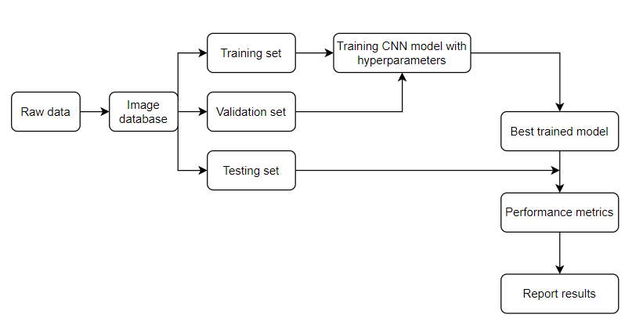
Figure 1. Workflow of the proposed method.

Description of the dataset
The proposed model is analyzed with a dataset that consists of one month of acceleration data for a long-span cable-stayed bridge in China (IPC-SHM 2020). The dataset contains 38 acceleration sensors and collects data at a sampling frequency of 20 Hz. The data collected by the sensors are labelled into seven different classes: normal, trend, square, missing, minor, drift, and outlier. In data preprocessing, the time series data is converted into images by graphing acceleration values against time, as illustrated in Figure 2. Each image has a one-hour time duration in the original database with a dimension of 875 x 656 pixels.
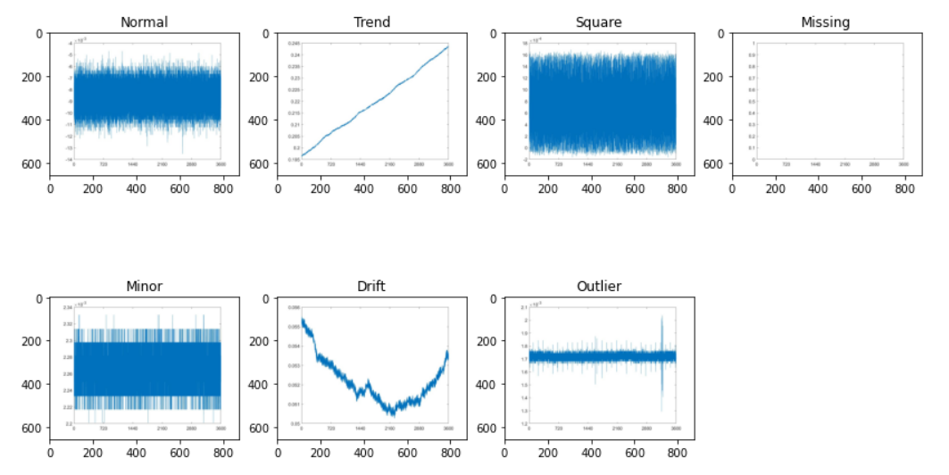
Figure 2. Typical multiclass anomaly data.
The original dataset is imbalanced, with nearly 50% of the data in the Normal class and only ~2% data belonging to the Outlier class. To verify the effects of data imbalance, three cases have been created, as shown in Table 1. Case 1 (C1) uses the original unbalanced full dataset as the model input. Case 2 (C2) uses a balanced dataset with randomly-selected 526 images in each class as the input dataset as it is the least number of images for an input class. However, this modification has significantly decreased the number of input images by 87%. To analyze the effect of the input sample size, Case 3 (C3) uses an augmented dataset with 3000 images in each class. During augmentation, the hourly timeframe can only be joined together if it is consecutive and has the same pattern label. The augmentation for C3 uses a sliding window of five minutes instead of one hour. Selection bias is eliminated by randomly selecting 3000 images in each class from the newly generated database.
Table 1. Quantity and percentage for each data class of the selected benchmark data.
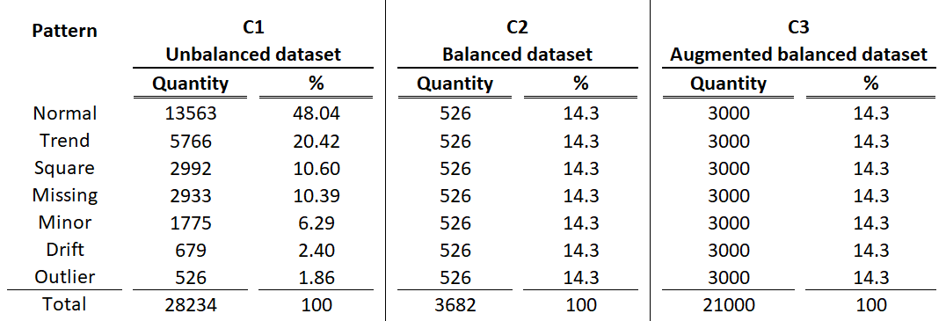
Before the original images are processed into the proposed model, each image is resized from 875 x 656 pixels to 100 x 100 pixels and converted from RGB to greyscale, as shown in Figure 3. This resizing of the image maintains the consistency of the entire database. Each database is split into training, validation, and testing sets with ratio and quantity for each of the subsets included in Table 2.

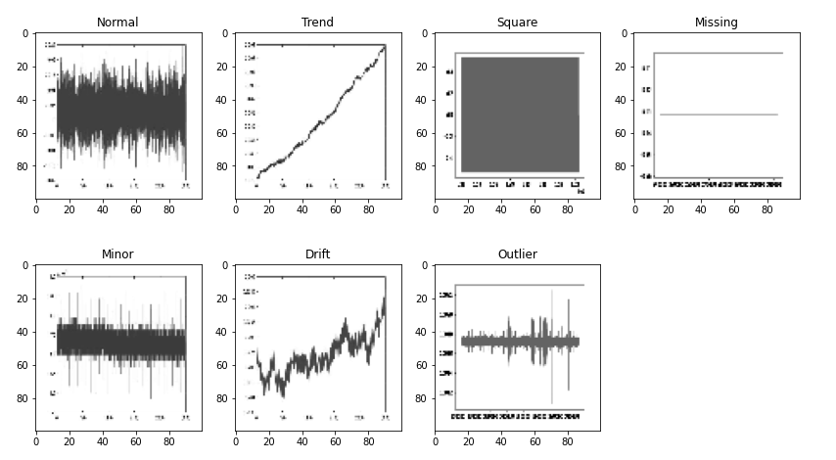
Figure 3. Image samples for each class after preprocessing.

Table 2. Ratio and quantity for the training, validation, and testing sets.
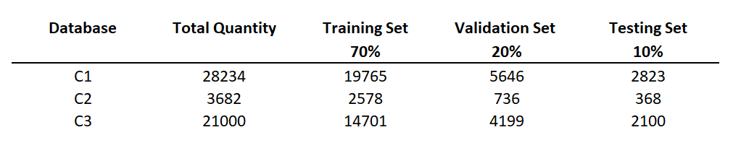

Result analysis
The proposed model is trained with the aforementioned dataset in three cases, respectively, with random search hyperparameter optimization. For each of the three cases, ten different sets of hyperparameters are randomly generated. The trial with the highest training accuracy and lowest validation loss is defined as the best hyperparameter combination. Five repetitions are generated using the best-tuned parameters for each of the three cases to calculate the mean values, as seen in Table 3. The model is free of underfitting as the accuracies are greater than 90% in all trials. It is also not overfitting the training set as the testing results are close to the training results for each of the respective trials. Table 4 shows a summary of detailed metrics for each class to understand the effects of balancing the database and the input sample size on the output.
Table 3. Overall accuracy and loss of three cases with the optimally-tuned hyperparameter.
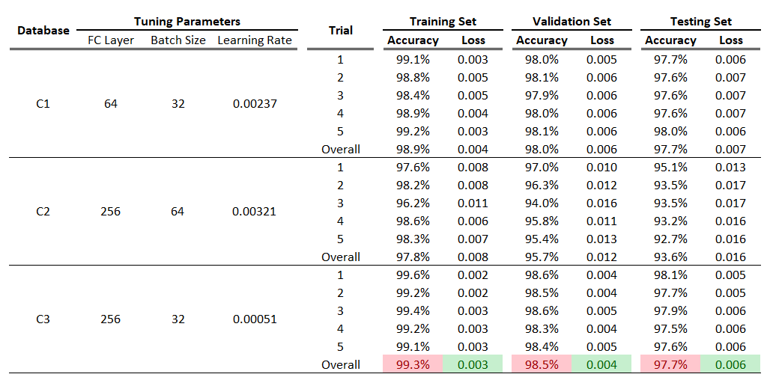
Table 4. Precision, Recall and F1 score for each case.
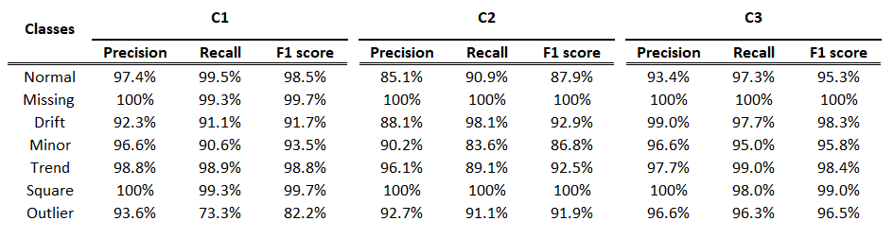
The detailed metrics conclude the following:
- C1 and C2: a database with more data points will generate a higher accuracy. The F1 score for classes Normal and Minor has decreased drastically due to the smaller sample size for the training set.
- C2 and C3: overall accuracy increases due to the larger sample size, although both are balanced.
- C1 and C3: balancing the database could improve the performance of the classes with fewer image samples originally, i.e., Outlier and Drift.

ConclusionS
This paper proposes a deep learning algorithm for the AD tasks within the realm of SHM. The proposed model requires the conversion of time series data into greyscale images, which then pass through several layers with hyperparameter tuning techniques to generate the best-performing model. The proposed model is tested with three cases using a database generated by a long-span cable-stayed bridge in China. The three cases are the original unbalanced database; balancing the database using the smallest number of images in a class; and balancing the database with augmented samples. The testing results reveal that balancing the database allows to improve the F1 score of the classes with fewer image samples originally, and a database with more image samples will increase the overall accuracy of the model performance. It concludes that augmenting the balanced database leads to the best results, with a mean overall accuracy of 97.74% across five trials on the testing set.
The application for the proposed model is not restricted to SHM but could be applied to classification problems containing time series data as raw data points. The complete flow of the model requires standardizing the input into a grayscale image database before passing it into the proposed model. With sufficient raw data preprocessing, the proposed model does not need modifications as the images are passing through. Incorporating a random search hyperparameter optimization algorithm to categorize different classes results in higher efficiency and accuracy. The proven success of the proposed model in SHM demonstrates the potential to expand its use in other imbalance dataset classification applications.

References
- Dong C. and Catbas, N. (2020). A review of computer vision-based structural health monitoring at local and global levels. Structural Health Monitoring. 20(2).
- Li, H. and Ou, J. (2016). The state-of-the-art in structural health monitoring of cable-stayed bridges. Journal of Civil Structural Health Monitoring. 6(1).
- Das, S. and Saha, P. (2018). A review of some advanced sensors used for health diagnosis of civil engineering structures. Measurement. 129.
- Thiyagarajan, K., Kodagoda, S. and Nguyen, L. (2017). Predictive Analytics for Detecting Sensor Failure Using Autoregressive Integrated Moving Average Model. 12th IEEE Conference on Industrial Electronics and Applications.
- Ni, F., Zhang, J. and Noori, M. (2019). Deep learning for data anomaly detection and data compression of a long‐span suspension bridge. Computer-Aided Civil and Infrastructure Engineering. 35(7).
- Jeong, S., Ferguson, M. and Law, K. (2019). Sensor data reconstruction and anomaly detection using bidirectional recurrent neural network. Sensors and Smart Structures Technologies for Civil, Mechanical, and Aerospace Systems 2019. 10970.
- Mao, J., Wang, H. and Spencer, B. (2020). Toward data anomaly detection for automated structural health monitoring: Exploiting generative adversarial nets and autoencoders. Structural Health Monitoring. 20(4).
- Sarmadi, H. and Karamodin, A. (2020). Novel anomaly detection method based on adaptive Mahalanobis-squared distance and one-class kNN rule for structural health monitoring under environmental effects. Mechanical Systems and Signal Processing. 140.
- Bao, Y., Tang, Z., Li, H. and Zhang, Y. (2018). Computer vision and deep learning–based data anomaly detection method for structural health monitoring. Structural Health Monitoring: An International Journal. 18(2).
- Tang, Z., Chen, Z., Bao, Y. and Li, H. (2018). Convolutional neural network‐based data anomaly detection method using multiple information for structural health monitoring. Structural Control and Health Monitoring. 26(1).
- Arul, M. and Kareem, A. (2020). Data Anomaly Detection for Structural Health Monitoring of Bridges using Shapelet Transform. ArXiv.
- Jana, D., Patil, J., Herkal, S., Nagarajaiah, S. and Duenas-Osorio, L. (2022). CNN and Convolutional Autoencoder (CAE) based real-time sensor fault detection, localization, and correction. Mechanical Systems and Signal Processing. 169.
- Liu, G., Niu, Y., Zhao, W., Duan, Y. and Shu, J. (2022). Data anomaly detection for structural health monitoring using a combination network of GANomaly and CNN. Smart Structures and Systems. 29(1).
- Delgado, J. and Oyedele, L. (2019). Deep learning with small datasets: using autoencoders to address limited datasets in construction management. Applied Soft Computing. 112.
- Chen, J., Pi, D., Wu, Z., Zhao, X., Pan, Y. and Zhang, Q. (2021). Imbalanced satellite telemetry data anomaly detection model based on Bayesian LSTM. Acta Astronautica. 180.
- Bao, Y., Chen, Z., Wei, S., Xu, Y., Tang, Z. and Li, H. (2019). The State of the Art of Data Science and Engineering in Structural Health Monitoring. Engineering. 5(2).
- Islam, A., Belhaouari, S.B., Rehman, A.U. and Bensmail, H. (2022). KNNOR: An oversampling technique for imbalanced datasets. Applied Soft Computing. 115.
- Duman, E. and Tolan, Z. (2021). Comparing Popular CNN models for an imbalanced dataset of dermoscopic images. Journal of Computer Science. IDAP-2021.
- Galar, M., Fernandez, A., Barrenechea, E., Bustince H. and Herrera, F. A Review on Ensembles for the Class Imbalance Problem: Bagging-, Boosting-, and Hybrid-Based Approaches. IEEE Transactions on Systems, Man, and Cybernetics, Part C (Applications and Reviews). 42(4).

