Axial-Flexural Interaction for FRP-Confined Reinforced Masonry Columns
Khalid Saqer Alotaibi¹, Belal AbdelRahman², Khaled Galal³
¹Department of Civil and Construction Engineering, College of Engineering, Imam Abdulrahman Bin Faisal University, Dammam, 31451, Saudi Arabia
^{2,3}Department of Building, Civil and Environmental Engineering, Gina Cody School of Engineering and Computer Science, Concordia University, Montreal, Quebec, Canada, H3G 1M8
Email : kalotaibi@iau.edu.sa, belal.abdelrahman@concordia.ca, khaled.galal@concordia.ca

ABSTRACT: This paper proposes a simplified methodology to predict the axial strength gain and the ultimate strain gain required to establish the axial load-moment interaction diagram of fully grouted reinforced masonry columns (RMCs) strengthened with Fiber Reinforced Polymers (FRP) jackets. The methodology considers short prismatic RMCs failing in a compression controlled-manner and it complies with equilibrium and strain compatibility principles. The proposed procedure is designed to predict the nominal capacity of RMCs for practical design applications, where the columns are subjected to both axial load and bending moment. The essential parameters to perform detailed section analysis are established, and suggested expressions are proposed to obtain the parameters' values. Practical values for the equivalent rectangular stress block parameters are proposed, which represent the actual stress distribution in the compression zone of FRP-confined concrete masonry section. The theoretical axial load-moment interaction diagrams obtained by the proposed procedure were compared with the available experimental data. The experimental test results are in good agreement with the analytical predictions by a good margin. A constant value of 0.80 for the parameters, α and β, which define the average stress and the distance to the neutral axis in the equivalent rectangular stress block is recommended for simplicity. The mean absolute percentage error was less than 6% between the experimental data and analytical predictions.

KEY WORDS: Confinement; Eccentric loading; Fiber-reinforced polymer (FRP); Interaction diagram; Reinforced masonry columns (RMCs); Retrofitting.

Introduction
Most reinforced masonry columns (RMCs) in constructed masonry structures are subjected to combinations of axial load and flexure moment. Some existing RMCs need to be strengthened in terms of their capacity or ductility. The need for additional bearing capacity could arise from a change in the structure use, insufficient design, errors in construction, and deterioration of materials, whereas the ductility enhancement is needed for seismic upgrading.
Using fiber reinforced polymers (FRP) jackets to confine RMCs is seen to be an effective technique to strengthen masonry columns with insufficient capacity or ductility. FRP jacket can be formed by wrapping FRP sheets around the columns where the fibers are aligned along hoop direction and perpendicular to the vertical axis of the column.
Several studies [1–4] investigated the application of FRP jackets to retrofit masonry columns built from different materials (tuff, clay, and limestone units). Recent studies [5–8] focused on the experimental behavior of concrete masonry columns strengthened by carbon FRP jackets.
This paper proposes a simplified methodology to compute the axial load-moment interaction diagram of fully grouted RMCs confined with FRP jackets. The proposed procedure follows the equilibrium and strain compatibility principles. The methodology only considers short prismatic RMCs that are subjected to large axial loads and small moments, i.e., axial-moment pairs that fall in the compression-controlled region of the axial load-moment interaction diagram.
The proposed procedure is designed to predict the nominal capacity of RMCs for practical design applications. However, no specific design guideline has been adopted in developing the proposed procedure. Hence, design engineers shall consider load factors, resistance reductions and ultimate axial strain limits consistent with a compatible design code to ensure safety of structures and consider material uncertainties.
The theoretical axial load-moment interaction diagrams obtained by the procedure proposed in this paper are compared to experimental data presented in Alotaibi and Galal [7].

Experimental data of FRP-confined concrete masonry columns
In this paper, the experimental data of 28 tests reported by Alotaibi and Galal [7] is used for validating the proposed interaction diagram methodology. The study featured 18 reinforced FRP-confined concrete masonry columns tested with concentric or eccentric monotonic compressive force, as shown in Figure 1 and Figure 2. The concrete masonry columns tested in that study were constructed from half scale concrete "C" pilaster units. The square cross section is fully grouted and has four longitudinal steel reinforcements with 12.7 mm nominal diameter. The masonry column has a length to cross section thickness ratio (L/t) of 4.97. The column with such slenderness ratio is considered as a short column. The general properties of the masonry columns, longitudinal steel reinforcement and composite jacket are summarized in Table 1. The maximum axial load capacity and maximum moment of a total of 18 concrete masonry columns strengthened with Carbon fiber-reinforced polymer (CFRP) jackets are presented in Table 2. Columns with unsuccessful strength or without FRP jackets are excluded. More details of the symbols used in the tables, tests, and the columns construction can be found in Alotaibi and Galal [7].

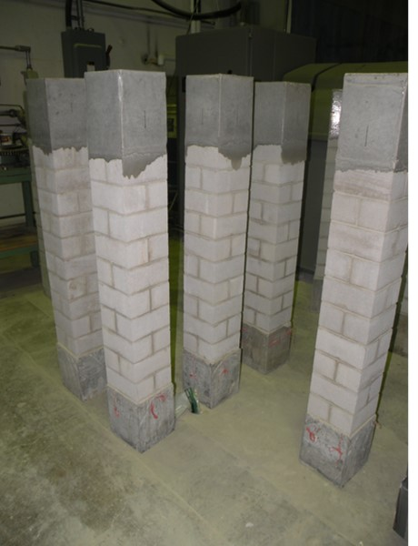 | 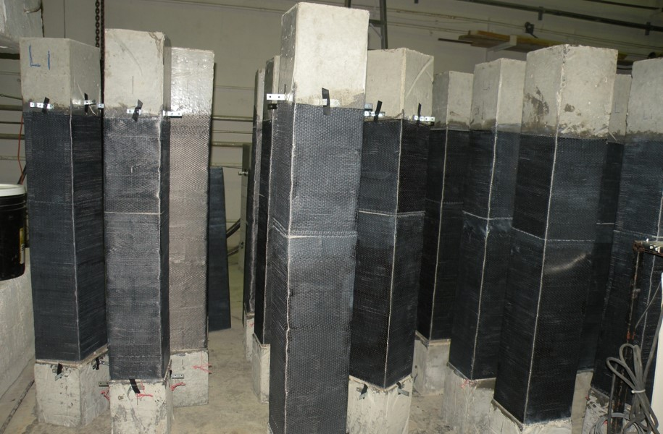
Figure 1. Reinforced masonry columns before (left) and after (right) FRP wrapping

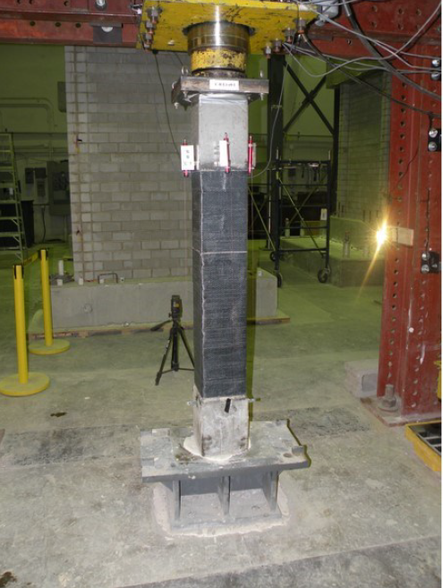 | 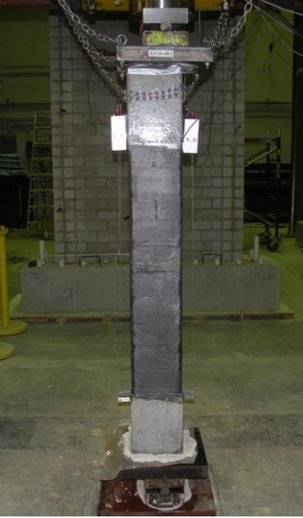
Figure 2. Testing of FRP-confined reinforced masonry columns under concentric and eccentric axial compression

Table 1 Properties of tested columns in the literature [7]
$$f_{md}$$  (MPa) | $$g_{m}$$  (kg/m³) | $$b$$  (mm) | $$h$$  (mm) | $$f_{y}$$  (MPa) | $$E_{s}$$  (GPa) | $$ε_{y}$$  (mm/mm)
10.96 | 2171 | 190 | 190 | 483.0 | 200 | 0.0024
$$E_{f}$$  (GPa) | $$t_{f}$$  (mm) | $$ε_{fk}$$  (%) | $${\begin{aligned}A\end{aligned}}_{s}$$  (mm²) | $$ρ_{g}$$  (%) | $$L$$  (mm) | $$r_{c}$$  (mm)
65.40 | 0.381 | 1.33 | 516 | 1.4 | 945 | 10

Axial load-moment interaction diagrams
The main difference of analysis between FRP-confined concrete and conventional concrete is the choice of stress-strain curve that presents the new confined material in the compression zone [9]. Hence, the same concept applies for concrete masonry is considered acceptable and valid.
Establishing axial load-moment interaction diagrams is essential to evaluate the axial and flexural capacities of an axially loaded masonry column. The shape of the interaction diagram is characterized by four fundamental points. Determining at least the axial load and moment values of fundamental points allows drawing simple interaction diagram. The points with the strain distributions in the cross section are illustrated in Figure 3.
Developing axial load-moment interaction diagrams is based on the well-known procedure of section analysis adopted for conventional reinforced concrete columns.
In the interaction diagram, the segment defined by the points A, B, and C, and the segment defined by the points C and D represent compression-controlled and tension-controlled failure, respectively.

Table 2 Test data in the literature [7]
Column label | $$t_{f}$$  (mm) | $$P_{max}$$  (kN) | $$M_{max}$$  (kN.m) | $$e$$  (mm)
L1-e0-1 | 0.381 | 759.06 | 0.00 | 0.00
L1-e0-2 | 0.381 | 814.00 | 0.00 | 0.00
L1-e0-3 | 0.381 | 777.38 | 0.00 | 0.00
L1-e20-1 | 0.381 | 446.37 | 11.02 | 24.69
L1-e20-2 | 0.381 | 531.99 | 13.11 | 24.64
L1-e20-3 | 0.381 | 469.27 | 11.67 | 24.87
L1-e40-1 | 0.381 | 321.39 | 14.59 | 45.40
L1-e40-2 | 0.381 | 382.74 | 17.56 | 45.88
L1-e40-3 | 0.381 | 273.78 | 11.93 | 43.58
L2-e0-1 | 0.762 | 861.62 | 0.00 | 0.00
L2-e0-2 | 0.762 | 819.50 | 0.00 | 0.00
L2-e0-3 | 0.762 | 762.73 | 0.00 | 0.00
L2-e20-1 | 0.762 | 540.23 | 12.79 | 23.68
L2-e20-2 | 0.762 | 527.87 | 13.23 | 25.06
L2-e20-3 | 0.762 | 629.50 | 15.46 | 24.56
L2-e40-1 | 0.762 | 366.71 | 17.45 | 47.59
L2-e40-2 | 0.762 | 352.52 | 16.89 | 47.91
L2-e40-3 | 0.762 | 359.85 | 16.85 | 46.83

This paper only addresses the segment of the axial load-moment interaction diagrams where the compression is considered the dominated failure mode. Assuming no contribution of the FRP confinement for strengthening columns failing in a tension controlled manner [9].

Figure 3. Axial load-moment interaction diagram

Predicting the strength gain
Determining the axial capacity of FRP confined concrete masonry (f_{mcd}) is necessary to axial load-moment interaction diagram prediction. Suitable strength model that gives a reliable estimation of the effectiveness of FRP strengthening system can be used to quantify the enhancement in the strength as a result of FRP jacketing. The model provided in CNR-DT 200 R1 [10] guide would be satisfactory for predicting the strength enhancement in masonry columns strengthened by FRP jackets.

A comparison between CNR-DT 200 R1 strength model and experimental data for fully grouted RMCs is carried out in terms of strength gain to ensure the reliability of strength model. Six stress-strain curves described in Alotaibi and Galal [7] for RMCs tested under axial compression load and strengthened with one and two layers of CFRP jackets were used, as shown in Figure 4. The labels L1 and L2 were utilized for masonry columns strengthened with one and two layers of CFRP, respectively. In Figure 4, the stress-strain curves for each group were averaged to obtain a unified representation of the behavior of the masonry columns confined with FRP jackets.

Figure 4. Averaged stress-strain curves for masonry columns strengthened with one and two layers of CFRP.

Averaged stress-strain curves for masonry columns strengthened with one and two layers of CFRP jackets with and without longitudinal steel reinforcements’ contribution are presented in Figure 5. The strength provided by the longitudinal steel reinforcements was subtracted from the total strength capacity of the FRP confined concrete masonry column. An elastic-perfect plastic response of the longitudinal steel reinforcements was assumed. The values of elastic modulus, yield strain and yield stress for the longitudinal steel reinforcements were obtained from experimental tests conducted on steel bars are summarized in Table 1. Strain compatibility between longitudinal steel reinforcements and concrete masonry was assumed.

Predicting the ultimate strain gain
The ultimate axial strain of FRP confined masonry columns must be defined in order to perform the detailed section analysis. Figure 6 shows the ultimate axial strain gain of confined masonry (ε_{mcu}/ε_{mu}) versus the ratio of effective confining pressure to unconfined masonry strength (f_{l,eff}/f_{md}). The ultimate axial strain gains were calculated by considering the ultimate axial strain of unconfined concrete masonry equals 0.0025 mm/mm.
Figure 5. Averaged stress-strain curves for masonry columns strengthened with one and two layers of CFRP.

The effective confining pressure is obtained by adopting the predictions of CNR-DT 200 R1/201 model.

Figure 6. Ultimate axial strain of confined concrete masonry in terms of effective confining pressure.

A similar function used by CNR-DT 200 R1/201 guide [10] for strength gain was utilized to establish the best-fit representation of the experimental data for the ultimate strain gain of confined masonry. The expression obtained from the regression analysis can be written as follows:
$$\frac{ε_{mcu}}{ε_{mu}}=1+\left(\frac{g_{m}}{1000}\right).{\left(\frac{f_{l,eff}}{f_{md}}\right)}^{0.26}$$ | (1)
From the proposed expression, the ultimate axial strains for concrete masonry columns confined with effective confining pressures of 0.245 and 0.489 MPa are equal to 0.0045 and 0.0049 (mm/mm), respectively.

Establishing the load-moment interaction diagram
Enhancement in the performance of RMCs due to the confinement by FRP jackets can only be expected when the coordinates of the applied axial load and flexural moment falls above the balance line; Where the balance line is a straight line between the origin point and the balanced point (Point C) in the axial load-moment interaction diagrams of unconfined columns.
The proposed design methodology only addresses the segment defined by the points A, B, and C correspond to compression-controlled region in the axial load-moment interaction diagram.
The first step in the construction of the axial load-moment interaction diagram is predicting the strength gain in axial load as a result of using FRP jackets to retrofit the concrete masonry column. The strength gain can be determined by from the CNR-DT 200 R1 design guideline. The ultimate axial strain of concrete masonry confined by FRP can be defined by the expression proposed in this paper by Eq. (1).
After determining the compressive strength (f_{mcd}) and the ultimate strain (ε_{mcu}) of FRP-confined masonry, the curve of the interaction diagram can be drawn by generating many points on the curve where the coordinates of any point indicate axial load and bending moment of FRP confined concrete masonry column. However, a simpler multi-linear interaction diagram can be drawn if the values of the points A, B, and C were determined.

accuracy of the proposed methodology
The experimental data reported in Table 2 were compared to theoretical axial load-moment interaction diagrams generated by the proposed procedure to evaluate the accuracy of the design equations. Figure 7 show comparisons of the experimental data against the theoretical predictions of the nominal capacities using the proposed approach by changing the position of neutral axis and using different values of the stress block parameters. In Figure 7, green dashed lines connecting the balanced points to the origin points were depicted to distinguish between compression-controlled failure and tension-controlled failure.

Figure 7. The comparisons of the experimental tests against the theoretical predictions (α=0.80, β=0.80).

Conclusions
This paper proposes a simplified methodology that predicts the axial load-moment interaction diagram of fully grouted RMCs strengthened with FRP jackets. The proposed methodology aims to predict the nominal capacity of FRP-confined concrete masonry columns for design purposes.
The strength model of CNR-DT 200 R1 design guideline was used to quantify the enhancement in the axial strength and determine the value of f_{mcd} parameter. An equation calibrated using available experimental data in Alotaibi and Galal [7] was proposed for predicting maximum usable FRP confined concrete masonry strain in the extreme compression fiber. The segment of the interaction diagram curve represents the region controlled by compression failure can be generated by selecting arbitrary neutral axis positions then calculating the nominal axial strengths and moments capacities for these positions. The results showed very good agreement between the proposed design predictions and experimental tests in Alotaibi and Galal [7]. It should be mentioned that more extensive experimental data are encouraged to increase the confidence and validate the proposed methodology.

Acknowledgement
The authors acknowledge the financial support of the Natural Sciences and Engineering Research Council of Canada (NSERC), Canadian Concrete Masonry Producers Association (CCMPA), L'Association des entrepreneurs en maçonnerie du Québec (AEMQ), and Canada Masonry Design Centre (CMDC).

References
[1] Campione G, Miraglia N. Strength and strain capacities of concrete compression members reinforced with FRP. Cem Concr Compos 2003; 25:31–41.
[2] Ludovico M Di, Claudio D’ambra;, Prota A, Manfredi G. FRP Confinement of Tuff and Clay Brick Columns: Experimental Study and Assessment of Analytical Models. J Compos Constr 2010;14:583–96.
[3] Faella C, Martinelli E, Paciello S, Camorani G, Aiello MA, Micelli F, et al. Masonry columns confined by composite materials: Experimental investigation. Compos Part B Eng 2011; 42:692–704.
[4] Alecci V, Bati SB, Ranocchiai G. Study of Brick Masonry Columns Confined with CFRP Composite. J Compos Constr 2009; 13:179–87.
[5] Alotaibi KS, Galal K. Axial compressive behavior of grouted concrete block masonry columns confined by CFRP jackets. Compos Part B Eng 2017; 114:467–79.
[6] Galal K, Farnia N, Pekau OA. Upgrading the Seismic Performance of Reinforced Masonry Columns Using CFRP Wraps. J Compos Constr 2012; 16:196–206.
[7] Alotaibi KS, Galal K. Experimental study of CFRP-confined reinforced concrete masonry columns tested under concentric and eccentric loading. Compos Part B Eng 2018; 155:257–71.
[8] Ashour A, Galal K, Farnia N. Analytical and Experimental Study on Upgrading the Seismic Performance of Reinforced Masonry Columns Using GFRP and CFRP Wraps. J Compos Constr 2018; 22:04018013.
[9] Rocca S, Galati N, Nanni A. Interaction diagram methodology for design of FRP-confined reinforced concrete columns. Constr Build Mater 2009; 23:1508–20.
[10] Guide for design and construction of externally bonded FRP systems for strengthening existing structures: materials, RC and PC structures, masonry structures. 2006:143.

