ABSTRACT: Heavy truckloads on a bridge cause vibration, which leads to bridge decks to crack and steel girders to fatigue. Understanding the Gross Vehicle Weight (GVW of a truck) and Axle weights determines the strength and the load-carrying capacity of the bridge decks and girders. The GVW is determined using the bridge Weigh in Motion (BWIM) system. This paper explores a new methodology to determine if geophones can be used to estimate the truck velocity, number of axles and axle spacings, and axle weights. Based on the test data set, the geophone could accurately determine the truck velocity and axle spacing. The truck, velocity, axle spacing and GVW will define the complete configuration of the truck.
Observation of velocity and axle spacings of moving truck using geophone sensor
Mirzaei, Maedeh^{1,4}, Thomson, Douglas², Helmi, Karim³, Mufti, Aftab¹
¹Department of Civil Engineering, SIMTReC, University of Manitoba, Winnipeg, Canada, R3T2N2
²Department of Electrical and Computer Engineering, University of Manitoba, Winnipeg, Manitoba, Canada, R3T2N2
³ Building and Construction Engineering Department, Arab Academy for Science, Technology and Maritime Transport, Alexandria, Egypt
⁴Email: mirzaei2@myumanitoba.ca

KEYWORDS: Axle detection, Axle spacing, Axle weight, Bridge weight-in-motion, Geophone sensor, Gross vehicle weight, Truck, Truckloads.

INTRODUCTION
Bridges are an essential part of the transportation and infrastructure area. Heavy truckloads are one of the critical elements for bridges that cause fatigue in steel girders and deterioration in concrete bridge decks. Preventing the failure of bridges due to an increase in traffic loads will be an essential factor that should be considered further [1]. Therefore, observing the vehicle loads that pass over the bridges performs a significant role in planning the bridge networks for monitoring and maintaining the bridge structures [2]. Based on structural health monitoring techniques, some methods like a BWIM Bridge-Weight-In-Motion system were designed to estimate the weight of heavy vehicles without stopping them on the highway [3]. The BWIM has two components, the axle weights and configuration and the gross vehicle weights. Structural Innovation and Monitoring Research Group (SIMTReC) has developed a BWIM system for calculating gross vehicle weights. The system is being extended to include estimates for axle weights and configuration. Critical to this extension is having a means to accurately estimate vehicle velocity, the axel number, and the distance between axles. The work presented here explores using a geophone sensor mounted over a bridge bearing to determine vehicle velocity, axel number and distance between axels. A geophone is a sensor that outputs a voltage in response to the movement of the sensor [4]. The geophone measures the dynamic displacement of the compressible bridge bearing, which is compressed by tire loads passing over the expansion joints. The measurements of the vertical velocity of the bearing are used to determine the time at which tire loads pass over the bearing. The vehicle velocity, axel configuration, and axel distances can be estimated from these times. An algorithm was devised for filtering the signals to remove unnecessary noise and vibrations from the raw geophone signal. The geophone has the advantage of being easy to install. In addition, only a single sensor is required as a geophone can detect signals from bearings at both ends of a simply supported span.
This paper focuses on determining vehicle configuration, axle numbers, velocity, and axle spacings of the trucks based on analyzing the geophone signals. The method has been validated on a bridge model in the structural health monitoring laboratory at the University of Manitoba. Also, verifying tests have been done on a medium-span bridge in the field.

FIELD TESTS
The geophone was attached under a girder beside the bearing, as shown in Fig. 1. The geophone used in this work, a model SG-5, has a natural cut-off frequency of 5 Hz and a sensitivity of 80 V/m/s.

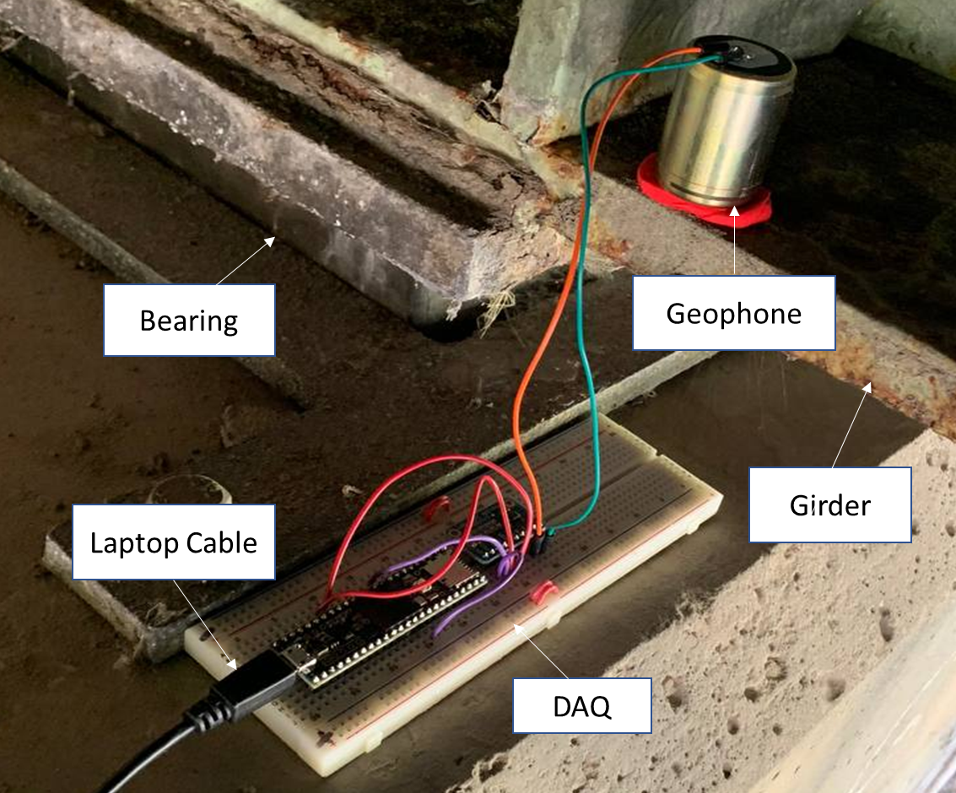
Fig. 1. The geophone attachment besides the bearing under the second expansion joint

The geophone recorded a series of positive and negative spikes in vertical velocity measurement. The spikes correspond to the bearing, which is compressed and released by each axle load when a truck passes. The configuration, numbers, and axle position can be estimated from the spikes in the signal, which are shown in Fig. 2.

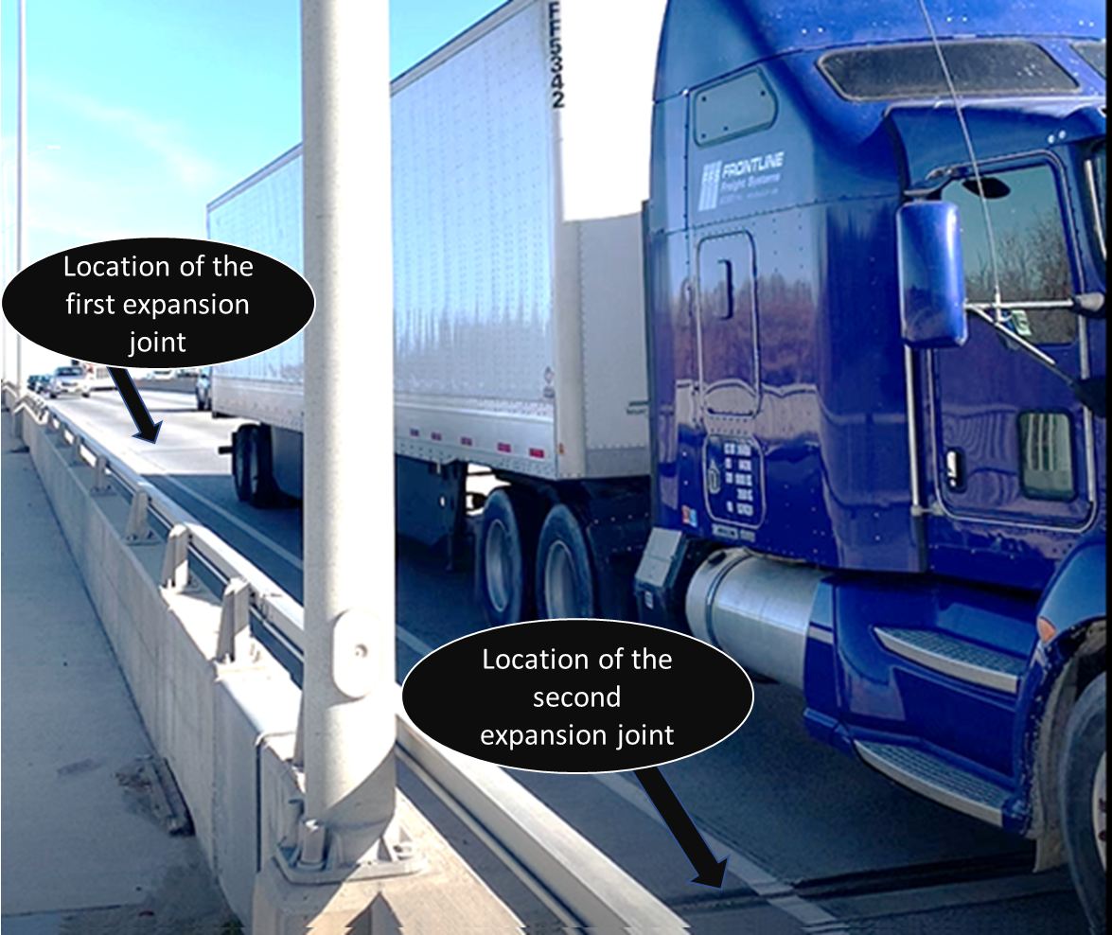
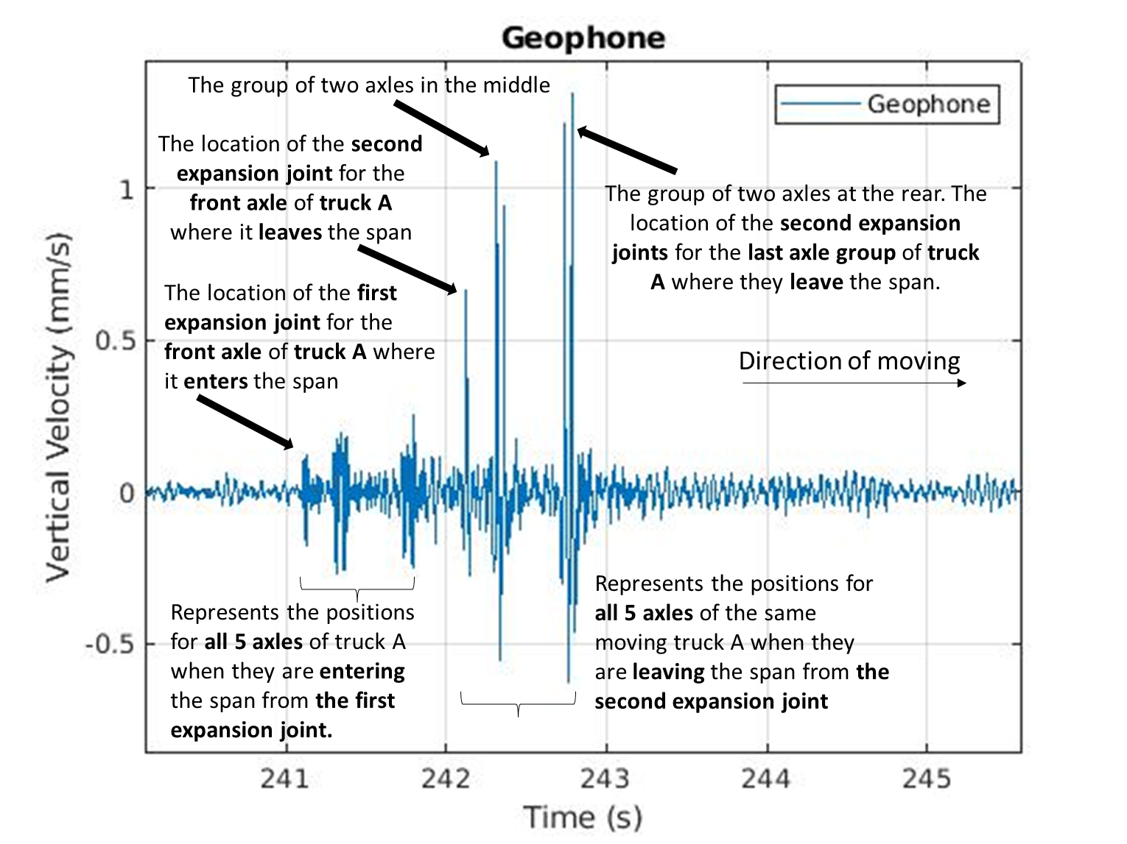
Fig. 2. Geophone signal for a 5-axel truck entering and leaving the span. The geophone is located under the second joint.

Each signal for each truck has two sections, section one (241 to 242 seconds) with shorter amplitude shows the positions when the axles enter the span, and section two (242 to 243 seconds) with larger amplitude represents the positions when the axles for the same truck leave the span. The geophone is located under the second joint, producing a larger signal for wheel loads over that joint. The timing of entering and exiting the span for the front axle based on this repetitive behaviour allows for calculating the truck's velocity.

Estimating the velocity of trucks in the field

Velocity calculation based on the geophone signals
Two different methods were used for the field test to estimate the velocity of more than 30 different trucks. The first method used geophone signals, and the second used video recordings. The geophone velocity estimate used the time difference between the first axel entering and the first axel leaving the span. An example is shown in Fig 3, where the axel enters the span crossing the first expansion joint at 182.3s and crossing the second expansion joint leaving the span at 183.5s. The velocity was calculated by dividing the distance between the expansion joints by the time difference.
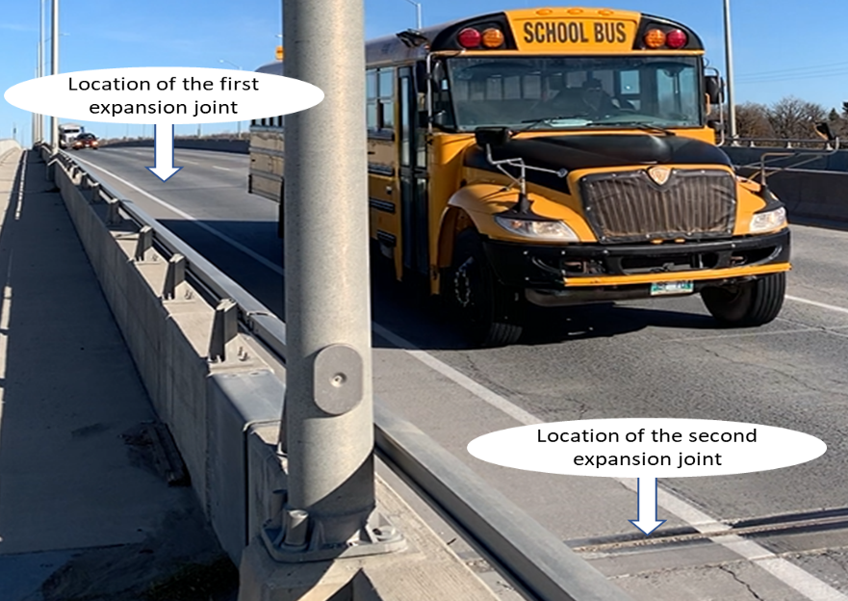
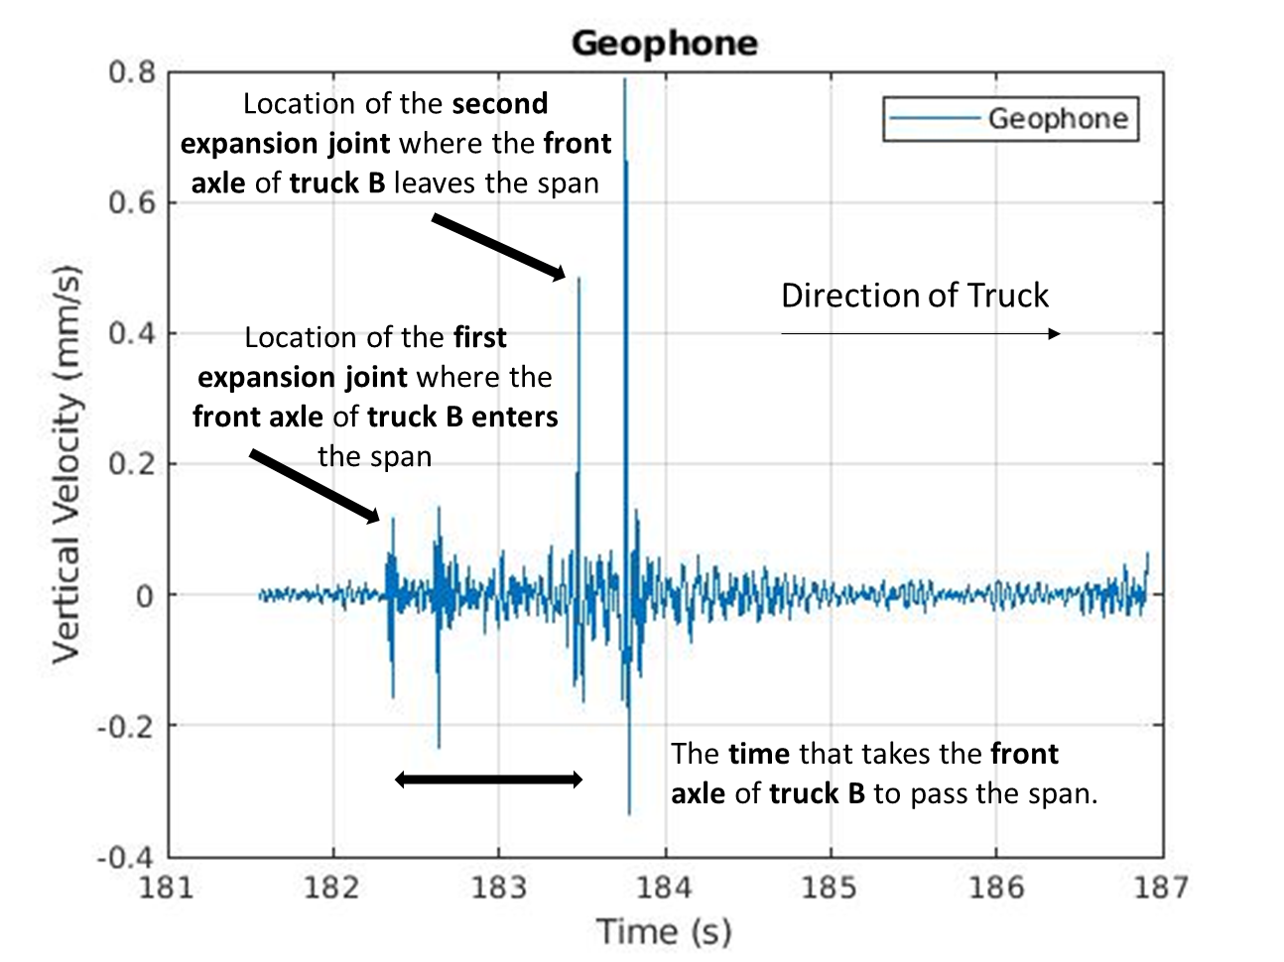
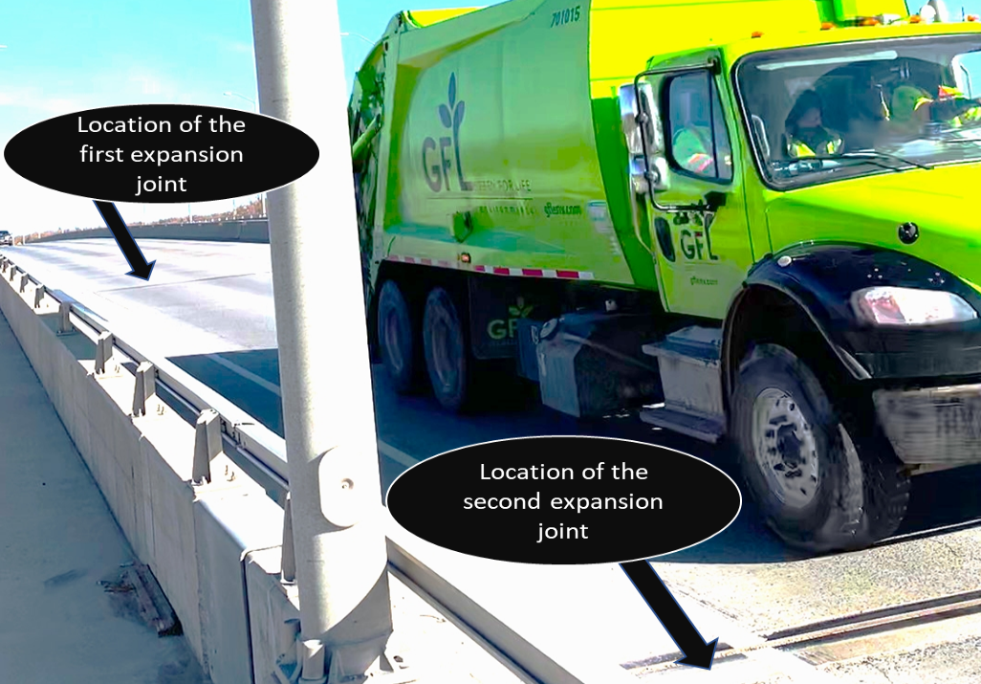
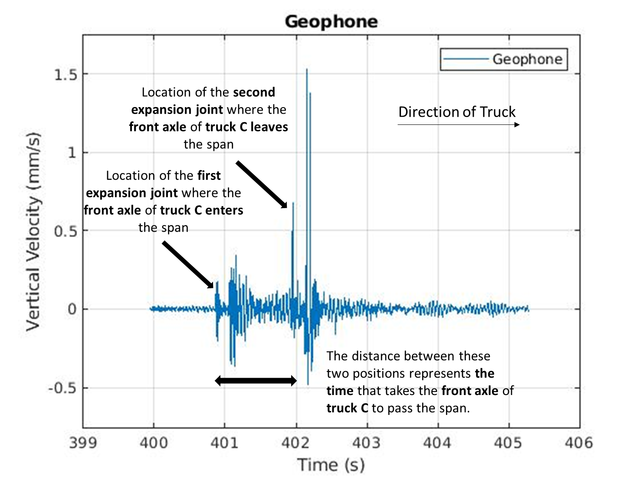
Fig. 3. Detecting front axle positions for velocity calculation

Velocity calculation based on the video camera
The other method of estimating the velocity is using video taken at the same time as the geophone recordings [5]. The starting time of the video and the geophone recording was synchronized for all datasets. The video camera was set above the bridge to view entering and leaving expansion joints on the bridge. The time between entering and leaving the front axle was determined by going through the video frame by frame. The velocity is calculated by subtracting entering and exiting times and dividing them by the span length.

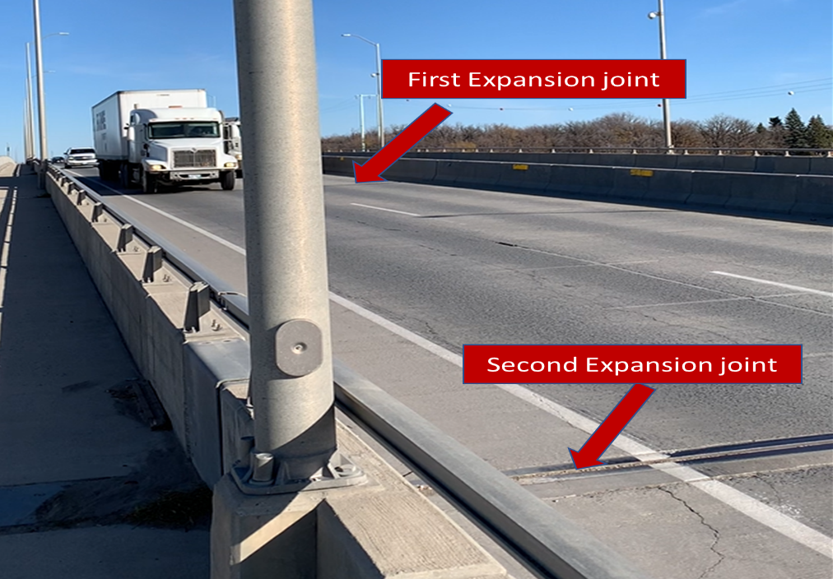
Fig 4. Represents the perspective and location of the video camera and the way of capturing the time that the front axle enters and exits the span. The second expansion joint is the location of the geophone.

Knowing the length of the span between the joints and having the time required for the truck to traverse the span, the velocity of each truck was calculated.

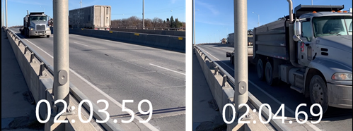
Fig 5. Catching the time of entering and exiting the span for the truck's front axle based on the video camera.

Table 1 represents the velocity result based on the geophone and video camera data for three random trucks for the velocity calculation. There might be differences based on the exact response of the structures as the wheel enters and exits the span. However, the initial data's estimation of the velocity base is represented here with less than a 2% difference.

Table 1. Field Velocity Results
Truck Number | Geophone Velocity  (m/s) | Video Velocity  (m/s) | Velocity Difference  (%)
Truck 1 | 25.74 | 25.26 | 1.86
Truck 2 | 23.94 | 23.49 | 1.87
Truck 3 | 28.15 | 27.69 | 1.63

Axle distances calculation based on computed velocity
Once the velocity is known, the axel spacing can also be estimated. The time when each axel leaves, the span can be determined from the geophone signal. An example is shown in Fig 6. For a 5-axel truck. Each axel is marked with a red dot. The distance between each axel can be calculated by knowing the time for each point and the velocity. The results were then compared with video estimates using the above methods for velocity estimation.
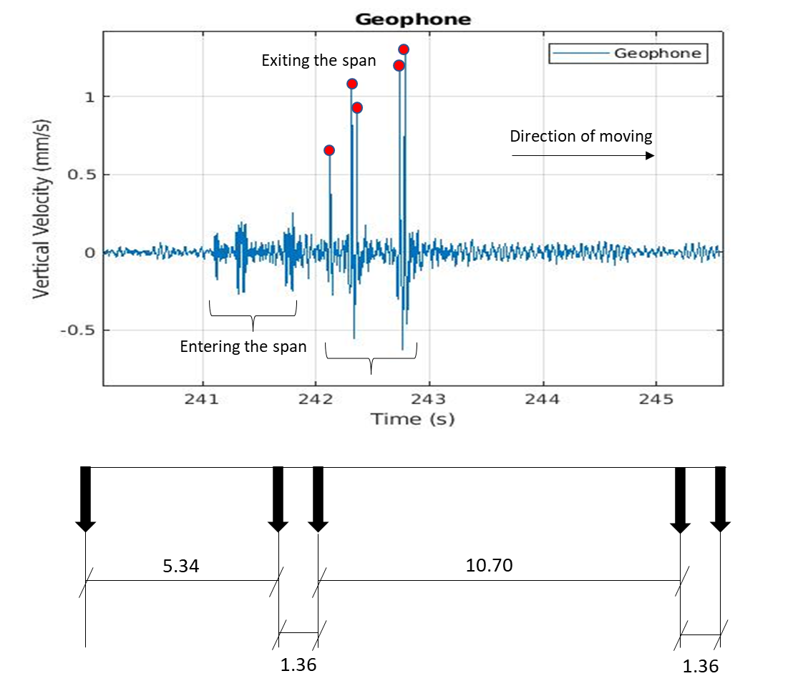
Fig 6. Calculated configuration of the 5-axle truck event. Peaks determine the number of detected axels exiting the span.

Table 2. The geophone and The Video Camera axle spacings in the field
Truck Numbers | Number of axles | Distance Front to Back based on velocity obtained from geophone  (m) | Distance Front to Back  Based on velocity obtained from video  (m) | Actual Distance  (m)
Truck 1 | 2 | 7.26 | 7.07 | 7.22
Truck 2 | 3 | 7.44 | 7.43 | 7.37
Truck 3 | 5 | 18.70 | 18.45 | 18.50

Table 3. Axle spacings based on the geophone
Truck Number | Front to second | Second to third | Third to fourth | Fourth to Fifth
Truck 1 | 7.26 | - | - | -
Truck 2 | 6.17 | 1.27 | - | -
Truck 3 | 5.34 | 1.36 | 10.70 | 1.3

SHM LABORATORY TESTS
The same geophones methodology was duplicated using a model bridge in the laboratory to explore further and clarify this method. The model bridge has structural characteristics scaled to the bridge used for field testing [1]. The test was performed for two different datasets for the model truck with four axles. The front-to-back axle distance is 0.76 m. Two geophones in the laboratory test were used to understand better the geophone signals observed in the field. The geophones were attached to the model bearing under two expansion joints, as shown in Fig. 7.
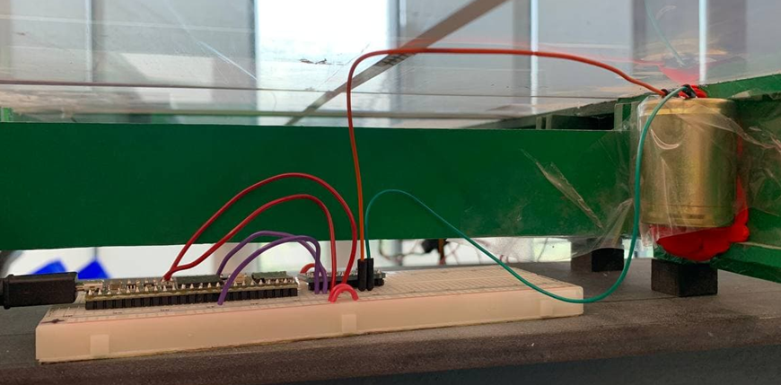
Fig. 7. The geophones attachment in the lab

The same methodology was used to calculate the truck's velocity in the field tests. Fig. 8 shows axle detection using the geophone in the laboratory test, which illustrates the two sections (the location of expansion joints) where the truck axels enter and exit the span. Each geophone responds when the truck enters and when it leaves the span. Therefore, only one is needed to detect the entry and departure of the truck.
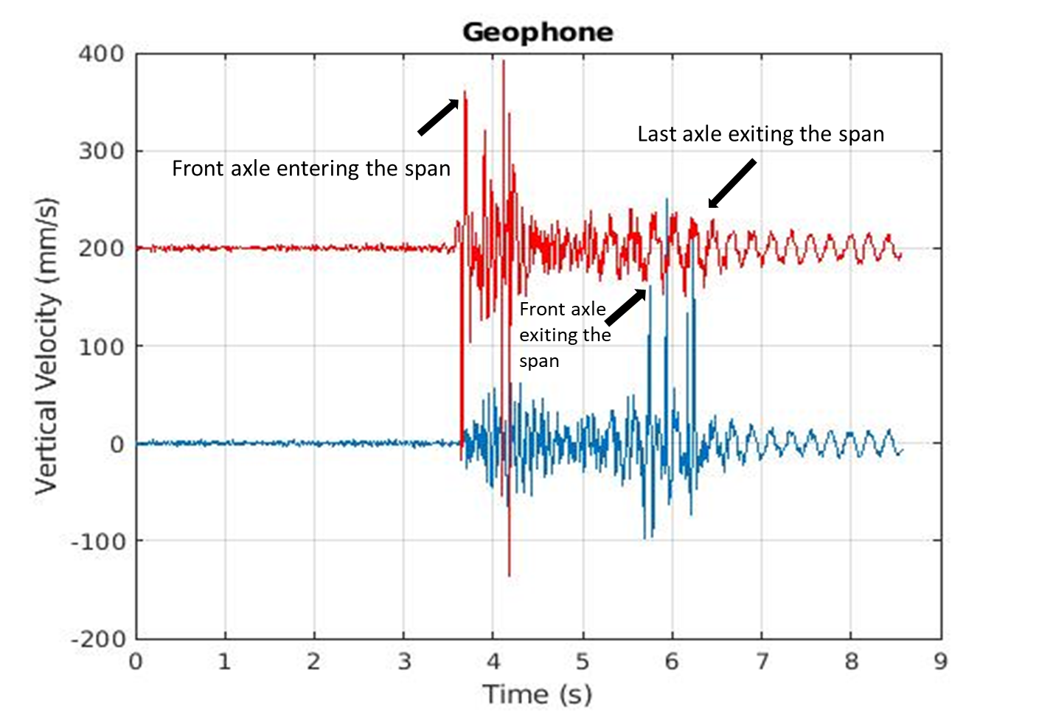
Fig. 8. The red signal is for the geophone attached to the entering expansion joint, and the blue signal is for the exiting expansion joint.

Fig 8. allows for detecting the truck's front axle when it enters the span for calculating the velocity. With the help of the other geophone, which was attached under the first expansion joint, we determine that detecting the entering positions where the axles enter the span is correct as the signals from both geophones start and end simultaneously. Based on the larger magnitude signal related to the axles, the positions of other axles can also be detected. The result of the velocity calculation in the laboratory tests is shown in Table 3.

Table 4. Geophone Velocity in the lab
Truck Number | Geophone Velocity (m/s)
Dataset 1 | 1.43
Dataset 2 | 1.41

Table 5. Geophone truck axle spacings in the lab
Truck Numbers | Distance Front to Back(m) | Actual distance  (m)
Dataset 1 | 0.75 | 0.76
Dataset 2 | 0.73 | 0.76

The truck's velocity, the number of axles, configuration, and axle spacings were calculated as laboratory test results. Some sources of error will be related to the sampling rate and the variation in the structural response from one truck to another. The sampling rate needs to be high enough to capture the rise and fall of the geophone signal accurately. Depending on the exact structural response, there might also be variations as the wheel leaves and enters the span. However, the preliminary data presented here yielded velocity estimates with less than 10% error.
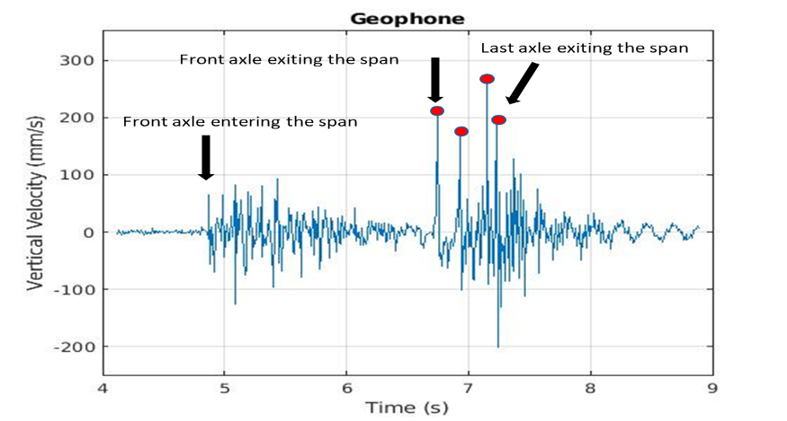
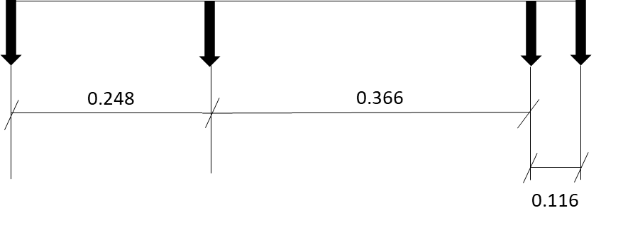
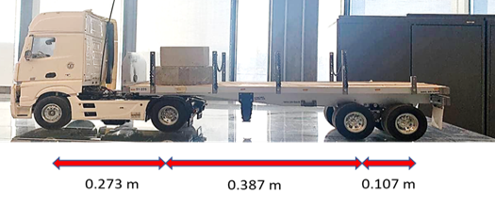
Fig. 9. The model truck configuration, the number of axles, the calculated axle spacings and the actual axle spacings.

Summary, conclusions and future work
- This paper demonstrated the use of a geophone as an axle detector which then could be incorporated into a BWIM system.
- The geophone accurately determines the truck's velocity and axle spacing with reasonable accuracy.
- Further research is ongoing to determine individual axle weights.

References
- Faraz, S., 2021. Experimental and field investigation of a bridge-weigh-in-motion (BWIM) system. Improving the accuracy of a bridge inspection, evaluation, and fatigue assessment.
- Statistics Canada. (2017). “New Brunswick [Province] and Canada [Country] (table). Census 34 573 Profile. 2016 Census. Statistics Canada Catalogue no. 98-316-X2016001. Ottawa. Released 574 November 29,
- Helmi, K., Bakht, B. and Mufti, A., 2014. Accurate measurements of gross vehicle weight through bridge weigh-in-motion: a case study. Journal of Civil Structural Health Monitoring, 4(3), pp.195-208.
- Bahrani, N., Blanc, J., Hornych, P. and Menant, F., 2020. Alternate method of pavement assessment using geophones and accelerometers for measuring the pavement response. Infrastructures, 5(3), p.25.
- Algohi, B., Khalid, H., Bakht, B., Mufti, A., and Regehr, J. (2018) "Some observations on BWIM data collected in Manitoba". 10th International Conference on Short and Medium Span Bridges Quebec City, July 31-August 3.

