ABSTRACT: Varying temperature is a significant load of long-span cable-stayed bridges. However, quantitative studies on temperature behavior of long-span cable-stayed bridges are limited and focus on 2D or 3D of a bridge segment only. The present study investigates the global temperature behavior of long-span cable-stayed bridges efficiently and accurately by using one channel bridge of the Hong Kong-Zhuhai-Macao Bridge as the testbed. Real-time ambient temperature and solar radiation data is considered and collected from the observatory. The numerical heat-transfer analysis and the field monitoring data are integrated to calculate the temperature distribution of the entire bridge, which is then used to obtain the temperature-induced responses of the sea-crossing bridge. The heat-transfer analysis and structural response analysis share the same finite element meshes, offering a convenient and rapid global temperature monitoring of large-scale cable-stayed bridges.

Global 3D temperature behavior of cable-stayed bridges
Yushi Shan¹, Lingfang Li¹, Qi Xia², Yong Xia¹
¹ Department of Civil and Environmental Engineering, The Hong Kong Polytechnic University, Kowloon, Hong Kong, China
² School of Civil Engineering, Southeast University, Nanjing, China
Email: yushi.shan@connect.polyu.hk, lingfang.ce.li@polyu.edu.hk, q_xia@seu.edu.cn, ceyxia@polyu.edu.hk
KEY WORDS: Temperature behavior; Cable-stayed bridges; Heat transfer analysis.

Introduction
Exposed to ambient temperature and solar radiation, bridges are subjected to seasonal and diurnal thermal effect. Variations in structural temperature will induce deformations and stresses, especially for long-span cable-stayed bridges. The large scale and the high indeterminacy have made their thermal behavior even more complex. Besides, studies have shown that structural behaviors may be significantly influenced by temperature effect more than vehicle loads or structural damage [1]. With the booming construction of long-span bridges in recent years, the in-depth investigation of their thermal behavior has been increasingly demanded.
Studies on the thermal behavior of bridges can be dated back to 1960s when Zuk [2] investigated several highway bridges and pointed out that air temperature, solar radiation, wind, humidity, and material type are main influencing factors for temperature distribution. Early studies have also been done by Capps [3], Priesley [4], and Dilger et al [5]. Since the 1970s, numerical analysis has been developed to calculate temperature distribution of bridges. 1D approaches have been investigated by Emerson [6] and Hunt and Nigel [7], which assumes the temperature only varies in one direction. 2D methods have been applied by Tong et al. [8] and Lucas [9]. Besides, Zhou et al. [10] proposed the 2D air element to investigate the vertical and transversal temperature differences. With the development of the structural health monitoring (SHM) system, explorations have also been done in 3D areas but limited to the component level in the study conducted by Xia et al. on the Tsing Ma Suspension Bridge [11]. Assumptions that the temperature variation in one or two dimensions is insignificant lays the foundation for those studies. Comprehensive understanding of the global temperature behavior of large-scale bridges has yet to be studied. Zhou et al. also derived simple analytical formula of temperature-induced displacement of three spans [12] and multi-span [13] suspension bridges and beam bridges [14].
This study aims to investigate the global temperature behavior of long-span cable-stayed bridges by using a channel bridge of the Hong Kong-Zhuhai-Macao Bridge (HZMB) as the case study. With real-time ambient temperature and solar radiation data, numerical analysis and field monitoring data are integrated to conduct the thermal analysis and subsequent structural analysis. Calculated temperature and response results are compared with the corresponding measurements.

Qingzhou Channel bridge and its monitoring system

Qingzhou Channel Bridge
The HZMB is known as the world’s longest sea-crossing bridge that connects three regions with a total length of 55 km. The Qingzhou Channel Bridge, one of its three main channel bridges, is a cable-stayed bridge with a total length of 1,150 m and a main span of 458 m, as shown in Figure 1. The steel box girder, covered by 70-mm-thick asphalt, carries a dual three-lane highway, and is continuously supported by two H-shaped towers, two auxiliary piers and two transitional piers. As high as 163 m, the H-shaped tower is composed of two concrete box legs, a concrete lower transom, and a steel upper transom which is assembled into the shape of a Chinese knot.
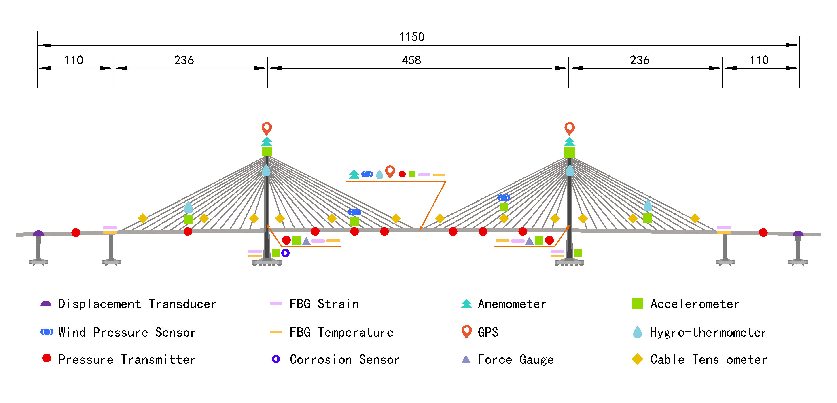Figure 1 Configuration and sensor layout of the Qingzhou Channel Bridge

Structural health monitoring system of the Qingzhou Channel Bridge
An SHM system was designed for the HZMB and operated since 2018 when the bridge was first open to public. About 262 sensors were installed on the Qingzhou Channel Bridge to monitor its environmental conditions, external loads, and structural responses, including anemometers, hydro-thermometers, GPS stations, accelerometers, liquid leveling system, displacement transducers, cable tensiometers, strain gauges, thermometers, corrosion sensors, and reaction dynamometers. The layout of the sensor arrangement is shown in Figure 1.

Refined finite element model of the qingzhou channel bridge

General information
Previous studies on the temperature behavior of long-span are limited to simplified 2D or 3D bridge segments. In order to comprehensively and accurately simulate the thermal distribution of the whole bridge, a 3D refined element model of the Qingzhou Channel Bridge was established based on ANSYS, as shown in Figure 2. The refined model consists of 493,941 nodes and 520,422 elements, including 170,336 solid elements for the steel box girder, the asphalt concrete layer, tower legs, lower tower transoms, and piers, 349,962 shell elements for diaphragms, U-ribs, and upper tower transoms, as well as 124 link elements for cables and bearings.
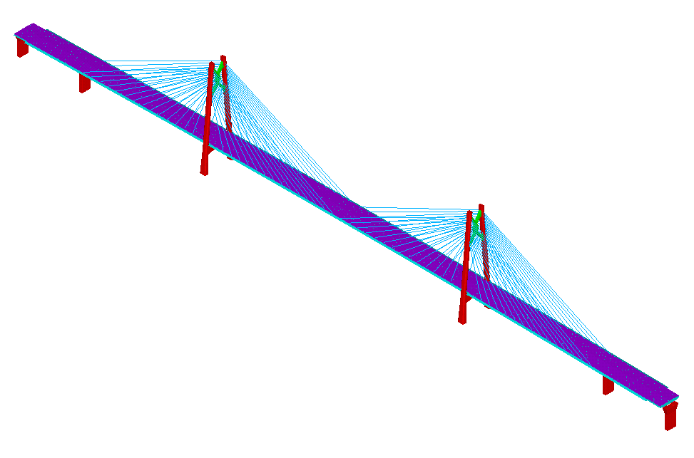
Figure 2 Refined finite element model of the Qingzhou Channel Bridge

For the thermal analysis, thermal elements, including SOLID70, SHELL57 and LINK33, are applied; while for the structural analysis, they are changed to structural elements, namely SOLID45, SHELL181 and LINK180, respectively.
A modal analysis was firstly conducted to calculate the modal properties, including frequencies and mode shapes, which were compared with those obtained from in-situ vibration data. The refined model was calibrated by adjusting mass and modulus properties of the steel girder. After adjustment, the frequency differences are around 1% for the first four vertical bending modes, which indicates a good agreement between the model and the real bridge and provides a validated basis for the numerical analysis.
Wind speed data and ambient temperature data are extracted from the SHM system of the bridge. Besides, solar radiation data is collected from the Hong Kong Observatory. Material parameters for the thermal analysis are listed in Table 1.
Table 1. Material parameters for thermal analysis
Parameter | Asphalt | Steel | Concrete
$ρ$ (kg/m³) | 2,500 | 7,850 | 2,600
$c$ (J/kg/℃) | 967.5 | 460 | 925
$k$ (W/m/℃) | 2.5 | 60 | 2.71
$$ε$$ | 0.92 | 0.8 | 0.88
$$α$$ | 0.95 | 0.685 | 0.65

Thermal boundary conditions
Since the girder and towers are box-sectioned, both internal and external thermal boundary conditions need to be considered.
For external thermal boundary, all the external surfaces are categorized according to their geometric configurations and materials, based on which the solar radiation received by each surface at different times can be calculated. Then, together with monitored external ambient temperature, the boundary conditions can be determined.
For internal thermal boundary, since solar radiation takes no participation, the equivalent ambient temperature equals to the internal ambient temperature. Particularly, as there is only one sensor point of the ambient temperature in the vertical direction inside the girder box, different coefficients are introduced for different inner surfaces to simulate the vertical temperature difference. The inner surfaces are categorized into four types, including the bottom surface of the top plate, the surface of the U-rib on the top plate, the surface of the U-rib on the bottom plate, and the top surface of the bottom plate, which are abbreviated as TP, TU, BU, and BP.
Since periodic temperature variation can be simplified as a sine function, four piecewise sine functions are constructed considering the magnitude difference and the phase difference between the structural temperature of the four surfaces and the internal ambient temperature.
Given the measured wind, ambient temperature, and solar radiation data, boundary conditions of all external and internal surfaces can be calculated and expressed as the overall heat transfer coefficient and the equivalent ambient temperature to be input into ANSYS. Based on the material properties and boundary conditions, the thermal analysis is ready to be conducted. Last but not least, a pre-analysis is performed for one or more consecutive days to achieve a nonuniform equilibrium of the temperature field and provide the initial condition for the subsequent thermal analysis.

Temperature distribution
Since summer is the hottest time of the year with the highest solar radiation level which provides the best meteorological conditions, Jul 5 to 7, 2019 was chosen as the representative period for the thermal analysis. Pre-analysis had been conducted for four days before the chosen dates.
The sensor arrangement of the thermometers measuring girder temperature is shown in Figure 3.

Figure 3 Sensor arrangement of the thermometers measuring girder temperature
The sensors measure temperature of the bottom surface of the top plate, the surface of the U-rib on the top plate, the surface of the U-rib on the bottom plate, and the top surface on the bottom plate, which correspond to the four types of internal faces, TP, TU, BU, and BP. With the integrity and the normality of the data evaluated, seven points on the mid-span section were chosen as the representative measuring points of the four types of surfaces, and specifically, point 6 in red and point 16 in magenta for TP in the south and north side respectively, point 5 in blue and point 15 in green for TU in the south and north side respectively, point 4 in red and point 14 in magenta for BP in the south and north side respectively, and point 21 in blue for BU, the only measuring point for BU.
The temperature of these representative points during Jul 5 to 7, 2019 are calculated and compared with the corresponding measurements, as shown in Figure 4.
(a) Top plate

(b) Bottom plate
Figure 4 Experimental and calculated temperature of the mid-span girder section

In Figure 4, the curves in solid lines with legends ended with letter E are experimental temperature from sensor measurements, and those in dashed lines with legends ended with letter C are calculated temperature from FE model simulation. The numbers in the middle of legends and the colors of the curves are corresponding to those of the measuring points in Figure 3 for clarity. The TaIN and TaOUT curves refer to the ambient temperature inside and outside the girder respectively, which are added to show the initial conditions of the temperature field.
The following results can be observed from Figure 4:
- The temperature of the top plate in summer can reach as high as 50 ℃ with the variation of 20 ℃ in a day, while the maximum temperature of the bottom plate is about 34 ℃ with the variation within 4 ℃ in a day.
- The structural temperature versus the ambient measurements. From Figure 4(a), the structural temperature curves are all higher than the TaIN curve because the solar radiation contributes significantly to the heat accumulation on the top plate. From Figure 4(b), the structural temperature curves are generally between TaIN and TaOUT curves due to that the convection and irradiation from the inside and outside ambient air are the main source of heat energy of the bottom plate with little solar radiation received, and that the insulation effect of the box section results in higher internal ambient temperature.
- The structural temperature of the plate versus that of the U-rib on the plate. From Figure 4(a), the blue and green curves are lower and later than the red and pink curves, which indicates the temperature of the U-rib is lower than that of the top plate, and that there is a lag effect. From Figure 4(b), it can be similarly analyzed that the temperature of the U-rib is higher than that of the bottom plate, but the lag effect also exists. The insulation effect and the heat conduction from the plate to the U-rib happening later than the heat exchange between the outer surface and the outer air are the main triggers.
- The structural temperature in the south side versus that in the north side. No matter whether the experimental temperature in solid lines or the calculated temperature in dashed lines are concerned, the temperature curves in red and pink almost coincide with each other, which is the same with the blue and green curves. It means that the temperature on the south and the north side of the girder is almost the same. Located a little lower than the Tropic of Cancer, the Qingzhou Channel Bridge is a little farther south to the subsolar point at noon during the early June to the early July every year. However, since the transverse slope gradient is quite small, and the subsolar point at noon almost coincides with the bridge site during the analyzed period, the difference between the south and the north side is rather trivial.
- The experimental measurements versus the calculated results. The differences between the solid curves and the corresponding dashed curves are relatively small. The root mean square error (RMSE) is about 0.76 ℃ for the whole girder section with area of different parts weighted, which means that the average difference between the calculated temperature and the measured temperature is lower than 1.0 ℃. Thus, the calculated results have a good agreement with the monitored data and the effectiveness of the model has been verified.

temperature-induced Displacement responses
After the thermal analysis, the finite element model is converted for the structural analysis to further calculate the temperature-induced responses. Two typical types of displacement of cable-stayed bridges are concerned, the longitudinal displacement of the girder ends and the vertical deflection of the mid-span girder section. The chosen girder sections are shown in Figure 5.

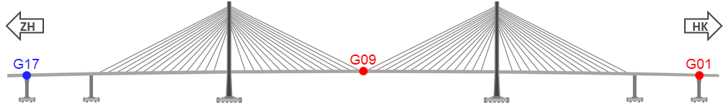
Figure 5 Girder sections for comparison

The displacement responses of these representative girder sections during Jul 5 to 7, 2019 are calculated and compared with the corresponding measurements, as shown in Figure 6. The measurement results at the south and north points of each section have been averaged. The displacement is relative to the reference value, that is, being subtracted by the initial displacement.
(a) longitudinal displacement of the girder ends

(b) vertical deflection of the mid-span girder section
Figure 6 Displacement responses of the bridge

The longitudinal displacement is positive along the expansion direction, and the vertical upward deflection is positive.
From Figure 6(a), the calculated results of two girder ends in dashed lines are almost the same with a phase difference of about one hour, which is reasonable since the bridge is symmetric about the mid-span section and the longitudinal displacement of the tower is the reason for the phase difference. The calculated total expansion magnitude in one day is close to the measured results, which can reach 200 mm. However, the measurement results show obvious difference between the two girder ends. The girder end in the Zhuhai side expands significantly more than that in the Hong Kong side since the U17E curve fluctuates more violently than the U01E curve, and this phenomenon is continuous for consecutive days, which needs further investigations.
From Figure 6(b), the calculated vertical deflection of the mid-span section is in good agreement with the experimental ones. The maximum deflection variation in one day is about 50 mm. In the morning, even though the temperature of the top plate is still higher than the bottom plate, it decreases faster than that of the bottom plate, so the girder bends downward relatively. In the afternoon, the temperature of the top plate is higher and also it increases faster than that of the bottom plate, so the girder bends upward relatively.

Conclusion
This study investigates the global temperature behavior of the Qingzhou Channel Bridge in HZMB. A refined finite element model was established with external and internal thermal boundary conditions carefully determined. A thermal analysis as well as a subsequent structural analysis is conducted by integrating the numerical analysis and the field monitoring data. The temperature distribution and the induced displacement responses of the girder are calculated and compared with the monitoring counterparts. The following conclusions can be drawn:
- The calculated temperature and deflection results have a satisfactory agreement with the monitoring data, which means the refined model is capable of simulating the thermal behavior of the real bridge effectively.
- The solar radiation absorption, the insulation effect of the box section, and the lag effect of heat conduction are the main influencing factors of the temperature distribution of the girder section.
- The calculated and monitored total expansion magnitude of the girder are similar, while different from the simulation results showing generally even contribution of two ends, the measured expansion in the Zhuhai side is significantly larger than that in the Hong Kong side, which may indicate that the real structure differs from the design very likely. This merits further monitoring and investigations.

ACKNOWLEDGMENTS
This research is supported by RGC-GRF (Project No. 15206821), the Key-Area Research and Development Program of Guangdong Province (Project No. 2019B111106001), and National Key R&D Program (Project No. 2019YFB1600700).

References
- Xu Y L, Xia Y. Structural health monitoring of long-span suspension bridges. Spon Press: London, 2011.
- Zuk W. Thermal behaviour of composite bridges-insulated and uninsulated. Highway Research Record, 1965, 76(1): 231-253.
- Capps M W. The thermal behavior of the Beachley Viaduct/Wye bridge. TRRL Report LR 234, Ministry of Transport, Road Research Laboratory, 1968.
- Priestley M J N. Design of concrete bridges for temperature gradients. ACI Journal, 1978, 75(5): 209-217.
- Dilger W, Ghali A, Cheung M S, et al. Field measurements of Muskwa river bridge. Journal of the Structural Division, 1981, 107(11): 2147-2161.
- Emerson M. The calculation of the distribution of temperature in bridges. TRRL Rep. No. LR561, Dept. of the Environment, U.K. 1973.
- Hunt B, Cooke N. Thermal calculations for bridge design. Journal of the structural division, 1975, 101(9): 1763-1781.
- Tong M, Tham L G, Au F T K, et al. Numerical modelling for temperature distribution in steel bridges. Computers & Structures, 2001, 79(6): 583-593.
- Lucas J M, Berred A, Louis C. Thermal actions on a steel box girder bridge. Proceedings of the Institution of Civil Engineers-Structures and Buildings, 2003, 156(2): 175-182.
- Zhou L, Xia Y, Brownjohn J M W, et al. Temperature analysis of a long-span suspension bridge based on field monitoring and numerical simulation. Journal of Bridge Engineering, 2016, 21(1): 04015027.
- Xia Y, Chen B, Zhou X Q, et al. Field monitoring and numerical analysis of Tsing Ma Suspension Bridge temperature behavior. Structural Control and Health Monitoring, 2013, 20(4): 560-575.
- Zhou, Y., Xia, Y., Chen, B. and Fujino, Y., Analytical solution to temperature-induced deformation of suspension bridges, Mechanical Systems and Signal Processing, 2020, 139, Article 106568.
- Zhou, Y., Xia, Y., Sun, Z. and Fujino, Y., Analytical formulation of the temperature-induced deformation of multi-span suspension bridges, Structural Control and Health Monitoring, 2022, 29 (6), e2937.
- Zhou, Y., Xia, Y. and Fujino, Y., Analytical formulas of beam deflection due to vertical temperature difference, Engineering Structures, 2021, 240, Article 112366.

