ABSTRACT: Damping estimation is a critical task to perform during the design of slender structures or for existing structures. This is to ensure the response of the structure is within allowable limits and to determine if additional damping from auxiliary devices is necessary. If a slender structure is experiencing wind loading, a phenomenon known as aerodynamic damping arises, which has the potential to reduce the damping of the structure. This paper describes how to estimate aerodynamic damping ratios of concrete chimneys using a sophisticated system identification technique known as Second-Order Blind Identification. Multiple wind fields are generated and applied to a finite-element concrete chimney model in both along-wind and across-wind directions. Total damping estimates are acquired at various wind speeds and modes in both directions, which are compared to theoretical values. It is found that aerodynamic damping is positive in the along-wind direction but can exhibit negative values in the across-wind direction. A general discussion on the results, potential errors, and the need for further research is provided.
Aerodynamic Damping Estimation of Structures using Second-Order Blind Identification

Shea Laventureª, Ayan Sadhu^{b}, and Girma Bitsuamlak^{c}
ªFormer MESc Student, Department of Civil and Environmental Engineering, Western University, London, Ontario, Canada
^{b}Associate Professor, Department of Civil and Environmental Engineering, Western University, London, Ontario, Canada
^{c}Professor, Department of Civil and Environmental Engineering, Western University, London, Ontario, Canada

KEYWORDS: Aerodynamic damping; Second-order blind identification; Wind field simulation; Autocorrelation.

INTRODUCTION
Accurate damping estimation is important for the design of slender structures and the assessment of existing structures, as damping reduces the response of the structure. All structures have some intrinsic damping, known as structural damping, and are dependent on the materials used to build the structure. However, when a slender structure is exposed to wind loading, a phenomenon known as aerodynamic damping arises, which causes the total damping in the structure to be different than the structural damping. Aerodynamic damping is an important parameter to determine in slender structures, as it can often exhibit a negative value, especially in the across-wind direction. According to [1], the wind-induced response of structures is influenced by the incoming turbulence of the wind, vortex shedding, and lock-in from the motion-induced force. While the along-wind response is characterized by the turbulence and quasi-steady theory, the across-wind response is determined by the vortex shedding, meaning the quasi-steady theory cannot be used. Vortex shedding may create a phenomenon called lock-in, meaning the wake flow’s frequency matches the natural frequency of the structure, which generates a larger response and the potential for negative aerodynamic damping [1]. Negative damping often indicates the need for additional damping devices to reduce the response of the structure. The estimation of aerodynamic damping requires the need of accurate wind load and response determination and system identification for modal parameter evaluation.
[2] performed turbulent wind experiments on six different tall building models with varying cross-sections and structural properties. The circular cross-section building showed the lowest values of peak deflection, while rectangular and triangle-shaped models demonstrated the highest responses. [3] also estimated the along-wind and across-wind response of slender chimneys. The along-wind response was used to derive a theoretical equation and calculate the aerodynamic damping ratio in the along-wind direction. Across-wind response incorporated wake excitation, and vortex shedding was used to estimate the largest negative aerodynamic damping ratio in the across-wind direction. These formulations were demonstrated on a worked example, using a 200 m tall chimney and a wind profile that followed the power law. [4] examined aerodynamic damping of tall building models using wind tunnel test data of various building models with varying side and aspect ratios. It was found that the aerodynamic damping ratio exhibited positive values in the along-wind direction and negative values in the across-wind direction.
[5] performed wind-tunnel experiments on aeroelastic models with different values of roughness exposure, structural damping, stiffness, and taper ratio to determine the along-wind aerodynamic damping ratios using the random decrement technique. Experiments showed that the aerodynamic damping hardly increases depending on the roughness exposure, while the structural damping was found to have a large influence on the aerodynamic damping. [6] investigated the across-wind aeroelastic response of tall buildings with square cross-sections. In the range of positive aerodynamic damping, the ratios calculated using the proposed method agreed with the ratios found from the wind tunnel tests. [7] analyzed the nonlinear negative aerodynamic damping effect of tall buildings subjected to crosswind loading. The analysis used time-domain response simulations of a square building undergoing forced vibration in a wind tunnel, with the aerodynamic damping modelled as a nonlinear function of the building's displacement.
[8] conducted experiments on aeroelastic square building models to determine the across-wind aerodynamic damping ratio, using the random decrement technique. The research team observed that the positive peak of aerodynamic damping decreases when the chamfer ratio decreases. In addition to the chamfer ratio, slot ratios between 5% and 10% and a taper ratio of 1% is most effective at restraining aeroelastic responses. [9] conducted experiments on super tall building models with square and helical cross-sections to identify aerodynamic damping ratios, using the random decrement technique. Results showed that when the models were under along-wind direction loads, both the square and helical models displayed a similar trend for aerodynamic damping ratio, gradually increasing with reduced wind velocity and remaining positive. However, under across-wind direction loads, the aerodynamic damping ratio of the helical model was negative for lower reduced wind velocity and gradually increased to be positive, while the square model showed a reversed trend. [10] carried out more experimental studies to determine the aerodynamic damping ratios and aeroelastic instability of a supertall helical building using along-wind and across-wind responses. Using the random decrement technique, results showed a decrease in displacement compared to square model tests, in the lateral directions.
Various techniques have been used in the past to determine the modal parameters of slender structures under wind loading. However, many of these methods (e.g., random decrement technique or stochastic subspace identification) are tedious in nature and fail to identify closely spaced modes. Therefore, a system identification method, known as Second-order Blind Identification (SOBI), is implemented in this paper to determine the modal responses and damping ratios of slender structures. The SOBI technique is performed on a finite-element chimney model subjected to a simulated wind field. The aerodynamic damping ratios are compared with a theoretical formulation provided by [2] to determine the accuracy of the methodology.

Second-Order Blind Identification
SOBI is advantageous over other system identification methods in that it requires only output data to estimate modal parameters; this makes SOBI especially suitable for existing structures where input data may not be known. SOBI is based on second-order statistics, such as auto-correlation, and excels at separating the modal frequencies from unwanted noise that may be in the signal. The SOBI formulation is based on the past works of [11,12], which begins with the basic equation of motion:
$$\left[M\right]\left\{\ddot{x}\left(t\right)\right\}+\left[C\right]\left\{\dot{x}\left(t\right)\right\}+\left[K\right]\left\{x\left(t\right)\right\}=\left\{F\left(t\right)\right\}$$
where $\left[M\right]$ is the mass matrix, $\left[C\right]$ is the damping matrix, $\left[K\right]$ is the stiffness matrix, $\left\{x\left(t\right)\right\}$ is the displacement vector, and $\left\{F\left(t\right)\right\}$ is the force vector. The solution to the equation of motion may be written as a superposition of vibration modes in matrix form:
$$\left\{x\left(n\right)\right\}=\left[A\right]\left\{s\left(n\right)\right\}$$
where $\left\{x\left(n\right)\right\}$ is the measurement matrix of sampled components of x, $\left[A\right]$ is the modal transformation matrix, and $\left\{s\left(n\right)\right\}$ is the matrix of corresponding modal components. To find $\left[A\right]$, two covariance matrices at time 0 and time p are diagonalized:
$$\left[R_{x}\left(0\right)\right]=E\left[\left\{x\left(n\right)\right\}{\left\{x\left(n\right)\right\}}^{T}\right]=\left[A\right]\left[R_{s}\left(0\right)\right]{\left[A\right]}^{T}$$
$$\left[R_{x}\left(p\right)\right]=E\left[\left\{x\left(n\right)\right\}{\left\{x\left(n-p\right)\right\}}^{T}\right]=\left[A\right]\left[R_{s}\left(p\right)\right]{\left[A\right]}^{T}$$
where $\left[R_{s}\left(p\right)\right]=E\left[\left\{s\left(n\right)\right\}{\left\{s\left(n-p\right)\right\}}^{T}\right]=\left[I\right]$, and $\left[A\right]$ is the unknown mixing matrix. First, the responses are whitened, which removes any correlation two responses may have had:
$$\left[R_{x}\left(0\right)\right]=E\left[\left\{x\left(n\right)\right\}{\left\{x\left(n\right)\right\}}^{T}\right]=\left[V_{x}\right]\left[λ_{x}\right]{\left[V_{x}\right]}^{T}$$
where $\left[V_{x}\right]$ is the eigenvector matrix and $\left[λ_{x}\right]$ is the eigenvalue matrix. The whitened signals are computed using the following expression [11]:
$$\left\{\overline{x}\left(n\right)\right\}={\left[λ_{x}\right]}^{-1/2}{\left[V_{x}\right]}^{T}\left\{x\left(n\right)\right\}=\left[Q\right]\left\{x\left(n\right)\right\}$$
where $\left[Q\right]$ is the whitening matrix.
$$\left[R_{\overline{x}}\left(0\right)\right]=E\left[\left\{\overline{x}\left(n\right)\right\}{\left\{\overline{x}\left(n\right)\right\}}^{T}\right]=\left[I\right]$$
$\left[R_{x}\left(p\right)\right]$ becomes $\left[R_{\overline{x}\left(p\right)}\right]$ from whitening process:
$$\left[R_{\overline{x}\left(p\right)}\right]=\frac{1}{N}\left[\sum_{n=1}^{N}{\left\{\overline{x}\left(n\right)\right\}{\left\{\overline{x}\left(n-p\right)\right\}}^{T}}\right]=\left[Q\right]\left[R_{x}\left(p\right)\right]{\left[Q\right]}^{T}=\left[Q\right]\left[A\right]\left[R_{s}\left(p\right)\right]{\left[A\right]}^{T}{\left[Q\right]}^{T}$$
$\left[R_{\overline{x}\left(p\right)}\right]$ is now diagonalized:
$$\left[V_{\overline{x}}\right]\left[R_{\overline{x}}\left(p\right)\right]{\left[V_{\overline{x}}\right]}^{T}=\left[λ_{\overline{x}}\right]$$
Since $\left[λ_{\overline{x}}\right]$ has distinct eigenvalues, the mixing matrix is estimated by:
$$\left[\hat{A}\right]={\left[Q\right]}^{-1}\left[V_{\overline{x}}\right]=\left[V_{x}\right]{\left[λ_{x}\right]}^{T}\left[V_{\overline{x}}\right]$$
Finally, unitary transformation is performed to acquire the modal responses in the time domain:
$$\left\{\hat{s}\left(n\right)\right\}={\left[\hat{A}\right]}^{-1}\left\{x\left(n\right)\right\}$$
where $\left\{\hat{s}\left(n\right)\right\}$ is the modal response in the time domain. The modal responses in the time domain are then autocorrelated, where the decay of the response is used to find the total damping ratio. Autocorrelation is performed using
$$R_{ff}\left(τ\right)= \int_{-∞}^{∞}{f\left(t\right)\overline{f\left(t-τ\right)}dt}$$
where $f\left(t\right)$ is the modal response, $\overline{f(t)}$ is the complex conjugate of $f\left(t\right)$, and τ is the time lag.

Finite Element Chimney Model
The structure considered is a reinforced concrete chimney that follows a similar design by [16], using SAP2000 as shown in Fig. 1. The chimney has a height of 100 m, thickness of 0.305 m, bottom diameter of 5 m, and top diameter of 2.5 m; the concrete has a compressive strength of 28 MPa. The wind force is applied in both along-wind and across-wind directions, shown in Fig. 2, at ten different heights using the power law profile. The power spectrum of the resulting acceleration response is acquired in both directions, shown in Fig. 3 and Fig. 4, which clearly show the natural frequencies of the first four modes.

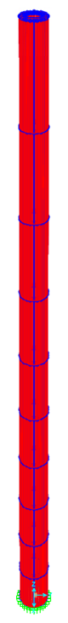
Figure 1: Finite-element model of the chimney.

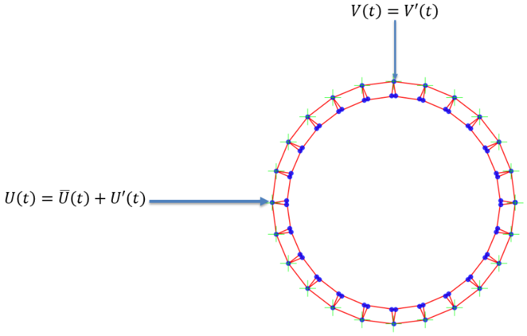
Figure 2: Top-down view of chimney model
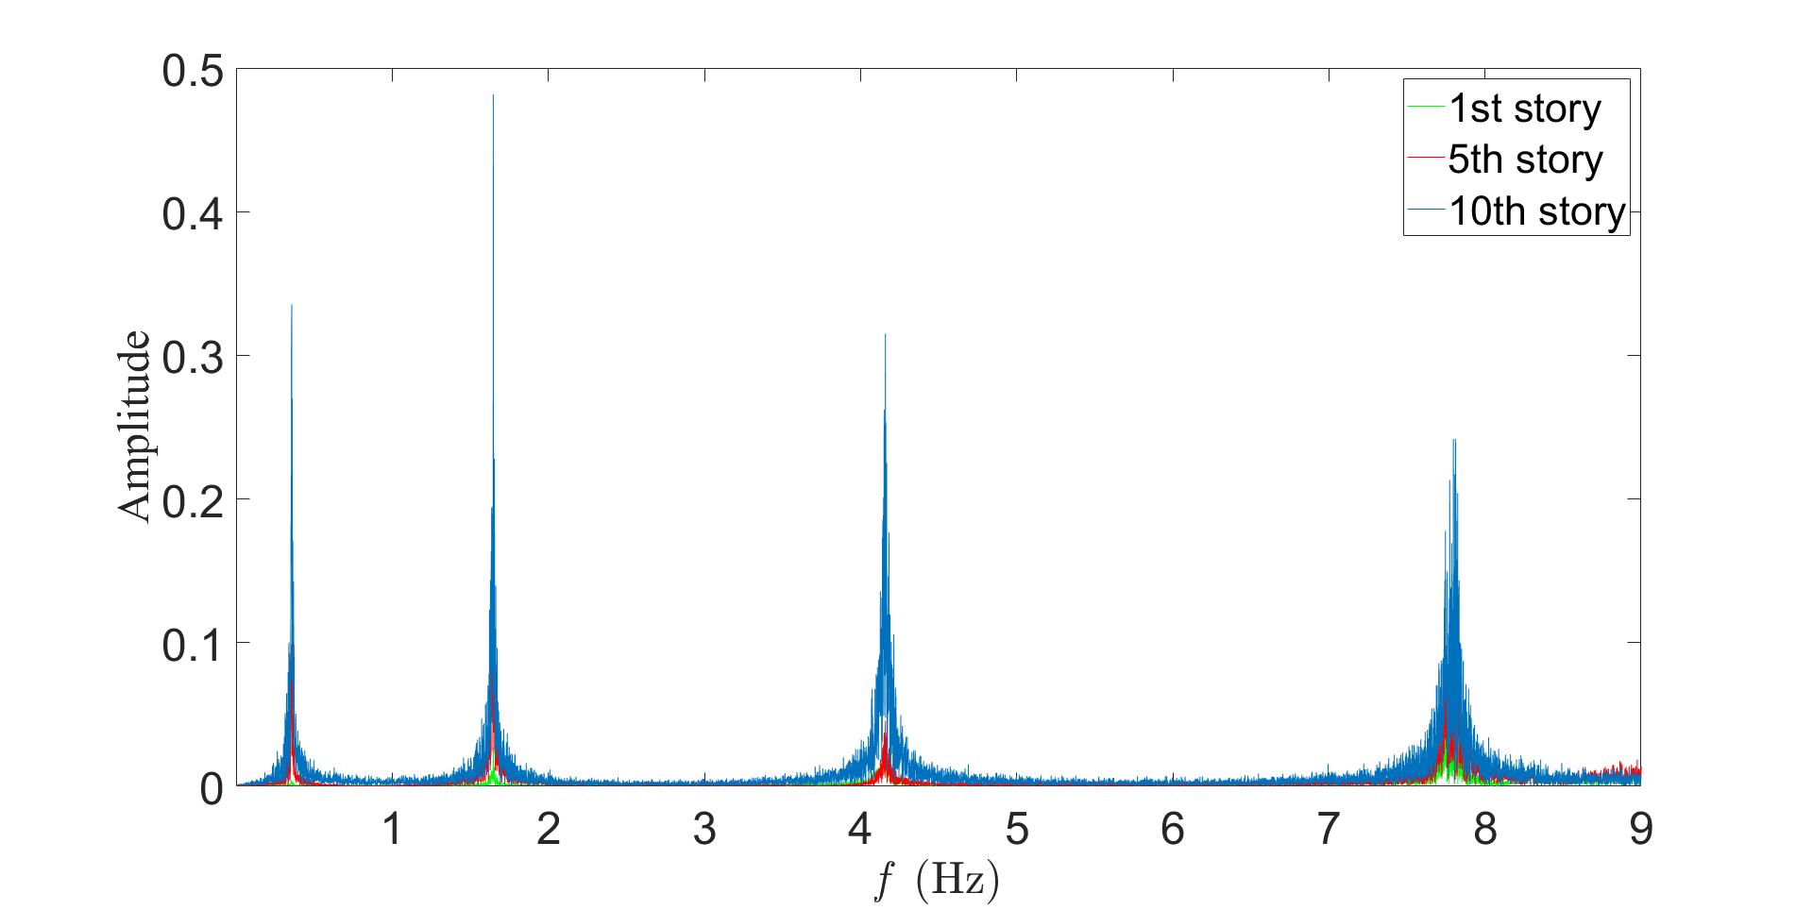
Figure 3: Power spectrum of acceleration response in along-wind direction.

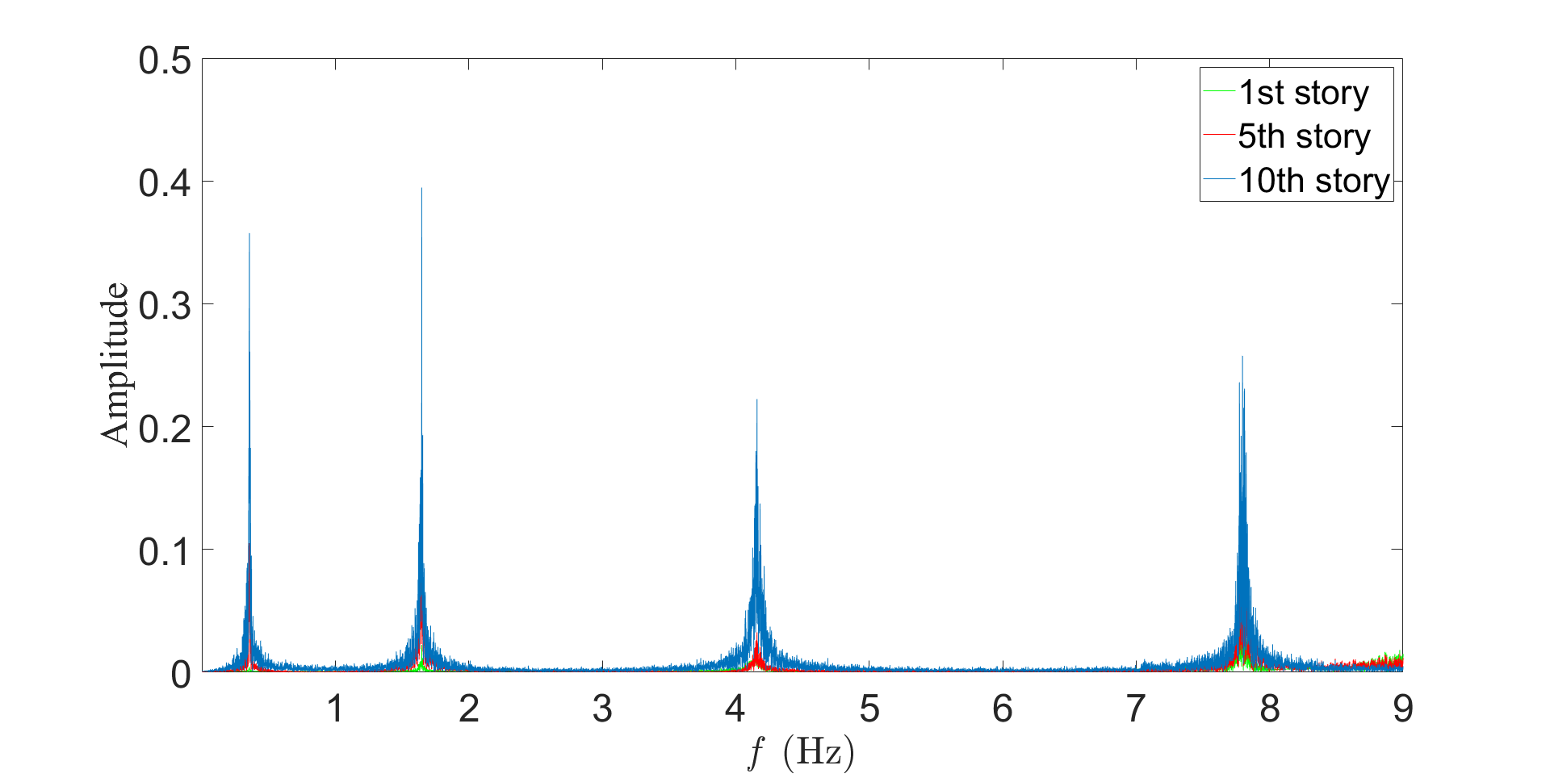
Figure 4: Power spectrum of acceleration response in across- wind direction.

SOBI and Aerodynamic Damping Results
The SOBI technique is now performed on the acceleration response of the chimney. The fast Fourier transform (FFT) of the modal response for both along-wind and across-wind directions is shown in Fig. 5 and Fig. 6, respectively. One of these modal responses is used to estimate the total damping ratio, as shown in Fig. 7. Using this autocorrelation process, the total damping ratio is estimated for the first four modes of both along-wind and across-wind directions for wind speeds of 10, 20, and 30 m/s. The difference between the total and structural damping ratios is used to estimate the aerodynamic damping ratio, which is compared to the theoretical value given by [3]. The theoretical aerodynamic damping ratios are calculated using the following:
$$ζ_{a_{j}}= \frac{\left[\frac{C_{D}}{4π}\right]\left[\frac{ρD_{H}^{2}}{m_{H}}\right]\left[\frac{U_{H}}{f_{j}D_{H}}\right]\int_{0}^{H}{\left\{Φ_{U}Φ_{D}μ_{j}^{2}\left(z\right)\right\}dz}}{\int_{0}^{H}{\left\{Φ_{m}μ_{j}^{2}\left(z\right)\right\}dz}}$$
where $C_{D}$ is the drag coefficient, $ρ$ is the air density in kg/m³, $D_{H}$ is the top chimney diameter in m, $m_{H}$ is the chimney mass in tonnes/m, $U_{H}$ is the mean wind speed in m/s, $f_{j}$ is the frequency of mode j in Hz, and $H$ is the chimney height in m. $Φ_{U}$, $Φ_{D}$, and $Φ_{m}$ are the power law, chimney taper, and mass profiles, respectively, and $μ_{j}$ is the mode shape of mode j.

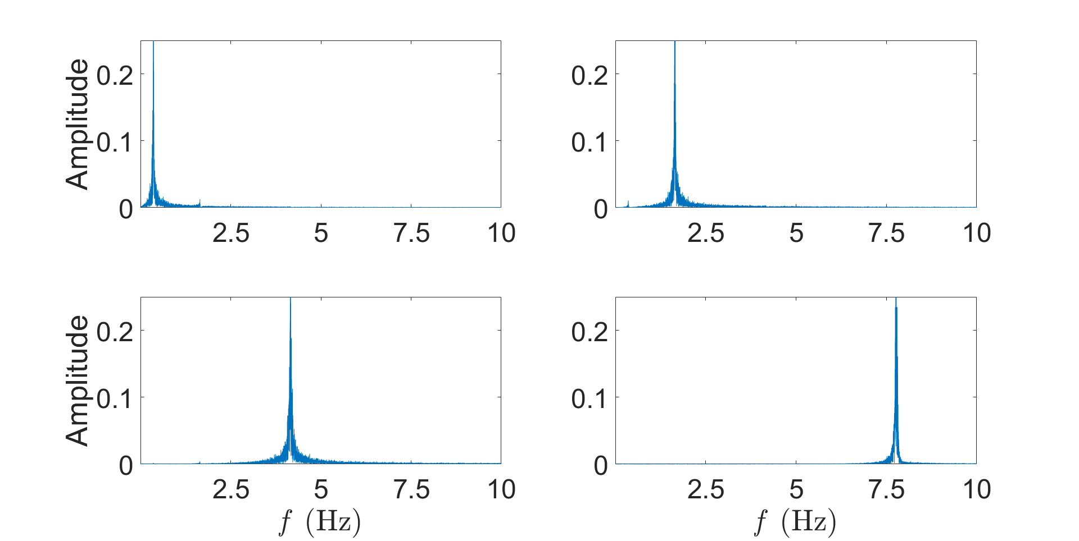
Figure 5: Fourier spectra of the resulting modal response obtained from along-wind response.

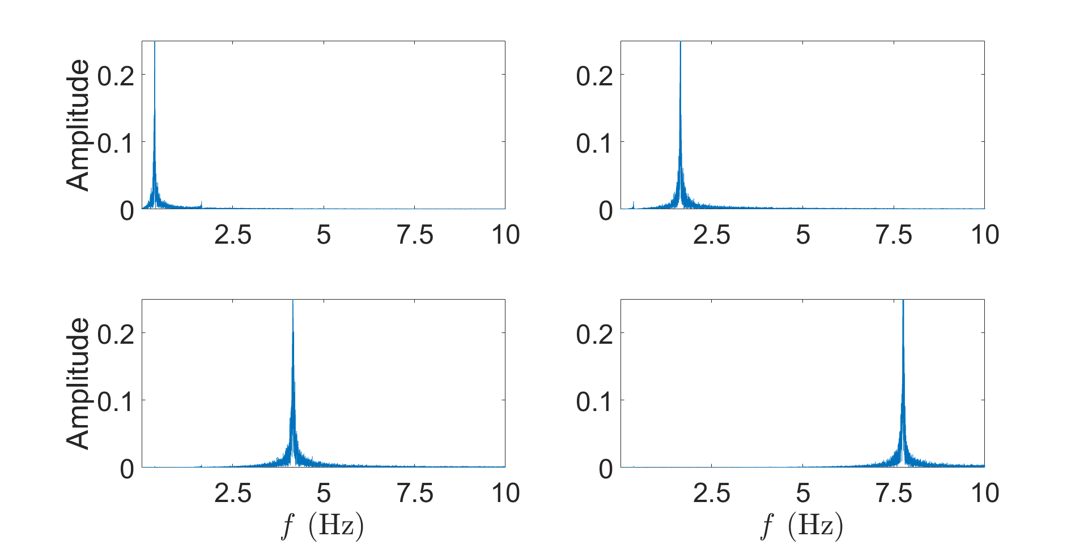
Figure 6: Fourier spectra of the resulting modal response obtained from across-wind response.
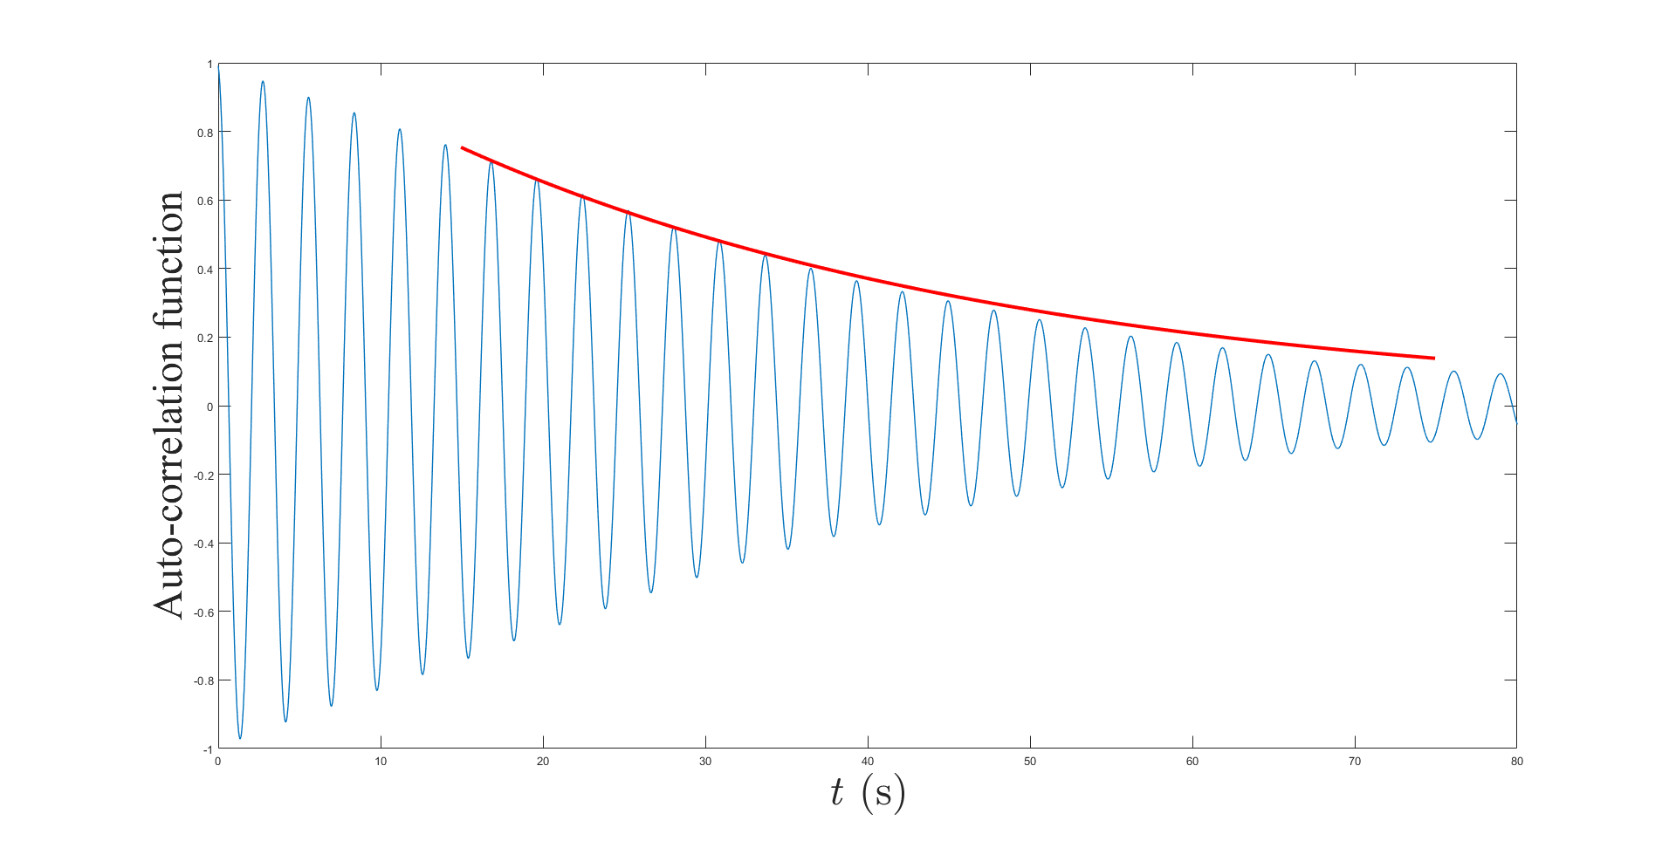
Figure 7: Autocorrelated modal response for mode 1, along-wind direction, 10 m/s (ζ = 1.25 %).

The results for the aerodynamic damping ratio estimates are listed in Table 1 and Table 2, where ζ_{T}, ζ_{S}, and ζ_{A} are the total, structural, and aerodynamic damping ratios, respectively.

Table 1: Aerodynamic damping in along-wind direction.
Table 2: Aerodynamic damping in across-wind direction.

CONCLUSION
In this paper, SOBI method is explored for the estimation of aerodynamic damping in a flexible chimney structure. Multiple wind fields are generated and applied to a finite-element concrete chimney model in both along-wind and across-wind directions. The time series of the wind field is simulated using the power law for the mean wind speed and the von Karman spectrum for the turbulence. Total damping estimates are acquired at various wind speeds and modes in both directions, which are compared to theoretical values. Aerodynamic damping is acquired by subtracting the structural damping, found using a free vibration test, from the total damping estimate.
REFERENCES
[1] Cheng, C. M., Lu, P. C., and Tsai, M. S. (2002). “Acrosswind aerodynamic damping of isolated square-shaped buildings”. Journal of Wind Engineering and Industrial Aerodynamics, 90, 1743-1756.
[2] Davenport, A.G. (1971). “The response of six building shapes to turbulent wind”. Philosophical Transactions of the Royal Society A, 269, 385-394.
[3] Davenport, A.G. (1984). “The response of chimneys to wind”, presented at the 5th International Chimney Congress, Essen, West Germany, October 3-5, 1984, 77-84.
[4] Marukawa, H., Kato, N., Fujii, K., and Tamura, Y. (1996). “Experimental evaluation of aerodynamic damping of tall buildings”. Journal of Wind Engineering and Industrial Aerodynamics, 59, 177-190.
[5] Cao, H., Quan, Y., Gu, M., and Wu, D. (2012). “Along-wind aerodynamic damping of high-rise buildings”, presented at The Seventh International Colloquium on Bluff Body Aerodynamics and Applications, Shanghai, China, September 2-6,2012.
[6] Venanzi, I. and Materazzi, A. L. (2012). “Acrosswind aeroelastic response of square tall buildings: a semi-analytical approach based of wind tunnel tests on rigid models”. Wind and Structures, 15(6), 1-14.
[7] Chen, X. (2013). “Estimation of stochastic crosswind response of wind-excited tall buildings with nonlinear aerodynamic damping”. Engineering Structures, 56(2013), 766-778.
[8] Gu, M., Cao, H. L., and Quan, Y. (2014). “Experimental study of across-wind aerodynamic damping of super high-rise buildings with aerodynamically modified square cross-sections”. The Structural Design of Tall and Special Buildings, 23, 1225-1245.
[9] Kim, W., Yi, J., Tamura, Y., Ohtake, K., and Yoshida, A. (2016). “Aerodynamic Damping of Helical Shaped Super Tall Building”, presented at the 2016 World Congress on Advances in Civil, Environmental, and Materials Research, Jeju Island, Korea, August 28-September 1, 2016.
[10] Kim, W., Yoshida, A., Tamura, Y., and Yi, J. (2018). “Experimental study of aerodynamic damping of a twisted supertall building”. Journal of Wind Engineering and Industrial Aerodynamics, 176(2018), 1-12.
[11] Belouchrani A, Abed-Meraim K, Cardoso J and Moulines E (1997). “A blind source separation technique using second-order statistics”, IEEE Trans. Signal Process, 45, 434-444.
[12] Musafere, F., Sadhu, A., and Liu, K (2016). “Towards damage detection using blind source separation integrated with time-varying auto-regressive modeling”. Smart Materials and Structures, 25, 015013 (19pp).
[13] Cheynet, E (2019). “Wind field simulation (the user-friendly version)” (https://www.mathworks.com/matlabcentral/fileexchange/50041-wind-field-simulation-the-user-friendly-version), MATLAB Central File Exchange. Retrieved August 30, 2019.
[14] “Guide for the assessment of wind actions and effects on structures”, National Research Council of Italy, Roma, CNR-June 11th, 2010.
[15] Shinozuka, M and Jan, C. M. (1972). “Digital simulation of random processes and its applications”. Journal of Sounds and Vibration, 25(1), 111-128.
[16] Hernandez, E. M., Bemal, D., and Caracoglia, L (2013). “On-line monitoring of wind-induced stresses and fatigue damage in instrumented structures”. Structural Control and Health Monitoring, 20, 1291-1302.

