ABSTRACT: Monitoring the damage evolution of existing concrete structures is critical for efficiently planning infrastructure maintenance and for selecting the optimal time for repairing or strengthening. The approach for detecting and locating damage in concrete structures depends on the measured vibration response of the structure and the type of sensors used for measurements. This paper proposes a damage identification approach for Ultra-High-Performance Fiber Reinforced Concrete (UHPFRC) beams based on the estimated modal properties of the beam from vibration measurements. First, the effect of different levels of damage on the dynamic response of the beam is investigated numerically in the finite element software ABAQUS. Dynamic impact tests have been performed on several beams specimens with increasing levels of damage and vibration responses have been measured on several locations of the specimens through accelerometers. Automated operational modal analysis is applied to the data to obtain the modal frequencies and mode shapes, which are then analyzed to validate the proposed damage detection algorithms. The results indicate that the detection and localization of defects can be achieved in the presence of measurement noise. Further analyses need to be performed to determine the probability of detection as a function of the level of damage, damage location, and the number of defects.
Vibration-based damage detection in UHPFC beams by using dynamic properties of the structure
Fahime Sokhangou¹, Luca Sorelli², Luc Chouinard³, Pampa Dey², David Conciatori²
¹ Pd.D. student (Water and Civil Engineering department of Laval University, Quebec City, Canada)
² Professor (Water and Civil Engineering department of Laval University, Quebec City, Canada)
³ Professor (Department of Civil Engineering, McGill University, Montreal, Canada)
Email : fahime.sokhangou.1@ulaval.ca , luca.sorelli@gci.ulaval.ca

KEYWORDS: Structural health monitoring; Concrete beams; Crack detection; modal analysis; inverse analysis

Introduction
In Western countries, a large proportion of existing infrastructures were built during the 60’s and 70’s and are reaching their expected service life. Given their current state, many structures will require urgent repairs, structural upgrades, or replacement in the following decades. In Canada, more than 40% of the bridges are 50 years or older. Structural health monitoring (SHM) has been used in civil, mechanical, and aerospace engineering applications to monitor the condition structures and optimize the type and timing of interventions. Damage detection methods can be classified into five increasing levels of complexity [1]: Level 1 for detecting the presence of damage, Level 2 for locating the damage, Level 3 for identifying the type of damage, Level 4 for quantifying the severity of the damage, and Level 5 for predicting the remaining service life of the structure. The physical parameters that are affected by damage or deterioration include mass, stiffness, and damping of the structural elements. Changes in these physical properties result in corresponding changes in dynamic properties such as fundamental frequencies and mode shapes and provide a means for detecting, locating, and quantifying damage [2]. Farrar et al. used the change in modal frequency for detecting damage in the I-40 bridge over the Rio Grande and also demonstrated that frequency shifts are not good predictors for the level of damage [3]. Furthermore, a change in modal frequency is just applicable for level 1 damage detection. Daei et al. introduced a two-stage method for solving the inverse damage identification problem in numerical models of beams and frames. In the first stage, damage locations are determined by using the concept of modal residual force vector (RFV), which is an index that is a function of the mass and stiffness matrices of the undamaged structure and frequencies and mode shapes of the damaged structure. In the second stage, a gravitational search algorithm (GSA), a metaheuristic optimization algorithm, is used to estimate the severity damage. The results show that the proposed method can estimate the extent and location of damage efficiently; however, the method lacks robustness in the presence of high levels of noise [4]. Sérgio et al. used vibration-based methods for monitoring the Baxio Sabor arch dam in Portugal. They applied automated operational modal analysis to the data obtained during the first three years of monitoring and studied the effect of environmental conditions on the dam's dynamic behavior. Then, they used Principal component analysis (PCA) and weighted regression models to reduce the impact of these conditions on natural frequencies. They simulated damage in a numerical model of the dam and used the results to test the ability of damage detection tools to find these anomalies [5]. Henar et al. investigated the application of UHPFRC for the strengthening of a steel bridge girder. They used changes in the longitudinal mode shape curvature to find the position of the artificial damage on a slab [6].
While the majority of the damage detection algorithms proposed in the literature have been shown to be very effective for various types of structural elements, their application to UHPFRC elements has been limited. The objective of this study is to test various damage detection procedures in UHPFRC elements, which have not been extensively studied in comparison to other types of materials for the presence and severity of flexural as well as shear cracks. The damage index investigated for this purpose is the absolute difference between the measured curvature of the damaged beam and the reference beam for detecting and locating the damage. To examine the advantages and limitations of the proposed method, an extensive experimental study, as well as numerical simulations using finite elements, are performed for increasing levels of damage.

Material and methods

Materials

The experimental setup is designed to simulate pin-pin support conditions. The beam has a length (L) of 2m and a rectangular cross-section (0.1m*0.15m) with 2% fiber content. UHPFC has better ductility and bond capacity compared to conventional and high performance concretes and grouts [7] .
Table 1. UHPFC composition
Components | (kg/m3)
Premix | 2195
Water | 118
Premia 150 | 30
Steel fiber (2%) | 156
Total mass | 2499

Laboratory test set-up
Figure 1 illustrates casting details, fabricated defects and set-up for the experiment. The specially designed supports reproduce pin-pin support conditions [9]. The beam is secured to the metal box with 6 bolts (three at the top, and three at the bottom), and the contact with the beam is adjustable using a 1 mm neoprene laminate at the top and bottom of the beam.

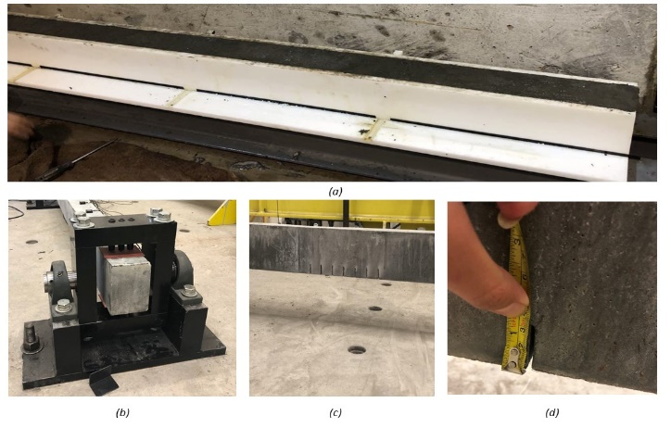
Figure 1. (a): Casting of the beam; (b): Boundary condition; (c) Cracks (d) Characterization of the cracks.
Twelve accelerometers were installed along the top surface of each beam with hot glue. The first and last accelerometers are installed at 50 mm from the supports and the rest are equally spaced (172 mm). The accelerometers are model 8310A25A1M11SP15M from Kistler, which are connected to an acquisition system (model 6100 by Vishay Precision Group). Excitations are mechanically induced by using an impact hammer at different locations on the top surface of the beams with enough energy to excite the beam. Figure 2 shows the accelerometer installation for the experimental set-up.
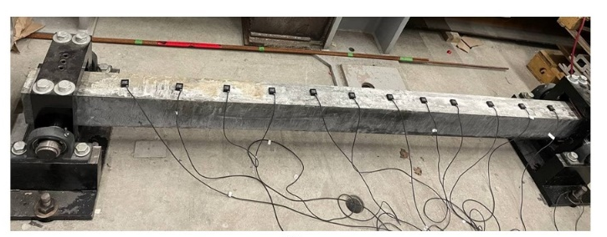
Figure 2. Accelerometers set-up
Figure 3 illustrate the different beams tested experimentally:(reference beam with no defect, and (b)damaged beam with two simulated damage zones. The flexural damage zone has seven cracks of 5 cm in depth, while the shear zone has been generated at 10 cm from the right support with three cracks of 3 cm in depth.

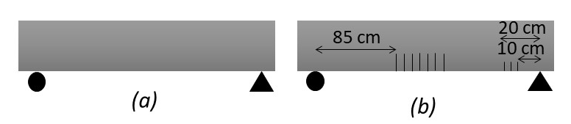
Figure 3. (a): Reference beam (b): damaged beam

Modal analysis
Several operational modal analysis methods, can be used to perform the data analysis, for example, the Peak Picking method (PP), the Enhanced Frequency Domain Decomposition method (EFDD), the Covariance driven Stochastic Subspace Identification method (SSI-Cov), and the poly-reference Least Squares Complex Frequency Domain method (p-LSCF) [9]. In the present study, the Automated Frequency Domain Decomposition (AFDD) algorithm was used to estimate the natural frequencies and mode shapes (Figure 4). The AFDD is a combination of two classical methods, the frequency domain decomposition method [11], [12] and the peak-picking algorithm [13]. The goal is to identify the mode shapes, eigenfrequencies, and modal damping ratios from acceleration records obtained during vibration measurement subjected to ambient noise. In cases when the assumption of white noise is not valid, the results are usually better than those obtained with the pick peaking method.
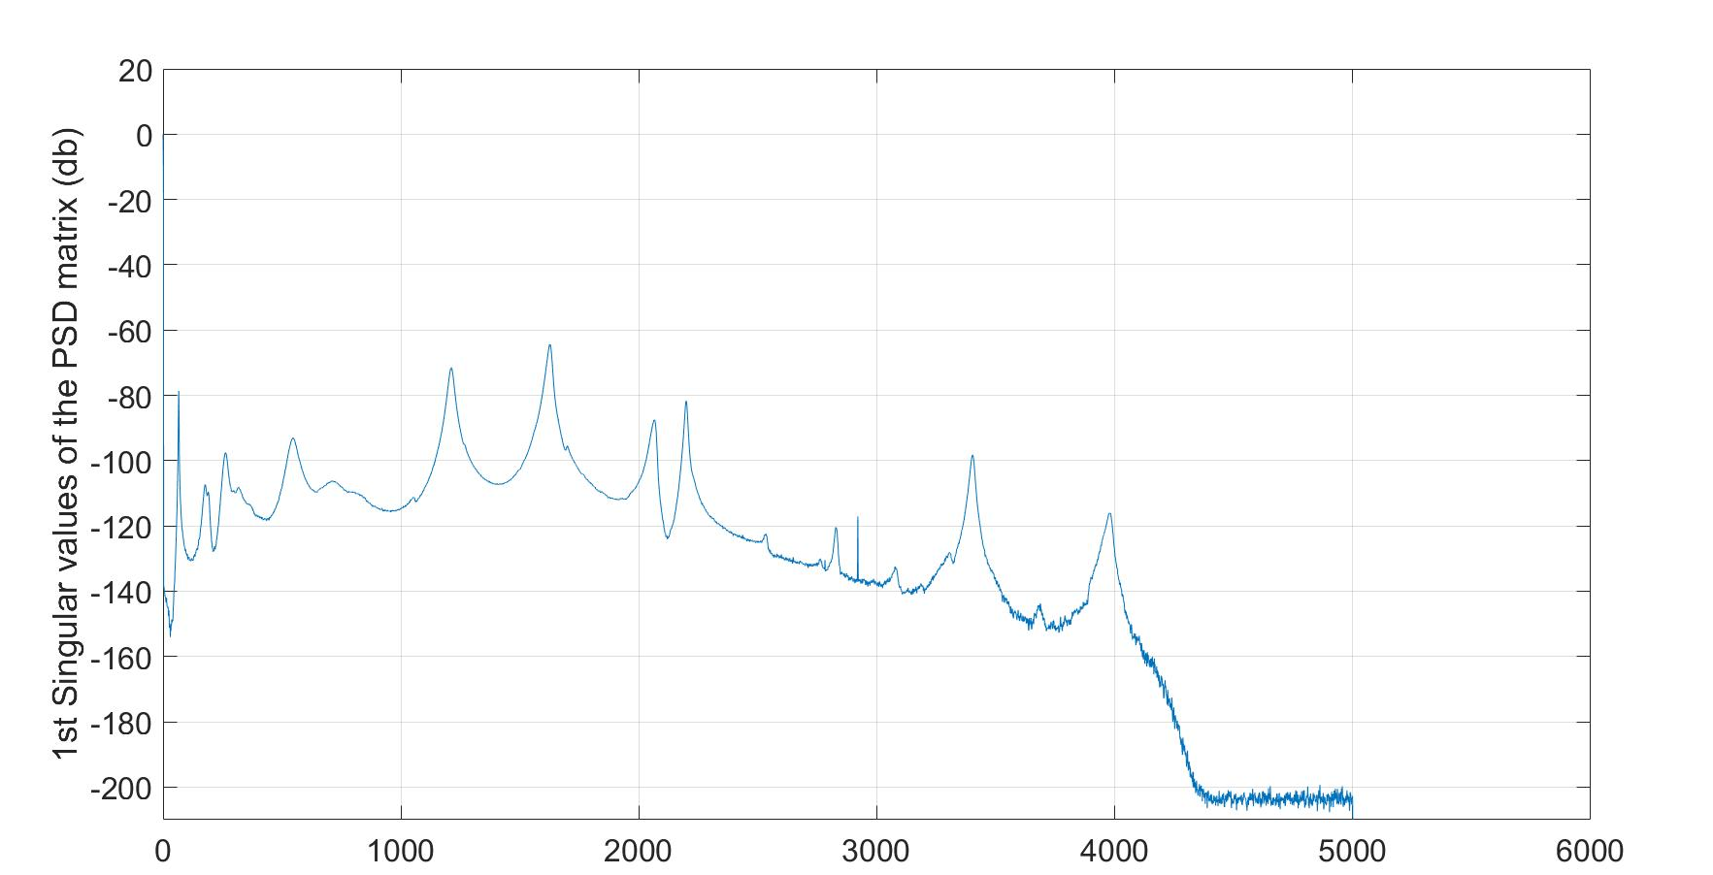
Figure 4. An example of the first singular value of the power spectrum matrix Model curvature-based damage identification method
For beam-like structures, modal curvature is defined as the second-order derivative of a given mode shape [13];

where h is the distance between measurement points during the vibration test. Damage along the beam is often associated with discontinuities in the curvature of mode shapes. Various damage indices can be defined in the basis of curvature. For example, a damage index can be defined by comparing the curvature of the beam between the reference (r, undamaged) and damaged (d) state;

where i is a position along the beam and n is a given mode of vibration.

Results

Finite element (FE) analysis results
Numerical modeling using the FE software ABAQUS® has been carried out to investigate the expected responses of the reference and damaged states of the beam and evaluate the effectiveness of the damage indices (Table 2). The intensity of damage in the beam is calculated by the following equations for the bending and shear capacities;

where G, A, E, and I are the shear modulus, elastic modulus, section area and moment of inertia, respectively.
Table 2. Numerical natural frequencies from FE models
Scenario | f1 (HZ) | Diff  (%) | f2  (Hz) | Diff  (%) | f3 (Hz) |  | Diff  (%) |  | Damage Level (%)
Reference | 71.86 | - | 279.12 | - |  | 600.4 |  | - |  | D_{B}=0  D_{V} =0
Beam1 | 52.73 | 26.62 | 264.01 | 5.41 |  | 507.0 |  | 15.54 |  | D_{B}=70.37  D_{V}=20

Experimental results
For each experimental beam, a set of 20+ measurements were performed. The average value for the first three natural frequencies shows that the most noticeable change in the natural frequencies occurs for the first mode, which is consistent with the results from the numerical model (Table 3). In both cases (Experimental and numerical model), the second frequency has the smallest change due to the presence of the damage.
Table 3. Average bending natural frequencies
Scenario | f1 | Diff (%) | f2 | Diff (%) | f3 | Diff (%)
Reference | 65.90 | - | 271.58 | - | 550.71 | -
Beam1 | 50.04 | 24.07 | 257.81 | 5.07 | 487.94 | 11.40

Figure 5 compares the first, second and third mode shapes of the beams, respectively. Figure 5 shows slight changes in the mode shapes between the reference and damaged beam. Figure 6 illustrates changes in the slope of the mode shapes, which shows that the second mode shows the largest differences at the location of the central defects. Figure 7 shows that the curvature of the first mode shape is most effective in locating the presence of the defects in the middle of the beam. The defect near the right support is most evident by comparing curvatures for the third mode shape. Figure 8 shows the absolute difference between the curvatures of the damaged beam and the reference beam. Although the peak values occur at the damage location in the middle and right side of the beam, some smaller peaks are present to the left of the beam where no damage has been introduced, which will require further analysis and noise reduction techniques.

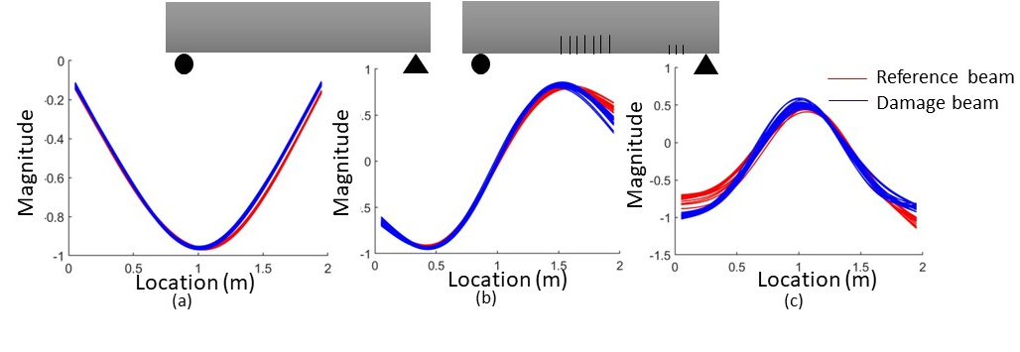
Figure 5. (a): first mode shape (b) second mode shape (c) third mode shape
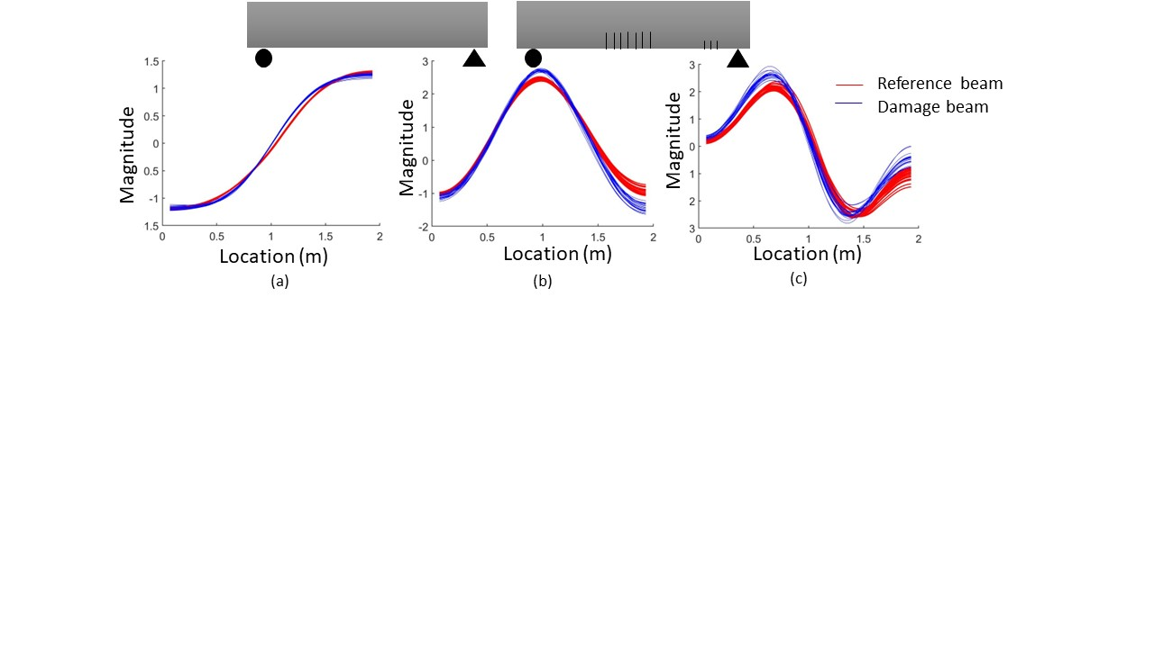
Figure 6. (a): first derivative of first mode shape (b): first derivative of second mode shape (c): first derivative of third mode shape

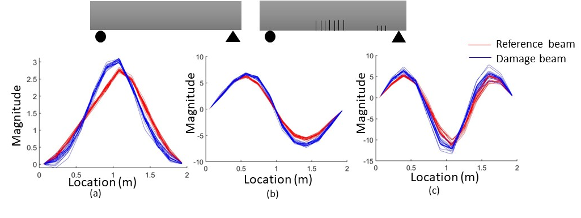
Figure 7. second derivative of first mode shape (b): second derivative of second mode shape (c): second derivative of third mode shape
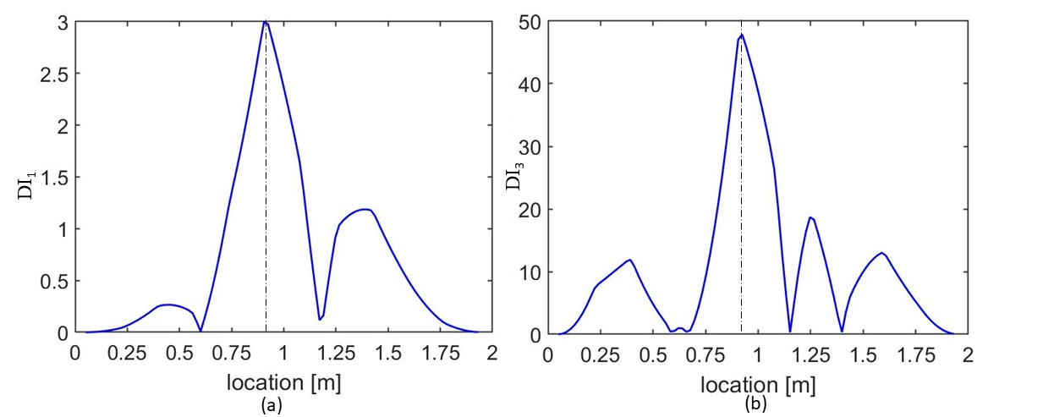
Figure 8. Plot of damage index for all nodes along the damaged beam (a): mode 1 (b): mode 3

conclusion
This paper presented numerical and experimental results on the applicability of mode shape curvature-based methods for localization of damage in UHPFC beams. The damage index is defined as the absolute difference between the curvature of damaged beam and reference beam. The results demonstrates that the proposed damage index is efficient when the severity of damage is moderate. However, further investigation will be performed in analyzing the experimental data for more refined detection and localization of defects under measurement noise. Parametric studies with the numerical model will also be undertaken to better understand the relation between the number, depth, and location of damage on the curvature of different vibration modes.

ACKNOWLEDGMENTS
The authors would like to acknowledge the financial support obtained from the Collaborative Research and Development Grants with Hydro-Québec (NSERC-CRD), Polycor Inc., and the Research Center of Concrete Infrastructures (CRIB).

References
[1] H. Sohn, C. R. Farrar, F. M. Hemez, and J. J. Czarnecki, “A Review of Structural Health Review of Structural Health Monitoring Literature 1996-2001.,” Los Alamos National Lab. (LANL), Los Alamos, NM (United States), LA-UR-02-2095, Jan. 2002. Accessed: Aug. 26, 2021. [Online]. Available: https://www.osti.gov/biblio/976152
[2] C. Rainieri, D. Gargaro, and G. Fabbrocino, “Statistical Tools for the Characterization of Environmental and Operational Factors in Vibration-Based SHM,” in Structural Health Monitoring and Damage Detection, Volume 7, Cham, 2015, pp. 175–184.
[3] C. R. Farrar et al., “Dynamic characterization and damage detection in the I-40 bridge over the Rio Grande,” Los Alamos National Lab., NM (United States), LA-12767-MS, Jun. 1994. doi: 10.2172/10158042.
[4] M. Daei, F. Sokhangou, and M. Hejazi, “A new intelligent algorithm for damage detection in frames via modal properties,” null, vol. 9, no. 4, pp. 222–236, Oct. 2017, doi: 10.1080/17508975.2016.1161584.
[5] S. Pereira, F. Magalhães, J. P. Gomes, Á. Cunha, and J. V. Lemos, “Vibration-based damage detection of a concrete arch dam,” Engineering Structures, vol. 235, p. 112032, May 2021, doi: 10.1016/j.engstruct.2021.112032.
[6] H. Martin-Sanz et al., “Vibration-based Damage Identification in the UHPFRC Strengthened Buna bridge,” 2019. [Online]. Available: http://infoscience.epfl.ch/record/269222
[7] “Ductal,” Ductal®, Jun. 29, 2016. http://www.ductal.com/fr/genie-civil (accessed Dec. 07, 2017).
[8] R. Capozucca and E. Magagnini, “RC beam models damaged and strengthened with GFRP strips under bending loading and free vibration,” Composite Structures, vol. 253, p. 112730, Dec. 2020, doi: 10.1016/j.compstruct.2020.112730.
[9] “OPERATIONALMODALANALYSISTECHNIQUESANDTHEIRTHEORETICALANDPRACTICALASPECTSACOMPREHENSIVEREVIEWANDINTRODUCTION.pdf.”
[10] R. Brincker, L. Zhang, and P. Andersen, “Modal identification of output-only systems using frequency domain decomposition,” Smart Mater. Struct., vol. 10, no. 3, pp. 441–445, Jun. 2001, doi: 10.1088/0964-1726/10/3/303.
[11] E. Cheynet, J. B. Jakobsen, and J. Snæbjörnsson, “Damping estimation of large wind-sensitive structures,” Procedia Engineering, vol. 199, pp. 2047–2053, Jan. 2017, doi: 10.1016/j.proeng.2017.09.471.
[12] A. Liutkus, “Scale-Space Peak Picking,” p. 5.
[13] C. R. Farrar, T. A. Duffey, P. J. Cornwell, and S. W. Doebling, “EXCITATION METHODS FOR BRIDGE STRUCTURES,” p. 8.

