Development and Validation of An Affordable Video Based Smart PIG For Pipeline In-line Inspection
Shuomang Shi¹, Phan Le¹, Thidas Wijethunga¹, Luyang Xu¹, Ying Huang^{1*}
¹ Civil, Construction and Environmental Engineering, North Dakota State University, Fargo, North Dakota, 58102, US
Email : shuomang.shi@ndsu.edu, phan.le@ndsu.edu, wijethunga@ndsu.edu, luyang.xu@ndsu.edu, Corresponding author : ying.huang@ndsu.edu*
ABSTRACT: In a century of enormous energy demand, pipelines play vital roles in the field of energy transportation. According to the U.S. DOT PHMSA, there are 2.6 million miles of pipelines that efficiently transport trillions of cubic feet of natural gas and hundreds of billions of tons of liquid petroleum products each year. While these berried or grounded pipes are exposed to various internal damages/anomalies such as inner corrosion which takes 15% of reportable failures, leading to an average cost of $3 million annually in property damage as well as several fatalities. This study aims to develop a low-cost smart PIG (Pipeline Inspection Gauge) based on video recording to effectively inspect the internal health conditions of pipelines. The smart PIG is remodeled based on a rigid single-section cleaning PIG body with four cleaning disks and two sealing disks which has a wide application and low cost. To enable the capacity of video recording, on the fore-end of the cleaning PIG, a waterproof PVC dome loaded with an HD camera and neutral light source is attached and sealed as the inspection unit. Driven by water pressure from rear-end, the whole smart PIG will move forward through pipelines and record visual data to perform image analysis of the internal health condition of the pipelines. Meanwhile, real-time monitoring provides intuitional information on the areas exposed to potential internal pipeline damages. The laboratory testing results show that the developed smart PIG can effectively complete ILI (In-line Inspection) tasks and provide clear images of internal conditions of an 8’’ diameter pipeline as well as the signs of corrosion risks located on the inner surface. Such cost-effective smart PIG design if further validated through field testing can be a great alternative to expensive smart PIGs which are required for inspection and maintenance of pipelines in service.

KEYWORDS: Pipeline; Smart PIG; In-line Inspection (ILI); Internal pipeline condition.

introduction
According to the US Department of Transportation’s Pipeline and Hazardous Materials Safety Administration (PHMSA), the US has taken first place in pipeline miles by over 2,225,000 kilometers transporting oil and naturel gas all over the nation. Relying on that, hundreds of public and private companies are operating these pipelines within the regulatory framework managed by the US Department of Transportation (USDOT). The pipeline networks are over years, proven significantly efficient and safe compared with other transporting ways such as ground and waterways. Though taking advantage of energy transporting, corrosion has been posting great threads to the durability and reliability of pipeline networks. Exacerbated by the aging of the pipeline materials, accumulated pipelines are corroded to failure and cause numerous financial losses. According to the PHMSA, nearly 30 percent of the fatal deterioration of underground pipelines is caused by external and internal corrosion. What’s more, internal corrosion has dominated their failure by taking 15% of all reportable incidents resulting in gas/oil transmitting problems, like pinhole, crack, and local material split. [1] Over years, a huge financial loss has been induced by improper protection of corrosion and maintenance. In the past few years, over 3 million dollars lost annually has been reported as proper damage and severe fatalities under the pipeline corrosion topic, which demands proper and effective ways of inspection, protection, and maintenance inside pipelines.[2]
An in-line inspection (ILI) service is defined as an investigation of the in-line condition by applying several intelligent tools of real-time monitoring. After years of development, ILI has become a common practice throughout the pipeline and transportation industries. In this area, the most commonly applied tool is called smart Pipeline Inspection Gauge (smart PIG), which is based on a regular cleaning PIG, mounting with smart monitoring and sensing devices, and utilizes non-destructive examination (NDE) methods to detect and locate potential damages inside pipelines. For instance, the active stereo omnidirectional vision sensor-based PIG to detect internal defects [3], and the Inuktun in-line vehicle services. [4] There are several types of smart PIGs used in ILI services. Each one of them has its pros and cons depending on different NDE abilities. Recently though, some manufacturers are combining the various functions of these separate tools into one, to get a single tool that can now be used to detect several different types of damage, making it into a more efficient and effective smart PIG. [5]. Literature shows that visual inspection through cameras has gained growing attention for oil/gas pipeline internal condition assessment, especially for unpiggable pipelines. There are two types of visual inspections currently available for pipeline internal condition assessment including crawling vehicles (normally have limited inspection length up to 100 m or 1000 ft. of pipeline segment per inspection) and video pigs (with no limit on inspection length). The crawling type of vehicles are the active stereo omnidirectional vision sensor [6], large variable geometry crawler [3], Inuktun pipeline inspection vehicle [4], and axial symmetric light stripe sensor. [7] For the pigable pipelines, some visual inspections are available using video pigs, such as video pigs commercially available from Dacon and Pipesurvey International [8,9].
Under the utilization prospective, a cost-effective smart PIG is to be developed and validated in this study.
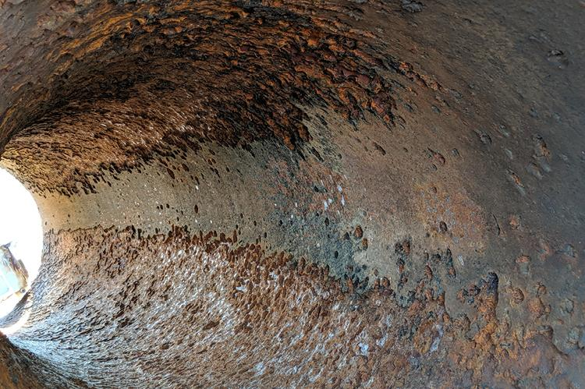
Figure 1. Internal corrosion of gas pipeline
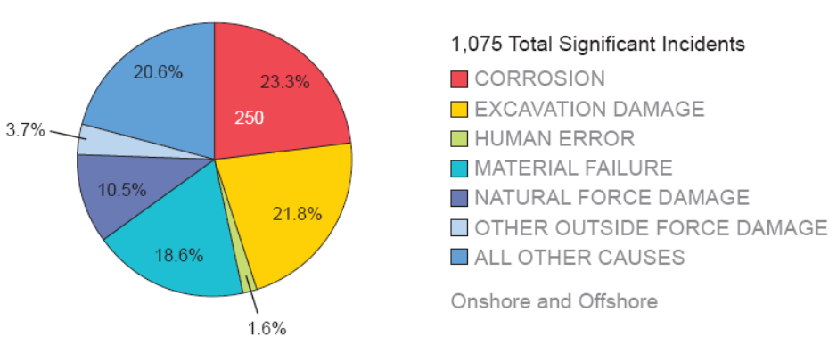
Figure 2. Causes of significant incidents in onshore and offshore natural gas transmission pipelines. (PHMSA)

experimental methodology

Smart PIG design
For the smart PIG design, a PIG with one section of body mounted with live stream camera with parameters in Table 1 was developed. As shown in Figure 3, a cylindrical electric housing was attached to the middle rod of the PIG body to enable the video recording capacity and the electronic components for data collection and processing. The 4 views of the rigid design of the smart PIG with detailed dimensions can be seen in Figure 3 as well. Figure 4 shows the detailed installation of the camera mounting and a Raspberry Pi High-Quality Camera with a 16mm lens attached. The
The advantage of this design outlet is that the front camera stays in the center, with all electronics held inside the cylindric housing. What’s more, the light sources could be attached around the housing, providing multiple light direction plans with waterproof light torches. The sealing of the housing is simple, as all the electric parts are all in one place, Teflon tapes and screwed back lids will do an excellent job closing the house. However, this plan applies over 2 feet length of the whole smart PIG. With a long rigid body, it has the limited travel-through ability when passing curved pipes, especially when at small angles. In this case, a long straight pipe was adopted to run the smart PIG, but if to be promoted, the housing of the camera and all other electrics should be more impact or well managed around the center cylinder, which makes use of hollow space around the PIG body.

Smart PIG real-time data collection and processing
After designing the outlet assembly plan for the smart PIG hardware solutions, programming was performed to wirelessly transmit recorded videos and perform data processing. As the Raspberry Pi was the device responsible for the streaming of data to an external device, the onboard Wi-Fi capabilities were used to achieve real-time data collection. To get the Raspberry Pi functional for collecting video in real-time, first, the Raspberry pie micro-SD card was put into an SD card reader and connected to a personal computer followed by renaming the application for initialization. After that, the SD card was connected to the Raspberry Pie auto-connecting to WiFi.
Table. 1 Parameter of camera and lens
Camera | Sony IMX477R, | Pixels | 4056(H) × 3040(V)
Sensor | 7.9mm CMOS | Pixel size | 1.55μm(H) × 1.55μm (V)
Output format | Raw12, Comp8 | Back focus | 12.55mm-22.4mm
Lens support | C/CS-mount | IR cut filter | Integrated
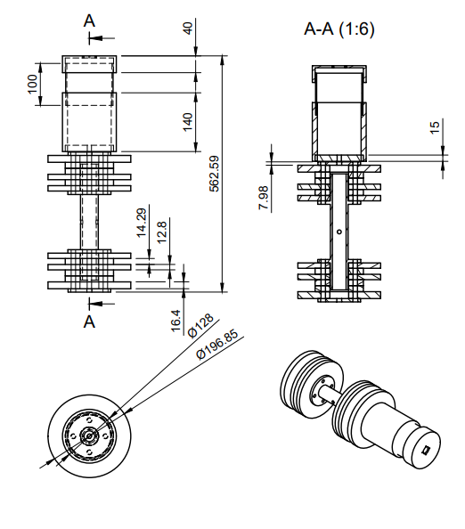
Figure 3. PIG body with electric housing plan
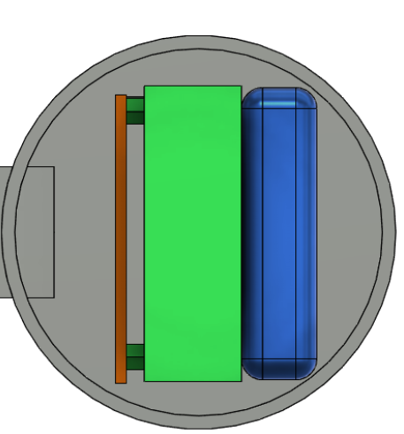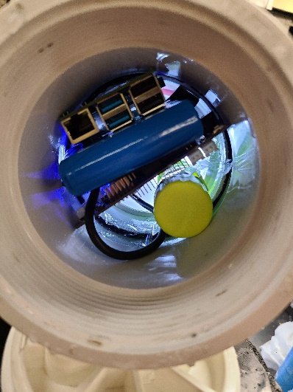
Figure 4. Designed and realistic Raspberry PI board and batteries inside the housing.
Then the live feed process was followed by the Raspberry Pi guidelines. The real-time recorded videos were recorded and processed in real time using the developed Python 3 program in Figure 5 to do transmit real-time images inside the pipe.
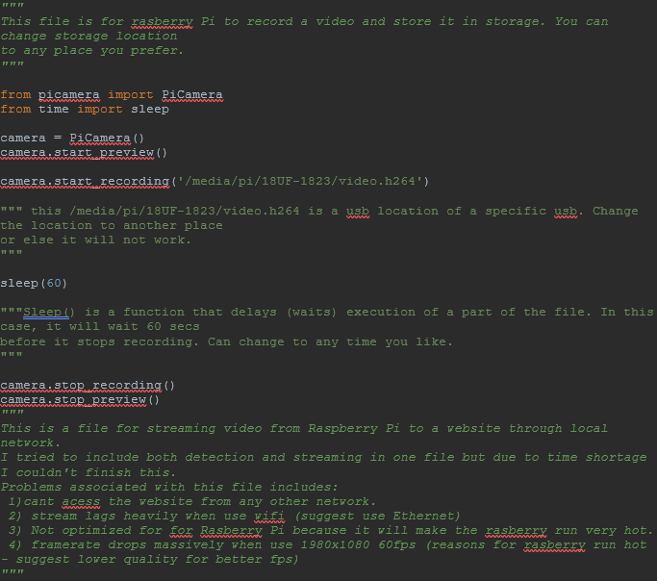
Figure 5. Development of the developed Python 3 code for the data processing from the Raspberry Pi.

Simulated laboratory tests for wet inline environment
To test the feasibility of the developed smart PIG, this section developed a simulated laboratory testing facility that was able to perform full-size smart PIG (Figure 6) operating tests. Figure 7 shows the lab testing facility setup. It has integrated a 30Gal water tank, a 6 ft-long 8-inch diameter steel pipe segment, a 250 HP water/liquid pump, a 1.5 in. diameter backwash hose, and a 2 in. diameter water draw hose. To ensure a safe testing environment, in this experimental test, water was used to simulate the wet inline environment instead of gas/oil due to the safety concern in the lab environment. While operating, the pump was turned on and the water inside the pipe would push the PIG moving from one end to the other. The smart PIG was tested in the testing facility and real-time monitoring was performed to get visual inspection results of color tapes inside the pipelines. Color tapes in red, blue, and green colors were printed and attached to the inner surface of the pipe to represent simulated damages (Figure 8 (a)). The light source could be either mounted surrounding the camera or on the side of the PIG, both can provide enough lumens of light to close areas around the camera under inline conditions. In this case, the light mounting keeps constant with the previously stated.
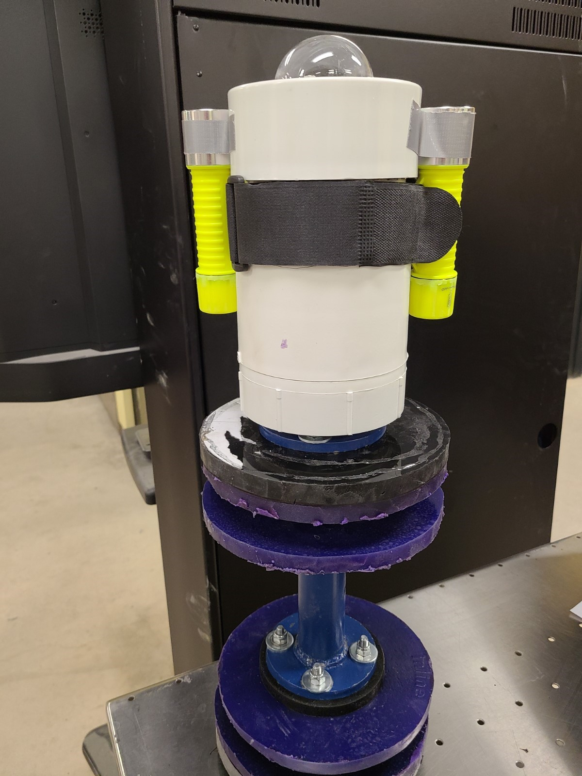
Figure 6. Camera mounted PIG with light source sided attached
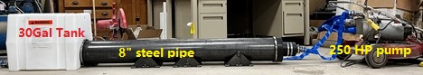
Figure 7. Wet condition test system installation, includes 8” ID steel pipe, 200HP pump, 30 Gal water tank and hoses

results and Discussions
The real-time camera vision kept on through the whole experimental process. For the smart PIG design in this study, it succeeded in the simulated lab testing in wet environments, however, throughout the experiment, we noticed that the quality of the image is dependent on the clearness of the water and the condensation built up on the dome and lens of the camera. Unexpectedly, during the experiment, some of the color strips used were dislodged and began to float and drift down the pipe. To investigate how the light locations may alter the detection results, various light positions were tested. Figure 8 (a) is a detected image of the design with the light mounted on the top with the high lumen setting which served as the control throughout the experiment. It is seen that the camera output a clear view and was capable to see the representative color patterns of the sensors developed in this project. Figure 8 (b) shows the recorded video of design alternative 2 with one light mounted on the bottom with high and low lumen setting and Figure 8 (c) shows the recorded video of design alternative 2 with two lights mounted on the bottom with high and low lumen setting. Figure 8 (d) show the recorded video of design alternative 2 with two lights mounted on the side with high and low lumen setting. These findings show that the location of the lights did contribute significantly to the detection.
From the results above, lights on the side showed the most effective of the light locations.
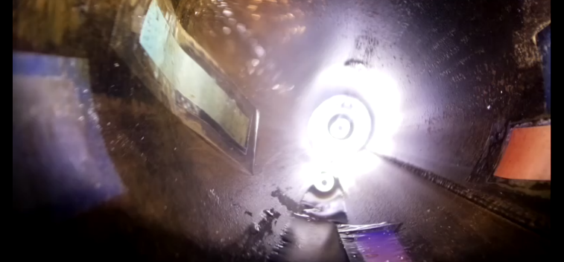
(a) control image
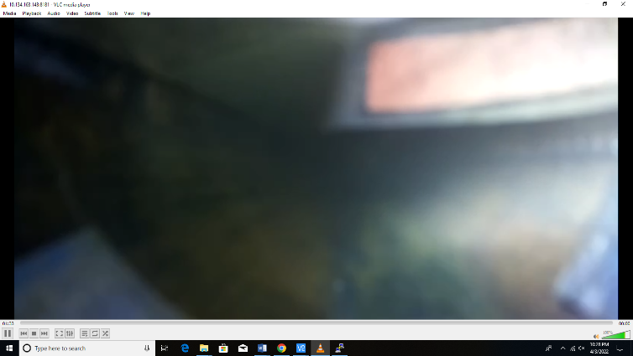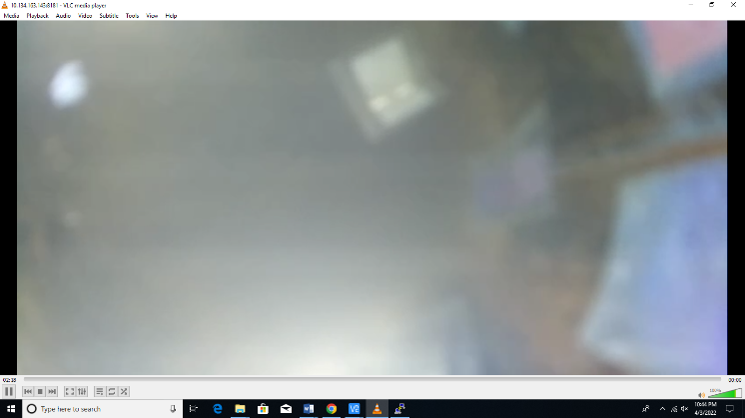
(b) Left: one light on bottom with high lumen setting. Right: one light on bottom with low lumen setting.
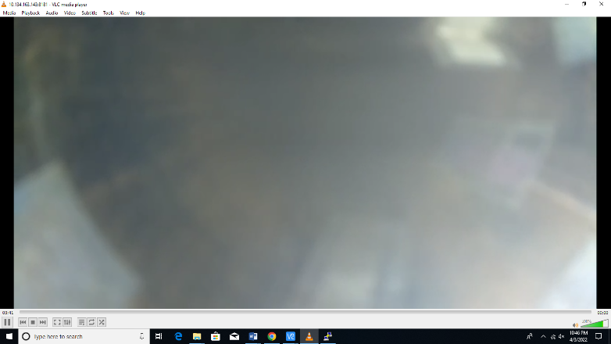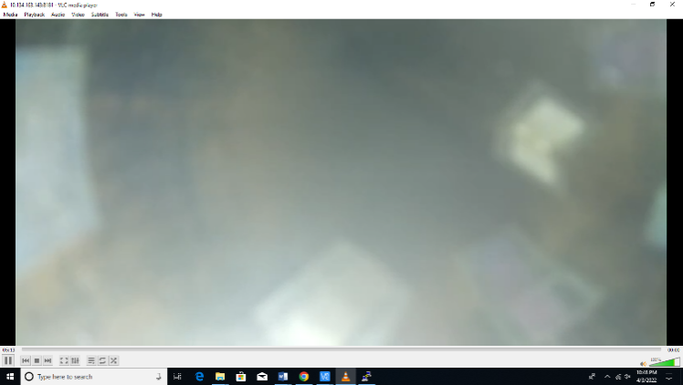
(c) Left: two lights on bottom with high lumen setting. Right: two light on bottom with low lumen setting.
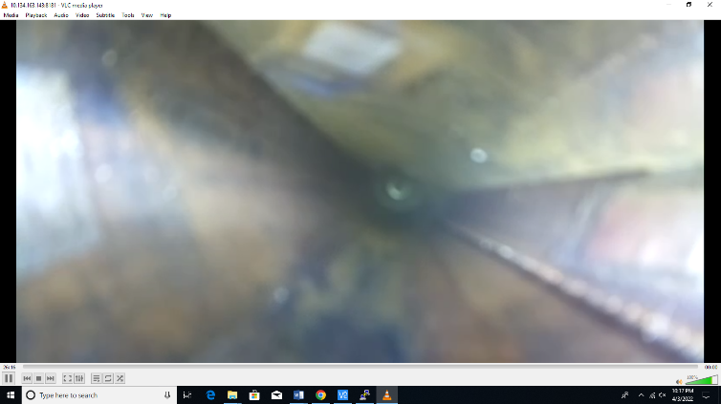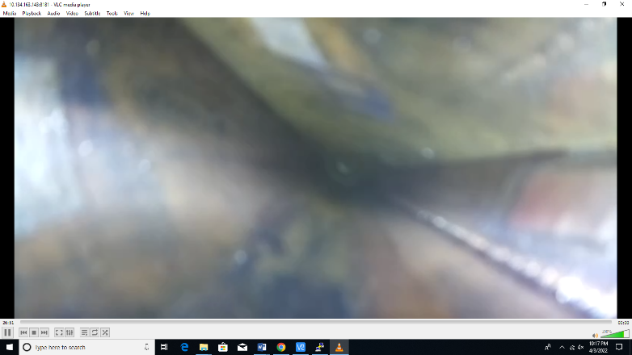
(d) Left: two light on side with high lumen setting. Right: two light on side with low lumen setting.
Figure 8. Visual images of deployed sensors from smart PIG design under in-line water transmitting condition
The test results revealed the feasibility of the smart PIGs assembly design, as well as the applicability of the whole test facility installation. During the test process, the PIG was moving forward smoothly in direction of the water flow. With enough water pressure from the rear end, the smart PIG finally reached the end of the 8” pipe. In the meanwhile, stable visualization of the inner pipe was obtained through software operation. The images indicated a reliable vision source from the Raspberry PI embedded HD camera. Which are light-sided high and low lumen setups. In the images shown above, the close range of the color tape was accurately observed. However, due to the focusing problem under flowing water condition, targets at the longer range was a blur. In this situation, the camera focusing issue is to be promoted to see the color tapes in distance.

conclusions
Validated by laboratory tests simulating water environments in pipelines, a cost-effective smart PIG mounted with an HD camera and light source is developed and proved functional under in-line conditions. The test facility of a 10 ft steel pipe inserted into a water tank was developed. A 30-Gal water pump is integrated into the water cycle system to successfully let the smart PIG runs in water in-line condition. The deployed smart PIG gives out a recognizable and visible view of particular color tapes as in-line markers. With notable color changes, the results suggested that the side-mounted light source, cooperating with both high/low lumen light is suitable for observing close-range in-line conditions as smart PIG went through the pipe.

ACKNOWLEDGMENTS
This work was partially supported the U.S. Department of Transportation Pipeline and Hazard Materials Safety Administration (PHMSA) under Grant No. 693JK31850008CAAP and and the National Science Foundation under Grant No.OIA-2119691. The findings and opinions expressed in this article are those of the authors only and do not necessarily reflect the views of the sponsors.

References
- Fessler R R. Pipeline corrosion[J]. Report, US Department of Transportation Pipeline and Hazardous Materials Safety Administration, Baker, Evanston, IL, 2018.
- Lam C, Zhou W. Statistical analyses of incidents on onshore gas transmission pipelines based on PHMSA database[J]. International Journal of Pressure Vessels and Piping, 2016, 145: 29-40.
- Wu, T., Lu, S. and Tang, Y. An in-pipe internal defects inspection system based on the active stereo omnidirectional vision sensor. in 2015 12th International Conference on Fuzzy Systems and Knowledge Discovery, FSKD 2015, 2016.
- Inuktun Services Ltd., Inuktun Pipe Inspection Vehicle, Versatrax 150™, http://inuktun.com/en/products/onsite-standard-products/versatrax-150-pipe-inspection-crawler/
- Gibson Applied Technology and Engineering, Inc., Pipeline Pigging Part 1: Cleaning Pigs & Pigging Strategy, GAT2004-GKP-2013.01 January 2013, pp.1-2Winters, B. Cleaning pig designs and applications. NACE Central Area Conference, T. D. Williamson-Pipeline Cleaning Pigs, Houston, TX.
- Rohrback Cosasco Systems, Inc., Corrosion monitoring primer, http://www.cosasco.com/documents/Corrosion_Monitoring_Primer.pdf
- Jarragh, A. Evaluation of the Effectiveness of Online Corrosion Monitoring Utlizing Electrical Resistance Linear Polarization Resistance Coupon Within Hydrocarbon Systems, 2014 NACE International, ISBN: 3934 2014 CP
- Pure Technology a xylem brand, PureRobotics, https://puretechltd.com/technology/purerobotics-pipeline-inspection-system/
- Maverick Inspection LTD., Remote Video Inspection (RVI), http://www.maverickinspection.com/services/remote-video-inspection/rvi-video-imagery-gallery/pipelines-compressors/

