Inclination monitoring of a bridge pier in the winter season with high-sensitivity MEMS sensor
Yasunori Miyamori¹, Yoichi Hinata², Yoshihito Imaizumi³, Tomohisa Takehara³, Shuichi Mikami¹, Toshiyuki Oshima¹
¹Department of Civil and Environmental Eng., Faculty of Engineering, Kitami Institute of Technology,
Koen-cho 165, 090-8507 Kitami, Japan
email: miyamoya@mail.kitami-it.ac.jp, mikamisi@mail.kitami-it.ac.jp, t-oshima@iea.att.ne.jp
²Nihon Kasetsu Co.,
16-14-6-50, Hassamu, Nishi-ku, 063-0836 Sapporo, Japan
email: hinata@nihonkasetsu.co.jp
³Koken Engineering Co.,Ltd.,
1-1, N18, E17, Higashi-ku, 065-8510 Sapporo, Japan
email: yoshi@koken-e.co.jp, t.takehara@koken-e.co.jp

ABSTRACT: In this study, the authors developed a remote inclination monitoring system with a high sensitivity MEMS sensor and an LPWA network module for the safety monitoring of scoured bridges. We installed the developed system on a bridge pier in the winter season and have examined its sensing performance and durability for five months. On the other hand, the monitoring system aims to detect the first stage of scouring with a high-sensitivity inclinometer. Therefore, the paper also reports the measurement results of the detailed movement of the bridge pier in a normal state in the winter season to establish an anomaly monitoring scheme. The monitoring system had successfully operated throughout the winter under -20 degrees Celsius from the measurement. The measured data showed a small amplitude of diurnal variation and seasonal fluctuation of the bridge pier in the ordinal state.
KEY WORDS: LPWA, high-sensitivity inclinometer, bridge scour monitoring, winter season.

Introduction
Recent changes in the global climate raise the risk of scouring under bridge piers or abutments in a cold region where rainfall is increasing. Bridges in such areas have rarely suffered from severe floods, and then they have a smaller safety margin than bridges in a warmer region. These cold regions generally have a low population density, and the investment on infrastructures is limited. On the other hand, the climate environment is much more severe in the winter season. This situation requires much effort and innovation for improving structural health monitoring techniques [1] [2].
Scour of a bridge under severe flooding sometimes makes the bridge collapse, and it causes human life loss and suspension of service long term. Moreover, bridge scours also progress under swell in a river. In this case, the bridge does not collapse but tilts and loses its serviceability. Such accident causes significant economic loss and a decrease in quality of life even though avoiding the loss of human life. There is a necessity for bridge scour monitoring in the earlier stage. The low-cost and efficient monitoring network system saves and improves the resilience of the local community. Therefore the authors developed a remote inclination monitoring system with a high sensitivity MEMS sensor and an LPWA network module for safety monitoring of scoured bridges [3].
Table 1. Specification of the monitoring system.
Item | Specification
Range | ±30°（X-axis, Y-axis）
Precision | 0.006°
Radio frequency band | 920.6 - 928.0 MHz
Modulation system | LoRa modulation  (spread spectrum)
Bandwidth | 62.5 - 500 kHz
Transmission rate | 146 - 22k bps
Transmission Output | Less than 13 dBm
Connection mode | Star network
Maximum communication distance | 15km
Operating temperature limits | -30℃ - 60℃

In this study, we installed the developed system on a bridge pier during the winter season and examined its sensing performance and durability for five months. On the other hand, the monitoring system aims to detect the first stage of scouring with a high-sensitivity inclinometer. The bridge authority should adequately understand the behavior within the normal range of the structure before the event to correctly find abnormal changes. Or general knowledge of minor normal structural responses will assist the judgment of the authority. The paper reports the measurement results of the detailed movement of the bridge pier in a normal state in the winter season to establish an anomaly monitoring scheme.

On-site test of the monitoring system

Monitoring system
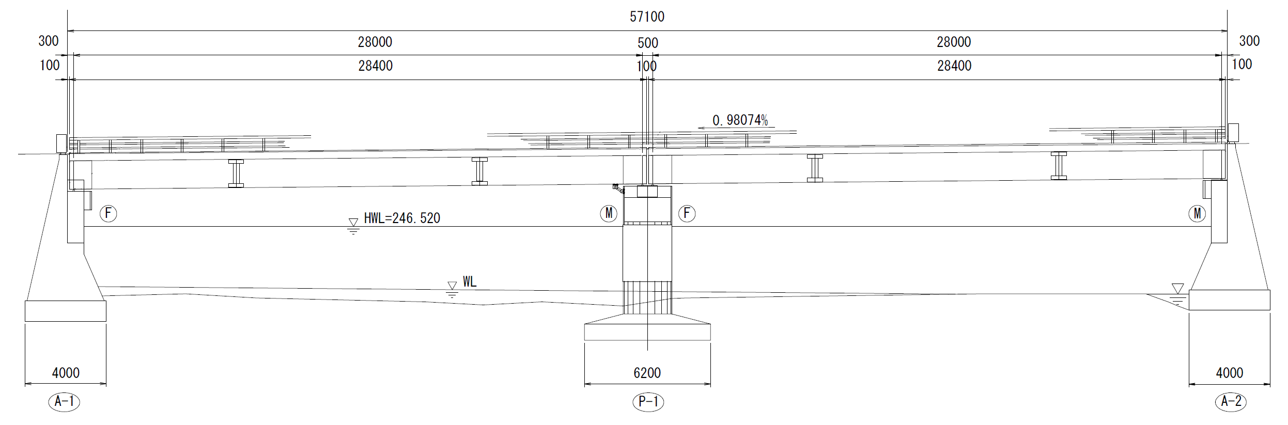
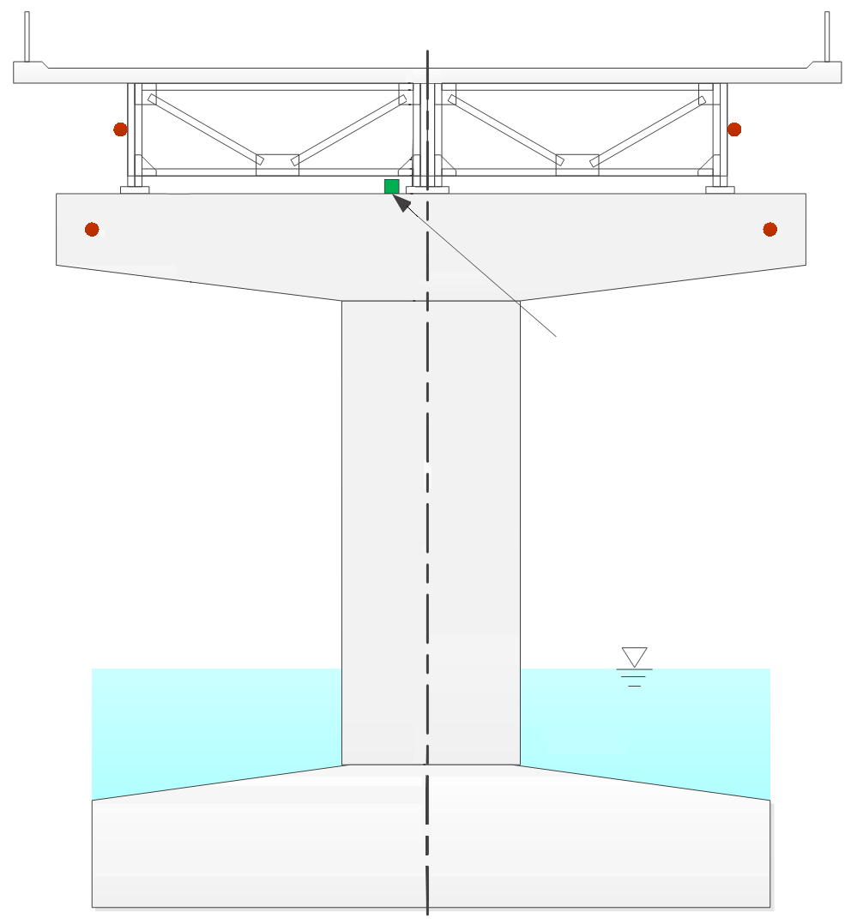
We developed a prototype monitoring system that can remotely diagnose bridges tilting in off-grid areas during the winter season in cold regions [3]. The measurement unit installed on the top of the bridge pier measures the tilt angle caused by the vertical displacement of the bridge piers with high accuracy MEMS tilt angle sensors, and the unit transmits the data to the gateway via LoRa communication. The data received by the gateway is resent to the cloud server via LTE communication.
Figure 1. General view of the bridge (side view).
Table 2. Specification of the bridge.
Total length | 57.1 m
Span length | 2@28 m
Width | 7m
Construction year | 1965
Type of super structure | Simple composite plate girder
Type of sub structure | Gravity type abutments, RC pier, Spread foundation

Figure 2. Sensor installation layout.
Section view of the pier
Inclinometer
Thermometer
G1
G2
G3
Flow
(Southeast)
(Northwest)
Table 1 shows the specifications of the measurement unit. The measurement unit consists of a LoRa communication module, a measurement device with a MEMS sensor, a power supply unit such as a lithium battery, and a microcomputer that controls the measurement, communication, and power supply. The MEMS tilt angle sensor uses a thermal accelerometer [4].

The test bridge and sensor installation
Table 2 shows the bridge specifications, and Figure 1 shows the general view of the bridge. The bridge is two spans simple plate girder bridge constructed in 1965. The bridge is located in the central mountain area in Hokkaido, Japan. The bridge crosses a river, and the RC pier on a spread foundation stands in the river flow.
Figure 2 is a section view of the pier, and the figure shows the sensor installation layout. The MEMS inclinometer was installed on the top of the pier by the middle girder, shown in Figure 3. Four thermometers were also installed on the bridge to measure the temperature of bridge members. Another data logging system measured these temperatures for the on-site test.
The bridge receives sunlight from the southeast side in the morning, and the bridge is in the shade along with the sun's movement in the afternoon.

On-site measurement test
The on-site measurement test was conducted from November 1st, 2020 to April 15th, 2021 to confirm its sensing performance and durability under a severely cold environment.
The primary monitoring system hourly measured the inclination of the bridge pier on two axes shown in Figure 4. The system applied the digital filter on the acquired data to eliminate the dynamic effect of traffic vibration. There was no data loss or data transmit error during the test period.
Another monitoring system measured the temperature of bridge members in 10-minute intervals. This temperature monitoring system lost the data in early January due to the insufficient battery level.

Monitoring results
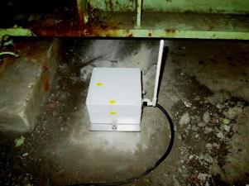
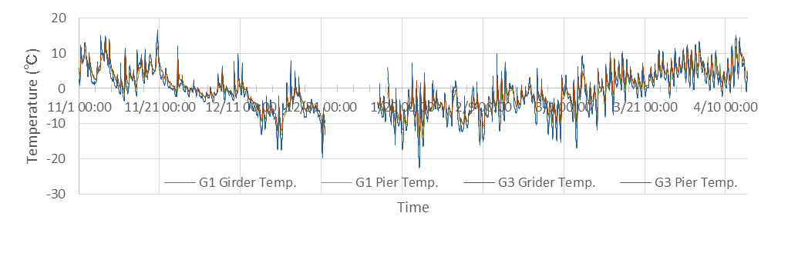
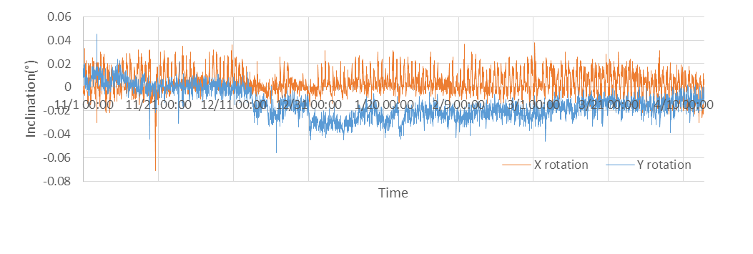
Figure 5 shows the time history of inclination in the whole test period. Figure 6 shows the time history of the temperature of the bridge. Figure 7 shows a typical daily change of these parameters in two days. Figure 8 shows trails of inclination of each day shown in Figure 7.
Figure 4. Orientation of the sensor.
Figure 3. Installation of the sensor unit.
P-1
Inclinometer
Flow
x axis
y axis
Movable support
Fixed support
G1
G2
G3
Figure 6. Time history of temperature.
Figure 5. Time history of inclination.
We observe the inclination has daily fluctuation in x-axis rotation through the test period. The oscillation is consistent with the temperature change of the structure. However, a detailed investigation is needed. Due to structural material differences, there are temperature differences and time delays between structural members. The effect of sunlight is also an essential item to explain the fluctuation. There was a seasonal fluctuation in the y-axis rotation and the seasonal temperature change. This inclination change was almost consistent with the linear expansion of the girder if the adhering of the movable bearing on the pier.
In Figure 7, the temperature change on 30 December was limited, and the inclination changes were also small. After the day, the temperature of the girders decreased in the dawn. The inclination of the y-axis rotation was also changed, and this tendency was explained by the linear expansion of the beam, as mentioned above. Then the structural temperature was raised in the morning, and the temperature had differences between the G1 and G3 sides. These temperature gaps may cause inclination in x-axis rotation.
Trails of inclination of each day are the combination of bi-axial tilting of the pier in Figure 8. The x-direction movement on 31 December is larger than the previous day. In these charts, the center of the daily trails is different. This difference needs to be considered to set the threshold of scouring warning. The neutral inclination of the day or the season shifts, as shown in Figure 8. If the threshold is determined to the origin of the coordinate axes, the threshold value gives excessive margin or risk. Therefore, yearly monitoring is needed to evaluate the normal movement of the structure, or numerical simulations will be the alternative solution.

Conclusion
In this study, the remote inclination monitoring system with a high sensitivity MEMS sensor and an LPWA network module for the safety monitoring of scoured bridges was installed on a bridge pier in the winter season and examined its sensing performance and durability. There was no data loss or data transmit error during the test period.
From measurement results, the monitoring system observed the small oscillation of the bridge pier with a high-sensitivity inclinometer. The temperature of the bridge members affects the movement of the pier. Further studies need to be conducted considering the effects of sunlight and the river's water level. And yearly monitoring and numerical simulation are also required to determine the proper threshold value for warning in the early scouring stage.

ACKNOWLEDGMENTS
This research is partially supported by the Adaptable and Seamless Technology transfer Program through Target-driven R&D (A-STEP) from Japan Science and Technology Agency(JST) and Innovation Research Support Program from Northern Advancement Center for Science and Technology.

References
- Giordano, P.F., Prendergast, L.J. & Limongelli, M.P. A framework for assessing the value of information for health monitoring of scoured bridges. J Civil Struct Health Monit 10, 485–496 (2020). https://doi.org/10.1007/s13349-020-00398-0
- Faulkner, K., Brownjohn, J.M.W., Wang, Y., et al. Tracking bridge tilt behaviour using sensor fusion techniques. J Civil Struct Health Monit 10, 543–555 (2020). https://doi.org/10.1007/s13349-020-00400-9
- Miyamori, Y., Hinata, Y., Imaizumi, Y., et al. A development of a hybrid remote safety monitoring system for scoured bridge substructures, Proc the 10th Intl Conf on Struct Health Monit of Intelligent Infrastruct, SHMII 10, ABS-290 (2021).
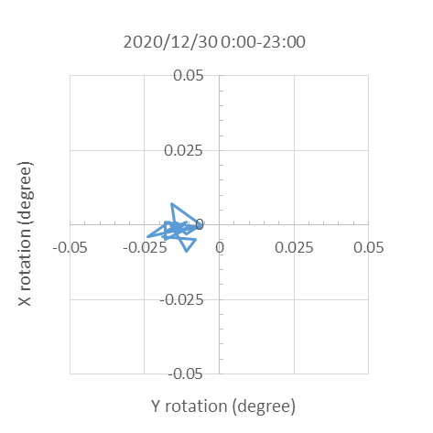
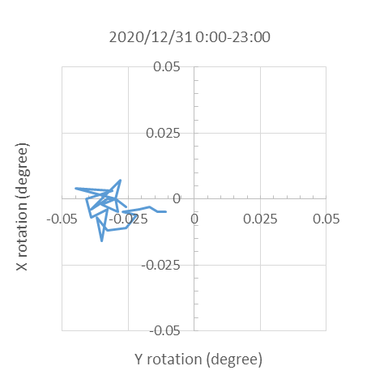
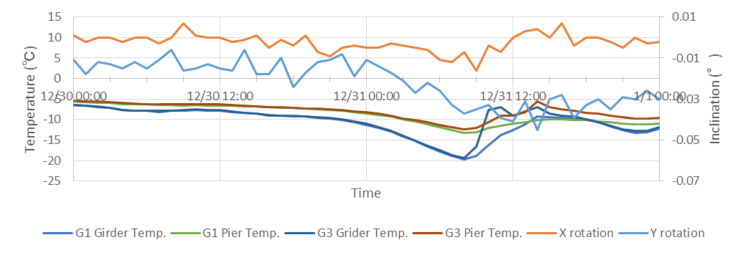
- Mukherjee, R., Basu, J., Mandal, P., et al. A review of micromachined thermal accelerometers, J. Micromech. Microeng. 27 123002 (2017).
Figure 8. Trail of inclination in a day.
Figure 7. Time history of inclination and temperature (12/30/2020-12/31/2020).

