Tomographic imaging for concrete core defects detection of CFST members using stress wave measurement considering multi-physics coupling effects
Jiang Wang¹, Bin Xu^{1, 2,*}, Hanbin Ge³ and Tianmin Zhou⁴
¹ College of Civil Engineering, Huaqiao University, Xiamen 361021, China
² Key Laboratory for Structural Engineering and Disaster Prevention of Fujian Province (Huaqiao University), Xiamen 361021, China
³ Department of Civil Engineering, Meijo University, Nagoya 468-8502, Japan
⁴ Department of Civil and Environmental Engineering, University of Houston, Houston, TX 77204-4006, USA;
Email : 18011086007@hqu.edu.cn, binxu@ hqu.edu.cn, gehanbin@meijo-u.ac.jp, zhoutm2011@gmail.com
* corresponding author
ABSTRACT: In this study, to detect concrete core defects in concrete-filled steel tube (CFST) members, a travel time tomography imaging method using stress wave measurement with piezoelectric-lead-zirconium-titanate (PZT) is proposed and numerically validated. The multi-physics coupling model consisting of a number of PZT actuators and sensors, steel tubes, and concrete is first established. The first arrival times of stress waves passing through the cross-section of CFST members from one PZT actuator excited by a pulse signal to a number of PZT sensors are measured in a pitch-catch form. To improve the accuracy of the shortest wave travel path when the wave refraction point is occasionally located at the intersection of the imaging grids where the traditional Snell laws do not work, a random walking algorithm is proposed. Based on an initial velocity model of the CFST member, the shortest wave travel path between each PZT actuator and each PZT sensor is obtained using the proposed random walking algorithm. Therefore, a simultaneous iterative reconstruction technique (SIRT) is employed to identify the velocity model of CFST members with concrete core defects. Finally, the location and size of concrete core defects in a CFST cross-section can be imaged with high resolution using the stress wave propagation measurement numerically determined by the CFST-PZT coupling model.
KEY WORDS: piezoelectric-lead-zirconium-titanate (PZT); actuator and sensor; CFST members; multi-physics coupling model; random walking algorithm; tomographic imaging; simultaneous iterative reconstruction technique (SIRT).

INTRODUCTION
CFST members as major vertical and axial load-carrying components have been widely used in super high-rise buildings and long-span bridges due to their superior mechanical properties including load-carrying capacity and ductility under dynamic loadings such as earthquakes, as an ideal alternative to traditional reinforced concrete (RC) structures. Unfortunately, the unavoidable shrinkage and creep of concrete core during the concrete consolidation and in service may cause various types of defects such as cracks, air void and interface debonding defects between the concrete core and the steel tube and finally lead to risk in structural safety [1, 2]. Therefore, there is an urgent need in the field of civil engineering to adopt economic and effective means to detect internal defects such as interface debonding between concrete core and steel tube and voids in the concrete core of CFST members.
Non-destructive testing (NDT) technologies including infrared thermal imaging method [3], electromagnetic method [4], X-ray method [5], radar method [6] and ultrasonic method [7], etc., have been applied in defects detecting in RC, steel and other metal structures. However, most of the traditional defect detection methods cannot effectively detect and qualitatively analyze the internal defects in CFST members due to the shielding effect of the steel tubes and the complexity of CFST members composed of two materials with different material properties.
Piezoelectric-lead-zirconium-titanate (PZT) materials have been widely used in structural health monitoring (SHM) of various engineering structures due to their low cost, fast response, lightweight and feasibility and have been recognized as one of the most promising materials for structural damage detection. Xu et al. proposed a method based on stress wave measurement from PZT patches to detect interface debonding defects of CFST members and verified the reliability of the proposed method numerically and experimentally [8, 9]. Song et al. embedded PZT sensors in concrete structures to detect the damage in RC members [10]. Moslehy et al. [11] successfully evaluated the health of concrete columns under dynamic loading using embedded piezoelectric smart aggregates. Besides, to further study the detection mechanism of the interface debonding defect in CFST members, Xu et al. [12-15] took the embedded PZT patch as a sensor and surface-mounted PZT patch as an actuator to detect the size of interface debonding defect of CFST members under different excitation signals by analyzing the wavelet packet energy of the output voltage response of the PZT sensor. Even the above studies show that most of the NDT technologies can detect the existence of embedded defects in CFST members or RC structures, further investigation on the development of quantitative evaluation approaches for the size and location of the unaccessible defects for CFST members is critical and imaging the defects is an attractive solution by visualizing the defects directly.
The tomography technology uses a mathematical model to process the projection value of the ray source without damaging the structure. It is an inversion technique for reconstructing the internal image according to the projection data obtained from the detection equipment outside the object and can obtain the quality degradation degree due to defect [16]. The tomography imaging technology using acoustic waves has been used in seismic exploration. The transmitting and receiving transducers are placed at different positions of the survey object, and the wave information including wave propagation time, amplitude, wavelength and frequency, etc., collected by the receiving transducer is used for ultrasonic imaging [17-19]. Recently, Liu et al. [20] proposed a high-resolution imaging method for CFST members according to travel time tomography (TTT) and reverse time migration (RTM) and numerically validated the feasibility of the proposed approach for the detection of the size and location of the concrete core defect of CFST cross-section. One of the challenges of the proposed approach is the higher computation cost when a fine finite element mesh is required. Moreover, because the traditional Snell laws do not work when the wave refraction point is occasionally located at the intersection of the imaging grids, it is desired to find a more general approach for the determination of the shortest wave travel path.
In this study, a travel time data acquisition method with PZT technology for tomography imaging of CFST members is proposed and validated with numerical simulation data from a CFST-PZT coupling system where the direct and inverse piezoelectric effects of PZT patches and the multi-physics coupling effect between CFST and PZT are considered. A random walk algorithm is proposed based on seismic ray theory to find the shortest-time wave travel path of stress wave propagation from the PZT actuator to the PZT sensor crossing the whole cross-section of the CFST member with concrete core defects. A simultaneous iterative reconstruction technique (SIRT) is used to reconstruct the velocity model to verify the accuracy of the tomographic imaging method utilizing the stress wave travel time acquired by the PZT sensor. Numerical results show that the proposed approach can accurately determine the size and location of the concrete core defect in CFST members.

tomography imaging FOR CONCRETE CORE DEFECT in CFST members

Equations of multi-physics coupling PZT-CFST systems
PZT sensors are used to collect the stress wave travel time in CFST members. In order to numerically investigate the stress wave propagation in the cross-section of CFST members using PZT actuating and sensing technologies, the multi-physics coupling system considering the coupling effect between PZT and CFST and the direct and inverse piezoelectrical effects of PZT materials should be modeled.
The piezoelectric equation of the employed PZT actuator and sensor can be found in the previous studies by the authors [12, 13]. The equation of motion for the multi-physics CFST-PZT coupling model can be described by generalized matrices and vectors in the following equation [14, 15].
$\left[\begin{matrix}\left[M\right] & \left[0\right] \\ \left[0\right] & \left[0\right]\end{matrix}\right]\left\{\begin{matrix}\left\{\ddot{μ}\right\} \\ \left\{\ddot{V}\right\}\end{matrix}\right\}+\left[\begin{matrix}\left[C\right] & \left[0\right] \\ \left[0\right] & \left[0\right]\end{matrix}\right]\left\{\begin{matrix}\left\{\dot{μ}\right\} \\ \left\{\dot{V}\right\}\end{matrix}\right\}+\left[\begin{matrix}\left[K\right] & \left[K^{Z}\right] \\ {\left[K^{Z}\right]}^{T} & \left[K^{d}\right]\end{matrix}\right]\left\{\begin{matrix}\left\{μ\right\} \\ \left\{V\right\}\end{matrix}\right\}=\left\{\begin{matrix}\left\{F\right\} \\ \left\{Q\right\}\end{matrix}\right\}$ (2)
where $\left[M\right]$ is the general mass matrix, $\left[K\right]$ stands for the stiffness matrix, $\left[K^{Z}\right]$stands for the electromechanical coupling matrix and $\left[K^{d}\right]$ is the dielectric matrix, $\left\{F\right\}$ represents the load vector,$\{V\}$ and {$Q\}$ are the electric potential on the electrode surface and the electricity of free charge, $\left[C\right]$ represents the damping matrix, $\left\{μ\right\}$ denotes the system displacement vector.

Tomography imaging algorithm
When the elastic stress wave passes through the discontinuous medium in a CFST member, the incident angle of the stress wave will have a shift as described by the Snell law. Figure 1 shows the Snell law for finding the refraction point.
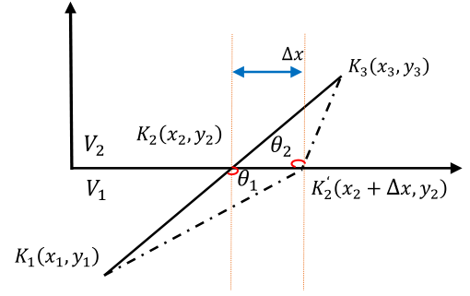
Figure 1. Snell law for finding the refraction point
In Figure 1, $V_{1}$ and $V_{2}$ represent two elements with different wave speeds in CFST members, respectively. $K_{1}$ and $K_{3}$ are two points located in the two elements, respectively, and $K_{2}$ is the intersection point. $θ_{1}$ and $θ_{2}$ are the angle between the ray and the interface. The shortest wave travel path point at the interface between two elements after refraction is $K_{2}^{‘}$, and $∆x$ represents the moving distance from $K_{2}$ to $K_{2}^{‘}$.
However, when the refraction point is occasionally located on the endpoints of two adjacent finite elements with different wave speeds, Snell law does not work. In this case, the shortest path travel time cannot be detected accurately and imaging results will be erroneous. Therefore, in this study, a random walk ray-tracing method combined with the Snell law is proposed as shown in Figure 2.
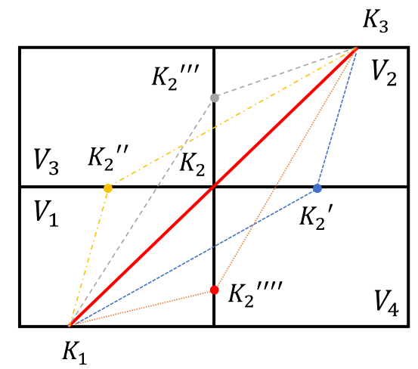
Figure 2. A random walk ray-tracing method combined with Snell law for finding refraction point
When the refraction point $K_{2}$ is on the finite element grid point as shown in Figure 2, the random walk method is adopted to find the shortest time wave travel path. The specific steps are to randomly move the refraction point $K_{2}$ along the surrounding finite element boundaries to form four new refraction points $K_{2}'$, $K_{2}''$, $K_{2}'''$ and $K_{2}''''$, and then the travel times from $K_{1}$ to $K_{3}$ passing through new refraction points are calculated and the shortest time wave travel path is determined according to the slowness of the passing grid.
In order to ensure the accuracy of the internal image reconstruction of the CFST member, the SIRT algorithm is used to perform image reconstruction [21].
$s_{j}=\frac{\sum_{i=1}^{I}{l_{ij}}({∆t_{i}}/{\sum_{j=1}^{J}{l_{ij}}})}{\sum_{i=1}^{I}{l_{ij}}}$ (3)
where $s_{j}$ represents the slowness, $i$ is the i-th ray, $j$ is the j-th imaging element. $l_{ij}$ stands for the length of the i-th ray in the j-th imaging element. $∆t_{i}$ denotes the time difference of the i-th ray. I means the total of rays and J stands for the total of elements.

wave Travel time simulation with multi-physics coupling cfst-pzt models
The multi-physical PZT-CFST coupling FEM model as shown in Figure 3 is discretized with 2D plane strain elements and the propagation of stress waves along the thickness direction of the CFST member is not considered. The internal void in the concrete core of the CFST member has a dimension of 50mm×100mm and the planner dimension of the CFST member is 410mm×410mm. The thickness of the steel tube is 5mm. 11 PZT patches with labels of A1-A11 mounted on the bottom surface of the specimen are used as actuators and 11 PZT patches labeled as S1-S11mounted on the upside are used as sensors. Each PZT patch has a length of 10mm and a thickness of 0.3mm, and the horizontal spacing between each PZT patch is 35mm. The polarization direction of the PZT patches is in its thickness direction. Concrete is treated as a homogeneous material and the material properties of CFST members are shown in Table 1.
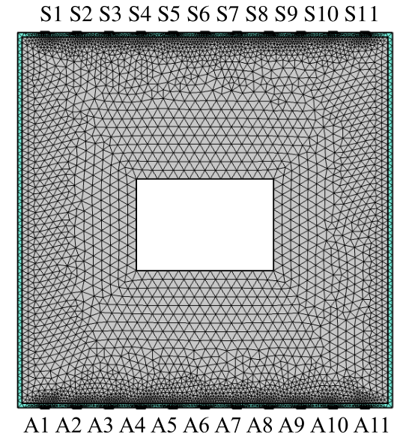
Figure 3. The PZT-CFST coupling FEM model with PZT actuators and sensors considering a void defect
Table 1 Material properties
Material | Young's modulus  (GPa) | Poisson's ratio | Density  (Kg/m³) | wave speed  (m/s)
Concrete | 25 | 0.22 | 2500 | 4000
Steel | 55.6 | 0.16 | 7850 | 5860
Air | / | / | / | 340
The finite element meshing of the coupling model is also shown in Figure 3. The maximum dimension of the elements should satisfy the following equation [14]
$h_{max}≤\frac{v}{5f}$ (4)
where $h_{max}$ is the maximum dimension of element, $v$ represents the wave speed and $f$ is the frequency of signal.
The equation of the employed pulse excitation signal with an amplitude of 10V is shown as follows.
$V=V_{0}e^{({-((t-\frac{2}{f})/f)}^{2})}$ (5)
where $V_{t}$ and $V_{0}$ refer to the excitation voltage signal and its amplitude, $t$ is the time instant.

time-domain response of PZT sensors
The voltage response time histories of the PZT sensors in the above multi-physics CFST-PZT coupling members are calculated using COMSOL software when one actuator is actuated. Figure 4 shows the time-domain response of PZT sensors from S1 to S6 when A6 is actuated. Considering the symmetry of the model and the space limitation here, only part of the voltage response time history is shown here.
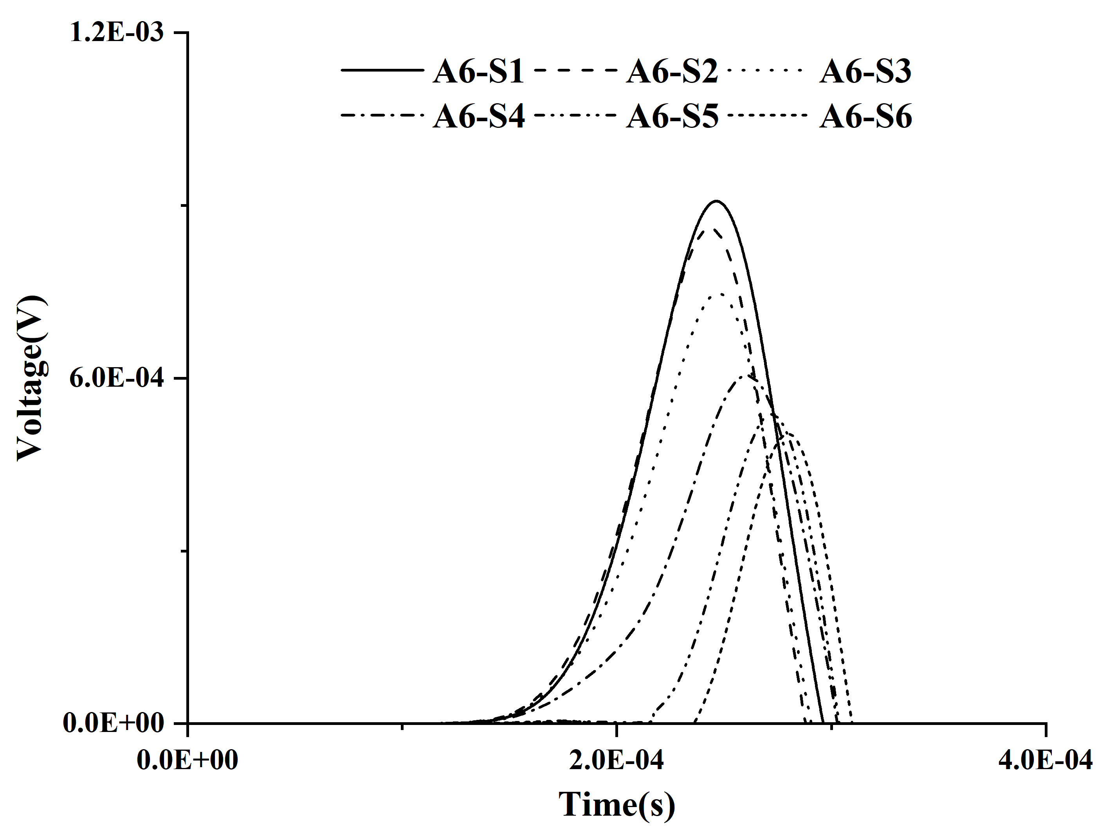
Figure 4. The time-domain signal for coupling Multi-physics CFST-PZT model
As shown in Figure 4, the travel time delay from the actuator A6 to the sensor S6 is the most obvious and the amplitude of the response of the sensor S6 is much lower than others. The reason is that the horizontal position of the PZT sensor S6 and the actuator A6 is located at the center of the void defect, which leads to obvious energy dissipation and attenuation of the stress wave between them. When the PZT sensor is far from the defect center, the corresponding travel time of the stress wave becomes shorter gradually and the corresponding amplitude of the response of the PZT sensor becomes greater. The effect of the void defect on the stress wave propagation within the CFST cross-section with a defect is clear.

Concrete core Defect imaging results

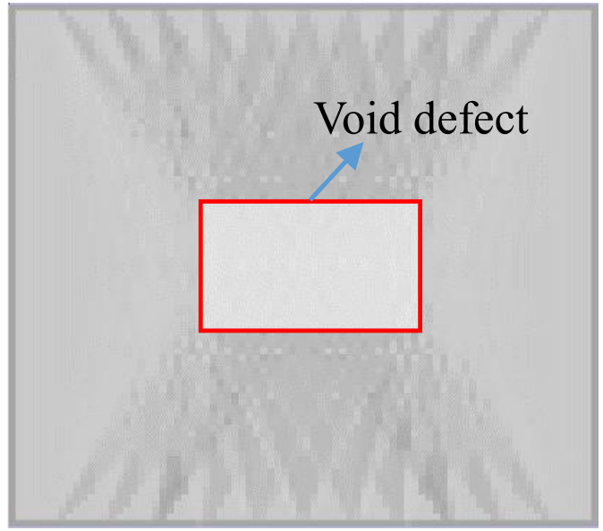 | 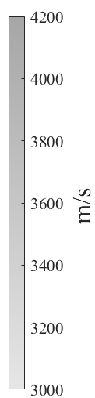
Figure 5. Stress wave imaging results for CFST
Using the stress wave propagation and travel time simulation results determined by the above CFST-PZT coupling model, the imaging of the CFST defect is carried out using the SIRT approach. Based on an initial velocity distribution estimation of the CFST model shown in Figure 3, the image reconstructed by the proposed imaging algorithm is determined and the result is shown in Figure 5. The void in the concrete core of the CFST member is represented as a blurred low-velocity region. For comparison, the solid red rectangular shows the real location of the void in the concrete core of the CFST member. It can be found that the boundary of the void defect in the concrete core of the CFST member is well imaged and its location, shape and size are close to that shown in Figure 3.

concluding remarks
In this study, multi-physics analysis on the output time-domain signals of surface-mounted PZT sensors of a CFST-PZT coupling model with an internal void defect is first carried out when the coupling effect between the PZT patches and CFST member and the direct and inverse piezoelectric effects of PZT patches considered. The propagation time of stress waves in the CFST is collected by the PZT sensors when the coupling model is excited with a PZT patch actuator under a pulse excitation signal. The theoretical shortest travel times of stress waves from a PZT actuator to different PZT sensors of the studied CFST member are obtained based on the Snell law and the proposed random walking method. The SRIT approach is employed to obtain a high-resolution image describing the void defect by minimizing the difference between the stress wave travel time in the CFST-PZT coupling model and the corresponding theoretical shortest travel time from a PZT actuator to each PZT sensor. The following conclusions can be made.
- In practice, for defect detection of CFST members, surface-mounted PZT parches are required to act as actuators and sensors. Determining the stress wave travel time using the multi-physics coupling model is preferred where the direct and inverse piezoelectric effects of PZT patches and the coupling effect between CFST and PZT are considered.
- Compared with the traditional Snell law, the random walking method can be used to determine the theoretical shortest travel time of stress waves for defect imaging when the refraction point is located at the intersection point of the imaging elements.
- The size and location of internal void defects in concrete core in CFST members are obtained using the SIRT image reconstruction algorithms. Results show the accuracy of the proposed tomography imaging method for CFST members with a void defect.
Future tasks include collecting stress wave propagation time for image reconstruction by experiments and considering the internal heterogeneity of concrete to reconstruct the image of CFST members with different defects.

ACKNOWLEDGMENTS
This research was funded by National Natural Science Foundation of China (NSFC) under Grants No. 51878305, and the Scientific Research Funds of Huaqiao University (Grant number 605-50Y18016) to the second author.

References
- H.B. Chen, X. Nie, S.Y. Gan, Y.D. Zhao and H.H Qiu, Interfacial imperfection detection for steel-concrete composite structures using NDT techniques: A state-of-the-art review, Engineering Structures, 2021, 245, 112778.
- C.E. Chalioris, C.G. Karayannis, G.M. Angeli, N.A. Papadopoulos, M.J. Favvata and C.P. Providakis, Applications of smart piezoelectric materials in a wireless admittance monitoring system (WiAMS) to structures - tests in RC elements, Case Studies in Construction Materials, 2016, 5 1–18.
- S. Hiasa, F.N. Catbas, M. Matsumoto and K. Mitani, Considerations and issues in the utilization of infrared thermography for concrete bridge inspection at normal driving speeds, Journal of Bridge Engineering, 2017, 22(11), 04017101.
- G. Villain, A. Ihamouten and D. Xavier, Determination of concrete water content by coupling electromagnetic methods: Coaxial/cylindrical transition line with capacitive probes, Ndt & E International, 2017, 88(JUN), 59-70.
- Q. Yuan, C. Junrui, D. Weihua, F.N. Dang, M. Lei and Z.G. Xu, A quasi real-time approach to investigating the damage and fracture process in plain concrete by X-ray tomography, Journal of Civil Engineering and Management, 2016, 22(6),792-799.
- J. Su, W. Zhang, H. Xiang and X. Guo, Application and analysis of ground penetrating radar in non-destructive testing and evaluation of civil airport runway, IOP Conference Series Earth and Environmental Sence, 2018, 153, 032011.
- G. Zhao, D. Zhang, L. Zhang and B. Wang, Detection of defects in reinforced concrete structures using ultrasonic nondestructive evaluation with piezoceramic transducers and the time reversal method, Sensors, 2018, 18(12), 4176.
- B. Xu, B and Li, G. Song, Active debonding detection for large rectangular CFSTs based on wavelet packet energy spectrum with piezoceramics, Journal of Structural Engineering, 2013, 139 (9),1435–1443.
- B. Xu, T. Zhang, G. Song and H. Gu, Active interface debonding detection of a concrete-filled steel tube with piezoelectric technologies using wavelet packet analysis, Mechanical Systems and Signal Processing, 2013, 36(1), 7–17.
- G.B. Song, H.C. Gu, Y.L. Mo, T.T.C. Hsu and H. Dhonde, Concrete structural health monitoring using embedded piezoceramic transducers, Smart Materials and Structures, 2007, 16(4), 959-968.
- Y. Moslehy, H.C. Gu, A. Belarbi, Y.L. Mo and G.B. Song, Structural health monitoring of reinforced concrete columns subjected to reversed cyclic loading using innovative smart aggregates, Proceedings of the 12th International Conference on Engineering, Science, Construction, and Operations in Challenging Environments-Earth and Space, Honolulu, HI, United States, March, 2010.
- B. Xu, H. Chen and S. Xia, Numerical study on the mechanism of active interfacial debonding detection for rectangular CFSTs based on wavelet packet analysis with piezoceramics, Mechanical Systems and Signal Processing, 2017, 86, 108–121.
- B. Xu, H. Chen and S. Xia, Wave propagation simulation and its wavelet package analysis for debonding detection of circular CFST members, Smart Structures and Systems, 2017, 19(2), 181–194.
- B. Xu, H. Chen, Y.L. Mo and X. Chen, Multi-physical field guided wave simulation for circular concrete-filled steel tubes coupled with piezoelectric patches considering debonding defects, International Journal of Solids and Structures, 2017, 122, 25–32.
- B. Xu, H. Chen, Y.L. Mo and T.M. Zhou, Dominance of debonding defect of CFST on PZT sensor response considering the meso-scale structure of concrete with multi-scale simulation, Mechanical Systems and Signal Processing, 2018, 107, 515-528.
- C. Rosalie, A. Chan, W.K. Chiu, S.C. Galea, F. Rose and N. Rajic, Structural health monitoring of composite structures using stress wave methods. Composite Structures, 2005, 67(2), 1572166.
- J.E. Peterson,N.P. Paulson and T.V. Mcevilly, Applications of algebraic reconstruction techniques to crosshole seismic data, Geophysics, 1985, 50(10), 556-1580.
- J. Chen, C.A. Zelt and P. Jaiswal, Detecting a known near-surface target through application of frequency-dependent traveltime tomography and full-waveform inversion to P- and SH-wave seismic refraction data, Geophysics, 2017, 82, R1–R17.
- A. Dunham and E. Kiser, Local earthquake tomography of the Central Oregon forearc using a large-N, short duration, nodal array. Earth and Planetary Science Letters, 2020, 551.
- H. Liu, H.Y. Xia, M.W. Zhuang, Z.J. Long, C. Liu, J. Cui, B. Xu, Q.F. Hu and Q.H. Liu, Reverse time migration of acoustic waves for imaging based defects detection for concrete and CFST structures, Mechanical Systems and Signal Processing, 2019, 117, 210-220.
- Y.P. Wu, M. Yang, L.F. He, Q. Lin, M.M. Wu, Z.Y. Li, Y.Q. Li and X.G. Liu, Sparse-view neutron CT reconstruction using a modified weighted total difference minimization method, Applied Sciences-Basel, 2021,11(22), 10942.

